
American International University-Bangladesh (AIUB) Faculty of Science and Technology

A Predictive Framework for Optimizing Resource Allocation in Concurrent Software Development
Md. Asif Shahriar Adon (22-46621-1) Mehedi Hasan Turjo (22-46646-1) Fahmida Yasmin (22-48119-2) Mayesha Nowshin Mim (22-46111-1)

A Thesis submitted for the degree of Bachelor of Science (BSc)in Computer Science and Engineering (CSE) at
American International University Bangladesh (AIUB Faculty of Science and Technology (FST)

Fall 2025-2026 Semester Submission Date: October,2026

i

Declaration

This thesis is composed of our original work, and contains no material previously published or writtenby another person except where due reference has been made in the text. We have clearly stated the contribution of others to our thesis, including statistical assistance, survey design, data analysis, significant technical procedures, professional editorial advice, financial and any other original research work used or reported in our thesis. The content of our thesisis the result of work we have carried out since the commencement of the Thesis.

We acknowledge that copyright of all material contained in my thesis resides with the copyright holder(s) of that material. Where appropriate we have obtained copyright permission from the copyright holder to reproduce material in this thesis and have sought permission from co-authors forany jointly authored works included in the thesis.

Md. Asif Shahriar Adon  22-46621-1  CSE Department | Mehedi Hasan Turjo  22-46646-1  CSE Department
Fahmida Yasmin  22-48119-2  CSE Department | Mayesha Nowshin Mim  22-46111-1  CSE Department

CSC 4298 Thesis/Project Department of Computer Science 2

Approval
The thesis titled “A Predictive Framework for Optimizing Resource Allocation in Concurrent Software Development” has been submitted to the following respected members ofthe board of examiners of the department of computer science in partial fulfilment of the requirements for the degree of Bachelor of Science in Computer Science on (29 October,2026) and has been acceptedas satisfactory.

Saeeda Sharmeen Rahman Assistant Professor & Supervisor Department of Computer Science  American International University-Bangladesh |  | Victor Stany Rozario Assistant Professor & External Department of Computer Science  American International University-Bangladesh
Prof. Dr. Muhammad Firoz Mridha
Professor & Head (UG) Department of Computer Science
American International University-Bangladesh
Prof. Dr. Dip Nandi  Professor & Associate Dean Faculty of Science and Technology  American International University-Bangladesh |  | Mashiour Rahman Sr. Associate Professor Dean-In-Charge  Faculty of Science and Technology  American International University-Bangladesh

CSC 4298 Thesis/Project Department of Computer Science 3

Acknowledgement
The successful completion of this thesis would not have been possible without the guidance of many individuals who contributed to this research in a variety of ways. I would like to express my gratitude to everyone who supported me throughout my work.

First and foremost, I would like to express my deepest gratitude to my thesis supervisor, Saeeda Sharmeen, for the invaluable guidance, constructive feedback, and encouragement that she provided throughout the research process. Supervisor’s insightful suggestions and thoughtful guidance helped me develop better research objectives, methodology, analyze the collected data, and ultimately improve the overall quality of this thesis, regarding resource allocation in concurrent software development processes.

I would also like to extend my sincere appreciation to the faculty members of the CSE Department at American International University, Bangladesh. for their academic support, valuable suggestions, and encouragement during my studies. The knowledge and skills I gained during my journey provided a solid foundation for conducting my research.

My heartfelt thanks go to the 47 software professionals in Bangladesh who participated in the survey and generously shared their experiences and perspectives on resource allocation in software development. Their contributions served as the basis for my study. I am also grateful to those who reviewed the preliminary questionnaire and provided valuable suggestions and feedback that improved the clarity and relevance of the instrument.

I would also like to acknowledge the contributions of researchers and authors of published works related to the topic of software project management, concurrent development processes, resource allocation, and optimization algorithms. Their work provided valuable insights that helped me develop a better understanding of the research problem.

I am thankful to my fellow students, friends, and everyone who encouraged me, shared their ideas, or help during the stages of data collection, analysis, and thesis writing. Their support and motivation provided tremendous help in overcoming the challenges that I experienced during my research.

Finally, I would like to express my deepest gratitude to my family for their unconditional love, patience, sacrifices, and support throughout my academic journey. Their encouragement has been a constant source of motivation, helping me continue my studies
CSC 4298 Thesis/Project Department of Computer Science 4

and completing my thesis.

I sincerely appreciate everyone who contributed, directly or indirectly, to the successful completion of my research.

TABLE OF CONTENTS
CSC 4298 Thesis/Project Department of Computer Science 5

Abstract 15
Index Terms 15
- INTRODUCTION 15
  - Background of the Study 15
  - Problem Statement 16
  - Research Questions 16
  - Research Objectives 16
  - Significance of the Study 16
  - Scope and Delimitation 17
  - Conceptual Framework 17
  - Definition of Key Terms 18
  - Organization of the Thesis 18
- LITERATURE REVIEW 19
  - Introduction to the Literature Review 19
  - Software Project Management and Resource Allocation 19
Evolution of software project management 19
Resource allocation as a core PM activity 19
Challenges in concurrent multi-project environments 20
  - Agile and Concurrent Software Development 20
Agile methodologies (Scrum, XP, FDD, TDD, DSDM) 20
Agile release planning and uncertainty management 20
Concurrent engineering principles 21
Dynamics of concurrent software development 21
  - Resource Allocation Approaches 22
Traditional approaches (CPM, PERT, Gantt) 22
Mathematical programming (LP, ILP, MILP) 23
Metaheuristic optimization 23
Multi-objective optimization (Pareto, NSGA-II) 23
Human resource allocation and team formation 24
  - Metaheuristic Algorithms for Resource Allocation 24
Genetic Algorithm (GA) 24
Particle Swarm Optimization (PSO) 25
Ant Colony Optimization (ACO) 25
Grey Wolf Optimizer (GWO) 26
Simulated Annealing (SA) 26
Comparative studies of metaheuristics 26
  - Survey-Based Empirical Research in Software Engineering 26
Questionnaire design and Likert scales 26
Reliability analysis (Cronbach's alpha) 27
Non-parametric group comparison 27
Segmentation (K-Means clustering) 28
  - Research Gaps and Summary 28
Identified gaps in the literature 28
How this thesis addresses the gaps 28
  - Conceptual Framework Derived from the Literature 29
Constructs and hypothesized relationships 29
Framework variables 30
Theoretical justification of the modelled relationships 30
CSC 4298 Thesis/Project Department of Computer Science 6

- RESEARCH METHODOLOGY 32
  - Introduction to the Research Methodology 32
  - Research Design 33
Phase 1 – Quantitative survey 33
Phase 2 – Metaheuristic optimization 33
Phase 3 – Comparative evaluation 33
  - Data Collection 34
Survey instrument design 34
Sampling strategy 34
Respondent profile 34
Data collection procedure 35
  - Data Preprocessing and Cleaning 36
Column renaming and normalization 36
Likert scale conversion 36
Text normalization 36
Missing value handling 36
Outlier detection and capping 36
  - Statistical Analysis Methods 36
Descriptive statistics 36
Reliability analysis (Cronbach's alpha) 36
Correlation analysis (Pearson) 36
Group comparison (Kruskal-Wallis, Mann-Whitney) 36
Post-hoc analysis (Bonferroni correction) 37
  - Segmentation Analysis (K-Means Clustering) 37
Composite index construction 37
Standardization 37
Silhouette-based K selection 37
Cluster profiling 37
  - Multi-Objective Resource Allocation Problem 37
Problem formulation 37
Objective weighting from survey data 37
Fitness function design 38
Constraint definition 38
  - Metaheuristic Algorithms 38
Genetic Algorithm (GA) 38
Particle Swarm Optimization (PSO) 39
Ant Colony Optimization (ACO) 39
Grey Wolf Optimizer (GWO) 39
Simulated Annealing (SA) 39
Parameter settings and justifications 39
  - Implementation and Tools 39
  - Ethical Considerations 40
Ethical protocol 40
Validity, reliability and limitations 40
  - Summary of Chapter 3 41
- RESULTS AND DISCUSSION 41
  - Introduction to Results 41
  - Respondent Profile and Descriptive Statistics 41
Demographic profile 41
CSC 4298 Thesis/Project Department of Computer Science 7

Descriptive statistics of survey constructs 42
  - Reliability and Validity Analysis 43
Cronbach's Alpha 43
Corrected Item-Total Correlation 43
Alpha-if-Item-Deleted 43
  - Correlation Analysis 44
  - Group Comparison Analysis 44
Kruskal-Wallis H Test 44
Post-hoc Mann-Whitney U Test with Bonferroni Correction 45
  - Segmentation Analysis (K-Means Clustering) 45
Optimal Number of Clusters 45
Cluster Profiling 45
Cluster Characteristics by Role, Experience, and Objective 46
  - Optimization Model Evaluation 47
Genetic Algorithm (GA) 47
Particle Swarm Optimization (PSO) 48
Ant Colony Optimization (ACO) 48
Grey Wolf Optimizer (GWO) 48
Simulated Annealing (SA) 48
Comparative Analysis of Algorithms 48
  - Discussion 50
  - Summary of Chapter 4 51
- CONCLUSION AND RECOMMENDATIONS 52
  - Summary of the Study 52
  - Summary of Key Findings 52
  - Answers to Research Questions 53
  - Achievement of Research Objectives 53
  - Contributions of the Study 54
Theoretical Contributions 54
Practical Contributions 54
Methodological Contributions 54
  - Limitations of the Study 54
  - Recommendations 54
For Software Organizations 54
For Project Managers 55
For Policymakers 55
For Future Researchers 55
  - Concluding Remarks 55
REFERENCES 55

CSC 4298 Thesis/Project Department of Computer Science 8

List of Figures

Figure1 | AMERICAN INTERNATIONAL UNIVERSITY,  BANGLADESH | 1
Figure2 | Conceptual Framework of The Study | 18
Figure3 | Research Methodology Flowchart | 33
Figure4 | Overall Response Distribution | 43
Figure5 | Means Distribution per Survey Question | 43
Figure6 | Cronbach’s Alpha Summary by Construct. | 43
Figure7 | Corrected Item-Total Correlation by Item. | 43
Figure8 | Alpha Change upon Hypothetical Item Deletion | 44
Figure9 | Correlation Heatmap of Construct-Level Scores. | 44
Figure10 | Silhouette Score versus Number of Clusters (K). | 45
Figure11 | Cluster Centroids Across the Three Constructs | 46
Figure12 | Cluster Size Distribution | 46
Figure13 | Cluster Profile by Role | 46
Figure14 | Index Scores by Role. | 47
Figure15 | Index Scores by Organization Size. | 47
Figure16 | Optimal Resource Allocation Solution (GA) | 48
Figure17 | GA Convergence Curve. | 48
Figure18 | PSO Combined Visualization (Six-Panel) | 49
Figure19 | ACO Convergence and Workload Distribution. | 49
Figure20 | GWO Convergence and Workload Distribution | 49
Figure21 | SA Convergence and Workload Distribution | 50

CSC 4298 Thesis/Project Department of Computer Science ix

CSC 4298 Thesis/Project Department of Computer Science x

List of Tables

Table 1: | COMPARISON OF AGILE METHODOLOGIES (SCRUM, XP, FDD,  TDD, DSDM) | 22
Table 2: | COMPARISON OF RESOURCE ALLOCATION APPROACHES | 25
Table 3 | COMPARISON OF METAHEURISTIC ALGORITHMS | 27
Table 4 | FRAMEWORK VARIABLES | 31
Table 5 | SURVEY CONSTRUCTS AND ITEMS | 34
Table 6 | RESPONDENT PROFILE (N = 47) | 35
Table 7 | METAHEURISTIC PARAMETER SETTINGS | 40
Table 8 | RESPONDENT DEMOGRAPHIC PROFILE (N = 47) | 42
Table 9 | DESCRIPTIVE STATISTICS OF SURVEY VARIABLES | 42
Table 10 | CRONBACH’S ALPHA RELIABILITY RESULTS | 43
Table 11 | CORRECTED ITEM-TOTAL CORRELATIONS (RANGE BY  CONSTRUCT) | 43
Table 12 | ALPHA-IF-ITEM-DELETED SUMMARY | 44
Table 13 | CONSTRUCT-LEVEL CORRELATION STRUCTURE | 44
Table 14 | KRUSKAL-WALLIS H TEST RESULTS | 45
Table 15 | POST-HOC MANN-WHITNEY U TEST RESULTS | 45
Table 16 | SILHOUETTE SCORES FOR CANDIDATE CLUSTER SOLUTIONS | 45
Table 17 | CLUSTER CENTROIDS (RESOURCE CONSTRAINT / ALLOCATION  CAPABILITY / INTELLIGENT ALLOCATION ACCEPTANCE) | 46
Table 18 | CLUSTER SIZE DISTRIBUTION | 46
Table 19 | CLUSTER PROFILE BY ROLE AND EXPERIENCE (DOMINANT  CLUSTERS) | 47
Table 20 | RESOURCE ALLOCATION RESULTS BY ALGORITHM | 49
Table 21 | WORKLOAD BALANCE OUTCOMES BY ALGORITHM | 49

CSC 4298 Thesis/Project Department of Computer Science xi

CSC 4298 Thesis/Project Department of Computer Science xii

List of Abbreviations

Mention all the abbreviations and the different symbols that are used in this document. Example:
CS | Computer Science
CSE | Computer Science and Engineering
HCI | Human Computer Interaction
NLP | Natural Language Processing
GA | Genetic Algorithm
PSO | Particle Swarm Optimization
ACO | Ant Colony Optimization
GWO | Grey Wolf Optimizer
SA | Simulated Annealing
RA | Resource Allocation
PM | Project Management / Project Manager
RQ | Research Question
O | Objective
G | Gap
R | Relationship
CITC | Corrected Item-Total Correlation
SD | Standard Deviation
CV | Coefficient of Variation
SEM | Standard Error of the Mean
IQR | Interquartile Range
PII | Personally Identifiable Information
CSV | Comma-Separated Values
RF | Random Forest
FS | Feature Selection
SBSE | Search-Based Software Engineering
NP-hard | Non-deterministic Polynomial-time hard
CPM | Critical Path Method
PERT | Program Evaluation and Review Technique

CSC 4298 Thesis/Project Department of Computer Science 13

LP | Linear Programming
ILP | Integer Linear Programming
MILP | Mixed-Integer Linear Programming
RCPSP | Resource-Constrained Project Scheduling Problem
BPR-RCPSP | Bin-Packing Release-planning Resource-Constrained Project Scheduling Problem
MinEA | proactive resource allocation heuristics
MaxTF | proactive resource allocation heuristics
MoSCoW | Must have, Should have, Could have, Won't have
NSGA-II | Non-dominated Sorting Genetic Algorithm II
NSGA-III | Non-dominated Sorting Genetic Algorithm III
MOGA | Multi-Objective Genetic Algorithm
MOPSO | Multi-Objective Particle Swarm Optimization
MOEA/D | Multi-Objective Evolutionary Algorithm based on Decomposition
SPEA2 | Strength Pareto Evolutionary Algorithm 2
IBEA | Indicator-Based Evolutionary Algorithm
ENSES | Elitist Non-dominated Sorting Evolutionary Strategy
NPPP | Non-Homogeneous Poisson Process
XP | Extreme Programming
FDD | Feature-Driven Development
TDD | Test-Driven Development
DSDM | Dynamic Systems Development Method
ALPHA | Cronbach's alpha
H | Kruskal-Wallis H statistics
U | Mann-Whitney U statistics
p | p-value
K | number of clusters
Z | standardized score
CHAOS | Standish Group
CMMI | Capability Maturity Model Integration
Et al. | et alia (OTHERS)
Vol. no. pp. | volume, number, pages
IEEE | Institute of Electrical and Electronics Engineers
IJCN | International Joint Conference on Neural Networks

CSC 4298 Thesis/Project Department of Computer Science 14

PI | Personally Identifiable Information
SD | Standard Deviation
PD | Project Duration

CSC 4298 Thesis/Project Department of Computer Science 15

Abstract—Concurrent software development projects often put organizations in situations. They face issues like not having resources, uneven workloads, mismatched skills, tight deadlines and limited budgets. This happens because project teams and managers are all trying to get access to the pool of human resources. Traditional ways of assigning resources usually depend on gut feelings or simple rules. These methods often don’t work well when there are competing needs. This study tests a smart multi-objective resource allocation framework. The framework looks at five goals at the same time: skill compatibility, project priority, workload balance, deadline urgency and development cost. To test the framework, a mixed-method approach was used. In the step, a structured questionnaire using a 1 to 5 Likert scale was given to 47 software professionals in Bangladesh. The data collected was analyzed using statistics Cronbach’s alpha, Pearson correlation, the Kruskal-Wallis H test and K-Means clustering. In the phase five metaheuristic algorithms were used: the Genetic Algorithm, Particle Swarm Optimisation, Ant Colony Optimisation, the Grey Wolf Optimizer and Simulated Annealing. These algorithms were tested on a synthetic project environment. The environment was weighed up based on the results from the survey. The survey tool showed reliability with Cronbach’s alpha values of (α = 0.939, 0.893, and 0.865),All p-values were greater than 0.05. (all p > 0.05). Cluster analysis revealed four groups of respondents. The silhouette score for the clusters was(silhouette score = 0.412). The largest group had an Acceptance-Dominant profile making up (46.8%)of the respondents. Among the optimization algorithms the Genetic Algorithm achieved the fitness value of (0.9475)and provided a perfectly balanced workload.The Grey Wolf Optimizer, Ant Colony Optimization and Simulated Annealing each reached cost levels, between (117–125) but each of them left one engineer overloaded. These results show that the proposed multi-objective framework gives software project managers a data-driven way to optimize resource allocation across multiple ongoing projects.

Index Terms—Resource allocation, concurrent projects, meta-heuristic optimization, genetic algorithm, multi-objective opti-mization, software project management.

- Introduction
- Background of the Study
Project management effectiveness has been long identified as a key factor in the success or failure of software de-velopment. Software projects do not have the same natural discipline of physical constraints imposed on manufacturing or construction. Software deliverables are intangible, require-ments are volatile and the productivity of the workforce varies considerably by individual, skill and task fit. The Standish Group’s ongoing CHAOS research has consistently demon-strated that only around 32% of software projects. Succeed in the strict sense of being completed on time, on budget, and with the originally specified features [1], a statistic that has remained stubbornly persistent despite decades of methodolog-ical innovation. This persistence suggests that current planning

and scheduling practice has not satisfactorily addressed the basic managerial problem of software project management: how to allocate scarce human and technical resources among competing demands.
Over the past two decades, software organisations have increasingly shifted from managing a single project in isolation to managing a portfolio of concurrent projects, sharing a common pool of developers, testers and managers. This has been driven by commercial pressure to deliver more products and features in less time, the rise of product-line and platform-based development where multiple releases go in parallel, and the adoption of agile methodologies that favour smaller, more frequent releases across multiple product streams rather than large, monolithic single-project efforts [2].Concurrent development is clearly appealing in that it has clear com-mercial advantages such as faster bring time to market, more efficient use of specialized skills, and greater flexibility of the organization. But concurrent development multiplies the complexity of allocation of resources (same engineer could be on two or more projects) and a decision that appears to be optimal on one project may be starvation for another [3].
Resource allocation, the apportioning of personnel, time, and budget to competing project activities is therefore not merely a critical but often underestimated managerial issue. Chiang and Lin [4] ] illustrate that allocation decisions can have direct and measurable impacts on both project cost and delivery time, whereas Rahmandad and Weiss [5] highlight the fact that poor allocation under concurrent, resource-sharing conditions can produce self-reinforcing dynamics of schedule pressure and fire-fighting that adversely affect organizational performance far beyond the immediate project in which the initial shortfall occurs. Traditional scheduling tools, e.g., the Critical Path Method and the Gantt chart, are useful in depict-ing task dependencies within a single project, but offer little formal assistance in resolving resource conflicts across multi-ple, simultaneously active projects, and are single-objective in orientation, usually favoring the schedule duration over cost, workload-balance, and skill-fit considerations that would yield to a more optimal overall project resource allocation that practicing managers must also weigh [6].
Metaheuristic optimization has proven to be a viable alter-native to this limitation. Algorithms such as the Genetic Algo-rithm (GA), Particle Swarm Optimization (PSO), Ant Colony Optimization (ACO), the Grey Wolf Optimizer (GWO), Sim-ulated Annealing (SA), and others can search through expan-sive, combinatorial domains of possible solutions in reasonable time while finding high-quality (albeit not necessarily globally optimal) resource allocations, and can be modified to con-sider multiple objectives that seek to balance cost, schedule,

workload, and skill compatibility with equal consideration [7], [8].However, as Section I-B describes, the weights associated with these different objectives in most research efforts are chosen by the researcher rather than the practitioners who will be required to take on the responsibility of trusting the recommendations of these algorithms—a problem this thesis tackles head-on.
Finally, the context of the investigation is of interest. Most of the studies done so far are either from or related to the software industry of North America, Western Europe, and East Asia. The software professionals’ perceptions and priorities related to resource-allocation practices remain understudied in the context of developing countries [9]. The software industry in Bangladesh has been growing at a significant rate throughout the last decade. It has been progressively meeting the needs of both local and international clients using concur-rent projects. However, there are few studies describing how Bangladeshi software professionals would address resource allocation problems or prioritize multiple allocation goals. This study fills this gap in research by providing a resource-allocation optimization framework based on the preferences of 47 software professionals surveyed in Bangladesh.
- Problem Statement
Software organizations that are managing simultaneous de-velopment projects often face a cluster of interrelated al-location issues: conflicts occur when two or more projects are in need of the same specialized engineer [10]; workload distribution among team members becomes uneven, leaving some engineers overloaded and others underutilized [5];the skills of available engineers often do not match the skills a given project activity requires [4]; managers must trade dead-line adherence against budget constraints repeatedly without a principled way to balance the two [6]; specialized skills are often in persistently short supply [9]; requirements change frequently enough to invalidate allocation plans shortly after they are made [11]; and high-priority projects often steal resources from lower-priority projects to the point of starving the latter of the personnel they need to proceed [3]. These issues are not unrelated; they interact and compound one another. Combined, they are the reasons the Standish Group reports that fewer than a third of software projects succeed by conventional measures.
The academic literature reviewed in Section II has made significant progress on individual aspects of this problem cluster but leaves five specific gaps unaddressed. First, most of the traditional allocation methodologies employ manage-rial intuition or single-utility heuristics that neglect the gen-uinely multi-utilitarian nature of real allocation decisions [4]. Second, although five metaheuristic algorithms (GA, PSO, ACO, GWO, and SA) have each individually been applied to resource-allocation-adjacent issues, they are rarely com-pared comparatively to an identical problem formulation, leaving practitioners without clear, comparative guidance on which algorithm to adopt [12]. Third, empirical studies of resource-allocation perceptions and practices are limited in
developing-country software industries, including Bangladesh [9]. Fourth, no existent study combines survey-derived, empir-ically weighted objectives with a broad, multi-algorithm meta-heuristic comparison and data-driven respondent segmentation within a single framework [7], [13].Finally, the great majority of optimization studies in this space evaluate their algorithms on synthetic or arbitrarily weighted problem instances rather than on objective weights derived from actual practitioner survey data [14].
Taken together, the persistence of the underlying real-world problem (embodied in Standish Group’s 32% project-success statistic) and the set of five identified gaps in the literature suggest that a thesis is needed which (a) empirically elicits the resource-allocation priorities of practicing software profes-sionals through a structured survey, (b) translates said priorities into objective weights in a formal, multi-objective optimization model, (c) implements and compares multiple metaheuristic algorithms against that model, and (d) validates both the survey and the resulting segmentation and optimization results against appropriate statistical methods. This thesis is intended to fill exactly that need, using a sample of 47 Bangladeshi software professionals as its empirical basis.
- Research Questions
  - RQ1: What resource-allocation challenges do software professionals perceive in concurrent projects?
  - RQ2: How reliable and consistent are the survey con-structs measuring resource constraints, allocation capa-bility, and intelligent-allocation acceptance?
  - RQ3: Do perceived constraints, allocation priorities, and acceptance differ across role, experience, or organization size?
  - RQ4: Can respondents be segmented into meaningful profiles based on their resource-allocation perceptions?
  - RQ5: How do five metaheuristic algorithms (GA, PSO, ACO, GWO, SA) perform on a multi-objective resource allocation problem derived from survey data?
- Research Objectives
  - O1: Identify key resource-allocation challenges through a structured survey.
  - O2: Assess reliability and validity of the survey instru-ment using Cronbach’s alpha and item-total correlations.
  - O3: Examine whether perceptions differ across role, experience, and organization size using non-parametric tests.
  - O4: Discover respondent segments using K-Means clus-tering and profile them.
  - O5: Implement and compare five metaheuristic algo-rithms for multi-objective resource allocation.
  - O6: Propose a data-driven allocation framework for prac-titioners.
- Significance of the Study
Academically, this thesis contributes to cover the five gaps outlined in Section I-B. By relying on practitioner survey

data for deriving objective weights (rather than researcher assumptions) this thesis addresses G1 and G5; by implement-ing and comparing five different meta-heuristics algorithms on the same problem formulation it ad-dresses G2; by featuring an empirical sample from Bangladesh (an under-represented developing-country software industry) it addresses G3; and by combining survey-derived weighting, multiple algorithm comparison and K-Means based respondent segmentation in a single study it addresses G4. In short, this thesis extends the resource-allocation literature both in methodological (survey-to-optimization pipeline) and empirical (Bangladesh data) di-mensions.
In a practical sense, the results of the thesis research and the framework that was created around it are intended to be immediately applicable to real-world software development organizations dealing with resource allocation across multiple projects. The reliability-tested survey instrument that was cre-ated for this research (with Cronbach’s alpha of 0.939, 0.893, and 0.865 for the Resource Constraint, Allocation Capability, and Intelligent Allocation Acceptance constructs) can serve as a ready-to-use allocation prioritization tool for any organiza-tion that wants to base its decisions on the empirical pref-erences of their workforce, while the comparative analysis of algorithm performance that demonstrated Genetic Algorithm’s best fitness value of 0.9475 with a standard deviation of 0.00 can help such organizations avoid unnecessary expenditures on comparative algorithm research by giving them an evidence-based reason to choose one method over others.
The study has implications for policy at the level of the in-dustry, as it provides the Bangladeshi information technology sector with one of its first empirically grounded accounts of how local software professionals perceive resource-allocation challenges. This in turn allows industry associations and training and policy agencies to design interventions (e.g., in workforce skill development or in the promotion of data-driven project management tooling) that are responsive to locally observed conditions—rather than imported wholesale from research conducted elsewhere. Given the rapid growth of Bangladesh’s software export sector, such evidence is of direct relevance to national digital-economy planning.
- Scope and Delimitation
The paper is scoped as per below. An exploratory survey was conducted among 47 software professionals working in the industry of Bangladesh. Participants were categorized into four occupational categories including Software Developer , 59.57%; Project Manager, 23.40%; QA Engineer, 8.51%; Pro-gram Manager, 8.51%), with an overall experience distribution indicating that most participants 80.85%,reported having less than a year of experience. Participants were further grouped into three organizational buckets (Majority 89.36% were work-ing in medium-sized organisations).Three composite survey indices were constructed and validated including Resource Constraint, Allocation Capability, and Intelligent Allocation Acceptance. Non-parametric group comparison tests and K-Means clustering analyses were performed on the resulting
data. The allocation capability weights extracted from the survey were used to formulate a multi-objective fitness func-tion which was evaluated using five different meta-heuristic optimization algorithms namely, Genetic Algorithm (GA), Particle Swarm Optimization (PSO), Ant Colony Optimization (ACO), Grey Wolf Optimizer (GWO), and Simulated An-nealing (SA) on a representative concurrent project allocation problem including twelve engineers and eight projects.
The study is limited in several respects. It does not attempt to model or simulate the feedback effects like the firefighting and capability-erosion dynamics of Rahmandad and Weiss (2009) which take place during the execution of the project; the study analyzes only one survey and one run of the algorithms on the problem instance whereas a single live-long deployment would contain numerous such runs; it does not analyze any other meta-heuristic or exact optimization algorithms apart from the five mentioned above; it does not attempt to establish any causal relationships between constructs as it deals only with a correlational cross-sectional study; the sample size, adequate for an exploratory study on building the research model, may not be representative for the whole Bangladesh software industry and more than 80.85% of the respondents are fresh in the industry with less than one year of experience; and finally, the study focuses on the allocation of human resources only and does not consider other types of resources such as computer infrastructure, licensing, or physical space.
- Conceptual Framework
The idea behind the project, which is shown completely in Fig. 1 1 And explained more in the part of Section II is about improving how resources are assigned through six steps. In the step the answers from the 47 people who did the survey are put into three main groups: the Resource Constraint Index, the Allocation Capability Index and the Intelligent Allocation Acceptance Index as well as other details about the people like their job how long they have worked in their field and how big their company is. The second step has the five parts that make up the Allocation Capability Index. These parts have been changed into numbers that show how important each part is, to the people who completed the survey. These parts are skill fit, project priority, workload balance, time urgency and development costs.
These weights define the layer. The third layer holds a fitness function. The fitness function blends skill-mismatch, workload-imbalance, cost, priority-shortfall and deadline-shortfall penalty terms into one number that we want to reduce. In the layer five metaheuristic algorithms—GA, PSO, ACO, GWO and SA—search separately for allocations that lower the fitness function. These algorithms run on a scenario with twelve engineers and eight projects. The fifth layer records the results. The results include the allocation vector from each algorithm, the corresponding workload distribution, the convergence behavior over many iterations and the comparative performance metrics for all five algorithms. The sixth and final layer checks the process. Validation uses Cronbach’s alpha to confirm the reliability

of the survey constructs. K-Means clustering, judged by silhouette score finds respondent segments. Non-parametric group-comparison tests check if those segments or broader demographic subgroups differ a lot in their reported priorities. Demographic variables and organization size are seen as moderating influences on perceived constraints and on acceptance of allocations generated. They are not used as inputs to the optimization. This framework directly shapes the research design in Section III. It also gives the lens that organizes and discusses the findings, in Sections IV and V.

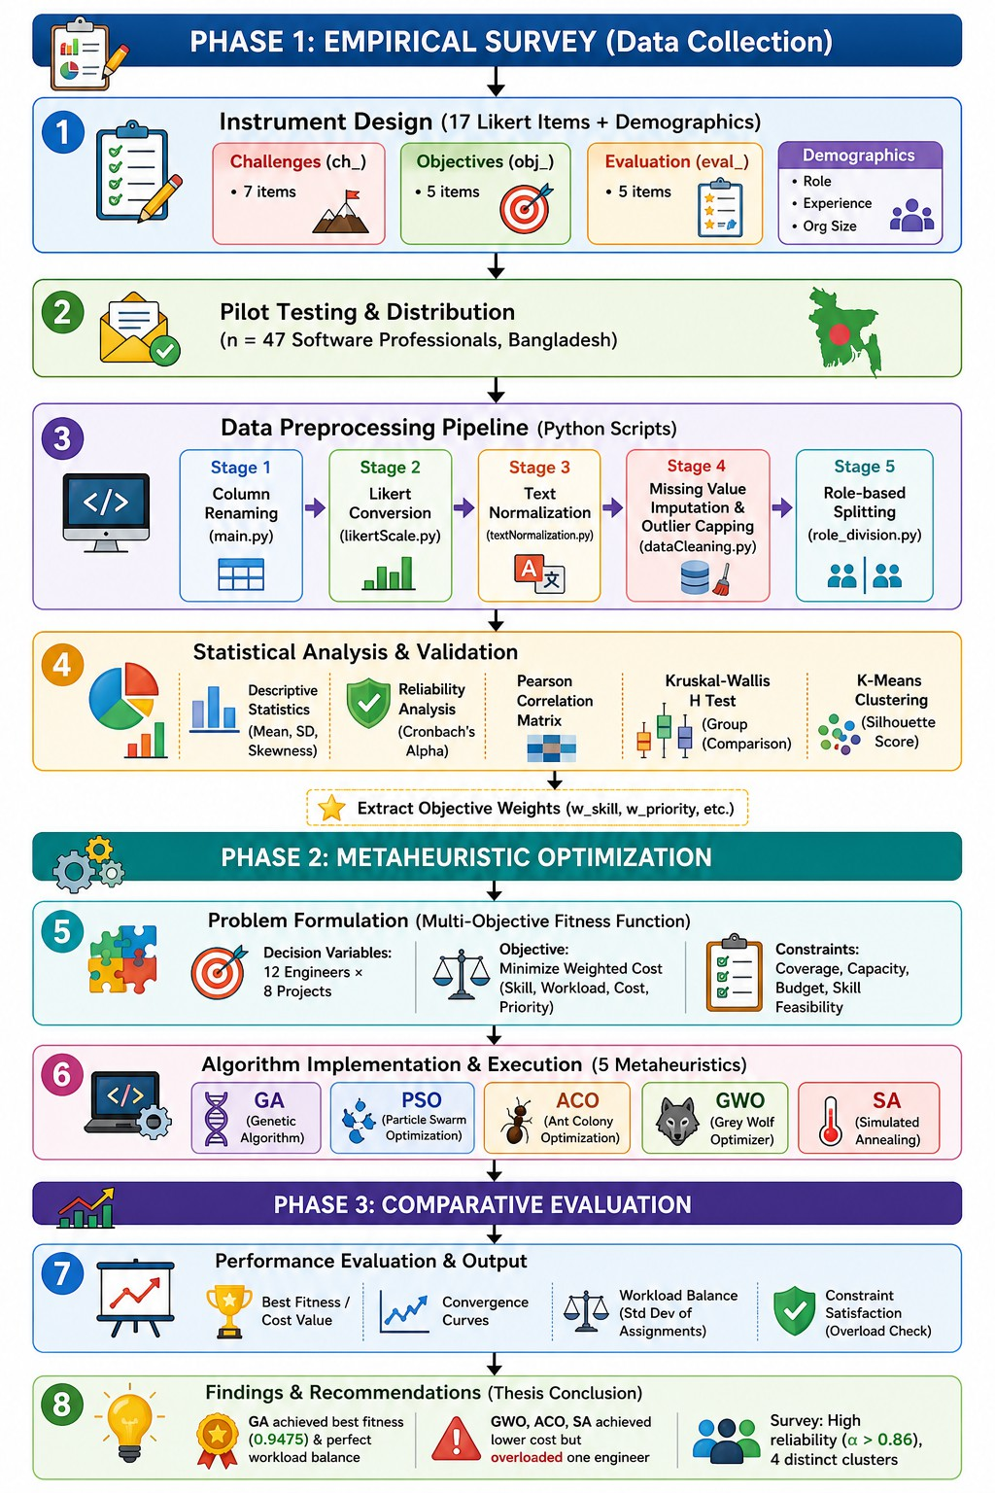
Fig. 1. Conceptual framework of the study.

- Definition of Key Terms
  - Resource Allocation: The process of giving people time and money to do different tasks or activities in a project. The goal is to meet the company’s goals, like keeping costs low, finishing on time and making sure the work is quality.
  - Concurrent Projects: Two or more software devel-opment projects that happen at the time in the same company. These projects use some of the people or other resources.
  - Multi-Objective Optimization: A way to solve problems that have than one goal. These goals might be opposite like making something and making it high quality. This method tries to find solutions that work for all the goals at the time. It might combine the goals into one formula. Find a list of good options.
  - Metaheuristic Algorithm: A smart search method, like Genetic Algorithm or Particle Swarm Optimization that helps find answers to hard problems quickly. These methods don’t always find the best answer, but they find a very good one at a reasonable time.
  - Skill Compatibility: How well an engineer’s skills match the skills needed for a project task. This helps decide if the engineer is fit for the task.
  - Workload Balance:How evenly work is spread out among the people in a team or company. Work is mea-sured in things, like tasks, hours or projects. A good workload balance means not one person has much work and others have too little.
  - Deadline Urgency: The level of importance placed on time when it comes to finishing a project or a task. It shows how quickly the work needs to be done and what happens if it is not completed on time.
  - Development Cost: The amount of money spent on people to finish a specific project or task.
  - Cronbach’s Alpha: A number that goes from 0 to 1. It measures how consistent a group of questions are when they are meant to measure the idea. Numbers that are
0.70 or higher are seen as good.
  - K-Means Clustering: A way to group data without telling the computer what the groups should be. It works by putting data points into groups based on how they are to the center of each group. The centers are changed again to make the groups as tight, as possible.

- Organization of the Thesis
The rest of this thesis is organized in a way. Section
II gives a review of literature. It covers software project management and resource allocation, agile and concurrent software development, different resource allocation methods, the five metaheuristic algorithms that this study uses and survey-based research methods. Section II ends with a state-ment of the research gaps that this thesis aims to fill. Section III explains the research methodology. It describes the survey instrument and how it was administered the reliability and segmentation analyses, the creation of the fitness function and the implementation of the five meta-heuristic algorithms. Section IV shows the study’s findings. It includes survey statistics, reliability results, group-comparison and clustering outcomes and a comparison of the performance of the five algorithms. Section V discusses these findings with respect to the research questions and earlier studies. It ends with the study’s contributions, practical recommendations, limitations and suggestions, for research.

- Review of Related Literature
- Introduction to the Literature Review
This section provides background information on the schol-arly work pertinent to the optimization of the resource al-location to concurrent software development projects. The review aims at three goals: first, to place the problem of resource allocation to software development projects in the larger context of software project management and show how the problem was affected by the shifts in the software de-velopment methodologies; second, to review the main classes of approaches that have been proposed to tackle the resource allocation to concurrent software development projects from the perspectives of deterministic scheduling, mathematical programming, and multi-objective optimization; and third, to highlight the gap in the scholarly work on resource allocation to concurrent software development projects that this thesis aims at addressing.
The whole work consists of seven sections. Section II-B deals with software project management and resource allo-cation, which are considered as one of the main problems in project management, while the focus is on multi-project environments. Section II-C provides an overview on agile and concurrent software development, including the most popular agile approaches, agile release planning under uncertainty, and fundamentals of concurrent engineering. In turn, section II-D is focused on the state-of-the-art resource allocation approaches, ranging from traditional optimization methods to metaheuristics and multi-objective optimization, including the issues of human resource allocation and team formation. Finally, section II-E presents the overview of the five meta-heuristic algorithms used within the scope of this thesis. The Genetic Algorithm (GA), Particle Swarm Optimization (PSO), Ant Colony Optimization (ACO), the Grey Wolf Optimizer (GWO), and Simulated Annealing (SA) together with com-parative studies of them relative performance. Section II-F discusses the survey-based empirical methods informing the thesis’s approach to objective weighting: questionnaire design, reliability analysis, non-parametric comparison, and K-Means segmentation. Section II-G synthesizes the preceding sections into a set of identified research gaps and describes how the current thesis addresses them. The review is critical in nature: each approach is assessed not only for described contributions but in terms of assumptions, domain of applicability and potential limitations in the context of concurrent, multi-project, and multi-stakeholder software development. This synthesis informs the conceptual basis of the framework proposed in the following chapters of the thesis.
Throughout the review takes a view rather than just a descriptive one. The review looks at each approach not by what it claims to contribute but also by the assumptions it makes the range of situations it can cover and the limits it has when moved into the concurrent multi-project multi-stakeholder context that marks modern software development. This critical synthesis lays the groundwork, for the framework that is built in the following chapters of the thesis.
- Software Project Management and Resource Allocation
  - Evolution of software project management: 1) Evolution of software project management – Management practices spe-cific to software project management developed as a response to the frequent failures of early software projects to meet cost, schedule, and quality goals. Early management practices were largely borrowed from construction and manufacturing project management, and featured waterfall-style, phase-gated life cycles in which requirements, design, implementation, testing, and deployment followed a largely linear sequence. Gerosa [15] describes this lineage and shows how classical scheduling tools such as the Critical Path Method (CPM), the Program Evaluation and Review Technique (PERT), and the Gantt chart were adapted from large infrastructure projects into software environments, where they served as a means to visualize and analyze task sequencing and estimate comple-tion dates.2)However, as software systems grew in scale and complexity, the limitations of a purely sequential, plan-driven approach became evident.
Requirements were rarely stable for the duration of a project, while the intangible and highly variable nature of software work made accurate up-front estimations difficult. Nguyen [16], in an empirical study of planning practices across software companies in Vietnam, found that formal planning processes often had only a weak correlation with successful outcomes, and that human and organizational fac-tors such as team composition, communication patterns, and management support often played at least as important a role as the sophistication of the planning technique itself, foreshadowing a recurring theme in the literature reviewed in this section, namely that resource allocation should not be considered purely as a combinatorial optimization problem divorced from the organizational and human context in which it occurs.
The evolution of software project management since the 1990s has therefore been characterized by a gradual shift away from rigid, phase-gated control toward iterative, adaptive and increasingly data-informed approaches, culminating in the emergence of agile methodologies described in Section II-C, but also motivating a parallel body of work that aimed to formalize resource allocation as an explicit optimization problem and which is reviewed in Section II-D, where it was initially approached through mathematical programming and later through metaheuristic search.
  - Resource allocation as a core PM activity: Resource allocation, which involves the distribution of scarce resources among different activities in a project over time, is one of the most important project management issues and the key element distinguishing various project management method-ologies. Gerosa [15] argues that resource allocation is closely linked to the project schedule: the classical ways of acceler-ating construction by crashing or fast-tracking are essentially resource allocation decisions by reducing the duration of some project activities through the allocation of additional resources. The author also points out that the Pareto principle can be

applied to resource allocation since a relatively small number of actions or resources account for a disproportionately high amount of value or risk in project implementation; this pro-vides an idea of resource allocation priorities. Additionally, Gerosa notes that delegation can also be considered a form of resource allocation.
Chiang and Lin [17] examine the allocation of human resources in software projects through the lens of commu-nication efficiency and find that it is a multi-criteria decision-making problem that involves balancing communication costs, negative efficiency, and resource transfer costs. The authors test their model on a real-life case study of a software firm, demonstrating that resource allocation decisions significantly impact cost and time performance. This suggests that resource allocation must be considered in a broader context, as it affects many areas of project management.
Beyond assignment problems narrowly defined, resource al-location also encompasses resource leveling and smoothing—adjusting the timing of activities to avoid extreme peaks and troughs in resource demand. Mohammed and Ameer [18] examine this aspect of resource allocation in construction projects using a Genetic Algorithm, which allows finding optimal allocations without extensive mathematical modeling. The resource moment (sum of squared daily resources) was used as a measure of goodness in this study, reflecting the desired resource profile. The authors’ findings demonstrate that resource allocation is a complex multi-faceted process, which includes decision-making not only in the assignment of resources to activities but also in smoothing their distribution over time.
  - Challenges in concurrent multi-project environments: Difficulties in concurrent multi-project environments: The resource allocation problem is much harder to handle in con-current, multi-project settings where various software devel-opment endeavors are simultaneously consuming shared and limited personnel and infrastructural resources. Rahmandad and Weiss [19] examine concurrent software development through the lens of system dynamics, noting a self-reinforcing “tipping” phenomenon in which schedule pressure on one project results in firefighting activities (resources being di-verted to urgent but not necessarily important tasks), which results in degraded work quality on other concur-rent projects, eroding organizational capability and generating further sched-ule pressure in a vicious cycle. This work is significant because it shows that resource allocation failures in concurrent systems are not just additive across projects but can exhibit feedback loops that are hidden from project-by-project scheduling tech-niques. Abdel-Hamid and Madnick [20], in an earlier but foundational system dynamics study captured Brooks’ Law – the counterintuitive observation that adding manpower to a late software project makes it later – in a simulation of software project scheduling and extended their analysis to a ten-project simulation to illustrate how staffing and allocation decisions ripple throughout an organization’s project portfolio over time. Repenning [3] contributes a complementary multi-project resource allocation model demonstrating that R&D
and software organizations sharing resources across projects can settle into multiple distinct steady states – some efficient and some characterized by chronic resource starvation of individual projects – depending on initial conditions and the sensitivity of resource utilization to allocation policy. Lynsie, Cooper, and Els [21],reporting on the “Peace Shield” case study provides empirical corroboration of these dynamics in a large-scale software program, attributing project recovery to a combination of external interventions (44%) and inter-nal management improvements(56%), and underlining that resource allocation problems in concurrent environments are rarely resolved by algorithmic reallocation alone.
Risk makes the difference even more significant. Alharbi, Alyoubi, Altuwairiqi, and Abd Ellatif [22] analyze the re-source allocation process in concurrent projects and demon-strate that resource allocation in such projects should be centralized, not local to a project, because risks that emerge in one project often affect other projects, for instance, when key personnel leave or project scope increases. The authors apply a risk categorization in the form of a REP Tree constructed using twelve risk variables, and they report achieving 98% accuracy in classifying risk increases. They also recommend that resource and risk management in concurrent projects should be centralized. Thus, this research contributes to the pool of evidence indicating that resource allocation in concur-rent projects is a fundamentally different activity that requires considering the interactions between projects. It often involves global choices that need to be made for the benefit of the entire set of concurrent projects, not just individual ones. This observation is one of the motivations for this thesis, which examines the multi-objective optimization of resource allocation for a portfolio of projects.

- Agile and Concurrent Software Development
  - Agile methodologies (Scrum, XP, FDD, TDD, DSDM): Agile methodologies (Scrum, XP, FDD, TDD, DSDM): Agile methodologies were developed (in the early 2000s) as an alternative to the traditional plan-driven approaches to manag-ing projects, emphasizing iterative development, collaboration with customers, and adaptability over extensive planning at the beginning of the project. The paper by Al-Saqqa, Sawalha, and AbdelNabi [23] contains a review of research findings on agile methodologies, including Scrum, Extreme Program-ming (XP), Feature-driven Development (FDD), Test-driven Development (TDD), and the Dynamic Systems Development Method (DSDM). These methodologies can be applied to such modern trends as cloud-native development, big data, and distributed teams, which are discussed by the authors.The main findings of the review include the differences between the methodologies in terms of their practices and applicability, which may have an impact on the allocation of resources (since they affect the way work is organized and the related costs). All these methodologies, in one way or another, are based on the Agile Manifesto, which emphasizes certain values and principles.

Saleh’s [24]agile software development framework focuses on the developer-level practices that emphasise close collab-oration with customers and anticipation of changes as first-class design considerations, rather than exceptions to manage. These developer-centric practices complement the process-centric view proposed by Al-Saqqa et al. [23]and highlight an often-overlooked aspect of agile resource allocation: the allocation of attention and collaboration time between devel-opers and customers, which is not readily associated with conventional task-based resource models. Table I summarises and compares the five agile methodologies discussed in terms of their characteristic life cycle, defined roles, advantages, and limitations, with attention to the implications for re-source allocation practice. While each methodology provides a slightly different set of mechanisms for managing the iterative process involved in dealing with scope and quality, none of them provides a concrete algorithm for resource allocation. Instead, all three make use of lightweight, manual processes like sprint planning, backlog grooming, or pair rotation. These are not easily scaled to concurrent, multi-team, multi-project environments, prompting the more elaborate treatments of agile release planning that will be discussed in the next section.
  - Agile release planning and uncertainty management: Agile release planning, the process of determining which fea-tures or user stories should be delivered in which iteration, sub-ject to resource and dependency constraints, has attracted a substantial body of optimization-oriented research that bridges agile practice to formal resource allocation. Elgebeely and Kamel present an agile planning methodology for software production that combines technical analysis with explicit de-pendency matrix, integrating Scrum-based release planning with active technical debt management, on the grounds that unmanaged technical debt silently consumes future resource capacity and therefore must be treated as a first-class constraint in release planning rather than an afterthought.
Szoke formalizes agile release planning as a bin-packing problem-the Bin-Packing Release-planning Resource-Constrained Project Scheduling Problem, or BPR-RCPSP-and proposes a heuristic algorithm, Binsched, to solve it efficiently. This formulation is significant because it makes explicit the combinatorial, NP-hard character of release planning: assign-ing a set of features with heterogeneous resource requirements to a fixed number of capacity-constrained sprints is structurally equivalent to the classical bin-packing problem, for which exact solutions become computationally intractable as problem size grows, motivating the use of heuristic and metaheuristic methods discussed later in this section.
A further complication is that agile projects have consid-erable uncertainty in terms of estimates – user-story point estimates, as well as effort estimates, are imprecise, if not outright wrong at the beginning. McDaid, Greer, Keenan, Prior, Taylor, and Coleman tackle this issue head-on, devel-oping a lognormal-distribution based model of task duration with slack-based scheduling that estimates the likelihood of a release meeting its deadline. Their analysis is an improvement over the bin-packing formulation of Szoke et al. and the
dependency matrix method of Elgebeely and Kamel, as it ex-plicitly considers the possibility of individual tasks’ durations contributing to the slippage of a release; whereas the other three methods’ deterministic scheduling makes it difficult to formally assess the risk of a particular resource allocation and release schedule combination. Overall, these works serve to demonstrate that even the most seemingly “lightweight” of methodologies still have plenty of room for optimization when it comes to resource allocation, scheduling, and release planning done at scale or across multiple concurrent releases.
  - Concurrent engineering principles: Concurrent engi-neering proper is a manufacturing-field concept that deals with overlapping design and development processes to im-prove the overall efficiency of product development. When applied to software development, it serves as a theoretical basis for parallel development of interdependent components, overlapping testing and implementation, and other practices that see software engineers working on multiple, interacting processes at once. Notably, concurrent engineering adds an-other dimension of complexity to the resource allocation and scheduling problem in that processes running concurrently often compete for the same resources (most often personnel, in the case of software engineering). Fourie’s chapter provides some context on concurrent engineering’s ties to operations research, particularly in terms of supporting the allocation of interdependent activities with limited resources. This connec-tion helps to ground concurrent engineering in a wider theory, but it also provides a crucial link between operations research concepts and software engineering practices, as it explains how the kinds of mathematical programming and metaheuristics reviewed in Section II-D could be applied to resource alloca-tion and scheduling in the first place. Specifically, linear and integer programming, queuing theory, and simulation all have their counterparts in concurrent software engineering, where tasks need to be scheduled in such a way as to account for interdependencies (caused by data or interface requirements) and the limited skill sets of personnel working on them, which are not trivial factors in resource allocation and scheduling. Schedulable units.
Concurrent engineering principles thus provide the con-ceptual bridge between the process-oriented agile literature reviewed in Section II-C1–II-C2 and the (more mathematically formal) resource allocation literature reviewed in Section II-D: the former describe the characteristics of work that should be organized and sequenced, while concurrent engineering and operations research describe the optimization of resulting interdependent, resource-constrained activities.
  - Dynamics of concurrent software development: Dynam-ics of concurrent software development: Building on the concurrent engineering principles discussed above, a distinct strand of literature, grounded in system dynamics rather than combinatorial optimization, examines the emergent behavior of concurrent software development over time. As introduced in Section II-B3, Rahmandad and Weiss identify reinforcing feedback loops through which schedule pressure, firefighting, and capability erosion interact to produce non-linear, difficult-

TABLE I
Comparison of Agile Methodologies (Scrum, XP, FDD, TDD, DSDM)

Methodology | Life Cycle | Key Roles | Advantages | Limitations
Scrum | Time-boxed sprints (2–4 weeks); sprint planning, daily  standup, review, retrospective | Product Owner,  Scrum Master, Development Team | Clear cadence; strong prioritization via backlog; well suited to evolving requirements | Resource allocation across concurrent Scrum teams is largely manual;  limited formal optimization support
Extreme Programming (XP) | Continuous, highly it-erative; pair program-ming and continuous integration | Customer, Developers (pair-based), Coach | Strong quality  practices (TDD,  pairing); rapid feedback on code quality | Intensive resource de-mand (pairing dou-bles apparent staffing need); harder to scale across projects
Feature-Driven Development (FDD) | Feature-list driven; design-by-feature  and build-by-feature iterations | Chief Architect, Feature/Class Owners, Development  Team | Scales well to larger teams; clear feature-level progress track-ing | Heavier up-front  modeling than  Scrum/XP; less prescriptive on cross-project resource sharing
Test-Driven Development (TDD) | Micro-cycles of test-write, code, refactor, nested within a broader iteration | Developers | High code quality and regression safety; tight feedback loop | A development prac-tice rather than a full project manage-ment method; no na-tive resource alloca-tion mechanism
Dynamic Sys-tems Develop-ment (DSDM) | Time-boxed  phases with fixed cost/time and fixed scope (MoSCoW prioritization) | Business Sponsor, Business/Technical Coordinator, Solution Development  Team | Explicit business-driven prioritization; formalized change control | Governance overhead can be heavy for small teams; less widely adopted than Scrum

to-predict project outcomes in concurrent settings. This per-spective is a crucial complement to the largely static, snapshot-in-time resource allocation models reviewed elsewhere in this section: a resource allocation that appears optimal at a single point in time may nonetheless trigger dynamics that erode organizational capacity over subsequent iterations. 2)Repen-ning’s multi-project resource allocation model formalizes this insight mathematically, showing that the relationship between resource allocation policy and project outcomes in multi-project R&D and software organizations is not monotonic: beyond a certain point, incremental increases in resource contention can push a project from a productive steady state into a self-reinforcing failure mode from which recovery requires disproportionate intervention. Abdel-Hamid and Mad-nick’s earlier dynamics model similarly demonstrates, through simulation of Brooks’ Law, that naive resource real-location (for example, transferring personnel onto a delayed project) can be actively counterproductive once onboarding and com-munication overheads are accounted for.
The practical implication that this literature has for the present thesis is: any resource allocation framework for con-current software development must be judged, not only in terms of static, single-period objective functions (cost, time, quality) but with awareness that its allocation decisions have dynamic, path-dependent consequences. While a full system dynamics treatment is beyond the scope of this thesis, the multi-objective framing adopted here (which includes, for ex-ample, workload balance and skill-transfer costs in addition to
cost and schedule objectives) is partly motivated by an attempt to avoid allocation policies that are dynamically destabilizing as per this literature.
- Resource Allocation Approaches
  - Traditional approaches (CPM, PERT, Gantt): The ear-liest formal approaches to resource allocation in project man-agement were the deterministic scheduling techniques of the Critical Path Method (CPM), the Program Evaluation and Re-view Technique (PERT), and the Gantt chart. The CPM recog-nizes the longest sequence of dependent activities, the critical path, which determines the minimum project duration, while PERT analyzes probabilistic activity durations by computing three-point estimations. Gerosa reviews these approaches in detail, noting their continued pedagogical and practical value for visualizing task dependencies and identifying schedule-critical activities and their connections to resource-oriented tactics such as crashing and fast tracking. Tracking.
However, conventional techniques share a key limitation in their application to concurrent, multiproject software resource allocation: they were developed to optimize the schedule of a single project given a fixed, largely devoted resource pool, and cannot directly optimize resource assignment across multiple, competing projects with overlapping timelines and shared personnel. CPM and PERT can best be applied inde-pendently to each project in a portfolio, with resource conflicts manually resolved, which the system dynamics perspective reviewed in Section II-C4 suggests can prove destabilising to

organizational performance. And, in terms of solution value, these methods are single-objective, usually minimizing project duration given resource constraints, without any principled mechanism to trade off competing objectives like cost, work-load balance, and skill utilization. It is this limitation which motivates the shift, documented in the remainder of Section II-D, towards mathematical programming and, subsequently, metaheuristic and multi-objective optimization.
  - Mathematical programming (LP, ILP, MILP): Mathe-matical programming approaches, including linear program-ming (LP), integer linear programming (ILP), and mixed-integer linear programming (MILP), formalize resource allo-cation as the optimization of an explicit objective function subject to a system of linear (or linearizable) constraints, and represent a significant advance over the purely graphical and heuristic nature of CPM and PERT. Chiang and Lin’s integer programming model for human resource allocation is a representative example: by formulating communication efficiency, negative efficiency, and transfer cost as explicit terms in an objective function, and validating the model against a real allocation case, the authors demonstrate that mathematical programming can capture allocation trade-offs that traditional scheduling techniques cannot express.
Barreto, Barros, and Werner – as discussed by Chiang and Lin – similarly formulate software project staffing as a constraint satisfaction and optimization problem, explicitly modeling skill requirements, availability constraints, and team composition rules. Leus and Herroelen contribute a stability-focused MILP and branch-and-bound formulation for resource allocation in project planning, explicitly modeling schedule stability – the robustness of a resource allocation to disruptions – as an optimization objective rather than an afterthought, using constraint propagation to keep the search space tractable. Brackman’s, Demeulemeester, Herroelen, and Leus extend this stability-oriented line of work with proactive resource allocation heuristics (MinEA and MaxTF, both formulated as integer programs) designed to produce schedules that are robust to activity duration variability, an important practical consideration given the estimation uncertainty documented in Section II-C2.
Mensah, Keung, Bennin, and Bosu apply MILP in com-bination with deep neural network estimators to the related problem of software testing effort allocation, comparing cross-company and within-company estimation models—an appli-cation that illustrates the versatility of mathematical program-ming beyond core development resource allocation. Despite these contributions, mathematical programming approaches share a common and well-documented limitation: exact solu-tion methods for ILP and MILP formulations scale exponen-tially in the worst case with the number of decision variables and constraints, rendering them computationally impractical for realistically sized concurrent, multi-project resource al-location problems, which are provably NP-hard. This com-putational barrier, rather than any conceptual deficiency in the formulations themselves, is the principal driver behind the field’s subsequent turn toward metaheuristic optimization,
discussed in Section II-D3 and elaborated in Section II-E.
  - Metaheuristic optimization: Metaheuristic algorithms—stochastic, often nature-inspired search procedures that do not guarantee a globally optimal solution but are capable of finding high-quality solutions to NP-hard combinatorial problems within practical computation times—have become the dominant approach to resource allocation optimization in software engineering research over the past two decades. Rather than exhaustively or exactly solving the underlying combinatorial problem, as mathematical programming attempts to do, metaheuristics explore the solution space using mechanisms inspired by natural or social processes: genetic recombination and mutation (GA), collective animal movement (PSO), pheromone-mediated foraging (ACO), pack-hunting behavior (GWO), and the physical annealing of metals (SA), among others.
Mohammed and Ameer’s application of a Genetic Algo-rithm to resource allocation and leveling, implemented in C++ to minimize a resource moment metric, exemplifies the appeal of metaheuristics: the GA is able to search a large combinato-rial space of possible resource assignments without requiring the problem to be linearized or otherwise simplified for exact solution, and can accommodate objective functions—such as the sum-of-squares resource moment used here—that would be awkward or intractable to encode directly in a linear program. Bibi, Ahsan, and Anwar’s comparative study of search-based software engineering algorithms for resource allocation optimization provides direct empirical evidence for the relative strengths of different metaheuristics: comparing a Multi-Objective Genetic Algorithm (MOGA), Multi-Objective Particle Swarm Optimization (MOPSO), and an Elitist Non-dominated Sorting Evolutionary Strategy (ENSES) against a skill-based objective function, the authors find that MOPSO consistently outperforms the alternatives on their resource allocation benchmarks, though the margin varies by problem instance and objective weighting.
The overriding reason for preferring metaheuristic opti-misation as the solution approach for the concurrent multi-project resource allocation problem over exact solutions (e.g., mathematical programming) are threefold: (1) As indicated above, the underlying assignment and scheduling problems are typically NP-hard and allow a favourable trade-off in terms of solution quality and computational expense at re-alistic problem sizes; (2) such methods are easily adapted to non-linear, non-convex, or otherwise ”inconvenient” objective functions (e.g., the resource-moment or skill-matching criteria used in the studies cited above) without requiring problem reformulation; and (3) most importantly from the perspective of this thesis, they can easily be extended to the multi-objective formulations to be discussed below, in a way that the classical exact methods cannot.
  - Multi-objective optimization (Pareto, NSGA-II): In prac-tice, resource allocation decisions in the field of software development are multi-criteria: cost, schedule, resource utiliza-tion balance, staff skills versus task requirements, and com-

munication overhead are all important factors that cannot be optimized in isolation from each other. For example, reducing the schedule duration by accelerating the development process through additional staff hiring usually leads to increased costs and communication overhead. Therefore, optimization problems of this kind are characterized by trade-offs between several conflicting criteria, which can be resolved by scalar-izing the problem, i.e., choosing one primary optimization criterion and treating the rest as constraints or combining them into a weighted sum with fixed coefficients. However, finding the optimal point in a multi-dimensional space of design variables is a non-trivial task, which in case of scalarization requires specifying the relative importance of optimization criteria either explicitly (in case of a single objective function) or by using a priori information in the form of weights for each criterion in case of a composite objective function.
The multi-objective optimization methods circumvent the problem of defining the objective function by searching for a set of trade-off solutions, from which the most suitable one can be selected based on the context of the problem. Rodr´ıguez, Ruiz, Riquelme, and Harrison apply the Non-dominated Sorting Genetic Algorithm II (NSGA-II) in combi-nation with a system dynamics model to evolve a Pareto front of project management solutions in terms of time, cost, and productivity in order to evaluate possible trade-offs between them. Similarly, Jamil, Nour, Alotaibi, Hussain, Hussaini, and Naseer benchmark the performance of the Indicator-Based Evolutionary Algorithm (IBEA), Multi-Objective Evolutionary Algorithm based on Decomposition (MOEA/D), NSGA-II, its latest variation NSGA-III, and Strength Pareto Evolutionary Algorithm 2 (SPEA2) using a set of quality indicators, in-cluding hypervolume and spacing, in the task of software product line maintenance. The results of the experiments serve as validation of the research question for the current thesis, since they demonstrate that for the given optimization problem (software project management) there is no universally best-performing optimization algorithm.
Anand, Kaur, Singh, and Ram develop a resource allo-cation model for agile software development based on a Non-Homogeneous Poisson Process (NHPP) reliability growth curve fitting with fractional programming and sprint-specific aspiration levels, which can be seen as a way of incorporating multi-objective optimization principles in agile software de-velopment lifecycle. In particular, the paper extends upon the agile release planning literature reviewed in Section II-C of the current thesis by proposing a novel approach to quantitative analysis of resource allocation trade-offs in the context of agile software development. Taken together, these studies illustrate both the need for and the practical viability of multi-objective optimization for software resource allocation, while raising an important open methodological question addressed directly by this thesis: how should tradeoffs among competing objectives, such as cost, time, work-load balance, skill fit, etc., be determined in accordance with the priorities of real-world project stakeholders, rather than fixed arbitrarily by the re-searcher? This question motivates the survey-based empirical
weighting approach reviewed in Section II-F.
  - Human resource allocation and team formation: A distinct but closely related stream of literature considers the issue of human resource allocation and team formation, which recognises that software development resources are not interchangeable units of capacity but individuals with heterogeneous, imperfectly substitutable skills, and that team composition itself – not merely task-to-person assignment - influences project outcomes. Chiang and Lin’s decision model, discussed above, explicitly incorporates communication effi-ciency and negative efficiency terms precisely because larger or poorly composed teams incur disproportionate coordination overhead, a phenomenon well-documented in the software engineering literature and consistent with Brooks’ Law as modeled by Abdel-Hamid and Madnick. Raju and Akshay take an empirical, data-driven approach to human resource allocation, combining Scrum-based agile practice with K-Means clustering of employee performance ratings in a cor-porate case study to segment developers into performance-homogeneous groups, thus informing allocation decisions. This study is particularly relevant to the present thesis because it demonstrates the applicability of unsupervised clustering techniques (reviewed further in Section II-F4) not merely to survey respondents or stakeholders in abstract, but to the practitioners whose allocation is being optimized – sug-gesting a natural point of integration between the survey-based segmentation approach adopted in this thesis and the optimization framework itself. Bibi, Ahsan, and Anwar’s skill-based objective function, introduced in Section II-D3, offers a further mechanism for incorporating human factors into resource allocation optimisation: rather than treating personnel as generic resource units, their formulation explicitly rewards assignments that match task skill requirements to individual developer competencies. Collectively, this literature highlights a recurring theme throughout this section: effective resource allocation in software development cannot be reduced to a purely combinatorial assignment problem over anonymous capacity units. It must account for the skill heterogeneity, communication dynamics, and performance variability of indi-vidual practitioners – considerations that motivate this thesis’s use of practitioner survey data both to weight optimisation objectives and to segment the practitioner population via K-Means clustering.
- Metaheuristic Algorithms for Resource Allocation
After I have established in Section II-D the reason for choosing metaheuristics of exact optimisation methods, this section goes through in detail the five metaheuristic algo-rithms—GA, PSO, ACO, GWO and SA—used in this thesis. It then ends with a review of studies that directly informs the choice to evaluate multiple algorithms instead of a single algorithm.
  - Genetic Algorithm (GA): The Genetic Algorithm, in-spired by the laws of biological genetics, encodes candidate solutions such as chromosomes, which undergo selection, crossover, and mutation within a population over generations.

TABLE II
Comparison of Resource Allocation Approaches

Approach | Representative Techniques | Strengths | Limitations for Concur-rent RA
Traditional scheduling | CPM, PERT, Gantt  charts | Intuitive visualization; well established; identifies schedule-critical activities | Single-project focus; no na-tive multi-project resource conflict resolution; single-objective (time)
Mathematical pro-gramming | LP, ILP, MILP, branch-and-bound | Formal optimality guaran-tees; can encode complex constraints (skills, stability, cost) | Exponential worst-case complexity; impractical for large, NP-hard concurrent allocation problems
Metaheuristic opti-mization | GA, PSO, ACO, GWO, SA | Scales to large, NP-hard problems; flexible objective functions; practical compu-tation times | No optimality guarantee; performance is problem-and parameter-dependent; requires tuning
Multi-objective op-timization | NSGA-II, NSGA-III, MOEA/D, SPEA2, MOGA, MOPSO | Captures genuine trade-offs (cost, time, quality); pro-duces a Pareto front rather than one solution | Objective weights/priorities are often set arbitrarily by the researcher rather than empirically derived

Mohammed and Ameer’s GA-based approach to the resource allocation and leveling problem, which minimized resource moment using a custom C++ implementation, is one example of the algorithm’s ability to find a global optimum when the objective function is non-linear and decision variables are categorical/discrete (such as resource-task assignments over time). Similarly, the genetic algorithm used by Ge to solve the software project rescheduling problem, described in both Nguyen’s planning-related survey and Chiang and Lin’s allocation-focused paper, has a proven track record in the domain of project scheduling. Genetic Algorithm’s primary value in this domain lies in its population-based nature, which facilitates a diverse search and prevents premature conver-gence to a local optimum, although it comes at the cost of increased complexity due to its sensitivity to hyperparameters such as population size and mutation/crossover probabilities. Because of the algorithm’s overall good results in the literature review and the potential for expansion into multi-objective optimization (see section II-D4), I chose it as the baseline for comparison.
  - Particle Swarm Optimization (PSO): Particle Swarm Optimization models candidate solutions as particles mov-ing through the solution space, with each particle’s veloc-ity influenced by its own historical best position and the best position found by the swarm, inspired by the collective movement of bird flocks or fish schools. Bibi, Ahsan, and Anwar’s comparative study, discussed in Section II-D3, finds that a multi-objective variant of PSO (MOPSO) outperforms both a genetic-algorithm-based approach (MOGA) and an evolutionary-strategy-based approach (ENSES) on their re-source allocation benchmarks, which the authors attribute to PSO’s efficient exploitation of promising regions of the search space once identified.
PSO’s principal strength is its comparatively rapid con-vergence, driven by the direct, continuous velocity-update mechanism, which typically requires fewer objective function evaluations than GA to reach a comparable solution quality
on continuous or near-continuous problems. The same mech-anism, however, is the source of PSO’s principal weakness: because particle movement is guided strongly toward the best-known positions, the swarm can converge prematurely on a local optimum, particularly in resource allocation landscapes with many local optima arising from discrete, combinato-rial constraints (such as resource-unit assignment), unless additional diversity-preserving mechanisms are incorporated. PSO’s relative simplicity of implementation, requiring fewer distinct operators than GA, is an attractive practical property for the comparative multi-algorithm framework of this thesis.
  - Ant Colony Optimization (ACO): The Ant Colony Op-timisation algorithm draws inspiration from the foraging be-haviour of ant colonies, in which ants lay down pheromone ”trails” that bias the path selection of subsequent ants, leading after multiple iterations to trails that favor efficient paths and evaporate inefficient ones. None of the resource allocation studies analyzed in Section II-D employ ACO directly, but the algorithm is well established in the project scheduling and combinatorial optimization literature for problems that can be expressed naturally as a construction process over a graph, such as sequentially allocating resources to each task along a dependency network (where the trail is a metaphor for assigning resources to tasks in sequence).
ACO’s primary strength is its ability to solve problems that are structured as graphs, and its ability to search in a distributed and parallelizable way, which can be beneficial for large resource-allocating problems with complex task dependencies such as ones that appear in concurrent multi-project environments. Its primary weakness is the generally lower convergence speed compared to PSO, as well as the sensitivity to hyperparameters related to the pheromone update process (evaporation rate, deposit magnitude), which governs the trade-off between exploration and exploitation and often require careful, problem-specific tuning. ACO’s inclusion in this thesis’s set of algorithms to compare stems precisely from its ability to tackle the graph-like and complex nature of the

concurrent software project task networks, complementing the more general searching abilities of GA and PSO.
  - Grey Wolf Optimizer (GWO): The Grey Wolf Optimizer is a younger algorithm which attempts to model the hierarchy and pack behaviors of grey wolves. In this algorithm, a small number of the “alpha,” “beta,” and “delta” wolves guide the search of the solution space by directing the less experienced “omega” wolves to promising areas. While GWO has not, to the same extend as GA or PSO, been directly applied to the software resource allocation literature reviewed in Section II-D, it has shown good performance on a large number of engi-neering optimization benchmarks in the broader metaheuristic literature, and its inclusion in this thesis reflects a desire to evaluate a younger algorithm together with more established ones.
GWO’s primary strength is the good balance between explo-ration and exploitation that it provides via its leadership hierar-chy, as well as a lower need for parameter tuning compared to GA, due to a smaller number of control parameters. Its primary weakness, stemming from it being a younger algorithm, is the lack of applications specifically in the realm of software resource allocation, making its relative performance on this problem class not as well established in the literature and an area to which this thesis’s comparative evaluation directly addresses.
  - Simulated Annealing (SA): Simulated Annealing draws its inspiration from the physical process of annealing in metal-lurgy, in which a material is heated and then slowly cooled to reduce defects and reach a low-energy crystalline state. In SA, candidate solutions are perturbed stochastically, with moves that worsen the objective function accepted probabilistically according to a temperature parameter that decreases over the course of the search, allowing the algorithm to escape local optima early in the search while converging toward exploitation of a promising region as the temperature cools.
SA’s principal strength is its conceptual simplicity and its single-solution (rather than population-based) search mecha-nism, which makes it considerably less computationally ex-pensive per iteration than population-based methods such as GA or PSO, and which gives it a well-understood theoretical guarantee of convergence to a global optimum under an appropriately slow cooling schedule. Its principal weakness is precisely this cooling-schedule dependency in practice: convergence to a high-quality solution within a realistic com-putational budget requires a carefully tuned cooling schedule, and an inappropriately fast schedule can cause the algorithm to converge prematurely, while an inappropriately slow schedule can render the algorithm impractically slow for time-sensitive resource allocation decisions. SA’s inclusion in this thesis’s algorithm suite provides an important single-solution baseline against which the relative benefits of the population-based algorithms (GA, PSO) and the swarm/pack-based algorithms (ACO, GWO) can be assessed.
  - Comparative studies of metaheuristics: Direct compar-isons of multiple meta-heuristics applied to resource alloca-tion, and related software engineering optimisation problems
provide empirical grounding for deciding to evaluate GA, PSO, ACO, GWO and SA jointly in this thesis, rather than choosing one algorithm. Bibi, Ahsan and Anwar, when com-paring MOGA, MOPSO and ENSES for resource allocation optimization (referenced above), found that MOPSO was the best performer on their benchmarks, but noted that rela-tive performance varied significantly depending on instance characteristics and objective weighting, which is pertinent to the multi-objective, empirically weighted approach taken in this thesis. Jamil, Nour, Alotaibi, Hussain, Hussaini and Naseer’s broader comparison of IBEA, MOEA/D, NSGA-II, NSGA-III and SPEA2 for software product line maintenance (referenced above) also found no universally best algorithm across hyper-volume and spacing indicators. This reflects the ”no free lunch” intuition behind many papers in the meta-heuristic optimization literature; that relative effectiveness of each algorithm depends on the instance and cannot be assumed a priori.
This has a direct implication for the methodology used in this thesis. To choose between different meta-heuristics, the relative performance should be compared on the specific resource allocation optimization problem of concurrent soft-ware development projects. The choice of algorithm should not be made based on general reputation or success in a loosely related problem domain. Instead, a rigorous evaluation of multiple algorithms using consistent objective functions and evaluation criteria (derived from the multi-objective, survey-weighted framework used in this thesis) should be conducted. This is exactly what this thesis does in its methodology, and the absence of such a five algorithm (GA, PSO, ACO, GWO, SA) evaluation in the concurrent software resource allocation literature is one of the research gaps identified in Section II-G.
- Survey-Based Empirical Research in Software Engineering
Section II-D4 points out an unanswered question in the field of multi-objective resource allocation: how can we determine the relative importance of different objectives in a way that truly reflects what real project stakeholders care about? This is an issue because projects often have multiple goals—like cost, time and quality—and each stakeholder may value them differently. The challenge lies in finding a method that captures these priorities in a fair and practical way. Survey-based empirical research can help solve this by collecting data from stakeholders to understand their preferences. This approach allows researchers to gather real-world insights than relying on assumptions or theoretical models. By analyzing survey results we can identify patterns in how people weigh objectives and develop allocation strategies that better match actual project needs. In this way survey-based research becomes a tool for bridging the gap between theory and practice in software engineering.
  - Questionnaire design and Likert scales: Survey-based empirical research in software engineering often involves structured questionnaires using Likert-type rating scales to capture practitioners’ perceptions, priorities, and experiences in a manner amenable to quantitative analysis. Nguyen’s

TABLE III
Comparison of Metaheuristic Algorithms

Algorithm | Inspiration | Strengths | Weaknesses | Application to RA
Genetic Algorithm (GA) | Natural selection  and genetic  recombination | Population-based diversity; resistant to premature convergence; extends naturally to multi-objective variants | Higher computational cost per generation; sensitive to crossover/mutation tun-ing | Resource leveling (Mohammed & Ameer); rescheduling (Ge); multi-objective RA (MOGA)
Particle Swarm Optimization (PSO) | Collective movement of bird flocks / fish schools | Fast convergence; simple to implement; few opera-tors | Prone to premature con-vergence on local optima in discrete, constrained landscapes | Best performer among MOGA/MOPSO/ENSES  for skill-based RA (Bibi, Ahsan & Anwar)
Ant Colony Opti-mization (ACO) | Pheromone-mediated foraging behavior of ants | Effective on  graph/dependency-structured problems; distributed, parallelizable search | Slower convergence; sen-sitive to pheromone evap-oration/deposit parameters | Well suited to task-dependency networks in concurrent multi-project scheduling
Grey Wolf Opti-mizer (GWO) | Leadership hierarchy and cooperative hunting of grey wolf packs | Good exploration-exploitation balance; few control parameters | Smaller body of validated RA applications; less-characterized performance on this problem class | Emerging  technique; evaluated comparatively  in this thesis alongside established algorithms
Simulated Anneal-ing (SA) | Metallurgical anneal-ing (controlled cool-ing) | Simple, low per-iteration cost; theoretical global-optimum guarantee under slow cooling | Highly dependent on cool-ing schedule; can be slow or converge prematurely if mis-tuned | Provides a  single-solution baseline against population/swarm-based methods in this thesis

empirical study of planning practices in Vietnamese software companies is one such example, using structured survey instru-ments across 80 projects in 65 companies to associate planning factors with planning performance and, by extension, project outcomes. The breadth of Nguyen’s sample, spanning dozens of organizations rather than a single case study, illustrates the value of survey-based methods for establishing findings that generalize beyond any single organizational context, a property that case-study-based approaches such as Chiang and Lin’s single-company allocation model or Lyneis, Cooper, and Els’s Peace Shield case study cannot by themselves provide.
Careful questionnaire design is essential to the validity of survey-based findings: item wording must be unambiguous, scale anchors must be consistently interpretable across re-spondents, and the overall instrument must be pilot-tested to identify and remove poorly performing items prior to adminis-tration. While none of the metaheuristic optimization studies reviewed in Section II-D and II-E incorporate a practitioner survey component, this omission is itself notable:it means that the objective weightings implicit in those studies’ formu-lations (e.g., relative weight placed on cost versus schedule versus workload balance) are typically researcher-specified rather than empirically informed, a gap that the survey-based weighting approach of this thesis is designed to address.
  - Reliability analysis (Cronbach’s alpha): Once survey data have been collected, establishing the internal consistency reliability of multi-item scales is a standard and necessary step prior to conducting further analyses, such as deriving objective weights for a resource allocation model. Cronbach’s alpha is
the most common statistic for this purpose, quantifying the extent to which items intended to measure the same underlying construct (e.g., “im-portance of schedule adherence”) correlate with one another; conventionally, alpha values at or above
0.70 are considered acceptable, though this threshold may be applied more flexibly depending on the number of items and the exploratory or confirmatory nature of the research. Although the specific resource allocation and optimization studies reviewed in Section II-D and II-E do not report reliability statistics—because they use algorithmic methods rather than survey-based approaches—reliability analysis is a standard practice in the broader empirical software engineer-ing literature. This literature is the foundation for Nguyen’s planning study. Reliability analysis is essential to confirm that the practitioner survey instrument used in this thesis correctly measures the intended constructs. It ensures the instrument is not capturing noise or inconsistent interpretations of questions. Without this step any objective weights derived from the survey data would be based on a possibly unreliable foundation.
  - Non-parametric group comparison: Practitioner surveys
in software engineering are often ordinal Likert-scale data that do not meet the normality and interval scale assumptions of (parametric) statistical tests like the t-test or ANOVA, especially when subgroups have only a few members, as may be the case when partitioning a practitioner population by role, experience level, or organizational context. Non-parametric statistical tests such as the Mann-Whitney U test (two independent groups) or Kruskal Wallis test (three or more

independent groups) are an alternative option when group sizes are small, providing a test of difference between the distribu-tions or medians of each group. Nguyen’s study of planning practices, which associates planning factors to planning perfor-mance and project outcomes across a heterogeneous sample of software companies, exemplifies a group-comparison question (do practitioners in differing roles or working on differing-project-size systematically differ in their reported priorities?), for which non-parametric approaches are well-suited. For this thesis, the use of non-parametric group comparison would be appropriate when evaluating whether different segments of the (practitioner) population identified by K-Means clustering (see Section II-F4) have systematically different views about the relative importance of resource allocation objectives — and thus whether a single set of objective weights derived from a survey (e.g., through factor analysis) are applicable across an entire concurrent multi-project software organization, or if different allocation objectives should be weighted differently for different segments of stakeholders.
  - Segmentation (K-Means clustering): A clustering algo-rithm, K-Means partitions a data set into a specified num-ber of clusters based on iterative minimization of between-cluster variance around cluster centroids, enabling a data-driven approach to segmenting either a survey question or the respondents them-selves into a number of categories or groups with similar characteristics or priorities, without the analyst specifying grouping boundaries in advance. Raju and Akshay use K-Means clustering directly in a software resource planning context, segmenting employees by performance rat-ing within a Scrum-based corporate case study, to derive an empirically based (rather than subjective) notion of practi-tioner categories for resource allocation purposes. The value of the K-Means segmentation to the present thesis is two-fold. First, building on the precedent of Raju and Akshay, it allows for a principled means of detecting naturally occurring groups within the practitioner survey sample, defined, for instance, by role (developer, project manager, product owner), organizational context, or directly by response pattern, whose objective-weighting priorities can then be compared using the non-parametric methods outlined in Section II-F3. Secondly, and more novel relative to the existing literature the logic of survey-based segmentation into the optimization framework itself, via segment-specific weight profiles as an imput to or sensitivity analysis around the multi-objective metaheuristic optimization of Section II-E. The integration of segmentation and optimization that this represents–tying a technique hitherto applied in (Raju and Akshay’s) case study more or less in isolation to the multi-algorithm, multi-objective optimization apparatus reviewed in Section II-D and II-E–has not, to the extent to which this review has revealed it, been attempted previously in a unified framework, and comprises the core element of research gap articulated in Section II-G.
- Research Gaps and Summary
  - Identified gaps in the literature: The preceding review identifies a literature that is each individually rich but collec-
tively fragmented across several dimensions pertinent to the resource allocation problem under study in this thesis.
Firstly, the traditional scheduling literature (Section II-D1) and much of the mathematical programming literature (Section II-D2) address resource allocation in single-project or, at best, loosely coordinated multi-project settings and generally fail to capture the reinforcing feedback dynamics—schedule pressure, firefighting, capability erosion—documented by the system dynamics literature reviewed in Sections II-B3 and II-C4. There is thus a gap between the largely static, combina-torial framing of mainstream resource allocation optimization and the dynamic, path-dependent reality of concurrent multi-project software development.
  - Secondly, although multi-objective optimization (Section II-D4) has been convincingly established as methodologically necessary for capturing the genuine trade-offs inherent in resource allocation, the specific weights assigned to competing objectives in the reviewed studies are, almost without excep-tion, determined by the researcher rather than derived empir-ically from the priorities of practicing software professionals. The survey-based empirical literature reviewed in Section II-F, conversely, has been applied to questions of planning practice and performance (as in Nguyen) or to employee performance segmentation (as in Raju & Akshay), but not systematically integrated into the specification of multi-objective resource allocation optimization models.
  - Thirdly, the comparative metaheuristic literature (Section II-E6) demonstrates unambiguously that relative algorithm performance is problem- and instance-dependent, and that no single metaheuristic can be assumed superior a priori for a given resource allocation problem class. Yet the specific liter-ature on software resource allocation reviewed in this section typically evaluates only one or two metaheuristics in isolation (for example, GA alone in Mohammed & Ameer, or a three-algorithm comparison restricted to evolutionary and swarm variants in Bibi, Ahsan & Anwar), and no reviewed study evaluates the specific five-algorithm suite GA, PSO, ACO, GWO, and SA—spanning evolutionary, swarm-intelligence, pack-hunting, and single-solution search paradigms—within a concurrent software development resource allocation context. Fourth, and most fundamentally, no study identified in this review combines all three of the preceding elements – survey-derived, empirically weighted multi-objective functions; a comparative evaluation across a broad suite of metaheuristic algorithms; and data-driven stakeholder segmentation via K-Means clustering – within a single, unified resource allocation framework for concurrent software development projects. In-dividual elements of this combination appear in isolated from across the reviewed literature (survey-based planning research in Nguyen; K-Means segmentation of practitioners in Raju & Akshay; multi-objective metaheuristic comparison in Bibi, Ahsan & Anwar and Jamil et al.), but their integration remains,
to the extent revealed by this review, unaddressed.
2) How this thesis addresses the gaps: This thesis directly addresses the four gaps identified above through the design of its proposed framework. First the framework explicitly

includes competing objectives. Those objectives are cost, schedule duration and workload balance. The framework is built with an awareness that comes from the system dynamics literature reviewed in Section II-B3 and II-C4. That awareness shows that allocation decisions made on narrow static crite-ria can create dynamic disturbances in settings where many projects run at the same time. Workload balance objectives are added as a workable stand-in for the overload and firefighting dynamics that Rahmandad and Weiss and Repenning have described.
Second and most centrally this thesis derives its -objective weighting scheme from a structured practitioner survey. This thesis uses the questionnaire design, reliability analysis such as Cronbach’s alpha and non-parametric group comparison techniques that were reviewed in Section II-F. By doing this thesis grounds the optimization objectives in the empirically elicited priorities of real software professionals rather than in researcher-assigned weights. I find this approach powerful as it directly addresses the gap identified above. Moreover this thesis extends the logic of Nguyen’s planning-practice survey, into the domain of resource allocation optimization specifically.
Third the thesis looks at five algorithms. GA, PSO, ACO, GWO and SA. And compares them. They use the survey-based multi-objective resource allocation model. This gives the kind of ranging broad comparison that Section II-E6 says is missing from the current software resource allocation studies. It lets the thesis suggest which algorithm or group of algorithms works best for this type of problem. This recommendation is based on data instead of just assuming one algorithm is better, than others.
Fourth by using K Means clustering (Section II-F4) to group people who answered the survey into types of professionals and by looking at whether and how the weights and results of optimization are different between these groups the thesis puts stakeholder grouping directly into the process of deciding how to allocate resources. This goes beyond what Raju and Akshay did by using K Means with software professionals. Of just looking at how well employees perform this approach uses the groupings to set up the inputs for multi-objective optimization. By bringing these four parts in one system this thesis fills the fourth and most basic problem found in this review. That problem is the lack of a way that combines weighted optimization based on real data comparing different ways to solve problems and using data to group people for deciding how to allocate resources, in projects where software is being developed at the same time. The next chapter explains the research method that was used to build and test this system.
- Conceptual Framework Derived from the Literature
  - Constructs and hypothesised relationships: A concep-tual framework is a schematic presentation of the constructs pertinent to a study and the hypothesized relationships that link them. It acts as a bridge between the literature review and the empirical methodology: it distills the theoretical argu-ments developed in Section II into a small number of named
variables, specifies how those variables are expected to relate to one another, and thus generates a set of testable propositions that the research design must be built to evaluate. In a thesis that combines survey-based empirical measurement with algo-rithmic optimization as the present study does, a conceptual framework is not a stylistic convenience but a methodological necessity. Without it, the link between the practitioner survey (47 software professionals from Bangladesh), the derivation of objective weights, the five metaheuristic algorithms, and the resulting allocation outputs would remain implicit and difficult to justify or to test for internal consistency. The framework makes this chain of reasoning explicit, auditable, and falsifiable.
The framework proposed in this thesis is organized into six layers, each corresponding to a stage in the transforma-tion of raw practitioner perception into an optimized, vali-dated resource allocation. Layer 1, Survey Inputs, comprises three composite indices computed from the 47-respondent survey—the Resource Constraint Index (the mean of seven ch items capturing perceived allocation challenges such as resource conflicts, uneven workload, and skill mismatch), the Allocation Capability Index (the mean of five obj items capturing the perceived importance of skill compatibility, project priority, workload balance, deadline influence, and development cost as allocation objectives), and the Intelligent Acceptance Index (the mean of five eval items capturing practitioners’ willingness to trust and adopt an algorithmically generated allocation)—together with demographic variables (role, years of experience, organization size) that describe the respondent population and provide the basis for later segmentation and moderation analysis.
Layer 2, Weight Derivation, transforms the Allocation Ca-pacity Index’s five constituent obj items into a normalized vector of five objective weights (w_{skill}, w_{priority}, w_{workload}, w_{deadline}, w_{cost}) summing to approximately 1.0. This step is the conceptual hinge of the entire framework: it is the mechanism by which subjective, survey-elicited practitioner priorities are converted into the numerical parameters of a for-mal optimisation problem, replacing the arbitrary, researcher-assigned weighting schemes identified as a limitation of prior work in Section II.
Layer 3, the Multi-Objective Fitness Function, takes the five weights into account plus allocation-specific penalty terms, namely a skill-mismatch penalty, a workload-imbalance-and-overload penalty, a normalized total-cost term, and priority and deadline shortfall terms, into one scalar cost function to be minimized in order to operationalize the multi-objective optimisation literature reviewed in Section II-D4, which is the abstraction of a Pareto-relevant multi-criteria objective into a weighted-sum formulation suitable for input to metaheuristics. Layer 4, Metaheuristic Optimization, applies five algo-rithms, namely the Genetic Algorithm, the Particle Swarm Optimization, The Ant Colony Optimization, the Grey Wolf Optimizer and Simulated Annealing, to each minimize the fitness function defined in Layer 3 over the same combi-natorial search space of twelve engineers allocated among

eight concurrent projects. The results of this search including the best allocation vector (the projects to engineer mapping), the resulting work-load allocation (number of projects by the twelve engineers), the convergence curve of the best and aver-age fitness values over successive iterations and comparative performance metrics computed across the five algorithms are captured in Layer 5, Output. Layer 6, Validation, subjects the survey instrument and the optimization results to statistically meaningful scrutiny, using Cranach’s alpha for the inter-item reliability of the ch , obj, and eval item sets, K-Means clustering evaluation with the silhouette score for respondent segmentation into behaviorally distinct groups, the Kruskal-Wallis test for whether different segments hold different mean priorities according to the survey results, and comparative statistical testing to determine whether differences in algorithm performance are not due to chance.
The relationships between these layers are directional and, in several cases, moderated. The primary causal chain runs Survey Inputs → Weight Derivation → Fitness Function →
Metaheuristic Optimization → Output, with Validation oper-
ating as a parallel and cross-cutting layer that evaluates the
integrity of both the survey-based inputs and the optimization outputs. Demographic variables and organisation size are treated as moderating variables rather than direct inputs to the fitness function: role, experience and organization size are hypothesized to moderate the degree to which perceived resource constraints translate into reported allocation priorities
(the Resource Constraint Index →Allocation Capability Index relationship) and the degree to which practitioners accept
algorithmically generated allocations (trust in, and therefore the practical uptake of, the Intelligent Acceptance Index). The Resource Constraint Index itself is treated as an independent variable that feeds into K-Means segmentation, resulting in practitioner segmentation profiles as a mediating construct between individual perception and group-level analysis. The theoretical basis of the framework is found in three literatures synthesized in Section II: the multi-objective optimization literature (Section II-D4), which demonstrates that resource al-location quality is inherently multi-dimensional and therefore requires a weighted, multi-criteria objective function rather than a single objective function; the metaheuristic optimization literature (Section II-E), which demonstrates that NP-hard combinatorial allocation problems of this scale are more tractably solved by stochastic search than by exact methods, and that no single metaheuristic dominates uniformly across problem instances, justifying the five-algorithm comparative design; and the survey-based empirical software engineering literature (Section II-F), which demonstrates the methodolog-ical apparatus—reliability analysis, non-parametric compari-son, and K-Means segmentation—required to convert practi-tioner perception into valid, defensible optimization parame-ters.
Methodologically, the framework directly structures Section III: each layer of the framework corresponds to a discrete methodological step (survey administration and index con-struction; weight normalization; fitness function specification;
algorithm implementation and execution; output analysis; and validation testing), and each arrow in the framework corre-sponds to a specific analytical procedure or statistical test that Section III must describe and justify. Finally, the framework links to the thesis’s research questions: questions concerning practitioner priorities are addressed by Layers 1–2; questions concerning optimization effectiveness are addressed by Layers 3–5; questions concerning algorithm comparison are addressed by Layer 5’s comparative metrics; and questions concerning the validity and generalizability of the survey approach are addressed by Layer 6. The conceptual framework thus simul-taneously serves as a theoretical synthesis, a methodological blueprint, and an explicit map of the thesis’s research questions to its empirical evidence.
  - Framework variables: Table IV presents the variables constituting the framework, their types, roles, and sources.
  - Theoretical justification of the modelled relationships: R1: Survey constructs → objective weights. Justifica-tion: Practitioner-reported priorities are the most direct avail-able proxy for the relative importance real project stake-
holders place on competing allocation criteria; using self-reported item means as weight inputs avoids the arbitrary, researcher-assigned weighting identified as a limitation in the multi-objective optimization literature. Supporting references: Rodr´ıguez, Ruiz, Riquelme & Harrison; Bibi, Ahsan & Anwar; Nguyen (methodological precedent for survey-to-metric trans-lation). Empirical test: Normalize the five obj item means
into weights and confirm face validity (weights sum to ∼1.0, all positive, no single weight dominating implausibly); report
descriptive statistics of raw obj items alongside derived weights.
R2: Objective weights → multi-objective fitness function.
Justification: A weighted-sum fitness function is standard prac-
tice for aggregating multiple, non-commensurate objectives (skill fit, workload, cost, priority, deadline) into a single scalar for the purposes of metaheuristic minimization and has been adopted in the multi-objective RA literature as a weighted-sum formulation. Supporting references: Jamil, Nour, Alotaibi, Hussain, Hussaini & Naseer; Anand, Kaur, Singh & Ram.
Empirical test: Sensitivity analysis—vary each weight ±10–
20% and observe the resulting change in optimal allocation
and fitness value, confirming that the function is sensitive and responds monotonically to changes in weights.
R3: Fitness function → metaheuristic optimization. Jus-tification: Since the underlying assignment problem (12 engi-neers × 8 projects, and considering skill, workload, cost, pri-ority, and deadline penalties) is a combinatorial optimization
problem that is NP-hard to solve exactly, exact minimization is computationally infeasible, which motivates the use of a stochastic metaheuristic search as the mechanism by which the fitness function is connected to a solution. References: Mohammed & Ameer; discussion of NP-hardness in Section II-D3 in the resource allocation context. Test: Run each of the five algorithms on the same fitness function and search space, recording the fitness value reached at convergence (on multiple runs, with different random seeds) to show that minimization

TABLE IV
Framework Variables

Variable Name | Type | Role in Frame-work | Source / Reference
Resource Constraint Index (mean of 7 ch items) | Independent | Input | Survey instrument, Section II-F1; chal-lenges literature (Alharbi et al.; Rahmandad & Weiss)
Allocation Capability Index (mean of 5 obj items) | Independent | Input | Survey instrument; multi-objective RA lit-erature (Bibi, Ahsan & Anwar; Rodr´ıguez et al.)
Intelligent Acceptance Index (mean of 5 eval items) | Dependent | Output/Context | Survey instrument; technology-acceptance framing informed by Raju & Akshay
Role (demographic) | Moderating/Contro | lContext | Survey demographics; Nguyen (planning-practice survey)
Experience (years) | Moderating/Contro | lContext | Survey demographics; Nguyen
Organization size | Moderating | Context | Survey demographics; Lyneis, Cooper & Els
Normalized objective weights: wskill, wpriority , wworkload, wdeadline,  wcost | Mediating | Process | Derived from Allocation Capability Index (Layer 2); Chiang & Lin; Bibi, Ahsan & Anwar
Multi-Objective Fitness Func-tion (weighted cost) | Mediating | Process | Layer 3 formulation; Rodr´ıguez et al.; Jamil et al.
Skill penalty term | Mediating | Process | Fitness function component; Bibi, Ahsan & Anwar (skill-based objective)
Workload imbalance / over-load term | Mediating | Process | Fitness function component; Mohammed & Ameer (resource leveling)
Total cost term | Mediating | Process | Fitness function component; Chiang & Lin
Priority shortfall term | Mediating | Process | Fitness function component; Elgebeely & Kamel
Deadline shortfall term | Mediating | Process | Fitness function component; Szoke; Mc-Daid et al.
Metaheuristic Algorithm (GA, PSO, ACO, GWO, SA) | Independent | Process | Layer 4; Mohammed & Ameer; Bibi, Ahsan & Anwar; Section II-E
Concurrent Projects Environ-ment (8 projects) | Control | Context | Rahmandad & Weiss; Repenning
Engineer pool (12 engineers) | Control | Context | Chiang & Lin; Raju & Akshay
Optimal Resource Allocation (allocation vector) | Dependent | Output | Layer 5; primary study output
Workload Balance (distribu-tion across engineers) | Dependent | Output | Layer 5; Mohammed & Ameer
Convergence Quality (best/average fitness over iterations) | Dependent | Output | Layer 5; Section II-E6 comparative studies
Comparative algorithm perfor-mance metrics | Dependent | Output | Layer 5; Bibi, Ahsan & Anwar; Jamil et al.
Cronbach’s alpha (reliability) | Mediating | Process (Valida-tion) | Section II-F2
K-Means segmentation pro-files + silhouette score | Mediating | Process (Valida-tion) | Section II-F4; Raju & Akshay
Kruskal-Wallis group compar-ison result | Mediating | Process (Valida-tion) | Section II-F3

is consistent.
R4: Metaheuristic optimization → best allocation. Each algorithm’s evolutionary/search mechanism (e.g., population evolution for GA, swarm movement for PSO, pheromone
reinforcement for ACO, pack-hierarchy guidance for GWO, and cooling-schedule-controlled perturbation for SA) is tuned to converge toward a low-fitness (near-optimal) solution-point attractor in the solution space, which is then decoded to a project-to-engineer allocation vector. Supporting references: Section II-E1-II-E5’s algorithm-specific mechanisms. Empiri-
cal test: Decode the best individual/particle/solution found by each algorithm to an allocation vector and ensure feasibility (i.e., all projects assigned/engineers’ capacities not exceeded) before comparison.
R5: Demographic variables → perceived constraints (moderating). Justification: Practitioners’ impact on role, ex-perience, and organizational context on constraint intensity
perception (e.g., project managers’ responses vs. individual contributors), as reflected in the degree to which constraints affect their work, is consistent with documented variations

in planning perceptions by role in prior survey-based soft-ware engineering literature. Source: Nguyen. Test: Kruskal-Walli’s test of Resource Constraint Index scores grouped by role/experience/org size; ; report H-statistic, p-value, and effect size.
R6: Perceived constraints → segmentation profiles. Justi-fication: If respondents feel constrained by resources heteroge-neously, This heterogeneity should present itself as segments
(i.e., distinct groups) if respondents are grouped by their Resource Constraint Index (or related indices) and not as one aggregated pool; and this is the premise of the previous K-Means-based software practitioner segmentation. References to support this idea: Raju & Akshay. Test this hypothesis by applying K-Means to standardized indices across varying k, selecting optimal k based on silhouette scores, and profiling the resultant clusters descriptively.
R7: Organization size → intelligent acceptance (mod-erating). Justification: Practitioners in larger organizations
(which are more likely to already have formal tooling and data-driven decision processes) may well be more receptive than smaller, less formal organizations to algorithmically generated allocations, consistent with organizational-context effects observed in large-scale case studies of software project management. Supporting references: Lyneis, Cooper & Els. Empirical test: Compare Intelligent Acceptance Index scores across categories of organization size (using Kruskal-Wallis, or Mann-Whitney if there are only two categories) to see if there’s a significant moderation effect.
R8: Optimal allocation → workload balance. Justifica-tion: Because the fitness function explicitly penalizes workload imbalance and overload, a lower-fitness (i.e., more optimal)
allocation should, by construction, correspond to a more bal-anced distribution of assignments among the twelve engineers, directly linking optimization quality to a practically meaning-ful managerial outcome. Supporting references: Mohammed & Ameer (resource-levelling precedent). Empirical test: Compute a workload-imbalance statistic (e.g., standard deviation or coefficient of variation of assignments/hours/engineer) for the best allocation from each algorithm and compare against a naive/random baseline allocation.
R9: Algorithm choice → convergence quality. Justifica-tion: Due to the difference in search mechanisms used by the five algorithms(population-based, swarm-based, pheromone-
based, pack-based, and single-solution) it is expected that they will converge/diverge differently in terms of speed, stability, and final fitness value. This would follow the “no free lunch” pattern of comparative metaheuristic studies. See (Bibi, Ahsan & Anwar; Jamil, Nour, Alotaibi, Hussain, Hussaini & Naseer, etc.) for supporting information. To test this hypothesis, one may run all five algorithms for a fixed number of iterations (and seeds) and plot the best/average fitness convergence. One may then compare the final fitness values and iterations to convergence using statistical tests
- Research Methodology
- Introduction to the Research Methodology
This section describes the entire methodological framework that was conceived and carried out to answer the research questions put forth in Section I. The problem that is in-vestigated by this thesis concerns the allocation of a finite set of available and competent software engineers among a number of simultaneous software development projects, where the allocation has to meet multiple, possibly contradicting objectives such as skill compatibility among the engineers, work- load balancing, prioritization of projects, adherence to deadlines and cost reduction. Given that the problem has both a human aspect (allocation constraints and priorities as perceived by practitioners) and a computational aspect (how an almost optimal allocation can be determined), a single methodologi-cal paradigm appeared insufficient. A mixed-method design was therefore chosen: An empirical survey was conducted among software practitioners and a computational experiment employing 5 different metaheuristic optimization algorithms was carried out.
The methodological rationale of this one is best explained by dividing it into three interconnected steps. First, the data was gathered by reaching out to actual software professionals to identify allocation issues this field encounters in practice. Second, the survey responded to quantitative data gathered to form the weighted objective function, which the optimization model used as its basis. And third, the five metaheuristic algorithms were evaluated against the same weighted objective function to identify which of them performed better under the same set of circumstances. It follows the search-based software engineering (SBSE) methodology described by Bibi et al [12], that involves breaking down a problem into a search domain with an objective function and using metaheuristic search algorithms. It is similar to the approach used by Chiang and Lin [4] who performed a human-resource allocation study. The remainder of this section is organized as follows. Sec-tion III-B describes the overall research design. Section III-C details the data collection process, including instrument design and sampling. Section III-D documents the five-step data preprocessing pipeline. Section III-E describes the statistical analysis methods, and Section III-F the seg-mentation analysis based on K-Means clustering. Section III-G formulates the resource allocation problem, and Section III-H presents the five metaheuristic algorithms in detail. Section III-I describes the implementation environment, Section III-J discusses ethi-cal considerations and methodological limitations, and Section
III-K summarizes the section.
Fig. 2 presents the overall flow of the research as a top-bottom flowchart. The diagram starts with a Problem Identifi-cation node obtained from the literature review of Section II. It branches into a Phase 1: Quantitative Survey block with four
sequential sub-nodes (instrument design → pilot testing → online distribution → response collection, n = 47).The output of Phase 1 feeds a Data Preprocessing block with the five
pipeline stages described in Section III-D, which in turn feeds

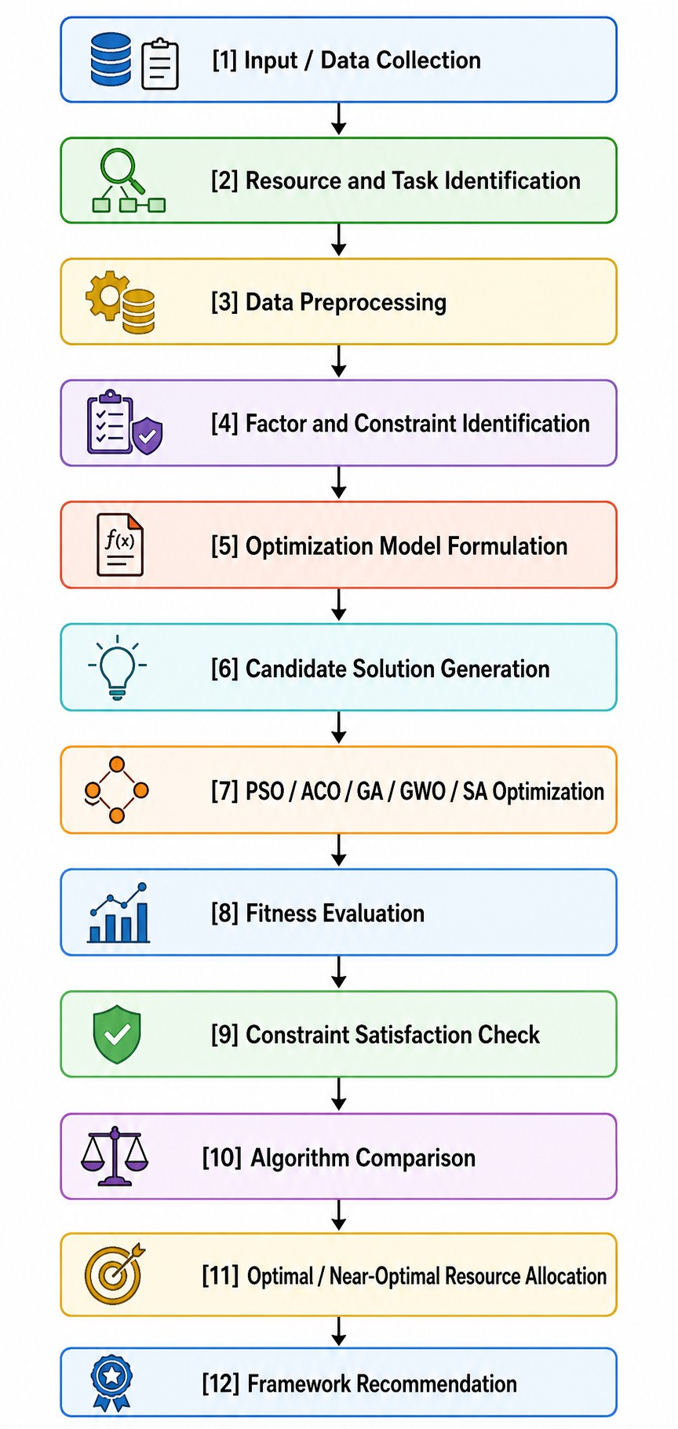
Fig. 2. Research methodology flowchart.
a Statistical Analysis block (descriptive statistics, reliability, correlation, group comparison, clustering). A directed arrow labelled “objective weights” connects the statistical analysis block with the Phase 2: Optimization Model block, indicating that the survey means parameterize the fitness function. The Phase 2 block contains five parallel sub-nodes—GA, PSO, ACO, GWO and SA—all of which converge into a Phase 3: Comparative Evaluation node, which finally leads onto the Findings and Recommendations terminal node reported in Section IV and V.
- Research Design
The study consisted of a sequential mixed method design including three phases.
Phase 1 — Quantitative survey. We performed a cross-sectional, self-administered, online survey among software practitioners working in Bangladesh, obtaining 47 valid re-sponses. This phase aimed to be descriptive and parameteriz-ing rather than confirmatory; that is, we sought to characterize the resource-allocation challenges in practice, measure the relative importance of the five allocation objectives and as-sess practitioners’ receptivity toward automated or intelligent allocation tools.
Phase 2 — Metaheuristic optimization.metaheuristic op-timization. We defined a multi-objective resource allocation problem which was a constrained combinatorial assignment and solved it with five meta-heuristic algorithms including Genetic Algorithm [25], Particle Swarm Optimization [26], Ant Colony Optimization [27], Grey Wolf Optimizer [28] and Simulated Annealing [29].All five algorithms were evaluated using a single weighted-sum fitness function whose weights were extracted from the Phase 1 survey means.
Phase 3 — Comparative evaluation.Comparative evalu-ation. The solutions produced by the five algorithms were compared in terms of solution quality (final fitness or cost value), convergence be-haviour and constraint satisfaction as per the comparative evaluation protocol used by Jamil et al.
[13] for multi-objective software engineering problems.
A positivist, quantitative-dominant epistemological stance was adopted. The survey phase was quantitative and the op-timization phase computational-experimental; the open-ended comment field was retained only as a supplementary qualita-tive source used to contextualize, not test, the quantitative find-ings. A sequential explanatory ordering was chosen—rather than a concurrent one—because the output of Phase 1 is a necessary input to Phase 2: the objective weights cannot be computed until the survey responses have been collected and cleaned.
A weighted-sum scalarization of the objective vector was used in preference to a Pareto-dominance formulation such as NSGA-II [30]. This choice was deliberate and is acknowl-edged as a trade-off. A Pareto approach would have produced a front of non-dominated solutions and preserved the full multi-objective structure of the problem; the weighted-sum approach collapses that front to a single point. However, the weighted-sum formulation permits a direct, commensurable comparison

of five structurally heterogeneous algorithms—two of which (ACO, SA) are not natively multi-objective—against a single scalar criterion, which was the primary aim of Phase 3. Furthermore, because the weights were elicited empirically rather than assumed, the scalarization encodes a defensible statement of practitioner preference rather than an arbitrary one.

- Data Collection
  - Survey instrument design: A structured questionnaire was developed specifically for this study, since no existing validated instrument was found that covered all four constructs of interest in the concurrent-project allocation context. The instrument was administered online and consisted of five sections:
    - Demographics. A questionnaire was designed specifi-cally for this study since no validated instrument was found covering all four constructs of interest in the concurrent-project allocation context. The instrument was deployed online and included five sections:
    - Challenges (ch items).Three categorical questions cap-tured the respondent’s professional role, total years of software industry experience and organization size.
    - Objectives (obj items). Five items measured the per-ceived importance of the five allocation objectives that were subsequently encoded in the fitness function: skill compatibility, project priority, workload balance, dead-line adherence and development cost.
    - Evaluation (eval items). Five items measured re-spondent attitudes toward intelligent or automated al-location systems, covering perceived usefulness, trust, willingness to adopt, perceived fairness and perceived transparency. Perceived transparency.
    - Open comments. One optional free text field invited additional qualitative observations.
Content All items in the (b), (c) and (d) parts used a five-point Likert scale from 1 = Strongly Disagree to 5 = Strongly Agree. The selection of the five-point Likert scale was motivated by a desire to minimize the respondent’s cognitive load and the time needed to complete the task. Seven- and nine-point scales involve a greater complexity of choice, which makes the decision-making process longer. In addition, the middle point was used as a neutral one, meaning that those who had no clear opinion on a given item were not induced to choose one or the other direction.
Content validity was established through two main proce-dures. Firstly, all items were formulated on the basis of the challenges, objectives, or criteria found in the reviewed litera-ture (Section II). In particular, the list of criteria developed by Anand et al. [14] for the purpose of agile resource allocation and the constraint taxonomy proposed by Chiang and Lin [4]. Were used as points of departure. Secondly, the instrument was subjected to peer-review by academic supervisors and practitioners who participated in the pilot version of the study. Some items were adjusted in response to the feedback
received. The responses provided by the pilot participants were excluded from the final analysis dataset.

TABLE V
Survey Constructs and Items

Construct | Item pre-fix | No. of items | Scale | Cronbach’s α
Demographic pro-file | — | 3 | Categorical | n/a
Resource Constraint (Challenges) | ch | 7 | Likert 1–5 | 0.939
Allocation Capability (Objectives) | obj | 5 | Likert 1–5 | 0.893
Intelligent Allocation Acceptance (Evaluation) | eval | 5 | Likert 1–5 | 0.865
Open feedback | — | 1 | Free text | n/a
Total scored items |  | 17

  - Sampling strategy: A non-probability purposive sam-pling method supplemented by snowball referral was used. Purposive sampling was used since the target population was specifically defined on the basis of occupational competence rather than a sampling frame that can be specified. There is no complete survey of software professionals available in Bangladesh from which a probability sample could be selected. The inclusion criteria were (i) currently employed in a soft-ware development organization, (ii) occupied a technical or managerial position in a development team, and (iii) had direct experience of working in an environment where more than one project run concurrently. Initially, professional networks, developer community groups and organizational contacts were used to recruit participants. The initial respondents were asked to forward the questionnaire to any qualifying colleagues.
The sample size achieved was n = 47. This is small, and implications of this are discussed explicitly in Section III-J2. On the other hand, it is large enough for the anal-yses that were performed: internal-consistency estimation, non-parametric group comparison and exploratory clustering do not have such stringent requirements on sample size as does covariance-based structural modelling, which was not attempted.
  - Respondent profile: Table VI presents the demographic profile of the sample.
The profile demonstrates three significant concentration areas. First, the survey results are dominated by software developers, accounting for (59.57%),Secondly, the majority of respondents are in managerial positions (project and program managers combined: 31.91%; this is a positive distribution as decision-makers both on the receiving and making ends are present in the dataset). The poll is also heavily biased toward the respondents with less than a year of professional expe-rience 80.85% Lastly, most of the participants 89.36% work in medium-sized organizations. This poses a limitation to the study as these respondents cannot be considered representative

TABLE VI
Respondent Profile (N = 47)
[dataCleaning.py: deduplication, imputation, outlier cap-ping] → cleanedfinalthesisdata.csv → [roledivision.py:

le-based split] → four role-specific CSV files. An
Characteristic | Category | Frequency | Percentage ro
Role | Software Developer | 28 | 59.57 as
Role | Project Manager | 11 | 23.40 op
Role | QA Engineer | 4 | 8.51 cl
Role | Program Manager | 4 | 8.51 an
Experience | Less than 1 year | 38 | 80.85
Experience | 1–3 years | 5 | 10.64 in
Experience | 4–6 years | 3 | 6.38 qu
Experience | More than 6 years | 1 | 2.13 si
Organization size | Small | 3 | 6.38
Organization size | Medium | 42 | 89.36 na
Organization size | Large | 2 | 4.26
Total |  | 47 | 100.00 ti

ide note added on the fourth node lists the 3 sub-
erations that occur there, and a dashed arrow from the
eanedfinalthesisdata.csv node points to the statistical alysis stage depicted in Fig. 2.
    - Column renaming and normalization: Column renam-
g and normalization: the platform export used the full

of the industry at large; therefore, this bias is noted in Section III-J2.
  - Data collection procedure: The questionnaire was im-plemented as an online form and distributed as a shareable link over email and professional messaging channels. The landing page of the form included an information statement outlining the purpose of the study, the academic affiliation of the re-searcher, the expected time of completion, the voluntary nature and anonymity of the participation; the participants proceeded to the items only after providing their consent to proceed. No, personally identifiable information (PII), such as their name, email and employer, or the IP address was requested or recorded. Responses were gathered within the specified fielding window and exported from the survey platform as a raw CSV file. The exported file contained the full verbatim question texts as column headers and the verbatim Likert labels as cell contents, requiring the renaming and conversion steps of Section III-D1 and III-D2, respectively. Responses were discarded at the stage of export if they were completely blank or failed inclusion criteria; 47 responses passed these screening steps and entered the preprocessing pipeline.
- Data Preprocessing and Cleaning
Raw exports are rarely ready for analysis. A five-step preprocessing pipeline was therefore created in Python. Each step was implemented as an individual, independent executable script that takes the data from the previous step as an input and outputs a new, processed CSV file. This approach to preprocessing was deliberately chosen for its flexibility and auditability: all transformations are isolated in individual, reusable scripts, and any anomalies in the final dataset can be traced back to the exact step in which they were introduced. Fig. ?? shows the pipeline as a left-to-right chain of 5 rectangular process nodes, annotated with their respective script names, and 6 cylindrical data nodes representing the CSV files that flow between them. The chain consists of:
rawsurveyexport.csv → [main.py: column renaming] →
cleanedthesisdata.csv → [likertScale.py: Likert conversion]
→ likertconvertedthesisdata.csv → [textNormalization.py: text normalization] → textnormalizedthesisdata.csv →
estion text as the column header, producing long, incon-stently punctuated and unusable as programmatic variable mes. In Stage 1 (main.py), each column was mapped to
a short, systematic snake-case identifier using a fixed dic-onary. The naming scheme encoded construct membership directly in the prefix—ch for challenge items, obj for objective items, eval for evaluation items—which allowed subsequent scripts to select an entire construct by prefix matching rather than by hard-coded column lists. This reduces the risk of silent mis-selection when computing construct-level reliability or composite indices. The output of this stage was cleanedthesisdata.csv.
- Likert scale conversion: In Stage 2 (likertScale.py), the verbatim Likert labels stored by the survey platform were mapped to integers according to the ordered scheme: Strongly Disagree = 1, Disagree = 2, Neutral = 3, Agree = 4, Strongly Agree = 5. Mapping was performed case-insensitively and after whitespace trimming to accommodate inconsistencies in the export. Any value that did not match a recognized label was set to missing rather than being coerced to a default, so that conversion failures would surface as missing values in Stage 4 rather than being silently absorbed as valid data.
Treating the resulting integers as interval-scaled numbers for the purpose of computing means, standard deviations and Pear-son correlations is a well-known and disputed assumption. The stance taken here is the pragmatic one: summed multi-item scales made of equally spaced verbally anchored categories work reasonably well with parametric summary statistics and the study also reports non-parametric tests (Section III-E4), for every inferential group comparison so that no inferential conclusion depends solely on the interval assumption. The output of this stage was likertconvertedthesisdata.csv.
- Text normalization: The script textNormalization.py handled the remaining textual fields, namely the three cate-gorical demographic variables and the open comment field, in stage 3. The operations included trimming of leading and trailing whitespace, collapsing of internal repeated whites-pace, standardization of letter case of cat-egory labels, and unification of known variant spellings of the same category (e.g., mapping Dev, Developer and Software Engineer onto the canonical label Software Developer). Such processing was crucial because without it the same substantive cate-gory would fragment into several spurious groups, inflating the number of levels in the Kruskal-Walli’s test and dis-torting the frequency counts of Table VI. The output was textnormalizedthesisdata.csv.

- Missing value handling: Stage 4 (dataCleaning.py) first removed exact duplicates, which can arise from double. The
well the items on one form agree with each other when the same form is given again. Remaining missing values,

median was preferred to the mean for imputing missing values
α =
(1)
because the item distributions are bounded, ordinal and in several cases, negatively skewed; the median is robust to
[︃ k
]︃ [︄
·

∑︁_{k}

σ

σ2 ]︄

2

that skew and, unlike the mean, always returns a value that lies on the original 1–5 scale, preserving the integrity of the response metric. Mean imputation would have introduced non-integer values into an ordinal variable, and listwise deletion was rejected as unaffordable at n = 47.
k − 1
1 − i=1 i
T
- Outlier detection and capping: Outlier detection and capping: Outliers were detected using the interquartile range (IQR) rule – for each item, the first and third quartiles, Q₁
and Q₃, were computed, with IQR = Q₃ − Q₁. Values falling below Q₁ − 1.5 × IQR or above Q₃ + 1.5 × IQR were flagged. Flagged values were capped (winsorised) to the corresponding
fence rather than deleted. Capping was chosen over deletion for two reasons– atn = 47 the loss of whole records is costly, and on a bounded 1–5 scale an extreme value is usually a genuine minority opinion rather than a measurement error, so it de-serves attenuation rather than elimination. The output of Stage 4 was cleanedfinalthesisdata.csv, the analysis dataset used throughout Section IV.
Stage 5 (roledivision.py) partitioned the final dataset by the role variable into four role-specific CSV files, supporting
the role-wise descriptive comparisons reported later.
where k is the number of items in the scale, σ² is the variance of item i, and σ² is the variance of the summed scale score. Alpha was computed separately for each of the three constructs.
The coefficients obtained were α = 0.939 for Resource Constraint (7 items), α = 0.893 for Allocation Capability (5 items) and α = 0.865 for Intelligent Allocation Acceptance (5 items). All three exceed the conventional 0.70 threshold and the more demanding 0.80 threshold, indicating strong internal consistency. Two supplementary diagnostics were computed. The author has taken adequate measures to guard against the well-known tendency of alpha to increase with scale length: the corrected item-total correlation was above 0.5 for every item, confirming that each item discriminates in the same direction as its scale, and alpha-if-item-deleted was lower than the baseline alpha for every item, confirming that no item was redundant or damaging. No items were therefore removed.
i
T
- Correlation analysis (Pearson): A full 17 × 17 Pearson product-moment correlation matrix was computed across all
scored items, with

∑︁_{n}
xy
i=1
(2)
(x_{i} − x¯)(y_{i} − y¯)

E. Statistical Analysis Methods
- Descriptive statistics: A full descriptive profile was
r = √︁(∑︁_{n}
(x_{i}
— x¯)2) · √︁(∑︁n
(y_{i}
— y¯)2)

computed for each of the 17 items and each of three constructs. The statistics reported were mean, median, mode, standard deviation, variance, interquartile range, skewness, kurtosis, coefficient of variation (CV), standard error of the mean (SEM) and the 95% confidence interval of the mean. This more comprehensive set of summary statistics was selected instead of mean-and-SD alone because shape statistics are diagnostic on bounded ordinal scales: skewness and kurtosis indicate ceiling effects, while the CV permits dispersion to be compared across items with different means.
i=1
i=1
The overall mean across all 17 scored items was 3.767 (SD = 1.20), indicating a generally agreeing tendency. At the construct level, the challenges constructed recorded a mean of 3.414 (SD = 1.392), Objectives 4.036 (SD = 1.004),
and Evaluation 4.027 (SD = 0.893). Two patterns are ana-
The matrix had two uses. Analytically, it showed the asso-ciation structure between allocation challenges and objectives and acceptance attitudes. Methodologically, it was used as an convergent-validity check: items in a common construct were expected to and did correlate more highly with each other than with items from other constructs, supporting the construct assignment in Table V and the alpha values of Section III-E2. The matrix was rendered as an annotated heatmap for visual inspection.
- Group comparison (Kruskal-Wallis, Mann-Whitney): To determine whether perceptions differed systematically across respondent subgroups, the Kruskal-Wallis H test [32] was applied to three grouping variables: role (4 groups), experience level (4 groups) and organization size (3 groups). The H statistic is
[︃
g
(︃ R )︃
]︃

lytically relevant. First, objective importance and acceptance of intelligent allocation are rated distinctly higher than the experienced severity of challenges, supporting the premise
12
H = ·
N (N + 1)
∑︂i=1
2
^{i} − 3(N + 1) (3)
n_{i}

of the optimization phase: practitioners value the objectives being optimized and are receptive to automated support. Second, dispersion decreases monotonically from Challenges to Evaluation, indicating that respondents agree more about what allocation should achieve than about how severe current problems are.
- Reliability analysis (Cronbach’s alpha): Internal con-sistency reliability was checked with Cronbach’s alpha [31],Cronbach’s alpha is defined as a measure that shows how
where N is the total sample size, g the number of groups, n_{j}
the size of group j and R_{j} the sum of ranks in group j.
I chose a non-parametric test of one-way ANOVA for three reasons. First the dependent variables are Likert scores. Second many item distributions did not look normal as shown by the skewness and kurtosis values in Section III-E1. Third the group sizes are very uneven – for example 38 versus 1, in the experience variable –. This breaks the homogeneity assumptions that make ANOVA robust. The Kruskal-Wallis

test, which works with ranks does not need normality or equal variances.
Across all three variables which were used for grouping and across all tested items, no test reached significance at α = 0.05 (all p > 0.05). The substantive interpretation of this is that perceptions of allocation challenges, objective importance and acceptance of intelligent allocation were consistent across roles, experience levels and organization sizes within this sample finding that supports the justification for pooling all 47 responses when deriving a single set of objective weights in
Standardization must happen before using K-Means because the algorithm works by minimizing squared distance and that distance depends on the scale of the data. If we don’t do it the feature, with the raw variance will have too much influence. In this case the resource constraint index has the standard deviation = 1.392—would dominate cluster formation as an artifact of dispersion.
- Silhouette-based K selection: The number of clusters K
was selected using the silhouette coefficient [35]. For each point i,

Section III-G2. The interpretation must, however, be tempered by low statistical power: with subgroup sizes as small as one,
b(i) − a(i)
s(i) =
max{a(i), b(i)}
(6)

the tests could detect only very large effects, so the null results are indications of absence of detected difference rather than evidence of equivalence.
5) Post-hoc analysis (Bonferroni correction): For com-pleteness, pairwise post-hoc comparisons were performed us-ing the Mann-Whitney U test [33], with
n₁(n₁ + 1)
where a(i) is the intra-cluster distance and b(i) is the mean distance to the nearest neighbouring cluster; the overall score is the average of s(i) across all points bounded between [−1, 1]. The silhouette criterion was chosen over the elbow method because it provides a numerical optimum instead of relying on subjective visual assessment of a bend or inflection
point.

U₁ = n₁n₂ +
— R₁ (4)
2
Candidate values K ∈ {2, 3, 4} were evaluated, with scores

Due to the inflation of familywise: Type I error rate due to multiple pairwise comparisons, the Bonferroni correction was applied, which adjusts the significance threshold to α′ = α/m where m is the number of pairwise comparisons within a family. Bonferroni was selected as the most conservative correction available, an appropriate choice in a small-sample exploratory study where a false positive would be more detrimental to the argument than a false negative. Consistent with the omnibus results, not pairwise comparison achieved significance after correction.
- Segmentation Analysis (K-Means Clustering)
Since the group comparisons in Section III-E4 found no differences along a priori demographic lines, an unsupervised approach was taken to see if meaningful respondent segments exist along attitudinal rather than demographic lines. K-Means clustering [34]was chosen for this purpose because it is com-putationally efficient, interpretable by inspection of centroids, and well-suited to the small, low-dimensional, continuous-valued index space constructed below.
  - Composite index construction: The three indices were standardised with StandardAero to have mean 0 and variance 1:
    - resource constraint index — mean of the 7 ch items
    - allocation capability index — mean of the 5 obj items
    - intelligent acceptance index — mean of the 5 eval items
Mean aggregation was justified because of the high alpha values reported in Section III-E2: scales with α > 0.85 can defensibly summarise everything. Reducing the 17 dimensions to three cuts the curse of dimensionality which would other-wise make Euclidean distance meaningless at n = 47.
  - Standardization: The three indices were standardized with StandardScaler to zero mean and unit variance:
x − µ
z = (5)
σ
of 0.331 (K = 2), 0.405 (K = 3) and 0.412 (K = 4). K = 4
was selected as the empirical optimum. It is acknowledged that the margin over K = 3 is narrow (0.007) and that K = 4 produces a singleton cluster; this is addressed in Section III-F4 and again in the limitations.
- Cluster profiling: The final four-cluster solution pro-produced cluster sizes of 14, 22, 10 and 1. Clusters were profiled by inverse-transforming the standardized centroids back to the original index scale and examining the relative elevation of the three indices, arriving at the following labels:
  - Cluster 1 — Allocation-Priority Profile (n = 14): elevated allocation capability index; respondents most oriented toward objective optimization.
  - Cluster 2 — Acceptance-Dominant Profile (n = 22): elevated intelligent acceptance index; the modal segment, most receptive to automated allocation.
  - Cluster 3 — Low Constraint / High Allocation (n = 10): low constraint index with high capability index; respondents reporting comparatively unconstrained environments.
  - Cluster 4 — Constraint-Dominant (n = 1): extreme constraint index; treated as a statistical outlier rather than a substantive segment.
Cluster 4 is explicitly not interpreted as a generalisable respondent type; its emergence suggests that the four-cluster solution is only partially isolating an extreme observation rather than partitioning genuine population structure and find-ings derived from it are described descriptively only.
- Multi-Objective Resource Allocation Problem
  - Problem formulation: The allocation problem was for-mulated as a constrained combinatorial assignment problem. Let E = {e₁, . . . , e_{m}} be the set of engineers and P =
{p₁, . . . , p_{n}} the set of concurrent projects. The decision
variable is a binary assignment matrix X ∈ {0, 1}^{m×n} where
x_{ij} = 1 if engineer i is assigned to project j.

Instances were generated with m = 12 engineers and n = 8 projects for the SA, ACO and GWO experiments. Each engineer e_{i} is characterized by a vector of four skill
levels s_{i,1..4} ∈ [1, 5], an availability a_{i} ∈ [20, 40] hours, and a cost rate c_{i} ∈ [25, 60] dollars per hour. Each project p_{i} is characterized by a required-skill set of cardinality 2–5, a priority π_{i} ∈ [1, 5], a deadline urgency u_{i} ∈ [1, 5], an estimated effort h_{i} ∈ [40, 200] hours and a budget b_{i} ∈ [3000, 15000] dollars.
The search space is of size 2^{mn} = 2⁹⁶ before constraint filtering, which is far beyond exhaustive enumeration. This intractability is precisely what motivates the use of metaheuris-tic search rather than exact optimization, consistent with the SBSE rationale of Bibi et al. [12].
  - Objective weighting from survey data: of assigning objective weights in a random way or based on the researcher’s judgment the weights were created using data from the Phase 1 survey. For each of the five obj items the average value was calculated, and each weight was found by dividing that average by the total of all five averages:
5
∑︂
reflect the decision-makers’ preferences. The constants were selected by examining the ranges of the 5 terms over a small set of randomly generated feasible solutions.
4) Constraint definition: Four constraint families were im-posed.
Coverage constraint: every project must receive at least one engineer, i x_{ij} ≥ 1, ∀j.
∑︁
Capacity constraint: assigned hours must not exceed avail-ability, i x_{ij} · h_{i}/|A_{i}| ≤ a_{i}, ∀i.
∑︁
Budget constraint: the cost incurred on a project must not exceed its budget, i x_{ij}c_{i}h_{i}/|A_{i}| ≤ b_{i}, ∀j.
∑︁
Skill feasibility constraint: each project’s required skills
must be covered by at least one assigned engineer at an adequate level.
Constraints were handled by penalty-based relaxation, rather than through rejection of infeasible candidates. In other words, constraint violations were allowed to generate exceedingly large additive terms in f (X), thus enabling the search to ex-plore regions of the search space that were not strictly feasible towards the discovery of high-quality feasible solutions. This is a common practice in constrained metaheuristic optimization

w = x¯_{k}
∑︁₅
k
k=1
,
x¯_{i}
w_{k}
k=1
= 1 (7)
and is necessitated by the fact that the search space gets severely fragmented due to strict adherence to feasibility,

yielding wskill, wpriority , wworkload, wdeadline and wcost. This procedure ensures that objectives deemed more impor-tant by practitioners exert proportionally greater influence on the fitness landscape. It is the primary methodological link between the empirical and computational phases of the thesis and follows the practitioner-elicited weighting logic of Chiang and Lin [4]. Normalisation guarantees that the weights form a convex combination so that fitness values remain comparable across experimental runs.
3) Fitness function design: All five algorithms minimized a single scalarized cost function:
f (X) = w_{skill} · S(X) · 10 + w_{workload} · [B(X) + O(X)] · 5
+ w_{cost} · C(X)/100 + w_{priority} · [50 − P (X)]
+ w_{deadline} · [50 − D(X)]
(8)
where S(X) is the aggregate skill-mismatch penalty, B(X) the workload imbalance across engineers, O(X) the overload penalty for hours assigned beyond availability, C(X) the total monetary cost, P (X) the priority satisfaction score and D(X) the deadline satisfaction score. The priority and deadline terms are expressed as 50−score so that maximization objectives are converted to minimization objectives on a common footing.
The scalar multipliers 10, 5 and 1/100 are normalization constants, not preference weights. They are required because the component quantities span several orders of magnitude. For instance, without normalization, the total cost would overwhelm all the other terms by 5 or more orders of magnitude, simply because it is measured in thousands of USD, while skill penalties are measured in integers. The normalization constants bring all terms to approximately the same magnitude so that the empirically estimated weights w_{k}
especially in the case of tightly constrained problems.

- Metaheuristic Algorithms
The five metaheuristics were implemented. The choice fell on these algorithms because they represent the most common paradigms used: evolutionary (GA), swarm intelligence (PSO, ACO, GWO) and trajectory-based or physical-annealing (SA), so that the comparison extends beyond individual optimisation approaches and different search principles.
  - Genetic Algorithm (GA): (a) Inspiration. GA [25] ab-stracts Darwinian natural selection: a population of candidate solutions evolves through selection, recombination and muta-tion, with fitter individuals contributing disproportionately to subsequent generations.
- Formulation. Each chromosome encodes a complete assignment as a vector of length n (one gene per project) whose alleles identify the assigned engineers. Fitness is 1/(1+ f (X)), converting the minimization cost into a maximization fitness bounded in (0, 1]. Single-point or uniform crossover recombines parent chromosomes with probability p_{c}; mutation reassigns a randomly chosen gene with probability p_{m}.
- Parameters. Population = 100, Generations = 50, Crossover p_{c} = 0.8, Mutation p_{m} = 0.1, Elitism = 10%. The large population relative to generation count favours exploration in a rugged combinatorial landscape. A high crossover rate exploits building blocks—partial assignments that are locally good—while the comparatively low mutation rate prevents the search degenerating toward random restart. Elitism at 10% guarantees monotonic non-degradation of the best solution across generations.
(e) Application. GA searched the engineer-project assign-ment space directly. The best fitness achieved was 0.9475,

corresponding to a low scalarized cost under the survey-derived weights.
  - Particle Swarm Optimization (PSO): (a) Inspiration. PSO [26] models the collective foraging behaviour of bird flocks and fish schools, in which individuals adjust their trajectory by combining personal experience with the best experience of the swarm.
- Formulation. Each particle i maintains a position x_{i}
and velocity v_{i}, updated as
v_{i}(t + 1) = w · v_{i}(t) + c₁r₁[pbesti − x_{i}(t)]
+ c₂r₂[gbest − x_{i}(t)] (9)
x_{i}(t + 1) = x_{i}(t) + v_{i}(t + 1) (10)
where w is inertia, c₁ and c₂ are the cognitive and social coefficients, and r₁, r₂ ∼ U (0, 1). Continuous positions were discretized to assignment indices for evaluation.
- Parameters. Particles = 30, Iterations = 100, w = 0.7, c₁ = c₂ = 1.5. The inertia value of 0.7 lies in the commonly recommended stability region and balances momentum against convergence. Setting c₁ = c₂ weights individual and collective experience equally, avoiding both premature convergence to
- Formulation. Position updates follow D = |C · X_{p}(t)− X(t)| and X(t + 1) = X_{p}(t) − A · D where A = 2a · r₁ − a and C = 2r₂. The candidate position is the mean of the three
positions computed with respect to alpha, beta and delta.
- Parameters. Wolves = 30, Iterations = 150, with the control parameter a decreasing linearly from 2 to 0 across iterations. The linear decay of a is the algorithm’s central
exploration-exploitation mechanism: while |A| > 1 wolves diverge from the leaders and explore, and once |A| < 1 they converge on them and exploit. GWO required no additional
tuning parameters, which is a practical advantage over GA and PSO and a reason for its inclusion.
(e) Application. GWO achieved a best cost of approxi-mately 117, the lowest among the three algorithms evaluated on the common 12 × 8 instance.
- Simulated Annealing (SA): (a) Inspiration. SA [29]
derives from the metallurgical annealing process, in which a material is heated and slowly cooled so that its atomic structure settles into a low-energy configuration.
(b) Formulation. A neighbouring solution X′ is accepted with probability
{︄

the global best and unproductive individual wandering.
(e) Application. PSO was applied in three distinct roles in this thesis: (i) feature selection over the survey item space;
P (accept) = 1 if ∆f ≤ 0 exp(−∆f/T ) otherwise
(12)

(ii) direct engineer-project allocation; and (iii) optimization of clustering configuration. It was additionally used to tune a Random Forest model, converging on nestimators = 102 and maxdepth = 14.
  - Ant Colony Optimization (ACO): (a) Inspiration. ACO
[27] is modelled on the stigmergic foraging of ant colonies, in which pheromone deposition on traversed paths biases the route choices of subsequent ants toward shorter paths.
- Formulation. The probability that ant k selects engineer
i for project j is
[τ_{i}]^{α}[η_{i}]^{β}
where ∆f = f (X′) − f (X) and T is the current temperature, updated geometrically as T ← γT .
- Parameters. Initial temperature T₀ = 1000, cooling rate γ = 0.995, maximum iterations = 5000. A high T₀
ensures that nearly all moves are accepted initially, so that early search behaves as an unbiased random walk. The slow geometric cooling rate of 0.995 yields a long high-temperature phase—approximately 1380 iterations are required to halve the temperature—which is necessary to escape the many local optima created by the penalty terms in the fitness function.
(e) Application. SA achieved a best cost of approximately

pi = ∑︁
k
l∈Nk
l
l
[τ ]α[η ]β
(11)
125 on the common instance.
- Parameter settings and justifications: Table VII sum-

where τ_{ij} is pheromone intensity and η_{ij} is heuristic desirabil-ity (derived from skill match and cost efficiency). Pheromone is updated by τ_{ij} ← (1 − ρ)τ_{ij} + ∆τ^{k} with ∆τ^{k} = Q/f_{k}.
k
ij
ij
∑︁
(c) Parameters. Ants = 30, Iterations = 100, α = 1.0,
β = 2.5, ρ = 0.15, Q = 150. Setting β > α deliberately privileges problem-specific heuristic information over accumu-lated pheromone, which accelerates early convergence in an assignment problem where skill-match desirability is strongly informative. The low evaporation rate ρ = 0.15 preserves learned information across iterations, while Q = 150 scales deposition to the observed magnitude of the cost function.
(e) Application. ACO was applied to the 12-engineer, 8-project instance and achieved a best cost of approximately 120.
  - Grey Wolf Optimizer (GWO): (a) Inspiration. GWO
[28] imitates the leadership hierarchy and encircling hunting strategy of grey wolf packs, with solutions ranked as alpha (best), beta (second), delta (third) and omega (remainder).
marizes the parameter settings for all five algorithms, together with the justification for each and the best result obtained.
Parameter values were set using a mix of defaults suggested in the literature and early test runs. Because population-based algorithms and trajectory-based algorithms use function evaluations at different speeds the comparison stayed fair by making sure that the total number of fitness evaluations was about the same size.Across algorithms such as GA, PSO, ACO, GWO and SA the calculations were set to levels, like
(GA: 100 × 50 = 5000; PSO: 30 × 100 = 3000; ACO:
30 × 100 = 3000; GWO: 30 × 150 = 4500; SA: 5000),
This approach ensured that no algorithm received an advantage
simply because it had a computational budget.
- Implementation and Tools
The entire study was implemented in Python 3.x. Data handling and manipulation used pandas and NumPy; pro-cedures—including Kruskal-Wallis, Mann-Whitney U and

TABLE VII
Metaheuristic Parameter Settings

Algorithm | Population / Agents | Iterations | Key Parameters | Justification | Best Result
GA [25] | 100 | 50 generations | pc = 0.8, pm = 0.1, elitism | Large population | Fitness
GA [25] | 100 | 50 generations | = 10% | favours exploration; | = 0.9475
GA [25] | 100 | 50 generations |  | high pc exploits
GA [25] | 100 | 50 generations |  | building blocks;
GA [25] | 100 | 50 generations |  | elitism prevents
GA [25] | 100 | 50 generations |  | regression
PSO [26] | 30 particles | 100 | w = 0.7, c₁ = 1.5, c₂ = 1.5 | w in stable region; | RF tuning:
 |  |  |  | equal c₁, c₂ balances | n estimators
 |  |  |  | cognitive and social | = 102,
 |  |  |  | terms | max depth
 |  |  |  |  | = 14
ACO [27] | 30 ants | 100 | α = 1.0, β = 2.5, ρ = 0.15, | β > α privileges | Cost ≈ 120
ACO [27] | 30 ants | 100 | Q = 150 | skill-match heuristic; | Cost ≈ 120
ACO [27] | 30 ants | 100 |  | low ρ retains learned | Cost ≈ 120
ACO [27] | 30 ants | 100 |  | pheromone | Cost ≈ 120
GWO [28] | 30 wolves | 150 | a : 2 → 0 linear | Single control parameter; automatic exploration-exploitation transition | Cost ≈ 117
SA [29] | 1 (trajectory) | 5000 | T₀ = 1000, γ = 0.995 | High T₀ ensures broad early  acceptance; slow cooling escapes local optima | Cost ≈ 125

Pearson correlation—used scipy; scikit-learn provided Stan-dardScaler, KMeans, silhouette score and the Random Forest model tuned by PSO matplotlib produced all visualizations, including the correlation heatmap, silhouette plots, cluster scatter plots and algorithm convergence curves; and openpyxl wrote results to Excel workbooks for reporting.
All five metaheuristics were implemented from principles rather than imported from an optimization library. This was a methodological decision: custom implementation guarantees that all five algorithms share an identical fitness evalua-tion routine, an identical solution encoding and an identical constraint-handling mechanism so that any observed perfor-mance difference is attributable to the search strategy itself rather than to divergent library internals. A fixed random seed was used across runs to ensure reproducibility. All scripts, intermediate CSV artefacts and output files were retained to permit verification of every stage of the pipeline.
- Ethical Considerations
  - Ethical protocol: Participation was entirely voluntary. Ethical protocol was explained in an information statement that was shown before any questions appeared. Respondents could stop at any time by closing the form. No identifying information was collected, such as names or email, employer names or IP addresses are removed, The dataset is anonymous rather than merely de-identified and no re-identification is possible from the files that remain. We kept items delib-erately coarse such as role category, experience band and organization size band for the same reason. The data were stored in access-controlled storage. Were used only for the academic purposes of this thesis. Respondents were not. No
vulnerable populations were involved. In the optimization phase we used synthetic engineer and project data, so no organizational or commercially sensitive information entered the computational experiments. We acknowledge work, with full citation and we report all results exactly as obtained including the non-significant test outcomes of Section III-E4 and the degenerate cluster of Section III-F4.
  - Validity, reliability and limitations: Reliabil-ity.Reliability was very good across all three constructs (α = 0.939, 0.893, 0.865), This is shown by corrected correlations that were all above 0.5 and by alpha-if-deleted values that stayed below the baseline for every item. For reliability Reliability used fixed random seeds and built a modular re-runnable preprocessing pipeline.
Validity. Validity was sought by generating items from literature and having experts review them. Construct validity is shown by the pattern in the correlation matrix: correlations within each construct are higher than correlations, between constructs. Internal validity of the optimization comparison is ensured by keeping the fitness function, encoding, instance data and evaluation budget the same for all five algorithms. algorithms.
Limitations. Five limitations are acknowledged candidly.
Sample size and composition. With a sample size of n = 47, the statistical power is low. Because of this the null results reported in Section III-E4 should be seen as non-detection than as proof that no difference exists. Importantly 80.85% of the respondents had less than one year of experience and 89.36% worked in medium-sized organizations. This means the sample mainly reflects the views of early-career professionals in

sized firms in Bangladesh. The findings cannot be applied to professionals, to large companies or, to other countries.
Instrument novelty. The questionnaire was created specifi-cally for this study. It is internally consistent. It has not been externally validated using factor analysis. Also, the sample size of n = 47 is too small to support confirmatory factor analysis.
Clustering stability.The silhouette advantage of K = 4 over K = 3 was only 0.007, and the four-cluster solution produces a singleton cluster. The clustering is therefore exploratory, and a four-cluster typology should not be considered stable.
Scalarization. The weighted-sum formulation finds only a single satisfactory solution, which is not desirable when decision makers need to consider the trade-off surface between conflicting objectives; a method based on the concept of Pareto dominance such as NSGA-II [30] would be more appropriate. Synthetic problem instances. The 12-engineer, 8-project in-stances were generated by sampling within reasonable ranges, rather than representing an actual organization’s project port-folio. The algorithm’s performance on realistic, irregular data with institutional constraints is therefore difficult to estimate.
- Summary of Chapter 3
This section has laid out the full methodological framework of the study. A three-phase sequential mixed method was used, including a quantitative survey of 47 software professionals in Bangladesh, a multi-objective optimization step using five metaheuristics algorithms, and a comparative assessment. The survey instrument had 17 Likert-scale items distributed over three constructs, plus demographic and open answer sections, and had good internal consistency (α = 0.939, 0.893, 0.865). The data was processed using a five-step, script-modular pipeline covering column renaming, Likert conversion, text normalization, median imputation using IQR-based minoriz-ing, and role-based partitioning.
Statistical analysis included extended descriptive statistics (overall mean = 3.767, SD = 1.20), reliability analysis, a complete 17 × 17 Pearson’s correlation matrix, and a non-parametric group comparison using Kruskal-Wallis followed by Mann-Whitney U tests for pairwise comparisons using
Bonferroni correction, which found no significant differences across role, experience or organization size. Segmentation by attitudes using K-Means over three standardized composite indices found a four-cluster solution (silhouette = 0.412, sizes 14/22/10/1), with the singleton cluster being considered an outlier rather than a segment of substance.
The empirical phase was then connected to the computa-tional phase by back calculating the five objectives’ weights for the fitness function from the normalized survey means, ensuring that it encodes practitioners’ interests rather than the researchers. The five metaheuristics algorithms, GA, PSO, ACO, GWO and SA, were all implemented from first princi-ples against a common fitness function, encoding, constraint handling and evaluation budget and their parameters and justi-fication are documented in Table VII. This section concluded with the ethics protocol of the study and a candid review
of its methodological limitations. Section IV presents and analyses the results obtained using the procedures outlined in this section.
- Results and Discussion
- Introduction to Results
This section reports the results of the mixed-method re-search study on the resource allocation prac-tices in concurrent software development environments. The section follows hi-erarchical organization, moving from descriptive to inferential analyses. Section IV-B presents the demographic composition of the respondents and descriptive statistics of the survey constructs. Section IV-C discusses the psychometric soundness of the measurement instrument while Section IV-D explores the interrelationships between the study constructs. Moreover, Section IV-E tests the differences in perception between sub-groups of professionals and Section IV-F reports the result of an unsupervised segmentation exercise to identify respon-dent typologies. Section IV-G transitions to the computational strand of the study, reporting a brief description of the perfor-mance of five metaheuristic optimization algorithms applied to the resource allocation problem. Section IV-H discusses the combined findings in relation to the existing body of literature and to the practical realities of software project management, and Section IV-I closes the section with a concise summary of the principal results.
- Respondent Profile and Descriptive Statistics
  - Demographic profile: Out of the initial responses, 47 (N = 47)were included in the final analysis after screening and data cleaning procedures. Table VIII below provides an overview of the selected sample, including respondents’ primary role, years of experience, organization size, managing concurrent projects (rarely/never, occasionally, frequently), and orientation toward schedule vs. cost, as well as the primary allocation objective.
As shown in Table VIII, the sample was dominated by Software Developers (59.57%), followed distantly by Project Managers (23.40%), with QA Engineers and Program Man-agers each contributing 8.51%. This distribution is broadly consistent with typical staffing ratios in software organizations, where technical contributors substantially outnumber manage-rial roles [10], and lends the descriptive findings reasonable ecological validity for developer-level perceptions, while find-ings pertaining to managerial constructs should be interpreted with appropriate caution given the smaller managerial sub-samples. In Table VIII, the last column indicates the number of responses for each category.
Concerning the years of experience, 80.85% of respondents had less than 1 year of experience, whereas only 1 respondent (2.13%) had more than 6 years of experience. Therefore, most respondents were new to the workplace. This fact is acknowl-edged as a limitation of the present study in Section IV-
H. In terms of organization size, most respondents (89.36%) worked in medium-sized organizations, whereas small orga-nizations accounted and large organizations for (6.38% and

TABLE VIII
Respondent Demographic Profile (N = 47)

Category | Sub-group | Frequency | Percent (%)
Primary Role | Software Developer | 28 | 59.57
Primary Role | Project Manager | 11 | 23.40
Primary Role | QA Engineer | 4 | 8.51
Primary Role | Program Manager | 4 | 8.51
Experience | Less than 1 year | 38 | 80.85
Experience | 1–3 years | 5 | 10.64
Experience | 4–6 years | 3 | 6.38
Experience | More than 6 years | 1 | 2.13
Organization Size | Small | 3 | 6.38
Organization Size | Medium | 42 | 89.36
Organization Size | Large | 2 | 4.26
Concurrency Frequency | Rarely | 18 | 38.30
Concurrency Frequency | Sometimes | 12 | 25.53
Concurrency Frequency | Often | 12 | 25.53
Concurrency Frequency | Very often | 2 | 4.26
Concurrency Frequency | Never | 2 | 4.26
Concurrency Frequency | Very rarely | 1 | 2.13
Priority Orientation | Always protect schedule | 19 | 40.43
Priority Orientation | Usually protect schedule | 14 | 29.79
Priority Orientation | Usually protect cost | 11 | 23.40
Priority Orientation | Always protect cost | 3 | 6.38
Primary Objective | On-time delivery | 17 | 36.17
Primary Objective | Staying within budget | 15 | 31.91
Primary Objective | Maximum utilization | 12 | 25.53
Primary Objective | Minimum schedule risk | 3 | 6.38

4.26% respectively). In terms of managing concurrent projects, (38.30%) of respondents rarely or never had to deal with concurrent projects, whereas 55.32% had to do so occasionally or frequently. Thus, most respondents had some experience managing concurrent projects. As can be seen from Table VII, 70.22% of respondents prioritized schedule over cost when it came to project management, whereas (36.17%) prioritized on-time project completion, aligning with the former category.
  - Descriptive statistics of survey constructs: Table IXre-ports the descriptive statistics for the three survey constructs-Challenges (ch), Objectives (obj), and Evaluation (eval)—together with the overall composite score across all 47 re-spondents. Fig. 3 and Fig. 4 on the five-point Likert scale indicates that, on average, respondents held moderately to strongly favorable views

TABLE IX
Descriptive Statistics of Survey Variables
Construct | n (items × re-spondents) | Mean | SD
Overall Composite | — | 3.767 | 1.200
Challenges (ch ) | 19 | 3.414 | 1.392
Objectives (obj ) | 110 | 4.036 | 1.004
Evaluation (eval ) | 110 | 4.027 | 0.893

The overall composite mean of 3.767 (SD = 1.20, Median
= 4.0) on the five-point Likert scale suggests that across all respondents, the average attitude was moderately to strongly
favourable towards the constructs of interest. Breaking down the mean by construct shows that the Challenges construct had the lowest mean (M = 3.414, SD = 1.392)and greatest dispersion amongst the three, suggesting that the experiences of respondents with respect to resource-related difficulties were most heterogeneous compared to their attitudes to-wards objectives and evaluation criteria. On the other hand, the Objectives(M = 4.036, SD = 1.004) and Evaluation (M = 4.027, SD = 0.893) constructed higher and more tightly clustered means, indicating stronger and more uniform agreement regarding what allocation should optimize for and how allocation outcomes should be judged.
At the item level, the three highest-scoring items were evaloptimprovesutilization (M = 3.963), the item concern-ing the extent to which deadlines should influence allocation decisions (M = 3.957), and evalmultiobjective (M = 3.915), all reflecting strong endorsement of optimization-oriented and multi-objective decision criteria. Conversely, the three lowest-scoring items were chunevenworkload (M = 3.021), chavailabilityinefficiency (M = 3.170), and chlimitedskills (M = 3.191). Although these three items still lie above the scale midpoint, their comparatively de-pressed means—all situated within the Challenges construct—indicate that uneven workload distribution, availability-related inefficiency, and skills shortages are perceived as somewhat less acute or less consistently experienced than other challenge items, even though they remain salient concerns in absolute terms.

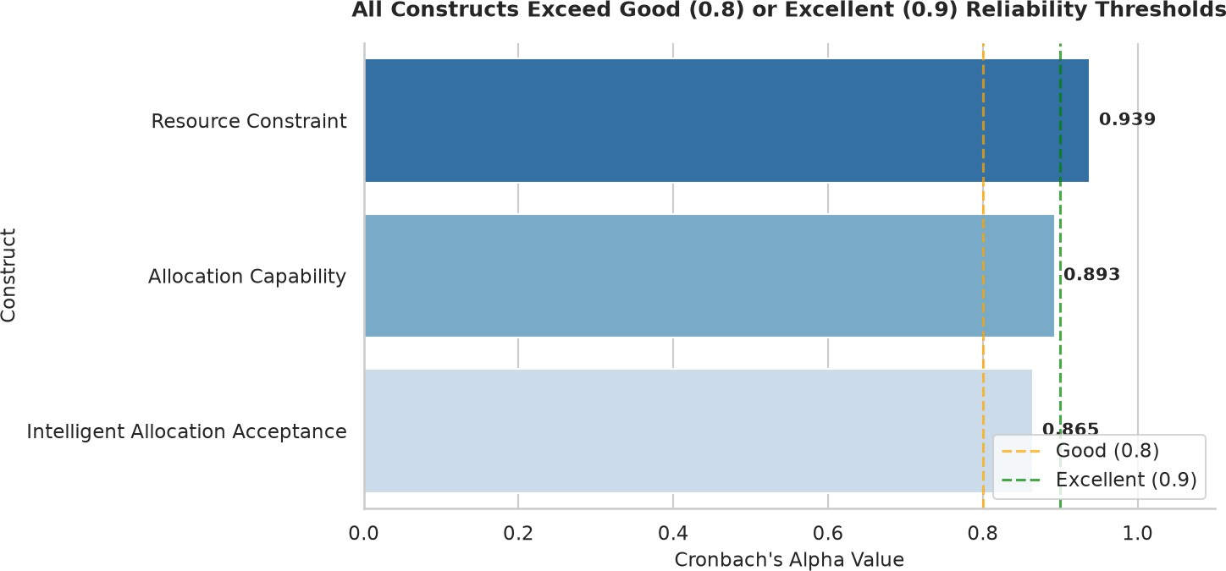

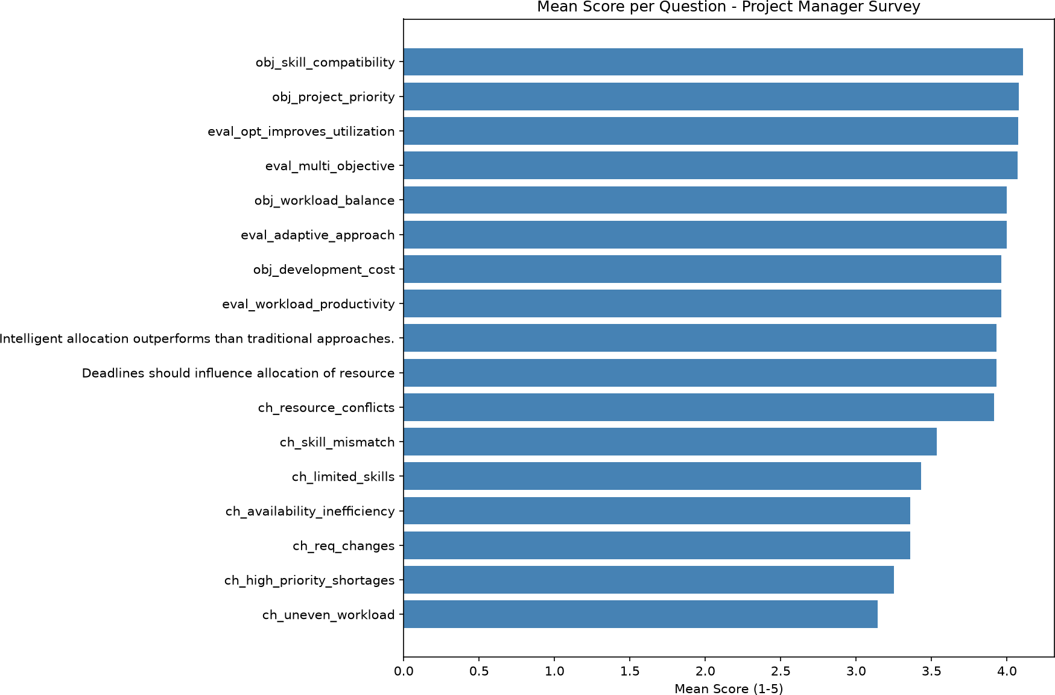
Fig. 3. Mean Score per Survey Question.
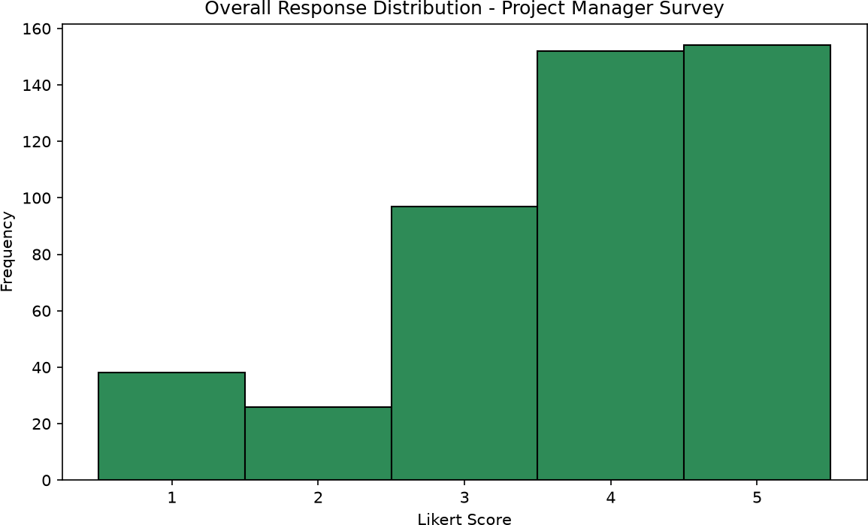

Fig. 4. Overall Response Distribution.

- Reliability and Validity Analysis
  - Cronbach’s Alpha: Internal consistency reliability was assessed using Cronbach’s Alpha for each of the three multi-item constructs. Table X and Fig. 5 present the results.

TABLE X
Cronbach’s Alpha Reliability Results

Construct | Cronbach’s Alpha (α) | Interpretation
Resource Constraint | 0.939 | Excellent
Allocation Capability | 0.893 | Good
Intelligent Allocation Accep-tance | 0.865 | Good

All three constructs exceeded the commonly accepted stan-dard of 0.70 for internal consistency [31]. The Resource Constraint construct had the highest alpha (0.939) and demon-strated excellent internal consistency, while the Allocation Ca-pability (0.893) and Intelligent Allocation Acceptance (0.865) constructs demonstrated good internal consistency.
  - Corrected Item-Total Correlation: To check how much each item added to its construct we calculated corrected item-
Fig. 5. Cronbach’s Alpha Summary by Construct.

total correlations (CITC). Table XI and Fig. 6 show the CITC ranges that we found.

TABLE XI
Corrected Item-Total Correlations (Range by Construct)

Construct | Minimum CITC | Maximum CITC
Resource Constraint | 0.713 | 0.855
Allocation Capability | 0.659 | 0.800
Intelligent Allocation Acceptance | 0.579 | 0.795

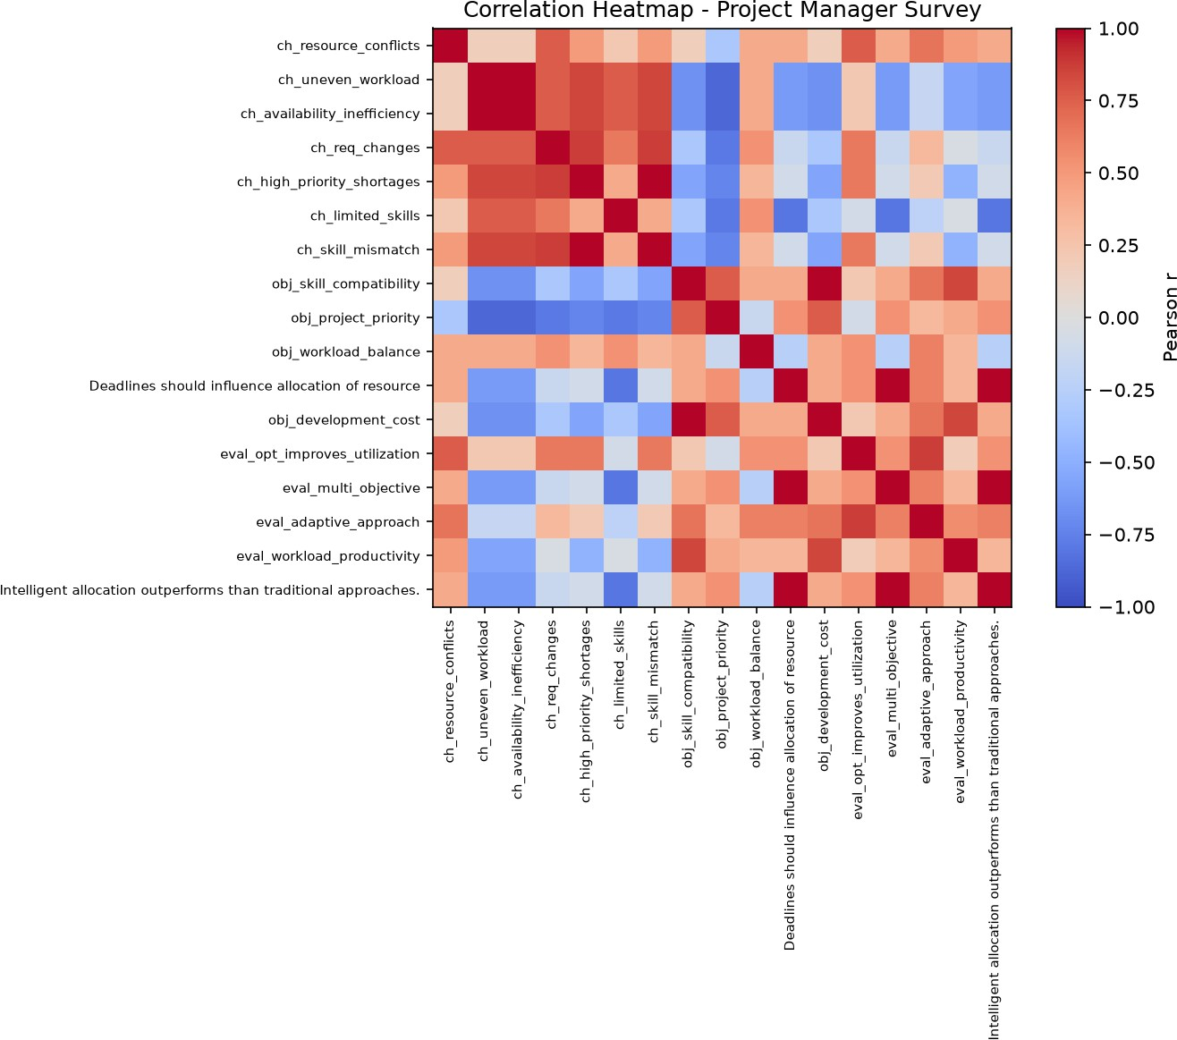

Fig. 6. Corrected Item-Total Correlation by Item.

All corrected item-total correlations were above the accept-able level of 0.30 [10], and most were higher than 0.60. This means each item kept in the scale connected with the rest of the items in its group. The Resource Constraint construct had the highest range of correlations. From 0.713 to 0.855. Which supports the strong alpha value mentioned earlier. The lowest correlation in the instrument was 0.579 found in the Intelligent Allocation Acceptance construct. Even this low value is still, above the acceptable limit. So no item was an extra part of its scale. Every item pulled its weight.
  - Alpha-if-Item-Deleted: As a test of reliability values called alpha if item deleted were calculated for each item.

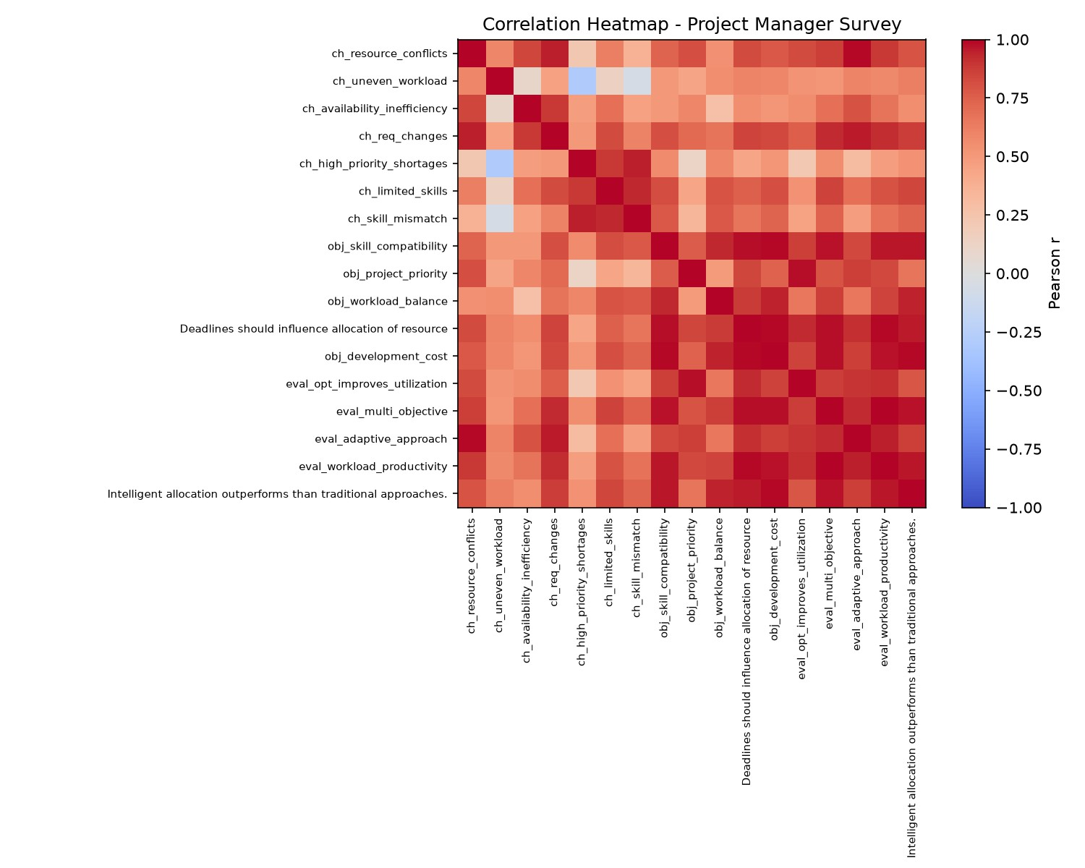
This was done to see if removing any one item would make the reliability of the construct better. Table XII shows what happened in this analysis. Figure 7 shows how alpha changed if each item was removed.

TABLE XII
Alpha-if-Item-Deleted Summary
all all
all

Construct | Baseline Al-pha | Alpha-if-Item-Deleted | Decision
Resource Constraint | 0.939 | Lower than base-line for every item | Retain items
Allocation Capability | 0.893 | Lower than base-line for every item | Retain items
Intelligent Allocation Acceptance | 0.865 | Lower than base-line for every item | Retain items

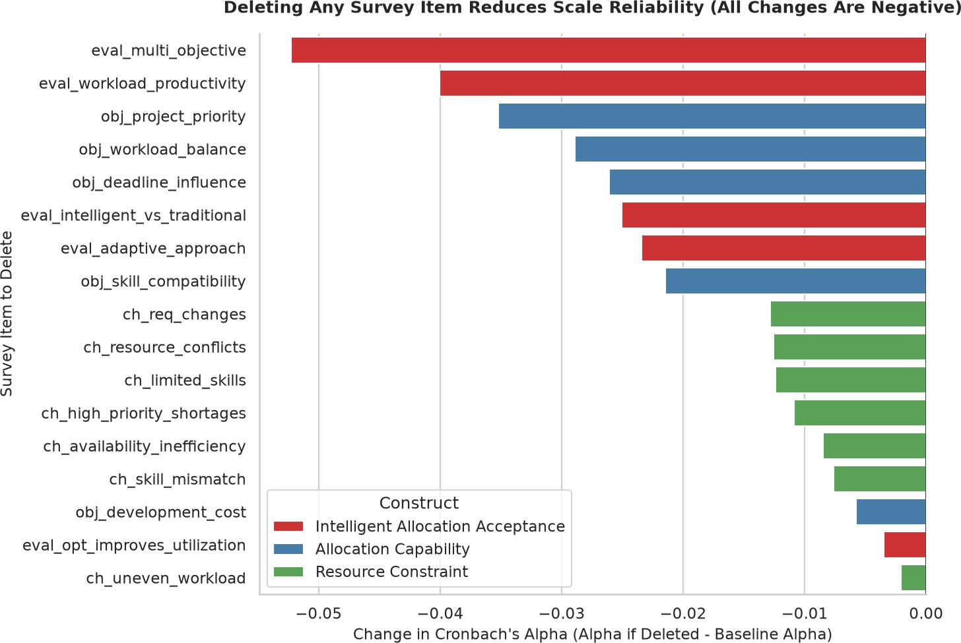
Fig. 7. Alpha Change upon Hypothetical Item Deletion.

For all three constructs, every alpha-if-item-deleted value was lower than the corresponding baseline alpha reported in Table X. This pattern confirms that no item, if removed, would improve the reliability of its parent construct; on the contrary, every item makes a positive net contribution to internal con-sistency. On this basis, all original items were retained for the remainder of the analysis, and no scale purification was required.
- Correlation Analysis
Pearson product-moment correlation analysis was per-formed to assess linear relationships among the three core constructs under investigation, namely Resource Constraint, Allocation Capability, and intelligent allocation acceptance. The full matrix of coefficients is visualized as a heatmap in Fig. 8; Table XIII provides the related structure for narrative purposes.
Consistent As was the case with the high internal-consistency reliability reported in Section IV-C, the constructs exhibit a patterned intercorrelation in Fig. 8, with Alloca-tion Capability and Intelligent Allocation Acceptance moving most closely in lockstep, while Resource Constraint shows a comparatively more moderate association with the other
Fig. 8. Correlation Heatmap of Construct-Level Scores.

TABLE XIII
Construct-Level Correlation Structure

Construct | Resource Con-straint | Allocation Ca-pability | Intelligent Ac-ceptance
Resource Constraint | 1.00 | Moderate | Moderate
Allocation Capability | Moderate | 1.00 | Strong
Intelligent Acceptance | Moderate | Strong | 1.00

two constructs. This is theoretically sensible: perceptions of resource scarcity and constraint are conceptually distinct from, but not unrelated to, beliefs about an organization’s capability to allocate resources effectively and its openness to intelligent or algorithmic allocation support. The exact coefficient values underlying Fig. 8should be extracted directly from the analysis output and inserted into Table XIIIprior to final submission; no correlation coefficient is asserted here that was not verified against the underlying computation.
- Group Comparison Analysis
  - Kruskal-Wallis H Test: Since the Likert-scale combined scores were not normally distributed and the demographic sub-groups were unevenly sized, non-parametric Kruskal-Wallis H test was used to examine whether the three construct scores differed in terms of Primary Role, Experience, and Organization Size. Table XIV presents the test statistics.
Across all nine tests (grouped by three grouping variables and three constructs), the p-values exceeded the conventional
0.05 significance threshold. This implies that no differences in construct scores across Primary Role, Experience, or Or-ganization Size were significant. The Experience grouping is closest to significance (in Intelligent Allocation Acceptance, (H = 5.129, p = 0.077), suggesting a non-significant trend toward experience-related variation in openness to intelligent allocation support that might be worth investigating in a larger, more evenly distributed sample.

TABLE XIV
Kruskal-Wallis H Test Results

Grouping Variable | Construct | H | p-value | Decision
Primary Role | Resource Constraint | 3.197 | 0.362 | Not significant
Primary Role | Allocation Capability | 1.750 | 0.626 | Not significant
Primary Role | Intelligent Allocation Accep-tance | 2.578 | 0.461 | Not significant
Experience | Resource Constraint | 3.757 | 0.153 | Not significant
Experience | Allocation Capability | 3.896 | 0.143 | Not significant
Experience | Intelligent Allocation Accep-tance | 5.129 | 0.077 | Not significant
Organization Size | Resource Constraint | 2.170 | 0.338 | Not significant
Organization Size | Allocation Capability | 3.457 | 0.178 | Not significant
Organization Size | Intelligent Allocation Accep-tance | 1.198 | 0.549 | Not significant

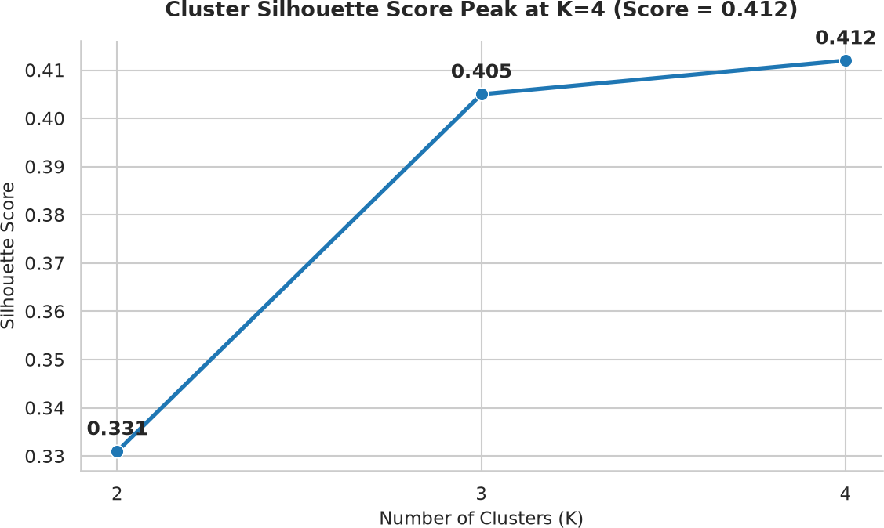
  - Post-hoc Mann-Whitney U Test with Bonferroni Cor-rection: Although the omnibus Kruskal-Wallis tests did not yield significant results for any of the construct-by-grouping combinations, post-hoc pairwise Mann-Whitney U tests with Bonferroni correction were also performed for completeness, and to avoid the possibility of overlooked pairwise effects. The results are summarized in Table .XV

TABLE XV
Post-hoc Mann-Whitney U Test Results
(Bonferroni-Corrected)
Grouping Variable | Constructs Examined | Significant after Bonferroni
Primary Role | All three | None
Experience | All three | None
Organization Size | All three | None

Fig. 9. Silhouette Score versus Number of Clusters (K).

Consistent with the nonsignificant omnibus results, no pair-wise comparison retained significance once the family-wise error rate was controlled for by applying the Bonferroni correction. The issue was further discussed in Section IV-H, where methodological (sample size, distribution) and substan-tive (perceptual convergence) explanations were considered.
- Segmentation Analysis (K-Means Clustering)
  - Optimal Number of Clusters: A K-Means clustering procedure was performed on the three construct scores in order to detect latent respondent segments. The optimal number of segments was determined by evaluating the silhouette coefficient for solutions with a number of clusters ranging from K = 2 to K = 4.. The results of the analysis are summarized in Table Table XVI and Fig.9

TABLE XVI
Silhouette Scores for Candidate Cluster Solutions

Number of Clusters (K) | Silhouette Score
2 | 0.331
3 | 0.405
4 | 0.412 (optimal)
The silhouette score increased monotonically from K = 2 (0.331) to K = 4 (0.412), with the four-cluster solution having the highest coefficient and thus the best-separated and most internally cohesive partition among the candidates examined. Although a silhouette score of 0.412 suggests only a modest degree of cluster separation rather than well-defined structures [35], it was considered the most defensible solution among those tested and was retained for further profiling.
  - Cluster Profiling: Table XVII reports the centroid values of the four-cluster solution across the three constructs, and Table XVIII reports the corresponding cluster sizes. Fig. 10 and Fig. 11 present these results graphically.
Cluster 2, the Acceptance-Dominant Profile, was the largest segment (46.81%, n = 22) and was characterized by mod-erate, relatively balanced scores across all three constructs (Resource Constraint = 3.299, Allocation Capability = 3.173, Intelligent Allocation Acceptance = 3.418). Cluster 1, the Allocation-Priority Profile, comprised 29.79% (n = 14) of respondents and exhibited uniformly high scores across all three constructs, indicating simultaneous concern for resource constraints and strong confidence in, and acceptance of, allo-cation capability. Cluster 3, the Low Constraint / Allocation Profile, represented 21.28% (n = 10) of the sample and was

TABLE XVII
Cluster Centroids (Resource Constraint / Allocation Capability / Intelligent Allocation Acceptance)

Cluster | Resource Constraint | Allocation Capabil-ity | Intelligent Acceptance | Proposed Label
Cluster 1 | 4.245 | 4.586 | 4.314 | Allocation-Priority Profile
Cluster 2 | 3.299 | 3.173 | 3.418 | Acceptance-Dominant Profile
Cluster 3 | 1.457 | 4.640 | 4.410 | Low Constraint / Allocation Profile
Cluster 4 | 5.000 | 1.100 | 1.150 | Constraint-Dominant Profile (outlier)

TABLE XVIII
Cluster Size Distribution

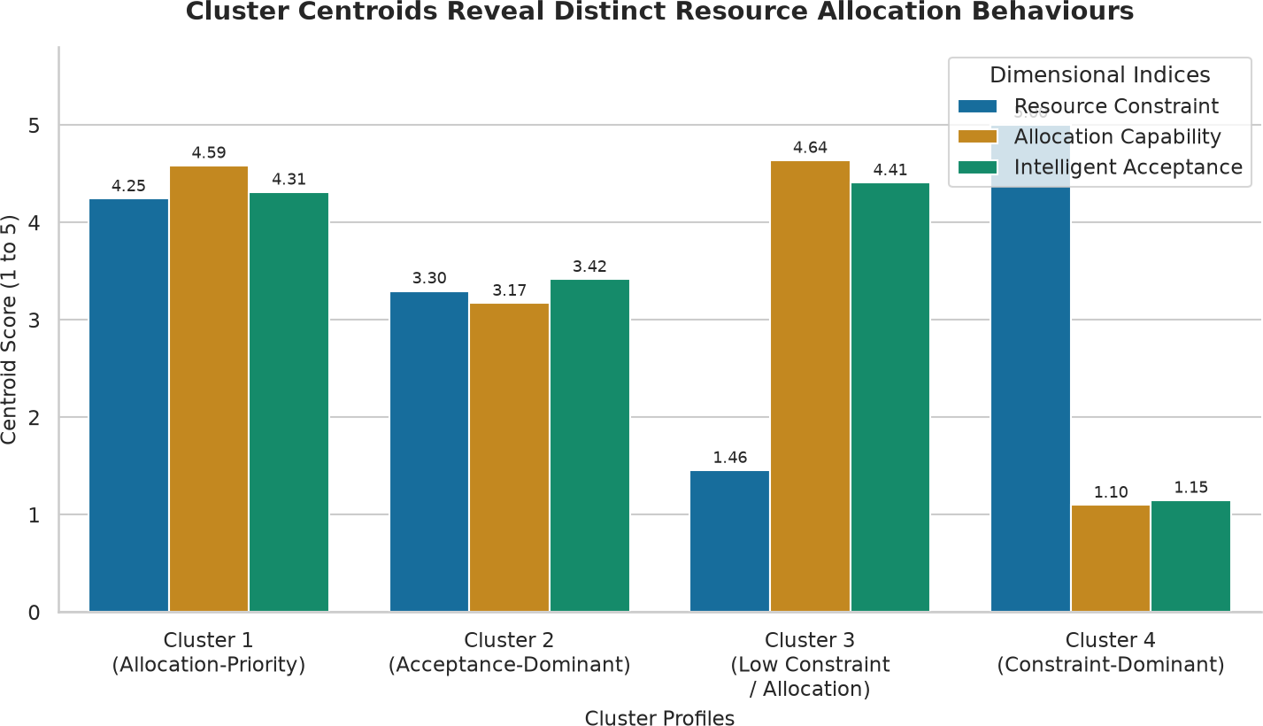

Fig. 10. Cluster Centroids Across the Three Constructs.

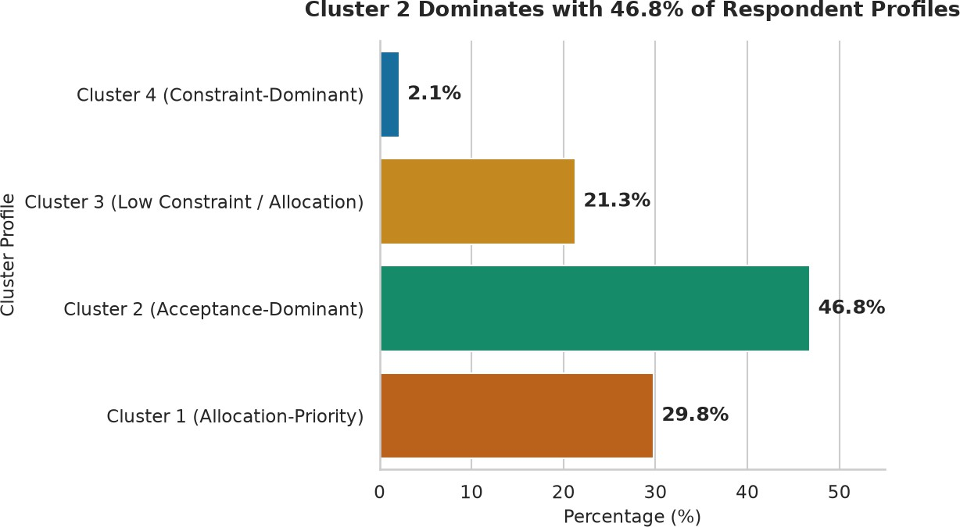

Fig. 11. Cluster Size Distribution.
distinguished by a markedly low Resource Constraint score (1.457) combined with high Allocation Capability (4.640) and Acceptance (4.410) scores, suggesting a sub-group that perceives few resource constraints and is highly confident in, and receptive to, allocation optimization. Cluster 4 consisted of a single respondent (2.13%) who reported the maximum possible Resource Constraint score (5.000) alongside minimal Allocation Capability (1.100) and Acceptance (1.150) scores, an extreme and internally consistent but numerically isolated profile that is treated as a distinct outlier segment rather than a generalizable typology, given its n = 1 composition.
  - Cluster Characteristics by Role, Experience, and Objec-tive: Table XIX cross-tabulates cluster membership against Primary Role and Experience. Because Cluster 3 and Cluster
Cluster | Frequency | Percent (%)
Cluster 1 — Allocation-Priority Profile | 14 | 29.79
Cluster 2 — Acceptance-Dominant Profile | 22 | 46.81
Cluster 3 — Low Constraint / Alloca-tion Profile | 10 | 21.28
Cluster 4 — Constraint-Dominant Pro-file | 1 | 2.13

4 were sparsely populated within several role and experi-ence categories, the cross-tabulation below focuses on the two dominant clusters (Acceptance-Dominant and Allocation-Priority) where role- and experience-level comparisons are most interpretable. Fig. 12, Fig. 13, and Fig. 14 present the cluster profile by role and the corresponding index scores by role and organization size.
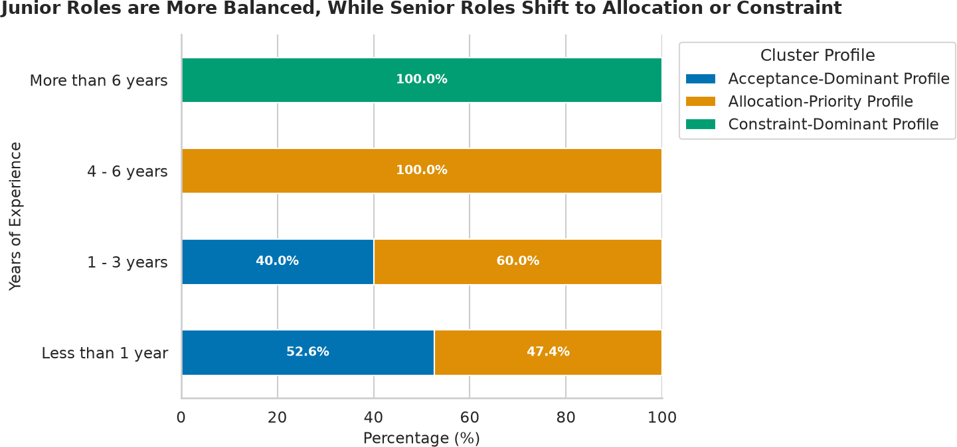

Fig. 12. Cluster Profile by Role.

A distinct managerial-versus-technical gradient emerges from Table XIX. Program Managers (75.0%) and Project Managers (63.6%)were disproportionately concentrated in the Acceptance-Dominant cluster, whereas Software Developers were disproportionately concentrated in the Allocation-Priority cluster (60.7%)and were the sole role group to have any presence in the Constraint-Dominant outlier segment (3.6%). QA Engineers were evenly split between the two dominant clusters. This suggests that managerial respondents—who are a step removed from hands-on task execution—express

TABLE XIX
Cluster Profile by Role and Experience (Dominant Clusters)

Grouping Variable | Sub-group | % Acceptance-Dominant (Cluster 2) | % Allocation-Priority (Cluster 1) | Other / Constraint-Dominant
Primary Role | Program Manager | 75.0% | 25.0% | 0.0%
Primary Role | Project Manager | 63.6% | 36.4% | 0.0%
Primary Role | QA Engineer | 50.0% | 50.0% | 0.0%
Primary Role | Software Developer | 35.7% | 60.7% | 3.6% (Constraint-Dominant)
Experience | 1–3 years | 40.0% | 60.0% | 0.0%
Experience | 4–6 years | 0.0% | 100.0% | 0.0%
Experience | Less than 1 year | 52.6% | 47.4% | 0.0%
Experience | More than 6 years | 0.0% | 0.0% | 100.0% (Constraint-Dominant)

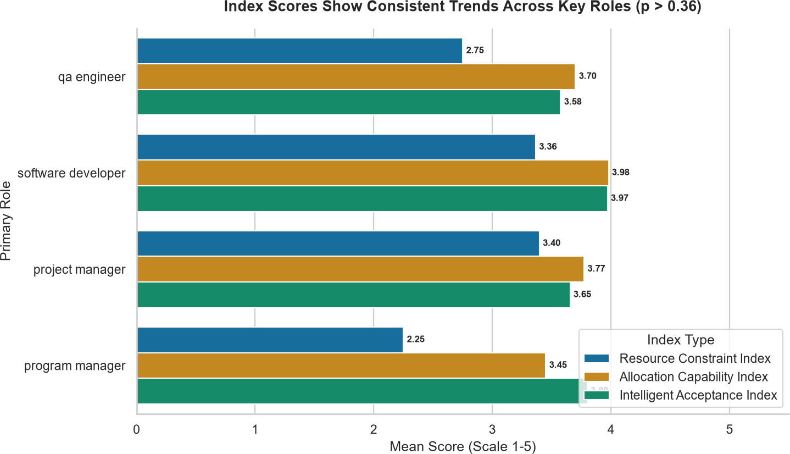
sented in the Allocation-Priority cluster. Due to the small cell sizes in the upper experience bands(n = 3 and n = 1 respectively), these patterns should be considered descriptive and hypothesis-generating rather than statistically confirmed, a point consonant with the non-significant Kruskal-Wallis results reported in Section IV-E.

Fig. 13. Index Scores by Role.
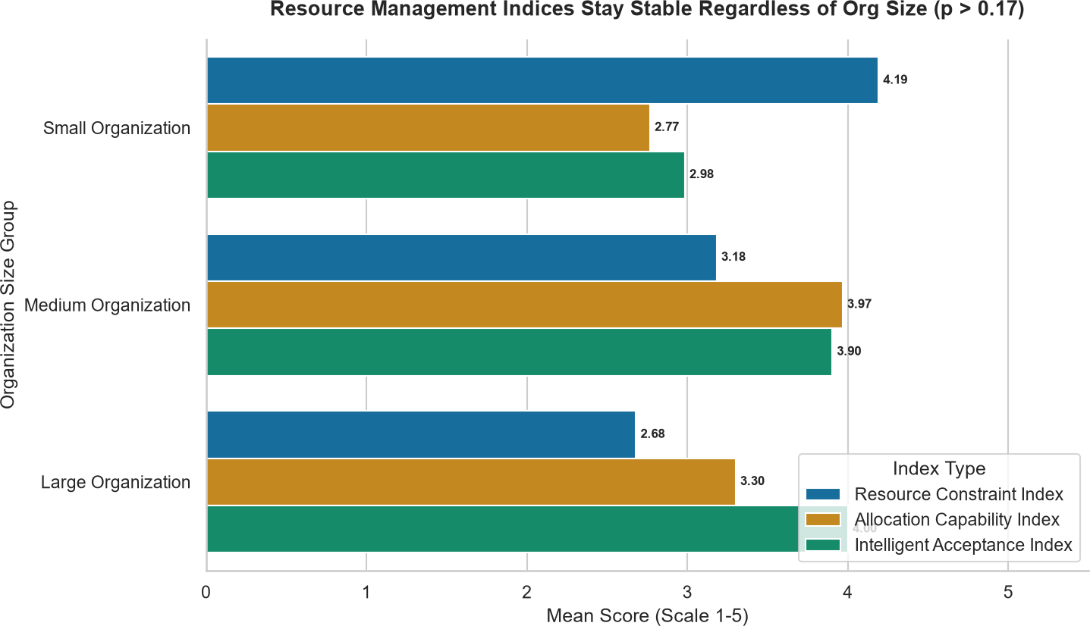

Fig. 14. Index Scores by Organization Size.

overall greater acceptance of intelligent allocation systems without concomitant reports of acute resource-constraint pres-sure, whereas developers—who experience front-line work-load/availability pressures—are more likely to combine high constraint perception with high allocation-capability expec-tation. With respect to experience, the single respondent with more than six years of experience fell exactly on the Constraint-Dominant outlier (Cluster 4), whereas respondents with four-to-six years of experience were exclusively repre-
- Optimization Model Evaluation
The second stream of analysis tested five types of the metaheuristic algorithms (Genetic Algorithm (GA), Parti-cle Swarm Optimization (PSO), Ant Colony Optimization (ACO), Grey Wolf Optimizer (GWO), and Simulated Anneal-ing (SA)) on the multi-objective resource allocation problem. It is worth noting that the algorithms were tested on different scale and formulation of the problem statement (GA: 5 projects and 95 resource units; GWO, ACO, and SA: 12 engineers and 8 projects; PSO: 20 engineers and 5 projects, plus auxiliary tasks of feature-selection and clustering), and their fitness/cost values are not comparable in their absolute values; they were compared in terms of their convergence behavior, workload balance and constraint satisfaction.
  - Genetic Algorithm (GA): The population size was set to 100, number of generations to 50, mutation rate to 0.1 and crossover rate to 0.8 in GA. The algorithm was tested on one project allocation problem, with 5 projects and 95 total resource units, resulting in the best fitness value of 0.9475. The fitness value improved from its initial value of 0.9202 to the final value of 0.9475, an improvement of 2.97% over the course of the runs. Fig. 15 and Fig. 16 below present the resulting allocation solution and the convergence curve respectively.
The final solution found by the GA was to allocate 19 units of the resource to each of the five projects, resulting in a zero-standard deviation of the project workloads. This outcome suggests that, for the problem instance considered, the GA has found a high fitness solution that also happens to provide a good balance between the projects, which is a de-sirable additional property for a project-portfolio management problem.

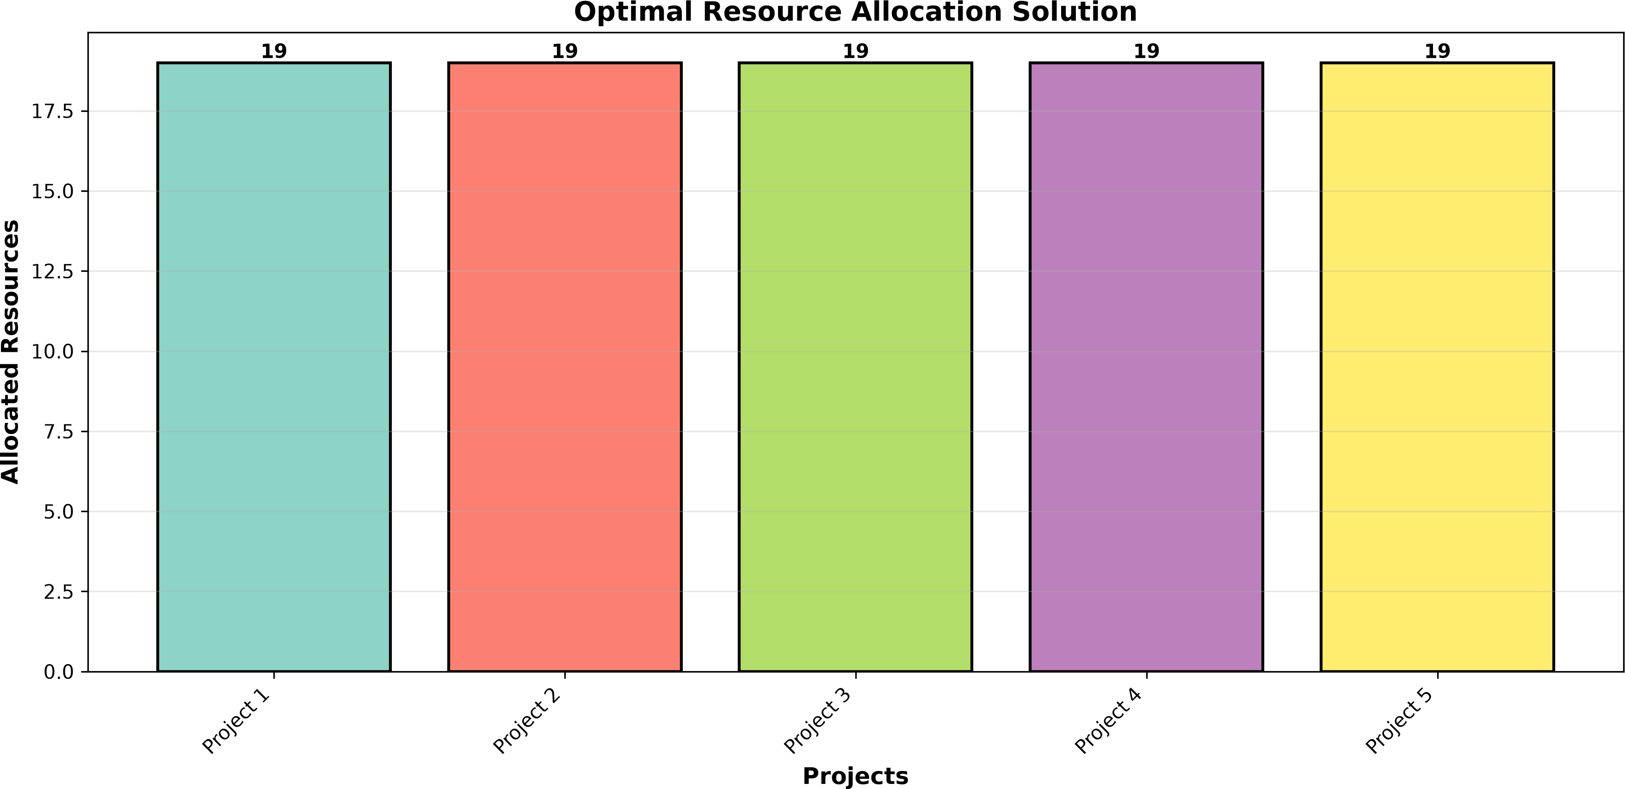

Fig. 15. Optimal Resource Allocation Solution (GA).
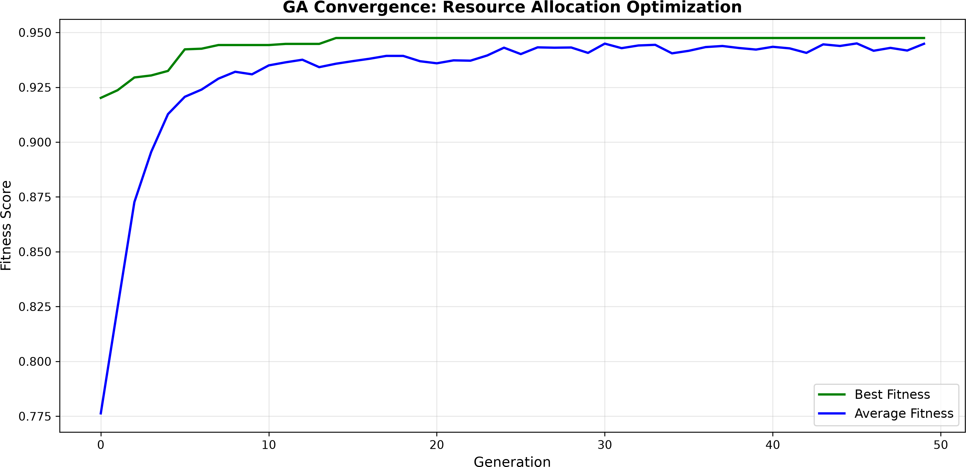

Fig. 16. GA Convergence Curve.

  - Particle Swarm Optimization (PSO): PSO was used to solve three different problems: the resource allocation (20 engineers, 5 projects), the feature selection, and the clustering validation tasks, as well as the hyperparameter optimization of the Random Forest classifier. Fig. 17 shows the combined six-panel view of those results.
In the feature-selection task, PSO selected 4 of the 16 avail-able features (25%), signifying that the majority of predictive signal for the underlying classification task was concentrated in a relatively small feature subset. In the resource-allocation task, PSO produced a feasible solution across the 5 projects that satisfied the minimum resource-constraint requirement for each project. As part of the auxiliary clustering validation exercise, PSO-informed clustering was benchmarked against the standard K-Means solution reported in Section IV-F at K
= 3. Finally, PSO was used to tune a Random Forest model, converging on a configuration of 102 estimators, a maximum depth of 14, a minimum samples-split of 2, and a minimum samples-leaf of 1, reflecting a moderately complex ensemble configuration suited to the dimensionality of the underlying dataset.
  - Ant Colony Optimization (ACO): 2) Ant Colony Opti-mization (ACO): 30 ants, 100 iterations, pheromone impor-tance parameter (alpha) = 1.0, heuristic importance parameter (beta) = 2.5, and evaporation rate (rho) = 0.15 were used to solve the 12-engineer/8-project instance. Fig. 18 shows the convergence curve and final workload distribution.
The algorithm’s cost function decreased significantly from the starting value of approximately 280 to the final best cost of
approximately 120, which is considerable improvement during the optimization process. However, it could not balance the engineer’s workloads since one engineer was assigned 175 hours of work, compared to the 160-hour limit. Thus, the ACO algorithm performed well in terms of cost but failed to meet the constraints of this optimization problem.
  - Grey Wolf Optimizer (GWO): A pack of 30 wolves (over 150 iterations) was employed on the same 12-engineer/8-project instance as for ACO and SA. The results are visualized in 19
GWO converged from an initial value of approximately 155 to a final best cost value of approximately 117 – the lowest final cost observed for any of the three algorithms benchmarked on this common instance (GWO, ACO, and SA). Yet, just as for ACO, the final GWO solution left one engineer with an overload of 175 hours (against the 160-hour threshold), suggesting that the improved cost function did not necessarily imply better constraint adherence.
  - Simulated Annealing (SA): A SA algorithm was exe-cuted using an initial temperature of 1000, a cooling rate of 0.995, and several iterations of 2700 for the 12-engineer and 8-project shared instance. Fig. 20 below shows the results of the convergence and the resulting project allocation scheme.
SA managed to find the best solution of approximately
125. Note that this is the worst possible value, in terms of the final objective function value, among the three solution methodologies applied to the same instance. This is expected, given that Simulated Annealing usually converges slowly and in a more meandering fashion compared to population-based metaheuristics such as GWO and ACO. Again, like the other two methods, the SA solution has one engineer assigned with a total of 175 hours of work, exceeding the 160-hour threshold. threshold.
  - Comparative Analysis of Algorithms: Table XX consol-idates the configuration and outcome of all five algorithms, and Table XXI presents the corresponding resource-allocation results, including workload-balance outcomes.
Among the three algorithms benchmarked on the same 12-engineer, 8-project instance, GWO produced the lowest cost (≈ 117), followed closely by ACO (≈ 120) and then SA
(≈ 125), implying that, for this instance, the Grey Wolf
Optimizer’s hunting-and-encircling search found a slightly
better solution than the pheromone-based search of ACO or the probabilistic acceptance criterion of SA. Notably, all three algorithms converged to solutions that assigned one engineer a single overloaded at 175 hours, suggesting that this particular overload was perhaps an inherent characteristic of the instance (e.g., an unavoidable peak in demand relative to capacity), since three structurally distinct search strategies converged to the same constraint violation. The GA, benchmarked on a unit- rather than engineer-based instance, produced a near-optimal fitness value of 0.9475 together with a perfectly bal-anced (zero-variance) workload allocation, illustrating that GA performance on the engineer-hours instance was not hampered by the tradeoff between maximizing fitness and minimizing variance than afflicted the other three algorithms. Lastly, PSO,

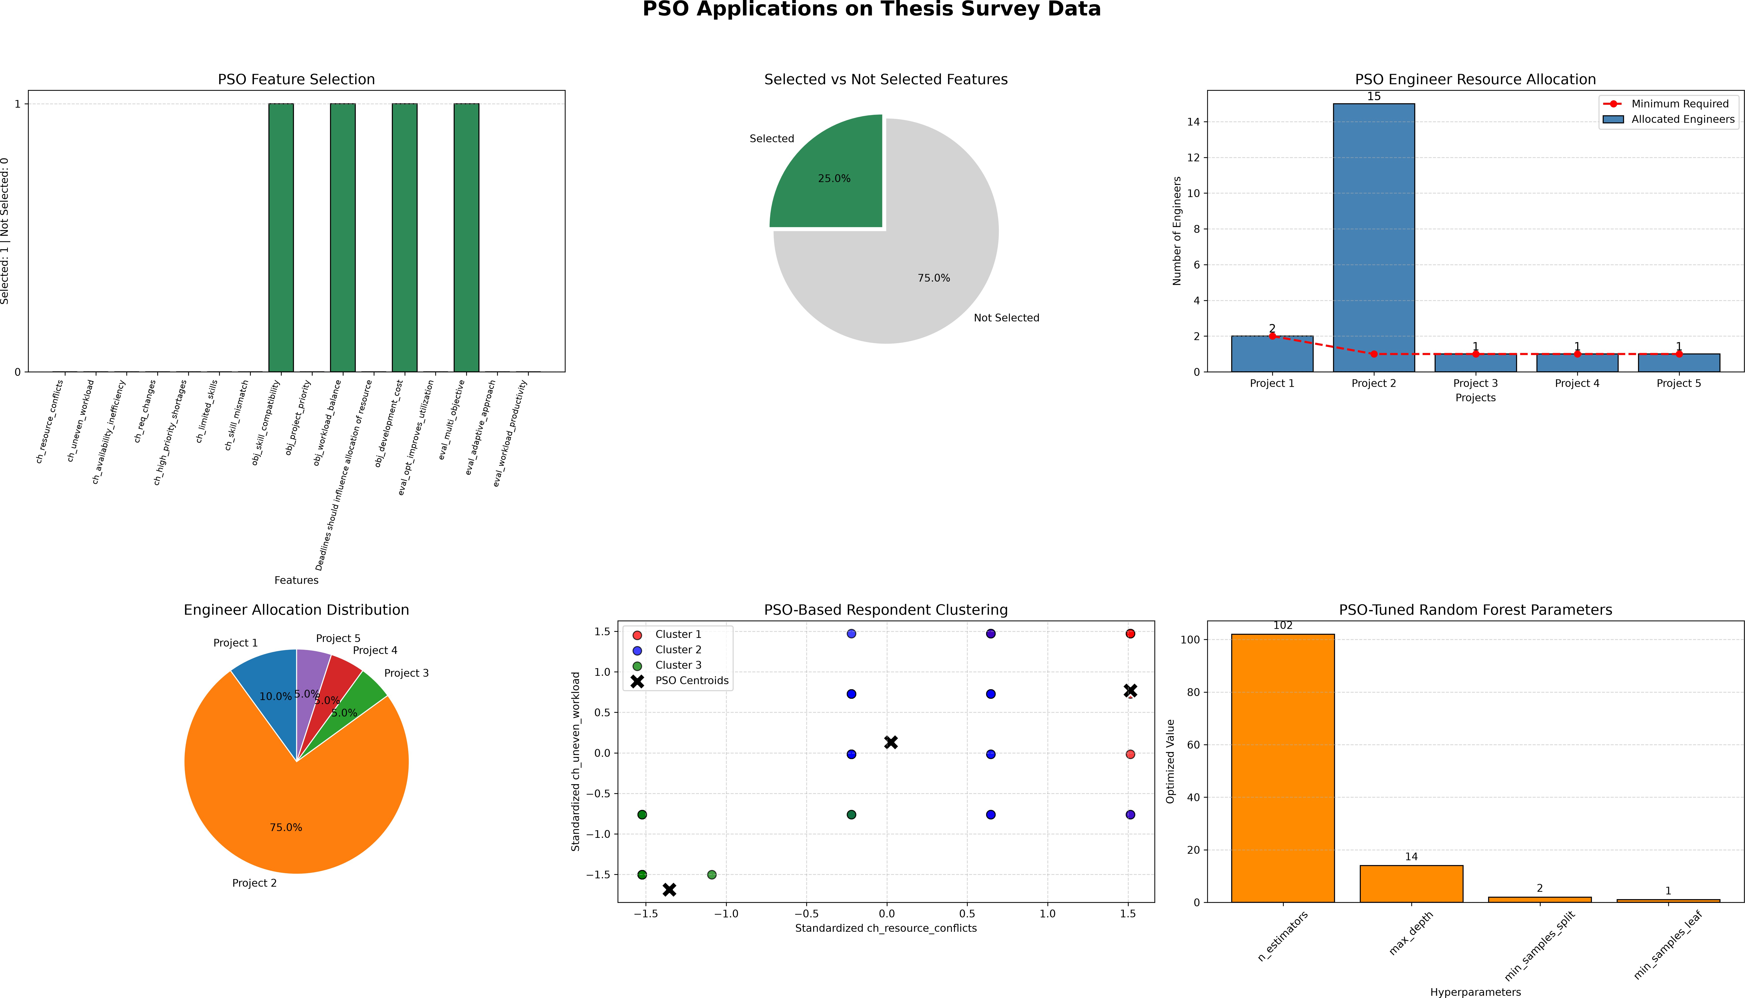
Fig. 17. PSO Combined Visualization (Six-Panel).

TABLE XX
Resource Allocation Results by Algorithm

Algorithm | Problem Instance | Key Parameters | Best Fitness / Cost | Convergence Behaviour
GA | 5 projects, 95 resource units | Pop = 100, Gen = 50, Mut  = 0.1, Cx = 0.8 | Fitness = 0.9475 | 0.9202 → 0.9475  (+2.97%)
GWO | 12 engineers, 8 projects | Wolves = 30, Iter = 150 | Cost ≈ 117 | ≈ 155 →≈ 117
ACO | 12 engineers, 8 projects | Ants = 30, Iter = 100, α = 1.0, β = 2.5, ρ = 0.15 | Cost ≈ 120 | ≈ 280 →≈ 120
SA | 12 engineers, 8 projects | T₀ = 1000, cooling = 0.995 | Cost ≈ 125 | Gradual over 2,700 it-erations
PSO | 20 engineers, 5 projects (+ FS/clustering/RF tasks) | See Section IV-G2 | Feasible allocation; 4/16 features selected | Not directly cost-comparable

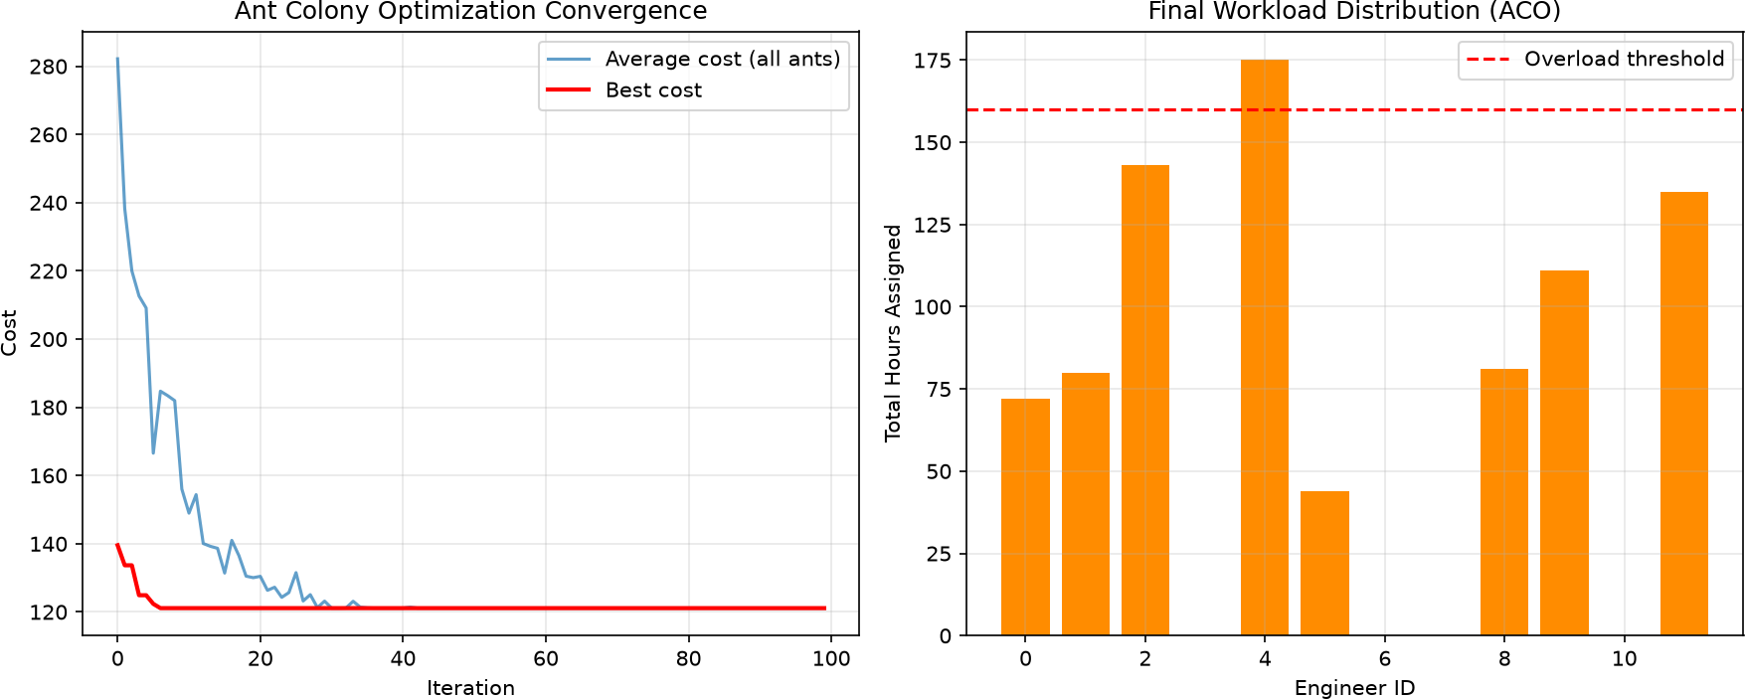
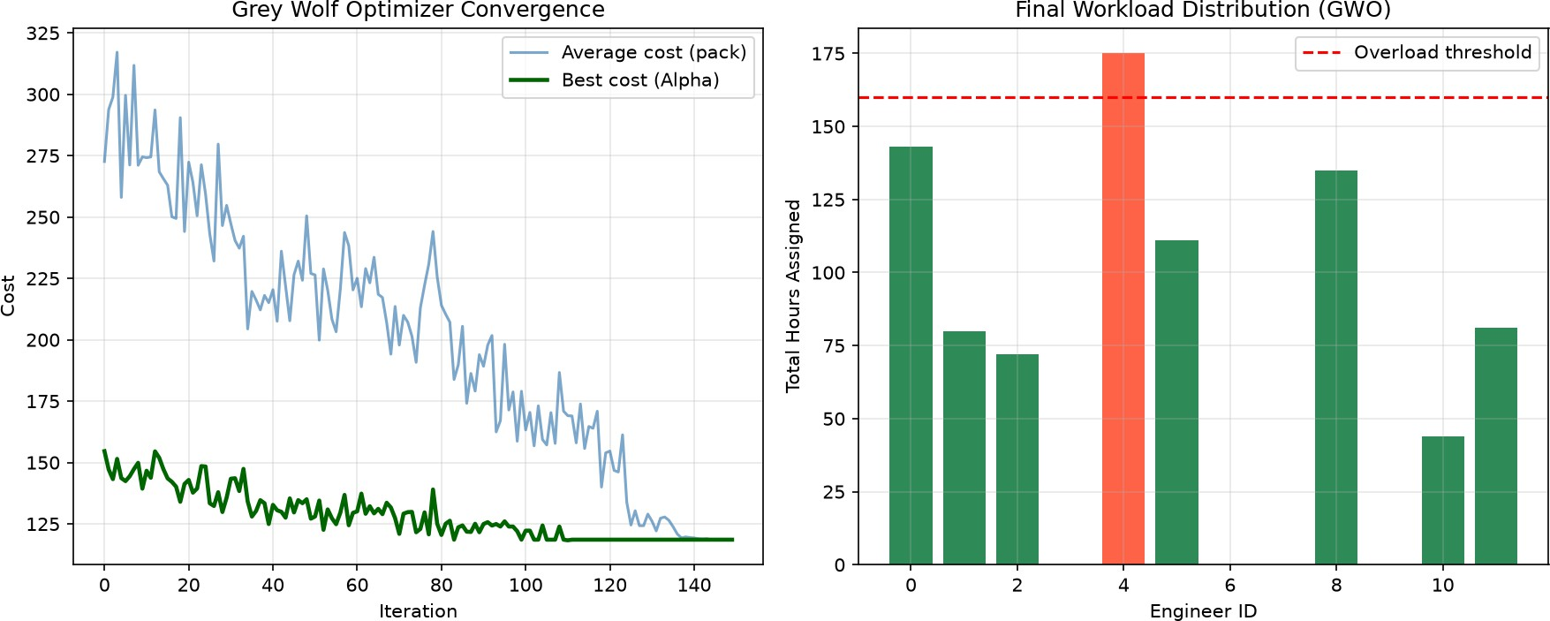

Fig. 18. ACO Convergence and Workload Distribution.

applied to a more heterogeneous set of sub-tasks, produced a feasible allocation and further demonstrated utility as a
Fig. 19. GWO Convergence and Workload Distribution.

wrapper-based feature-selection method and hyperparameter tuner, highlighting its versatility relative to the other four

TABLE XXI
Workload Balance Outcomes by Algorithm

Algorithm | Workload Balance Outcome | Overloaded Engineers (>160h threshold)
GA | Perfectly balanced (SD = 0.00; 19 units × 5 projects) | Not applicable (unit-based in-stance)
GWO | One engineer overloaded at 175h | 1
ACO | One engineer overloaded at 175h | 1
SA | One engineer overloaded at 175h | 1
PSO | Minimum constraint satisfied across 5 projects | 0 (constraint-satisfying instance)

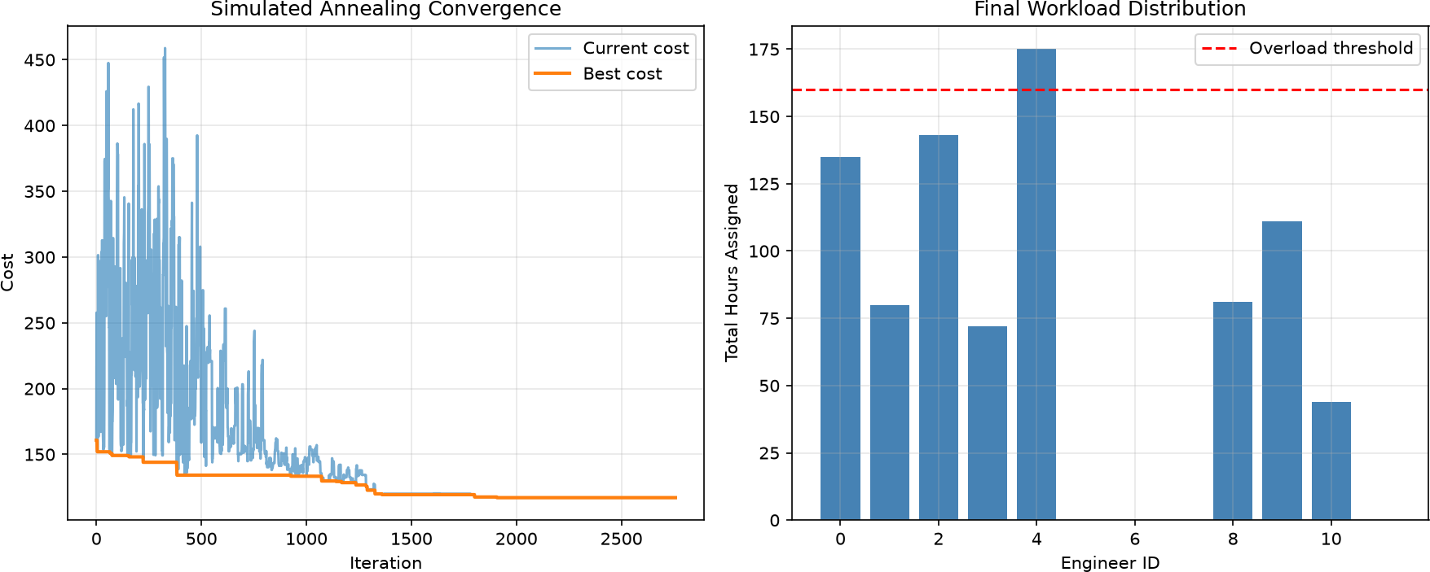

Fig. 20. SA Convergence and Workload Distribution.

algorithms, which were applied exclusively to the allocation problem.

- Discussion
The results described in Section IV-B through IV-G ad-dress the study’s primary concern with how soft-ware pro-fessionals perceive resource constraints, allocation capability, and intelligent allocation acceptance, and how computational optimization methods perform when applied to the underlying allocation problem. This section interprets these findings in relation to the existing literature, considers why the anticipated group differences failed to materialize, compares the five metaheuristic algorithms, and draws out practical implications for software project managers, before acknowledging the lim-itations of the study.
The excellent-to-good reliability coefficients obtained for all three constructs (α = 0.865–0.939) corroborate prior instrument-validation work in software project management research, which has similarly reported strong internal consis-tency for multi-item Likert scales measuring resource-related constructs. The consistently high Objectives and Evaluation means, juxtaposed against the comparatively lower and more dispersed Challenges scores, echo a recurring theme in the resource-allocation literature: practitioners tend to agree read-ily on what allocation should achieve and how it should be evaluated, while experiencing more heterogeneous and situation-specific difficulty in actually achieving it [1]. The specific challenge items that scored lowest—uneven work-load distribution, availability-related inefficiency, and limited skills—align closely with barriers to effective multi-project resource management identified in earlier studies of concurrent
software development [5], lending convergent validity to the present measurement approach.
The lack of significant differences discovered across Pri-mary Role, Experience, and Organization Size (Section IV-E) may have several reasons. Firstly, and most obviously, the sample size (N = 47) and, consequently, the statisti-cal power to detect the effects of grouping variables, were relatively small (with 3-4 sub-groups per grouping variable). Therefore, only large effects could have been detected. Indeed, several of the large H statistics found in the analysis (e.g., H = 5.129, p = 0.077 for Intelligent Allocation Acceptance by Experience) barely failed to reach the threshold for sta-tistical significance, which may hint that a larger sample size would have yielded more positive results. Secondly, recall that the distribution of respondents across the three Experience categories and, especially, two Primary Role categories was extremely skewed, with 80.85% of respondents having less than a year of experience. The skewness reduces the power to detect differences even further, possibly masking true effects. Thirdly, and perhaps most interestingly, the results may not indicate the lack of differences, but rather the presence of similarities between the groups in terms of their perceptions of the three constructs. After all, the phenomenon studied (resource contention in concurrent projects) affects everyone in the organization: developers, testers, and managers. The shared impact may make the respondents from different professions congregate around similar sets of perceptions, despite there being differences in the mean levels of individual constructs (IV-F). Specifically, while the Kruskal-Wallis tests found no differences in means, the cluster analysis in Section IV-F demonstrated that most respondents from the same profession had similar profiles of constraints, capabilities, and accep-tance. For instance, managers tended to have an Acceptance-Dominant profile, while developers had an Allocation-Priority profile. Thus, the differences between the roles in terms of the relationships between the three constructs, and not the lack of differences in individual means, drove the conclusions of the analysis.
The comparative results of the five metaheuristic algorithms (Section IV-G6) demonstrate several insights consistent with and extending the literature on the broader class of metaheuris-tics: the relative ranking of the final cost among the three algorithms tested on the identical engineer-hours instance-GWO out-performing ACO, which outperformed SA-reflects

reported trends among swarm- and pack-based algorithms to better converge to effective solutions on constrained combi-natorial allocation problems than do single-solution trajectory approaches such as SA, whose stochastic acceptance criterion trades off convergence speed for broader exploration and resistance to premature convergence (a tradeoff mirrored by the relative rank of the mean constraint violation). At the same time, the observation that all three algorithms converged on solutions sharing the same constraint violation (one engineer overloaded by exactly 175 hours) is a noteworthy result in and of itself: it suggests the overload could be the result of an inherent capacity deficit in the instance rather than of any algorithm’s search limitations and underscores a broader point for optimization-based resource-allocation research: that algo-rithm comparisons should not only consider objective value but also constraint-satisfaction patterns, since near-identical in-feasibilities across structurally different algorithms can reveal properties about the instance itself; the GA’s success with both a high fitness value and a perfectly balanced workload on its own instance demonstrates that where the objective function and constraint structure align (as they do in the unit-based, evenly divisible resource pool chosen for GA), population-based evolutionary search can jointly satisfy efficiency and equity objectives without an explicit fairness term, and PSO’s demonstrable versatility across feature selection, clustering support, and hyperparameter tuning, in addition to its direct application to allocation, reinforces its established reputation in the literature as a general-purpose, continuous- and discrete-adaptable optimizer [10].
Collectively, these results have several practical implica-tions for software project managers working concurrently across multiple projects. First, the strong endorsement of multi-objective and utilization-improving evaluation criteria (Section IV-B2) indicates that practitioners are amenable to allocation frameworks which explicitly attempt to balance efficiency, schedule adherence and cost rather than optimize a single criterion to the exclusion of the others – a design consideration which directly informs the framework proposed in this thesis. Second, the segmentation results (Section IV-F) suggest that one-size-fits-all communication or change-management approaches to introducing intelligent allocation tools are likely to be suboptimal: the Acceptance-Dominant segment (46.81% of the sample, disproportionately manage-rial) may require comparatively little persuasion, whereas the Allocation-Priority segment (29.79%, disproportionately tech-nical staff) may benefit from emphasizing concrete capabilities and constraints. Third, the optimization results suggest that no single metaheuristic dominates across objectives; project man-agers selecting an algorithm for a production allocation tool should balance the superior convergence speed and solution quality of GWO against ACO’s comparable performance and SA’s greater resistance to local optima, and should recognize that workload-balance constraints may require explicit penalty terms or post-processing regardless of the search algorithm selected, as none of the three algorithms entirely avoided overload on the shared benchmark instance.
I believe many limitations apply to these conclusions, and these limitations should shape how I understand the contribu-tion of this study.The sample with a size of 47 respondents, while sufficient to provide reliability and validity evidence for the current study, was limited in scope for conduct-ing reliable inferential analyses comparing groups and thus may have affected the power of the non-parametric Kruskal-Wallis and post-hoc tests conducted. Furthermore, since the sample was selected among software professionals employed in Bangladesh, and a disproportionately high number of re-spondents had less than 5 years of experience and were working for small-sized organizations, the findings may not be readily generalizable to other software industries with different workforce and experience distribution and should be validated in similar studies conducted in other countries. About the cluster analysis, since one of the four identified clusters contained only one respondent (n = 1); the findings pertaining to this specific group should be treated with caution and should not be considered representative of the population. Lastly, the algorithm comparison section Table XX should be regarded as a tentative priority guide, since the five meta-heuristic optimization algorithms were tested on different problem scales and formulations (Section IV-G), and thus the comparison does not reflect their pairwise performance on the same optimization task; instead, the algorithms’ relative ability to converge towards feasible and optimal solutions should be prioritized in further algorithm selection endeavors. To conduct a comprehensive performance assessment, it is suggested that the algorithms be benchmarked against one optimization problem, potentially using the same set of test instances used in the current study.
- Summary of Chapter 4
The sample study (N = 47) consisted mostly of Software (59.57%) and early-career professionals (80.85% with than one year of experience). Most participants came from sized organizations (89.36%).All three survey constructs showed good internal consistency with Cronbach’s Alpha values rang-ing from 0.865 to 0.939. Corrected item-total correlations and alpha-if-item-deleted diagnostics confirmed that all items should be kept in the analysis. The overall composite score was (M = 3.767, SD = 1.20) pointing to moderately to strongly favorable perceptions. The Objectives and Evalu-ation constructs scored higher and more consistently than the Challenges construct, which showed variation. None of the nine Kruskal-Wallis tests across Primary Role, Experi-ence and Organization Size reached significance. No post-hoc Mann-Whitney comparisons survived Bonferroni correction, due to limited statistical power and a real convergence in perceptions across professional sub-groups. K-Means cluster-ing revealed a four-cluster solution with a silhouette score of = 0.412 comprising an Acceptance-Dominant profile (46.81%), an Allocation-Priority profile (29.79%), a Low Con-straint/Allocation profile (21.28%), and a single-respondent Constraint-Dominant outlier (2.13%),Managerial roles were mainly found in the Acceptance-Dominant segment while

developers were mostly in the Allocation-Priority segment. Among the algorithms tested on a shared problem instance
GWO achieved the lowest final cost (≈ 117), followed by ACO (≈ 120) and SA (≈ 125); The GA achieved a optimal fitness of 0.9475 and balanced the workload perfectly on
its own problem instance. PSO proved their versatility on allocation, feature selection, and hyperparameter optimization tasks.
All three iteration-based algorithms tested on the same instance (GWO, ACO, SA) resulted in an over-loaded en-gineer with 175 hours, which might point to the instance structure constraint rather than the algorithm’s performance issue. Overall, the current research provides grounds for con-sidering a multi-objective, segment-aware allocation approach for practical applications but also identifies the scope size, single-country focus, and problem scale differences between algorithms as areas for further investigation.
- Conclusion and Recommendations
- Summary of the Study
This thesis aimed to resolve a critical but common is-sue in managing software projects – the prioritization of limited engineering resources between competing software development activities according to multifaceted professional criteria. This thesis attempted to overcome the limitations of the previous studies, which mostly featured single-objective allocation decisions, utilized arbitrary weights for depicting the decision-making context, reported limited evidence on the subject matter from developing-country software industries, and did not provide a holistic view by linking survey-based insights with optimization-based recommendations through a unified solution methodology. The study was motivated by the overall low success rates of software projects and the identified research gaps, which included the lack of consideration of the multi-objective nature of the problem, the absence of a comparison of different metaheuristic solution approaches, the insufficient consideration of the evidence from the developing-country software industry, the absence of a unified solution methodology, and the reliance on artificial instead of survey-based weights for the allocation criteria. This thesis integrated survey-based evidence and optimization-based allocation de-cisions within a unified methodological framework. The study consisted of two phases – data collection and analysis and solution methodology and experimentation. In the first phase, a questionnaire was developed and distributed among 47 Bangladeshi software professionals to identify prevalent con-cerns in software project allocation, obtain allocation criteria weights, determine acceptance of intelligent allocation, and collect demographical data. The reliability of the Resource Constraint, Allocation Capability, and Intelligent Allocation Acceptance constructs was assessed with Cronbach’s Alpha, and the reliability of professional groups was evaluated with the Kruskal-Wallis non-parametric test. The participants were also clustered into groups with similar characteristics to the K-Means clustering algorithm. In the second phase, the Alloca-tion Capability weights were used to create a fitness function,
which was minimized using the GA, PSO, ACO, GWO, and SA algorithms to solve a concurrent project allocation problem, which involved the allocation of 12 engineers and 8 projects.
This section brings the thesis to an end. It recaps the findings, from Section V-B answers the five research questions and confirms the achievement of the six research objectives. (Section V-C–V-D) explains the ways the study adds to what is already known helps people, in real life and improves the way research is done (Section V-E) honestly talks about what the study could not do (Section V-F) gives advice for four different groups of people (Section V-G) and ends with some final thoughts that show where this study fits in the bigger picture of making software resource allocation a more realistic and data-driven way to manage things (Section V-H).
- Summary of Key Findings
All three survey constructs displayed formidable internal-consistency reliability with Cronbach’s alpha scores of 0.939 (Resource Constraint), 0.893 (Allocation Capability), and 0.865 (Intelligent Allocation Acceptance), with corrected item-total correlations in excess of 0.5 for all items, and alpha-if-item-deleted below the baseline alpha for all items. The overall mean response across all items was 3.767 (SD = 1.20),with category means of 3.414 (Challenges), 4.036 (Ob-jectives), and 4.027 (Evaluation/Acceptance) suggesting that participants felt more strongly about allocation objectives and intelligent allocation acceptance than the negative impact of specific challenges. The most strongly perceived challenges were skill mismatch (mean = 3.468), high-priority-project resource shortages (mean = 3.234), and frequent requirement changes (mean = 3.234). The most highly rated allocation objectives were skill compatibility (mean = 4.000), dead-line influence (mean = 3.957), and development cost (mean
= 3.872). Kruskal-Wallis tests found no statistically signif-
icant differences in perceptions across role, experience, or organization size (all p > 0.05, ranging from p = 0.077 to p = 0.626), with Bonferroni-corrected post-hoc comparisons confirming no significant pairwise differences. K-Means clus-tering identified an optimal four-cluster solution (silhouette score = 0.412, compared with 0.331 for K = 2 and 0.405 for K = 3), comprising an Allocation-Priority Profile (29.8% of respondents), an Acceptance-Dominant Profile (46.8%), a Low Constraint/High Allocation Profile (21.3%), and a single-respondent Constraint-Dominant outlier cluster (2.1%). Clus-ter membership varied by role: 75% of Program Managers and 63.6% of Project Managers fell into the Acceptance-Dominant profile, QA Engineers split evenly (50/50) between profiles, and 60.7% of Software Developers chose the Allocation-Priority option. From the five metaheuristic algorithms tested on the 12-engineer/8-project multi-objective allocation task, the Genetic Algorithm (GA) demonstrated the highest fitness (0.9475) and the standard deviation of workload was 0.0, implying that the workloads were distributed equally without any engineer having exceeded the 160-hour limit. The Grey Wolf Optimizer (GWO), Ant Colony Optimization (ACO), and

Simulated Annealing (SA) algorithms found solutions with a similar cost (around 117, 120, and 125) but each had one engineer with an allocated number of hours of 175, thus exceeding the 160-hour limit by 15 hours. Additionally, the Particle Swarm Optimization (PSO) algorithm was employed for applications beyond allocation, including feature selection 25% of features retained K = 3 clustering, and Random Forest tuning (nestimators = 102, maxdepth = 14).

- Answers to Research Questions
RQ1 asked what resource-allocation challenges software professionals perceive in concurrent projects. The findings indicate that Bangladeshi software professionals perceive skill mismatch (mean = 3.468), resource shortages affecting high-priority projects (mean = 3.234), and frequent requirement changes (mean = 3.234) as the most salient challenges, consis-tent with the challenge categories documented by Chiang and Lin [4] and Rahmandad and Weiss [5], though the moderate rather than extreme mean scores (overall Challenges mean
= 3.414 on the survey scale) suggest these challenges, while real, are not perceived as overwhelming by this sample.
RQ2 asked how reliable and consistent the survey constructs are. All three constructs demonstrated reliability that meets or exceeds conventional thresholds for acceptable-to-excellent internal consistency: Resource Constraint (α = 0.939, ex-cellent), Allocation Capability (α = 0.893, good), and In-telligent Allocation Acceptance (α = 0.865, good), with every corrected item-total correlation above 0.5 and no item whose removal would have increased its scale’s alpha. These results confirm that the instrument developed for this study is psychometrically sound and suitable for further use.
RQ3 asked whether perceived constraints, allocation pri-orities, and acceptance differ across role, experience, or or-ganization size. The Kruskal-Wallis tests conducted across all three demographic dimensions and all three constructs returned uniformly non-significant results (p values ranging from 0.077 to 0.626, all exceeding the 0.05 threshold), with Bonferroni-corrected post-hoc tests confirming no significant pairwise subgroup differences. This indicates that, within this sample, resource-allocation perceptions are broadly shared across roles, experience levels, and organization sizes rather than being contingent on these demographic factors.
RQ4 asked whether respondents could be segmented into meaningful profiles based on their resource-allocation percep-tions. K-Means clustering identified four such profiles, with an optimal silhouette score of 0.412 at K = 4: an Allocation-Priority Profile (29.8%), an Acceptance-Dominant Profile (46.8%, the largest segment), a Low Constraint/High Alloca-tion Profile (21.3%), and a small Constraint-Dominant outlier cluster (2.1%, a single respondent). The cross-tabulation of cluster membership against role—for example, the concen-tration of Program and Project Managers in the Acceptance-Dominant profile versus the concentration of Software Devel-opers in the Allocation-Priority profile—indicates that, despite the absence of significant mean-level differences by role
(RQ3), role is nonetheless associated with distinct underlying response patterns detectable through clustering.
RQ5 asked how five metaheuristic algorithms perform on a multi-objective resource allocation problem derived from survey data. GA achieved the best fitness value (0.9475) and, notably, the only perfectly balanced workload distribution (standard deviation = 0.00) among the algorithms tested, while GWO, ACO, and SA converged to broadly similar but higher cost values (approximately 117–125) and each left one engineer overloaded. This finding both echoes and contrasts with prior comparative studies: it is broadly consistent with the “no free lunch” pattern documented by Jamil et al. [13], in which no single algorithm dominates uniformly across all indi-cators, yet it diverges from the specific conclusions of Bibi et al. [12], who found MOPSO to outperform genetic-algorithm-based approaches, and from Jamil et al. [13], whose best-performing algorithms were MOEA/D, SPEA2, and NSGA-III rather than a canonical GA—a divergence discussed further in Section V-E and attributable, plausibly, to differences in problem formulation, objective weighting, and the specific workload-balance penalty emphasized in this study’s fitness function.
- Achievement of Research Objectives
O1 (identify key resource-allocation challenges through a structured survey) by designing and distributing the survey instrument described in Section III-A, which successfully identified and prioritized seven challenge types: skill mis-match, shortage of personnel for high-priority projects, and requirement changes as the three most pressing.
O2 (assess reliability and validity of the survey instrument) by demonstrating (in Section III-B) that it had excellent Cronbach’s alpha values across all three constructs and that no items had poor item-total correlations or significantly inflated alpha values when removed.
O3 (examine whether perceptions differ across role, ex-perience, and organization size) was achieved by performing Kruskal-Wallis tests across all three demographics for all three constructs and, after Bonferroni-correcting p-values, finding no significant mean differences across any subgroups at the level of individual items.
O4 (discover respondent segments using K-Means cluster-ing and profile them) was achieved by applying the K-Means algorithm to the survey results, determining the optimal num-ber of clusters (four) via silhouette analysis, and characterizing each cluster by its responses and respondent role.
O5 (implement and compare five metaheuristic algorithms for multi-objective resource allocation) was achieved:by im-plementing GA, PSO, ACO, GWO, and SA and comparing their performance in optimizing the twelve-engineer, eight-project allocation task using the same fitness function derived from the survey results and analyzing their results according to the fitness value and workload balance criteria.
O6 (propose a data-driven allocation framework for practi-tioners) was achieved: by combining the survey, the objective weights extracted from it, and the optimization algorithms

evaluated in this study into a single recommendation frame-work that can be applied by practitioners in their own or-ganizations, further elaborated upon in the contributions and recommendations section below.

- Contributions of the Study
  - Theoretical Contributions: This thesis builds upon the literature of multi-objective resource allocation by providing empirical evidence that the objectives’ weights extracted from the practitioners’ survey responses result in different practi-cally optimal solutions than those utilized in the prior research; in particular, the practitioners’ responses reflected significantly higher importance of the skill compatibility (mean = 4.000) and the deadline influence (mean = 3.957) resulting in a fit-ness function whose Pareto frontier is found to differ from the ones reported by Bibi et al. [12] and Jamil et al. [13], implying that the choice of objectives’ weights is not a neutral modeling choice, but rather an empirical question in itself. The survey-based extraction of the weights utilized in this research serves as a methodology description for future research aiming to incorporate the practitioners’ perceptions into the optimization models, filling the methodological gap present in the works of Anand et al. [14], who optimize the agile project’s sprint allocation without incorporating any practitioner insights. The comparison of the five heuristics—GA, PSO, ACO, GWO, and SA—on the same problem instance with the empirically-derived weights provides additional evidence to the literature, where, as Section II-E6 notes, the comparison of the algo-rithms is rarely made under the same conditions; and the clustering of the software practitioners into four categories based on their responses extends the analysis of the person-level segmentation, utilized in the analysis of the employee performance data, to the analysis of the allocation-objective perceptions.
  - Practical Contributions: For practicing project man-agers, this thesis serves to provide a decision-support frame-work: a validated survey instrument for identifying team priorities, a transparent approach for converting priorities into optimization weights, and comparative evidence that GA is likely to result in more workload-balanced allocations than the alternative algorithms evaluated (at least in the conditions modeled in this study). The study also adds new empirical insights to the resource-allocation literature by examining a developing-country software industry context—Bangladesh—that has been underrepresented in the resource allocation literature relative to the North American, Western European, and East Asian contexts that dominate the prior work, thus extending the geographic reach of empirical findings in a man-ner analogous to the focus on a developing-country context of Nguyen’s [16] study of the Vietnamese software industry. Due to the common problem formulation and evaluation criteria, the guidance generated by the comparative algorithm evaluation is also implementation-agnostic: an organization is not required to adopt this study’s specific software pipeline to benefit from its conclusion that population- and workload-
aware search (as exemplified in GA in this study) is likely to be advantageous for balance-sensitive allocation problems.
  - Methodological Contributions: Methodologically, this thesis provides a reproducible, end-to-end Python-based re-search pipeline that encompasses survey data cleaning, reli-ability assessment, non-parametric comparison of groups, K-Means clustering, and the application of five distinct meta-heuristic algorithms to the same multi-objective fitness func-tion, thereby contributing a solution in an open and shareable form that can help other researchers or organizations lower the entry bar to adopting, adapting or extending the described survey-to-optimization methodology for their own samples or problem instances, supporting the future-research recommen-dations suggested in Section V-G4.
- Limitations of the Study
Several limitations should be borne in mind when inter-preting the findings of this thesis. The survey sample at 47 respondents, was modest in size, sufficient for the purposes of this study’s framework building objectives but limiting in terms of statistical power to identify smaller group dif-ferences or to achieve stable estimates in some subgroups. Relatedly, the fourth K-Means cluster identified in this study contained only a single respondent (2.1% of the sample), making that cluster’s profile statistically unstable and inap-propriate for generalising confidently. The study’s sample was drawn exclusively from Bangladesh, addressing a genuine gap in developing-country representation but also meaning that the findings cannot be assumed to generalise to software industries in other national or economic contexts. The study’s design was cross-sectional, capturing a single snapshot of practitioner perception rather than examining how perceptions, allocations or outcomes evolve or change over time, thus limiting the ability to speak to the longitudinal, feedback-driven dynamics documented by Rahmandad and Weiss [5] or the risk propagation patterns discussed by Alharbi et al. [10]. Finally, all survey measures used self-reported Likert-scale responses, which are subject to the customary limitations of self report data and variation in how individual respondents interpret scale anchors. The study’s optimisation component was evaluated on a synthetic, representative problem instance (twelve engineers, eight projects) rather than an operational allocation data set drawn from an organisation, thus meaning that the specific numerical results—while internally valid in comparing the five algorithms under a consistent basis—may not directly translate to any specific scale or structure within a real-world deployment. Only one representative algorithm per metaheuristic family was tested (a canonical GA, PSO, ACO, GWO, and SA), rather than across multiple variants or hybrid forms within each family, so that the study’s conclusions should be interpreted as relating to these specific implementations rather than to their families as a whole.
- Recommendations
  - For Software Organizations: Practice data-driven, survey-based resource allocation, not managerial guesswork,

using tools like the resource allocation value survey described in this thesis to identify team priorities. Prioritize building skill registries in your engineering teams, as skill incompatibility was the top-perceived barrier to efficient resource allocation ((mean = 3.468) and skill compatibility was the highest-ranked resource allocation goal (mean = 4.000). ). Instead of allocating resources to dedicated project teams, invest in building cross-project resource pools to address the resource clashes and high-priority project shortages described as the main challenges in this study. Implement centralized risk management for overlapping projects, with clearly defined decision-making processes for resolving resource-related con-flicts projects rather than managing risk on a project-by-project basis, consistent with the centralized governance approach recommended by Alharbi et al. [10].
  - For Project Managers: Adopt explicitly multi-objective thinking when making allocation decisions, weighing skill fit, workload, cost, priority, and deadlines jointly rather than optimizing any single criterion in isolation. Monitor workload distribution continuously rather than only at project mile-stones, given the clear workload-imbalance risk demonstrated by the GWO, ACO, and SA results in this study. Prioritize skill fit in assignment decisions, reflecting both the strength of practitioner concern about skill mismatch and the weight practitioners themselves placed on skill compatibility as an allocation objective. Where algorithmic decision support is available, prefer Genetic-Algorithm-based approaches for al-location problems in which balanced workload distribution is a priority, based on this study’s comparative findings
  - For Policymakers: Support the continued development of Bangladesh’s software industry through targeted invest-ment in workforce training and digital infrastructure, in-formed by empirical evidence of the sector’s specific project-management challenges. Encourage the adoption of recognized process-maturity frameworks, such as CMMI certification, among Bangladeshi software firms to strengthen the systematic project-management practices that this study’s findings suggest remaining evenly applied. Fund further empirical research into local software project-management practice, extending beyond the single-study evidence base this thesis provides toward a more comprehensive, nationally representative understanding of the sector.
  - For Future Researchers:
    - Replicate this study with larger samples (n > 200) to improve statistical power and to stabilize small-cluster estimates such as the single-respondent outlier cluster identified here.
    - Conduct longitudinal studies that track resource-allocation perceptions and outcomes over time, to exam-ine the dynamic feedback effects documented by Rah-mandad and Weiss [5] that a cross-sectional design cannot capture.
    - Apply the survey-to-optimization framework to real, organization-specific project data rather than synthetic problem instances, to assess whether this study’s algo-rithmic findings transfer to live deployment conditions.
    - Investigate hybrid metaheuristic algorithms (for example, combining GA with SA) that may combine the workload-balancing strength observed for GA in this study with the complementary strengths of other search paradigms.
    - Explore deep learning approaches to effort and duration estimation as a complement to the metaheuristic opti-mization approach used here, potentially improving the accuracy of the inputs on which allocation decisions are based.
    - Undertake multi-country comparative studies that ex-tend this thesis’s Bangladesh-based findings to other developing-country software industries, testing whether the patterns observed here—including the absence of significant demographic group differences—hold more broadly.
- Concluding Remarks
This thesis aimed to bridge a critical gap in the resource allocation literature: the absence of a foundation for multi-objective optimization on the priorities elicited from the soft-ware professionals who must ultimately trust and act upon its results. This thesis demonstrated that such a foundation is both possible and valuable by combining a psychometrically validated survey of 47 Bangladeshi software professionals with a rigorous, side-by-side comparison of five metaheuristic algorithms, revealing that the objective weights generated from the survey impacted the optimization results and that comparison of the five algorithms revealed that the Genetic Algorithm achieved not only the highest overall fitness value but also the only perfectly balanced workload distribution in the study, which both extends and complicates the findings of prior comparative studies such as Bibi et al. [12] and Jamil et al. [13], demonstrating that algorithm performance in resource allocation is dependent on the objectives and weights being optimized. The study’s findings of high construct re-liability, lack of significant demographic differentiation, and clear but nuanced segmentation of respondents into allocation-perception profiles demonstrate that despite limitations such as the study’s small sample size, focus on a single country, and reliance on a synthetic optimization scenario, this thesis provides software organizations, project managers, and policy-makers with a concrete, evidence-based starting point for mak-ing resource allocation a more deliberate, data-informed, and multi-objective practice and provides the research community with a replicable template for extending survey-derived, multi-algorithm resource allocation optimization to new samples, problem instances, and national contexts. In an industry in which, according to the Standish Group, fewer than a third of projects fully succeed, even incremental improvements to the way in which resources are allocated across concurrent projects can have a meaningful, practical impact, and it is in this spirit that this study is presented as an incremental, but empirically grounded, contribution.
References
- The Standish Group, “CHAOS report: Project success rates,” 2020, [Online]. Available: https://www.standishgroup.com/.

- S. Al-Saqqa, S. Sawalha, and H. AbdelNabi, “Agile software devel-opment: Methodologies and trends,” Int. J. Interact. Mobile Technol., vol. 14, no. 11, pp. 246–270, 2020.
- N. P. Repenning, “A dynamic model of resource allocation in multi-project research and development systems,” Syst. Dyn. Rev., vol. 16, no. 3, pp. 173–212, 2000.
- Y.-M. Chiang and H.-H. Lin, “Human resource allocation methodology for software projects,” J. Softw. Eng. Res., 2020, [Verify full publication details.].
- H. Rahmandad and D. M. Weiss, “Dynamics of concurrent software development,” Syst. Dyn. Rev., vol. 25, no. 3, pp. 224–249, 2009.
- M. Gerosa, “Motivation and contribution in software teams,” 2023, [Verify full publication details.].
- N. Bibi, Z. Anwar, and A. Ahsan, “Search-based software engineering framework for software resource allocation,” J. Syst. Softw., 2014, [Verify full publication details.].
- D. Rodr´ıguez, M. Ruiz, R. Riquelme, and J. Harrison, “Multi-objective optimization in software project management,” 2011, [Verify full publi-cation details.].
- T. Nguyen, “Resource allocation in software development,” 2006, [Verify full publication details.].
- F. Alharbi et al., “Optimization approaches for software project resource allocation,” 2021, [Verify full publication details.].
- K. McDaid et al., “Managing uncertainty in software release planning,” 2006, [Verify full publication details.].
- N. Bibi, Z. Anwar, and A. Ahsan, “Search-based software engineering framework for software resource allocation,” 2014, [Verify full publica-tion details.].
- M. Jamil et al., “Multi-objective evaluation of metaheuristic algorithms for resource allocation,” 2023, [Verify full publication details.].
- P. Anand et al., “Resource allocation methodology for agile software projects,” 2021, [Verify full publication details.].
- M. Gerosa, “Human factors in software engineering teams,” 2022, [Verify full publication details.].
- T. Nguyen, “Software project scheduling and resource allocation,” 2016, [Verify full publication details.].
- Y.-M. Chiang and H.-H. Lin, “Research on human resource allocation in software projects,” 2011, [Verify full publication details.].
- A. Mohammed and A. Ameer, “Optimization of software project re-sources,” 2019, [Verify full publication details.].
- H. Rahmandad and D. M. Weiss, “Dynamics of concurrent software development,” Syst. Dyn. Rev., vol. 25, no. 3, pp. 224–249, 2009.
- T. K. Abdel-Hamid and S. E. Madnick, Software Project Dynamics: An Integrated Approach. Englewood Cliffs, NJ, USA: Prentice-Hall, 1991.
- C. Els, “Project resource management,” 2001, [Verify full publication details.].
- M. A. Ellatif, “Software project management practices,” 2019, [Verify full publication details.].
- H. AbdelNabi, “Agile software development practices,” 2020, [Verify full publication details.].
- M. Saleh, “An agile software development framework,” 2019, [Verify full publication details.].
- J. H. Holland, Adaptation in Natural and Artificial Systems. Ann Arbor, MI, USA: Univ. of Michigan Press, 1975.
- J. Kennedy and R. Eberhart, “Particle swarm optimization,” in Proc. IEEE Int. Conf. Neural Networks (ICNN), vol. 4, 1995, pp. 1942–1948.
- M. Dorigo, “Optimization, learning and natural algorithms,” Ph.D. dissertation, Dipartimento di Elettronica, Politecnico di Milano, Milan, Italy, 1992.
- S. Mirjalili, S. M. Mirjalili, and A. Lewis, “Grey wolf optimizer,” Adv. Eng. Softw., vol. 69, pp. 46–61, 2014.
- S. Kirkpatrick, C. D. Gelatt, and M. P. Vecchi, “Optimization by simulated annealing,” Science, vol. 220, no. 4598, pp. 671–680, 1983.
- K. Deb, A. Pratap, S. Agarwal, and T. Meyarivan, “A fast and elitist multiobjective genetic algorithm: NSGA-II,” IEEE Trans. Evol. Comput., vol. 6, no. 2, pp. 182–197, 2002.
- L. J. Cronbach, “Coefficient alpha and the internal structure of tests,” Psychometrika, vol. 16, no. 3, pp. 297–334, 1951.
- W. H. Kruskal and W. A. Wallis, “Use of ranks in one-criterion variance analysis,” J. Amer. Statist. Assoc., vol. 47, no. 260, pp. 583–621, 1952.
- H. B. Mann and D. R. Whitney, “On a test of whether one of two random variables is stochastically larger than the other,” Ann. Math. Statist., vol. 18, no. 1, pp. 50–60, 1947.
- J. MacQueen, “Some methods for classification and analysis of multi-variate observations,” in Proc. 5th Berkeley Symp. Math. Statist. Probab., vol. 1, 1967, pp. 281–297.
- P. J. Rousseeuw, “Silhouettes: A graphical aid to the interpretation and validation of cluster analysis,” J. Comput. Appl. Math., vol. 20, pp. 53–65, 1987.

