
HEAVEN’S LIGHT IS OUR GUIDE

RAJSHAHI UNIVERSITY OF ENGINEERING &TECHNOLOGY DEPARTMENT OF MECHATRONICS ENGINEERING
PROJECT REPORT

Course No: EEE 2288
Course Title: Electro-Mechanical Systems and Drives Sessional
Name of the Project: Design and Implementation of a DC Motor and Motor Driver with Application-based Speed Control.
Submitted to
Sarafat Hussain Abhi, Assistant Professor, | Md. Zunaid Hossen,  Lecturer,

Department of Mechatronics Engineering, Rajshahi University of Engineering &

Department of Mechatronics Engineering, Rajshahi University of Engineering

Technology. Technology.
Submitted by:
Md. Ahaduzzaman Abir (2108020)
Miftahul Jannat Nabil (2108021)
Hasin Hasnat (2108022)
Md Nazmus Shakib (2108023)
Sajjad Hossain Nishan (2108024)
Md. Maherul Islam Maruf (2008030)
Date of Submission: 08/12/2024

Design and Implementation of a DC Motor and Motor
Driver with Application-based Speed Control.
Introduction:
The design and implementation of a DC motor and motor driver with application-based speed control represents a critical intersection of theory and practical application in electrical and electronic engineering. DC motors are favored in numerous industries due to their straightforward operation, reliability, and versatility. They are commonly found in applications ranging from household appliances to complex robotic systems, where precise motion control is essential. The ability to modulate the speed of a DC motor is particularly important, as it directly impacts the performance and efficiency of the system in which it operates. This project aims to create a comprehensive system that not only integrates a DC motor with a suitable motor driver but also incorporates advanced speed control techniques tailored to specific application needs. By leveraging contemporary electronic components and control methodologies, the project seeks to enhance the operational capabilities of DC motors, making them more adaptable to various real-world scenarios.
In this project, the focus will be on understanding the underlying principles of DC motor operation, including the electromagnetic principles that govern their functionality. The selection of an appropriate motor and driver is paramount, as it influences the overall system performance. Factors such as torque requirements, speed ranges, and power supply characteristics will guide the decision-making process. Furthermore, the implementation of effective speed control strategies, such as Pulse Width Modulation (PWM) and feedback mechanisms, will be explored to ensure precise control over motor operation. The integration of sensors for real-time monitoring and feedback will also be considered, allowing for the development of a more sophisticated control system. This detailed approach not only aims to fulfill the technical requirements of the project but also aspires to contribute to the broader field of motor control technology, paving the way for innovative applications in various sectors.
Objectives:
• Design and construct a functional DC motor, including armature winding, material selection, and mechanical assembly for smooth operation.
• Develop an H-bridge motor driver circuit to control the motor's speed and direction, enabling both forward and reverse rotation.
• Integrate a mobile or web application for real-time motor speed control via wireless communication with a microcontroller.
• Integrate all components (motor, driver, microcontroller, and web interface) to demonstrate remote control of motor speed and direction.
Τheory:
1. Definition of a DC Motor: A DC motor is an electromechanical device that converts direct current (DC) electrical energy into mechanical rotational energy. It operates based on the principle that a current-carrying conductor placed in a magnetic field experiences a force, known as Lorentz Force.
2.Basic Principle of Operation: The working principle of a DC motor is based on Faraday's Law of Electromagnetic Induction and Fleming's Left-Hand Rule. When a DC voltage is applied across the motor terminals, current flows through the motor's armature winding. This current interacts with the magnetic field generated by the stator (permanent magnet or electromagnet), producing a torque that causes the motor shaft to rotate.

3. Components: A DC motor primarily consists of:
• Stator: Provides a fixed magnetic field, generated by permanent magnets or field windings. • Rotor/Armature: The rotating part that carries current through the windings.
• Commutator: A mechanical switch that ensures current direction reverses at appropriate times to maintain continuous rotation.
• Brushes: Conduct current to the commutator, ensuring smooth operation.
These components work together to convert electrical energy into rotational motion.
4. Torque generation: When current flows through the armature windings, the interaction between the armature magnetic field and stator field generates torque. The magnitude of the torque depends on the current through the armature and the strength of the magnetic field. As the commutator reverses the current direction periodically, the motor shaft continues to rotate.
5. Speed and voltage relationship: The speed of a DC motor is directly proportional to the applied voltage and inversely proportional to the motor’s back electromotive force (EMF). By varying the voltage supplied to the motor, the speed can be controlled. Higher voltages produce higher speeds, while lower voltages slow down the motor.
6. Speed control: The system uses a Laravel-based website as a frontend interface where users can send commands to control the motor (e.g., start, stop, change speed). The Arduino acts as the hardware controller that interfaces with the DC motor and receives instructions sent by the website.
Required Resources:
• Materials for motor construction:
1.Copper wire
2.magnets
• | 3.iron core  4.bearings  5.shaft  6.PVC board  7.Copper pipe  Electronic components:
1.microcontroller (e.g., Arduino)
2.16x2 LCD display
3.BTS 7960 motor driver
4.Opto coupler
5.Power Supply 60W
6.Breadboard.

Schematic Diagram:
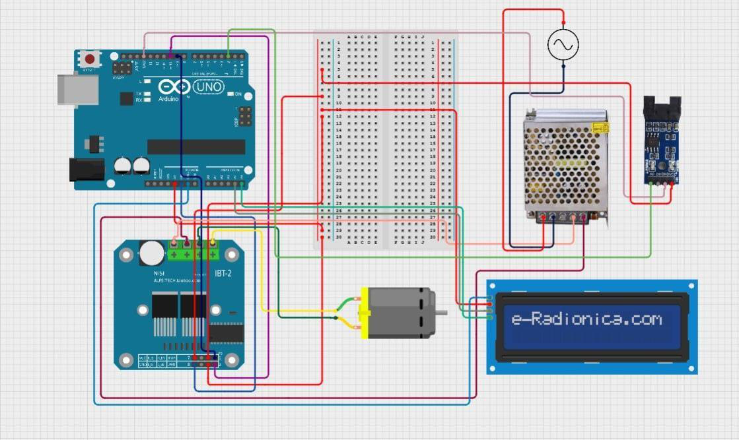
Fig: Circuit Diagram
Methodology:
• Motor Construction:
1. Rotor Assembly: A 8-inch, 7mm rod was used as the central component/shaft for constructing the rotor, providing structural integrity. The armature was constructed using PVC board and 3 windings per winding consisting 100 turns of the 26 gauge copper wire was achieved. Three commutators were crafted using copper sheets to regulate current flow in the coils, synchronizing and controlling the motor's movement. The coils were soldered in series to create a unified unit, enhancing current flow and optimizing motor performance.
2. Stator Construction: Two bearing rods were employed to support and stabilize the motor assembly, facilitating smooth rotation. Two powerful magnets were attached on each side strategically to interact with the coils, generating the necessary magnetic field for motor rotation. It was made sure that the magnet covered the whole armature windings.
• System setup:
The system consisted of a motor, a display to show the state and speed of the motor, a microcontroller to control all the logics for the system, a motor driver to control the motor rotation, an opto transducer used as a tachometer to reveal the motor speed and a bread board as a medium for wire connections.
• Speed Control (PWM):
The motor’s speed is controlled through Pulse Width Modulation (PWM), which adjusts the duty cycle of the signal sent to the motor. A higher duty cycle corresponds to more power and thus higher speed.

• Automation Using Website (Laravel):
The motor control is integrated with a Laravel-based website for remote operation. The website allows users to turn the motor on/off and adjust the speed through a user-friendly interface. The Laravel backend handles requests and communicate with the microcontroller or relay for motor control.
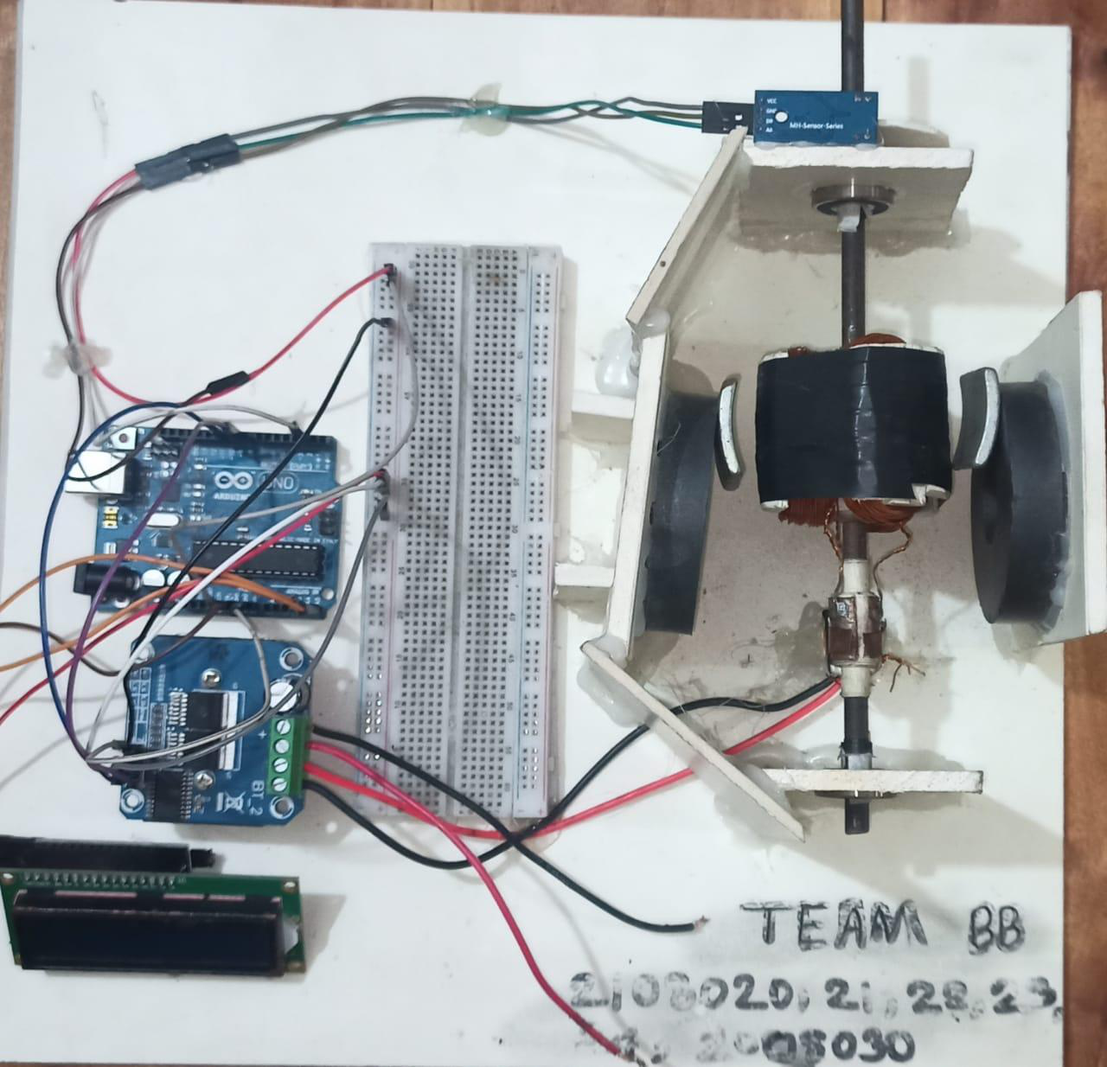
Fig: Full overview of the system
Working procedure:
The system consists of a Laravel-based website, an Arduino microcontroller, a motor driver module, and a DC motor. The main objective of the system is to control the motor's operations (start, stop, and speed control) remotely using a web interface. The Laravel-based website serves as the frontend where users can send commands, while the Arduino acts as the intermediary hardware that processes these commands and controls the motor driver module to operate the motor.
When a user accesses the Laravel-based web interface, they interact with various control buttons (e.g., start, stop, or set speed). Upon pressing a button, the website sends specific control signals (commands) to the Arduino microcontroller through a serial communication interface. For example, the website may send signals like START, STOP, or numerical values for speed control. The Laravel backend ensures that the commands are transmitted correctly to the serial port where the Arduino is connected.
The Arduino, upon receiving commands via the serial monitor, interprets these signals and sends appropriate outputs to the motor driver module. The motor driver module is responsible for powering the motor and controlling its behavior. For instance, when the Arduino receives a START command, it activates the motor driver to supply power to the motor, making it run. Similarly, a STOP command disables the motor driver, cutting off power and stopping the motor. For speed control, the Arduino uses Pulse Width Modulation (PWM) to vary the voltage supplied to the motor, thus adjusting its speed.

This entire system allows real-time control of the motor through the web interface, offering flexibility and ease of use. The integration of Laravel for the frontend, Arduino for processing, and the motor driver for hardware control ensures seamless communication between software and hardware components. The system demonstrates the effective use of web technology and microcontrollers to achieve remote motor control, making it suitable for various applications like automation, robotics, IOT based projects.
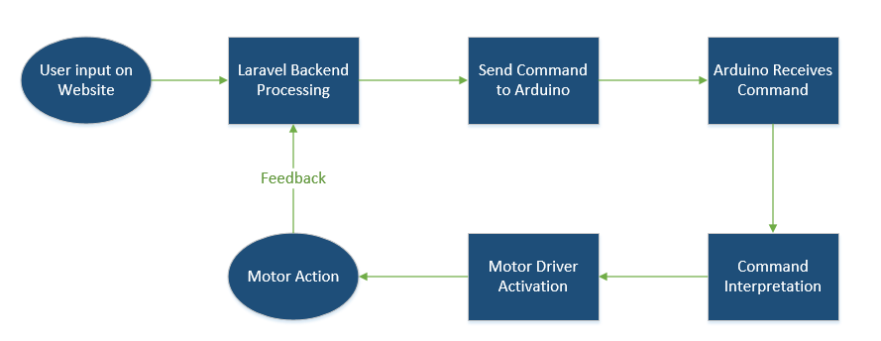
Fig: Control flow of the system

Fig: Frontend of the website

Final Cost Analysis:
Component Name | Quantity | Cost  (BDT)
Arduino Uno | (1 piece) | 650
Magnet | (2 pairs) | 150
Coper Wire (26 gauge) | (150 grams) | 200
Motor Driver | (1 piece) | 600
Power Supply | (1 piece) | 650
Shaft | (1 piece) | 10
Jumper Wires | (As necessary) | 20
Bread Board | (1 piece) | 70
PVC Board | (1 piece) | 170
16*2 LCD Display | (1 piece) | 250
Optical encoder speed sensor | (1 piece) | 130
Others |  | 100
Total |  | 3000
Outcome:
• The motor reliably turns on and off using the control system.
• Speed control is adjustable through smooth transitions, with the ability to vary
motor speed using PWM.
• The system operates efficiently, with minimal power loss and stable performance
under varying speeds.

Discussion:
The project design centers on the seamless integration of a DC motor with an appropriate motor driver, allowing for controlled and adjustable speed. The motor driver acts as an interface between the low- power control signals from a microcontroller and the high-power requirements of the DC motor. Various components, including transistors, MOSFETs, or integrated motor driver ICs, are evaluated for their suitability in terms of efficiency, cost, and simplicity.
Speed control is achieved using Pulse Width Modulation (PWM), which effectively modulates the average voltage supplied to the motor. This method offers precise control while minimizing energy loss. A microcontroller, such as an Arduino or similar platform, is programmed to generate PWM signals, which are fed into the motor driver. Testing the system under different load conditions highlights its responsiveness and stability. Data from these tests confirm that the designed system meets the desired specifications for speed control. Some challenges were occurred during this project such as calculating winding turns, high voltage issues, brush complications, coding & automation.
Conclusion:
This project effectively showcases the design and implementation of a DC motor and motor driver system with web-based speed control. Through the integration of a microcontroller-driven Pulse Width Modulation (PWM) technique, precise and efficient speed regulation was achieved. The results emphasize the significance of selecting appropriate components and employing robust control algorithms to optimize system performance.
This work highlights the potential of DC motor systems in a wide range of practical applications, establishing a foundation for further research into advanced motor control methods.

