[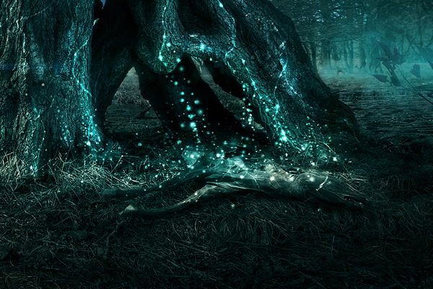](https://www.google.nl/url?sa=i&rct=j&q=&esrc=s&source=images&cd=&cad=rja&uact=8&ved=0ahUKEwi_1aeYzo3LAhUH6Q4KHWHfA-sQjRwIBw&url=https%3A%2F%2Fwww.behance.net%2Fgallery%2F4430067%2FMixed-Science-Fiction&bvm=bv.114733917,d.ZWU&psig=AFQjCNEeAt_i1YVS7GCdNCLLQ390O4FUQw&ust=1456307399430307)[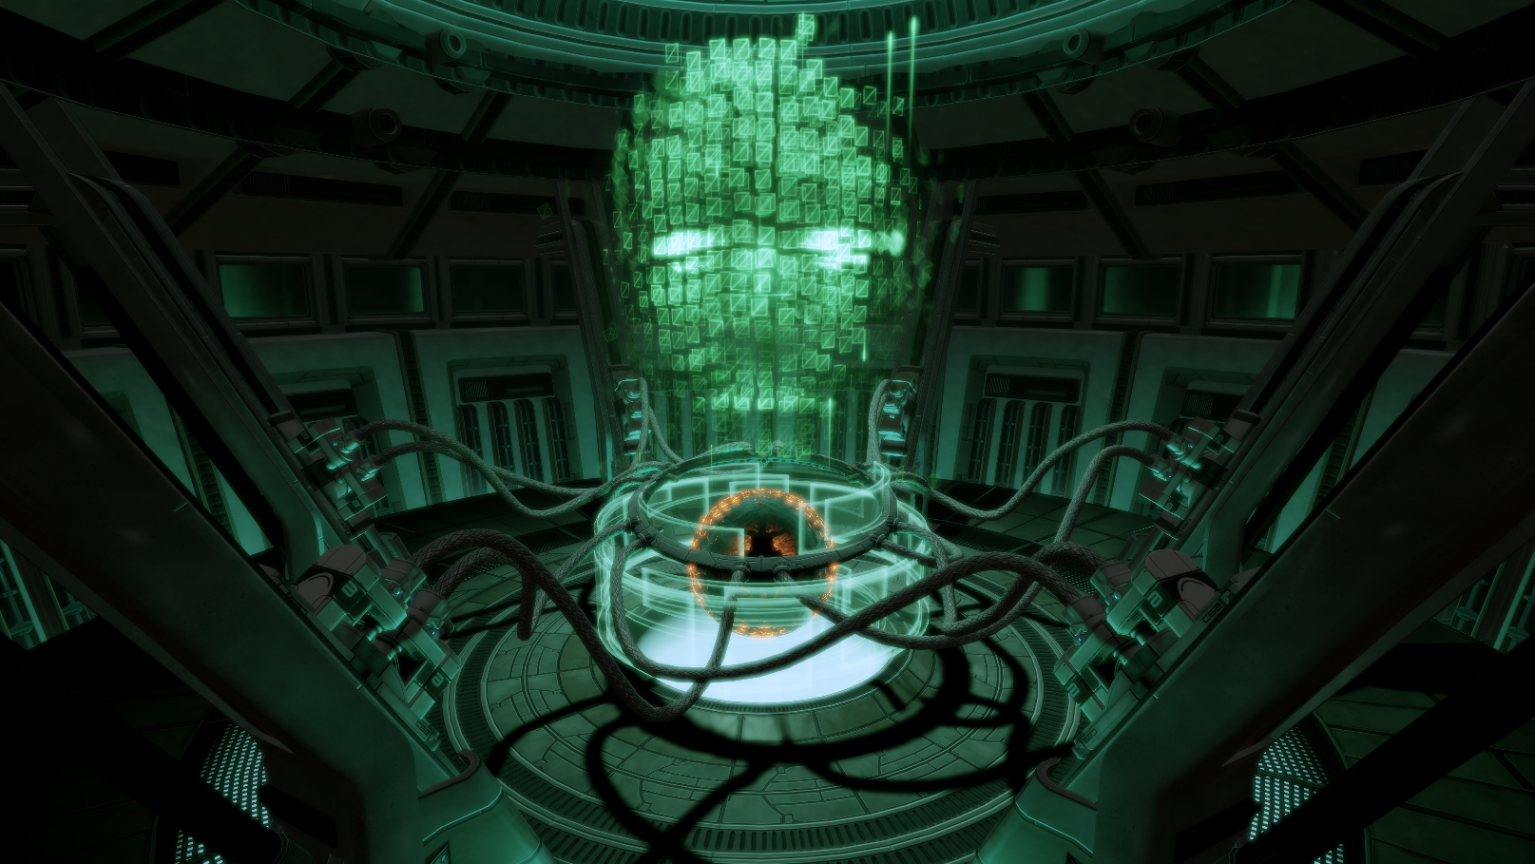](http://www.google.nl/url?sa=i&rct=j&q=&esrc=s&source=images&cd=&cad=rja&uact=8&ved=0ahUKEwjFnMbPzY3LAhVCRQ8KHVMMBFEQjRwIBw&url=http%3A%2F%2Fmasseffect.wikia.com%2Fwiki%2FOverlord%3A_Atlas_Station&bvm=bv.114733917,d.ZWU&psig=AFQjCNEf9Ujqdj546769AqMAgYSNu1WboQ&ust=1456307281016872)

[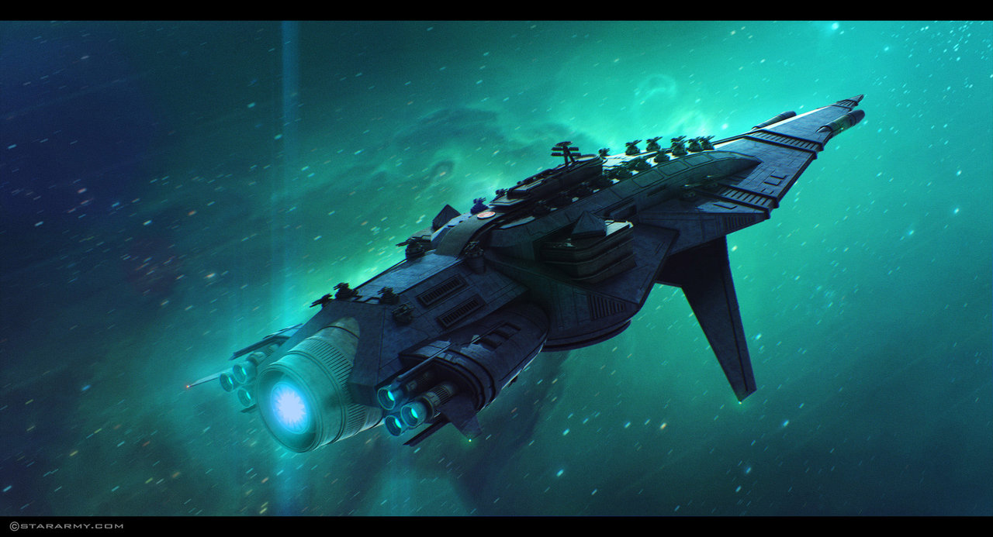](http://legacyofsol.wikidot.com/space-vessel)

[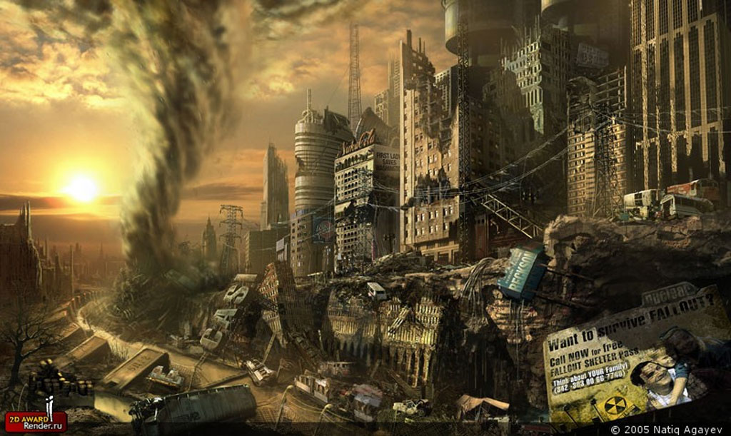](https://www.google.nl/url?sa=i&rct=j&q=&esrc=s&source=images&cd=&cad=rja&uact=8&ved=0ahUKEwi44-CfzI3LAhVIJw4KHZW9B-0QjRwIBw&url=https%3A%2F%2Fwww.darkmoon.me%2F2012%2Famerica-in-ruins-by-john-kaminski%2F&psig=AFQjCNFLXtTIK5Cd_H7v22rzNJvVl_Qoxg&ust=1456306913395099)