Ifogponic



i-Fogponic — Tumbuh Canggih di Rumahmu
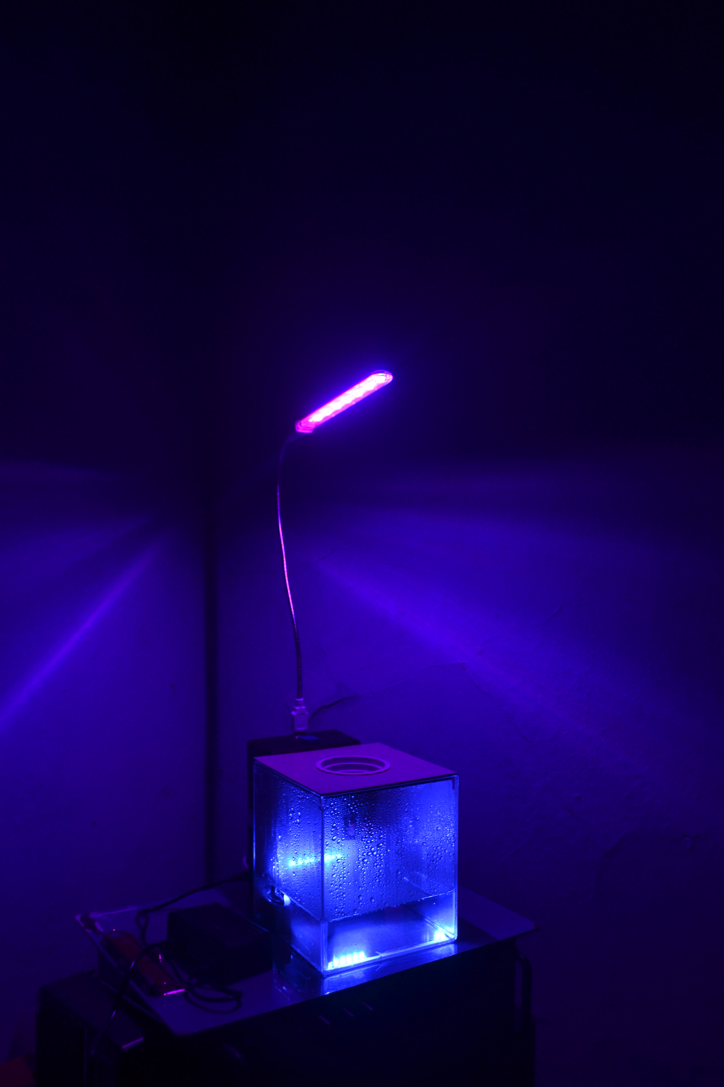

Biaya Produksi Rata - Rata

Harga Per Komponen
Komponen | Harga (Rp)
Netpot T6 Multi | Rp550
TDS Sensor Meter V1.0 | Rp92.500
LM2596 LOW RIPPLE 3A Step down 5V (2x Rp25.000) | Rp50.000
PCB USB Female 2.0 to DIP Adapter | Rp1.790
Waterproof Outdoor Adaptor 3A | Rp39.999
Mesin Kabut Mist Maker Humidifier Ultrasonic Stenlis | Rp39.250
SOCKET SOKET DC MUR 2.1X5.5MM | Rp1.000
8 BIT WS2812B 5050 RGB | Rp5.800
MODULE DHT11 SENSOR | Rp9.900
BOX ELEKTRONIK X5 | Rp12.000
RELAY 5V 2 CHANNEL | Rp14.900
RTC DS3231 SERI SN | Rp26.900
ESP-32S DEVELOPMENT BOARD | Rp65.000
Kotak akrilik serbaguna 13x13x14cm | Rp34.000
Grow Light LED Full Color Spectrum 10W - FE02 | Rp28.000

Biaya Tambahan
Item | Harga (Rp)
Kabel | Rp2.500
Lem | Rp2.500
Timah | Rp1.000
PVC | Rp5.000
Sekrup | Rp1.200

Total Biaya Produksi
Total biaya produksi satu unit adalah Rp433.789

Biaya Produksi + Ongkir Yang Saya Dapat

Harga Komponen + Ongkir
Komponen | Harga (Rp)
Netpot T6 Multi | Rp3.174
TDS Sensor Meter V1.0 | Rp93.836
2x LM2596 LOW RIPPLE 3A Step down 5V | Rp53.344
PCB USB Female 2.0 to DIP Adapter | Rp1.627
Waterproof Outdoor Adaptor 3A | Rp39.784
Mesin Kabut Mist Maker Humidifier Ultrasonic Stenlis | Rp35.579
SOCKET SOKET DC MUR 2.1X5.5MM | Rp1.000
8 BIT WS2812B 5050 RGB LED | Rp5.800
MODULE DHT11 SENSOR | Rp9.900
BOX ELEKTRONIK X5 | Rp12.000
RELAY 5V 2 CHANNEL | Rp14.900
RTC DS3231 SERI SN | Rp26.900
ESP-32S DEVELOPMENT BOARD | Rp65.000
Kotak akrilik serbaguna 13x13x14cm | Rp34.849
Grow Light LED Full Color Spectrum 10W - FE02 | Rp29.048

Biaya Tambahan
Item | Harga (Rp)
Kabel | Rp2.500
Lem | Rp2.500
Timah | Rp1.000
PVC | Rp5.000
Sekrup | Rp1.200

Total Biaya Produksi
Total biaya produksi satu unit adalah Rp438.941

Daftar Barang
Kotak Akrilik -> https://shopee.co.id/kotak-akrilik-serbaguna-13x13x14cm-i.271484547.28459943679
Grow Light -> https://shopee.co.id/TC-LMP-FENGLAIYI-Lampu-Cahaya-Tanaman-Grow-Light-LED-Full-Color-Spectrum-10W-FE02-i.21063728.23028753894
Adaptor -> https://shopee.co.id/waterproof-outdoor-adaptor-charger-24v-1a-2a-3a-psu-power-supply-trafo-box-24-volt-1-2-3-ampere-kabel-mist-maker-poe-switch-universal-Taiwan-AC-dc-i.36709567.18080933921
Humidifier -> https://shopee.co.id/Mesin-Kabut-Mist-Maker-Humidifier-Ultrasonic-Stenlis-i.190217140.6208503240
DC Soket -> https://shopee.co.id/SOCKET-SOKET-DC-MUR-2.1X5.5MM-PANEL-MOUNT-FEMALE-POWER-SUPPLY-BULAT-i.62956347.3628566752
RGB Light -> https://shopee.co.id/8-BIT-WS2812B-5050-RGB-LED-DRIVER-BOARD-FULL-COLOR-5V-RAINBOW-WS2812B-i.62956347.3916969352
DHT11 -> https://shopee.co.id/MODULE-DHT11-SENSOR-SUHU-DAN-KELEMBABAN-HUMIDITY-SENSOR-i.62956347.4811619012
Box X5 -> https://shopee.co.id/BOX-ELEKTRONIK-X5-KOTAK-RANGKAIAN-ARDUINO-14-5-X-9-5-X-5-CM-i.62956347.5814502958
Relay -> https://shopee.co.id/RELAY-5V-2-CHANNEL-OUTPUT-250VAC-30VDC-10A-WITH-OPTOCUPLER-MODULE-FOR-ARDUINO-UNO-MEGA-RASPBERRY-PI-i.62956347.6709658450
RTC DS3231 -> https://shopee.co.id/RTC-DS3231-SERI-SN-REAL-TIME-CLOCK-I2C-BATTERY-MODULE-MODUL-DS3231SN-i.62956347.7309663812
ESP 32 -> https://shopee.co.id/ESP32-ESP-32-DOIT-WIFI-BLUETOOTH-IOT-ESP-32S-DEVELOPMENT-BOARD-i.62956347.7287068642
Step Down 5V -> https://www.tokopedia.com/rajacell/lm2596-low-ripple-3a-step-down-3-3v-5v-12v-fix-and-adjustable-out-buck-converter-stepdown-fix-5v-18ab5
Netpot https://www.tokopedia.com/anekahidroponik/aneka-netpot-hidroponik-berbagai-ukuran-putih-netpot-t6-multi
TDS Sensor -> https://www.tokopedia.com/xyzhobby/tds-sensor-meter-v1-0-sensor-pengukur-kualitas-air-measuring-water-quality-for-arudino

