Nama : Fahrozi Aldinata (2202267)
Kelas : 22S03
Matkul : Android Studio
Kalkulator
Kode
- Activity_main.xml
<?xml version="1.0" encoding="utf-8"?>
<LinearLayout xmlns:android="http://schemas.android.com/apk/res/android"
android:orientation="vertical"
android:layout_width="match_parent"
android:layout_height="match_parent"
android:padding="16dp"
android:background="#f2f2f2">
<!-- Display hasil/input -->
<TextView
android:id="@+id/display"
android:layout_width="match_parent"
android:layout_height="80dp"
android:background="#ffffff"
android:text="@string/display_default"
android:textSize="32sp"
android:gravity="end|center_vertical"
android:padding="16dp"
android:textColor="#000000" />
<!-- Grid tombol kalkulator -->
<GridLayout
android:id="@+id/gridLayout"
android:layout_width="match_parent"
android:layout_height="wrap_content"
android:layout_marginTop="16dp"
android:columnCount="4"
android:rowCount="5"
android:alignmentMode="alignMargins"
android:useDefaultMargins="true">
<!-- Baris 1 -->
<Button android:id="@+id/btnC" android:text="@string/btn_c"/>
<Button android:id="@+id/btnDel" android:text="@string/btn_delete"/>
<Button android:id="@+id/btnPersen" android:text="@string/btn_percent"/>
<Button android:id="@+id/btnBagi" android:text="@string/btn_divide"/>
<!-- Baris 2 -->
<Button android:id="@+id/btn7" android:text="@string/btn_7"/>
<Button android:id="@+id/btn8" android:text="@string/btn_8"/>
<Button android:id="@+id/btn9" android:text="@string/btn_9"/>
<Button android:id="@+id/btnKali" android:text="@string/btn_multiply"/>
<!-- Baris 3 -->
<Button android:id="@+id/btn4" android:text="@string/btn_4"/>
<Button android:id="@+id/btn5" android:text="@string/btn_5"/>
<Button android:id="@+id/btn6" android:text="@string/btn_6"/>
<Button android:id="@+id/btnKurang" android:text="@string/btn_subtract"/>
<!-- Baris 4 -->
<Button android:id="@+id/btn1" android:text="@string/btn_1"/>
<Button android:id="@+id/btn2" android:text="@string/btn_2"/>
<Button android:id="@+id/btn3" android:text="@string/btn_3"/>
<Button android:id="@+id/btnTambah" android:text="@string/btn_add"/>
<!-- Baris 5 -->
<Button android:id="@+id/btnAkar" android:text="@string/btn_root"/>
<Button android:id="@+id/btn0" android:text="@string/btn_0"/>
<Button android:id="@+id/btnKoma" android:text="@string/btn_comma"/>
<Button android:id="@+id/btnSamaDengan" android:text="@string/btn_equal"/>
</GridLayout>
</LinearLayout>

- MainActivity.Java
package com.example.kalkulator;
import android.os.Bundle;
import android.view.View;
import android.widget.Button;
import android.widget.TextView;
import androidx.appcompat.app.AppCompatActivity;
public class MainActivity extends AppCompatActivity {
private TextView display;
private String currentInput = "";
private String previousInput = "";
private String operator = "";
private boolean isNewInput = true;
@Override
protected void onCreate(Bundle savedInstanceState) {
super.onCreate(savedInstanceState);
setContentView(R.layout.activity_main);
display = findViewById(R.id.display);
// Tombol angka
Button btn0 = findViewById(R.id.btn0);
Button btn1 = findViewById(R.id.btn1);
Button btn2 = findViewById(R.id.btn2);
Button btn3 = findViewById(R.id.btn3);
Button btn4 = findViewById(R.id.btn4);
Button btn5 = findViewById(R.id.btn5);
Button btn6 = findViewById(R.id.btn6);
Button btn7 = findViewById(R.id.btn7);
Button btn8 = findViewById(R.id.btn8);
Button btn9 = findViewById(R.id.btn9);
// Tombol operator
Button btnAdd = findViewById(R.id.btnTambah);
Button btnSubtract = findViewById(R.id.btnKurang);
Button btnMultiply = findViewById(R.id.btnKali);
Button btnDivide = findViewById(R.id.btnBagi);
// Tombol lainnya
Button btnC = findViewById(R.id.btnC);
Button btnDelete = findViewById(R.id.btnDel);
Button btnEqual = findViewById(R.id.btnSamaDengan);
Button btnPercent = findViewById(R.id.btnPersen);
Button btnRoot = findViewById(R.id.btnAkar);
// Listener tombol angka
View.OnClickListener numberClickListener = v -> {
Button button = (Button) v;
if (isNewInput) {
currentInput = button.getText().toString();
isNewInput = false;
} else {
currentInput += button.getText().toString();
}
display.setText(currentInput);
};
btn0.setOnClickListener(numberClickListener);
btn1.setOnClickListener(numberClickListener);
btn2.setOnClickListener(numberClickListener);
btn3.setOnClickListener(numberClickListener);
btn4.setOnClickListener(numberClickListener);
btn5.setOnClickListener(numberClickListener);
btn6.setOnClickListener(numberClickListener);
btn7.setOnClickListener(numberClickListener);
btn8.setOnClickListener(numberClickListener);
btn9.setOnClickListener(numberClickListener);
// Listener tombol operator
View.OnClickListener operatorClickListener = v -> {
Button button = (Button) v;
if (!currentInput.isEmpty()) {
previousInput = currentInput;
currentInput = "";
operator = button.getText().toString();
display.setText(getString(R.string.operator_display, previousInput, operator));
}
};
btnAdd.setOnClickListener(operatorClickListener);
btnSubtract.setOnClickListener(operatorClickListener);
btnMultiply.setOnClickListener(operatorClickListener);
btnDivide.setOnClickListener(operatorClickListener);
// Tombol reset
btnC.setOnClickListener(v -> {
currentInput = "";
previousInput = "";
operator = "";
display.setText(getString(R.string.display_default));
isNewInput = true;
});
// Tombol hapus satu karakter
btnDelete.setOnClickListener(v -> {
if (!currentInput.isEmpty()) {
currentInput = currentInput.substring(0, currentInput.length() - 1);
display.setText(currentInput);
}
});
// Tombol persen
btnPercent.setOnClickListener(v -> {
if (!currentInput.isEmpty()) {
double value = Double.parseDouble(currentInput);
currentInput = String.valueOf(value / 100);
display.setText(currentInput);
}
});
// Tombol akar
btnRoot.setOnClickListener(v -> {
if (!currentInput.isEmpty()) {
double value = Double.parseDouble(currentInput);
currentInput = String.valueOf(Math.sqrt(value));
display.setText(currentInput);
}
});
// Tombol sama dengan
btnEqual.setOnClickListener(v -> {
if (!currentInput.isEmpty() && !previousInput.isEmpty()) {
double num1 = Double.parseDouble(previousInput);
double num2 = Double.parseDouble(currentInput);
double result = 0;
boolean valid = true;
switch (operator) {
case "+":
result = num1 + num2;
break;
case "-":
result = num1 - num2;
break;
case "x":
result = num1 * num2;
break;
case "÷":
if (num2 != 0) {
result = num1 / num2;
} else {
display.setText(getString(R.string.error_divide_by_zero));
valid = false;
}
break;
}
if (valid) {
String formattedResult = formatResult(result);
display.setText(getString(R.string.operation_result_format,
previousInput, operator, currentInput, formattedResult));
currentInput = formattedResult;
previousInput = "";
operator = "";
isNewInput = true;
}
}
});
}
private String formatResult(double result) {
if (result == (long) result) {
return String.format("%d", (long) result);
} else {
return String.format("%s", result);
}
}
}

- String.xml
<resources>
<string name="app_name">Kalkulator</string>
<string name="display_default">0</string>
<string name="btn_c">C</string>
<string name="btn_delete">Delete</string>
<string name="btn_percent">%</string>
<string name="btn_divide">÷</string>
<string name="btn_multiply">x</string>
<string name="btn_subtract">-</string>
<string name="btn_add">+</string>
<string name="btn_equal">=</string>
<string name="btn_comma">,</string>
<string name="btn_root">√</string>
<string name="btn_7">7</string> <!-- Added numeric values as strings -->
<string name="btn_8">8</string>
<string name="btn_9">9</string>
<string name="btn_4">4</string>
<string name="btn_5">5</string>
<string name="btn_6">6</string>
<string name="btn_1">1</string>
<string name="btn_2">2</string>
<string name="btn_3">3</string>
<string name="btn_0">0</string>
<string name="operator_display">%1$s %2$s</string>
<string name="operation_result_format">%1$s %2$s %3$s = %4$s</string>
<string name="error_divide_by_zero">Error: ÷0</string>
</resources>

Ouput
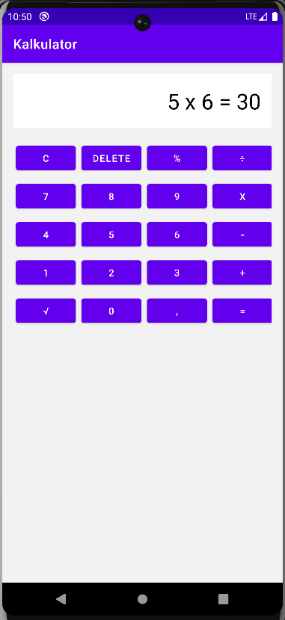
Intent
Kode
- Activity_main.xml
<?xml version="1.0" encoding="utf-8"?>
<LinearLayout
xmlns:android="http://schemas.android.com/apk/res/android"
android:layout_width="match_parent"
android:layout_height="match_parent"
android:orientation="vertical"
android:padding="16dp">
<EditText
android:id="@+id/editUsername"
android:layout_width="match_parent"
android:layout_height="wrap_content"
android:hint="@string/hint_username"
android:inputType="text"
android:autofillHints="username"/>
<EditText
android:id="@+id/editPassword"
android:layout_width="match_parent"
android:layout_height="wrap_content"
android:hint="@string/hint_password"
android:inputType="textPassword"
android:autofillHints="password"/>
<Button
android:id="@+id/btnLogin"
android:layout_width="match_parent"
android:layout_height="wrap_content"
android:text="@string/btn_login"/>
</LinearLayout>

- MainActivity.Java
package com.example.intent;
import android.content.Intent;
import android.os.Bundle;
import android.widget.Button;
import android.widget.EditText;
import android.widget.Toast;
import androidx.appcompat.app.AppCompatActivity;
public class MainActivity extends AppCompatActivity {
EditText editUsername, editPassword;
Button btnLogin;
@Override
protected void onCreate(Bundle savedInstanceState) {
super.onCreate(savedInstanceState);
setContentView(R.layout.activity_main);
editUsername = findViewById(R.id.editUsername);
editPassword = findViewById(R.id.editPassword);
btnLogin = findViewById(R.id.btnLogin);
btnLogin.setOnClickListener(v -> {
String username = editUsername.getText().toString().trim();
String password = editPassword.getText().toString().trim();
if (username.isEmpty() || password.isEmpty()) {
Toast.makeText(this, "Username dan Password harus diisi!", Toast.LENGTH_SHORT).show();
return;
}
Intent intent = new Intent(MainActivity.this, MainActivity2.class);
intent.putExtra("USERNAME", username);
intent.putExtra("PASSWORD", password);
startActivity(intent);
});
}
}

- Activity_main2.xml
<?xml version="1.0" encoding="utf-8"?>
<LinearLayout
xmlns:android="http://schemas.android.com/apk/res/android"
android:layout_width="match_parent"
android:layout_height="match_parent"
android:orientation="vertical"
android:padding="16dp">
<TextView
android:id="@+id/txtUsername"
android:layout_width="match_parent"
android:layout_height="wrap_content"
android:text="@string/label_username"
android:textSize="18sp"/>
<TextView
android:id="@+id/txtPassword"
android:layout_width="match_parent"
android:layout_height="wrap_content"
android:text="@string/label_password"
android:textSize="18sp"/>
</LinearLayout>

- MainActivity2.java
package com.example.intent;
import android.os.Bundle;
import android.widget.TextView;
import androidx.appcompat.app.AppCompatActivity;
public class MainActivity2 extends AppCompatActivity {
@Override
protected void onCreate(Bundle savedInstanceState) {
super.onCreate(savedInstanceState);
setContentView(R.layout.activity_main2);
TextView txtUsername = findViewById(R.id.txtUsername);
TextView txtPassword = findViewById(R.id.txtPassword);
// Ambil data dari Intent
String username = getIntent().getStringExtra("USERNAME");
String password = getIntent().getStringExtra("PASSWORD");
// Set default jika null
if (username == null) username = "Unknown User";
if (password == null) password = "No Password";
// Menggunakan string resource dengan placeholder
txtUsername.setText(getString(R.string.username_label, username));
txtPassword.setText(getString(R.string.password_label, password));
}
}

- Androidmanifest.xml
<?xml version="1.0" encoding="utf-8"?>
<manifest xmlns:android="http://schemas.android.com/apk/res/android">
<application
android:allowBackup="true"
android:icon="@mipmap/ic_launcher"
android:label="@string/app_name"
android:theme="@style/Theme.Intent">
<activity android:name=".MainActivity2" android:exported="true"/>
<activity android:name=".MainActivity" android:exported="true">
<intent-filter>
<action android:name="android.intent.action.MAIN"/>
<category android:name="android.intent.category.LAUNCHER"/>
</intent-filter>
</activity>
</application>
</manifest>

- String.xml
<resources>
<string name="app_name">Aplikasi Login</string>
<string name="hint_username">Masukkan Username</string>
<string name="hint_password">Masukkan Password</string>
<string name="btn_login">Login</string>
<string name="label_username">Username:</string>
<string name="label_password">Password:</string>
<string name="username_label">Username: %s</string>
<string name="password_label">Password: %s</string>
</resources>

Output
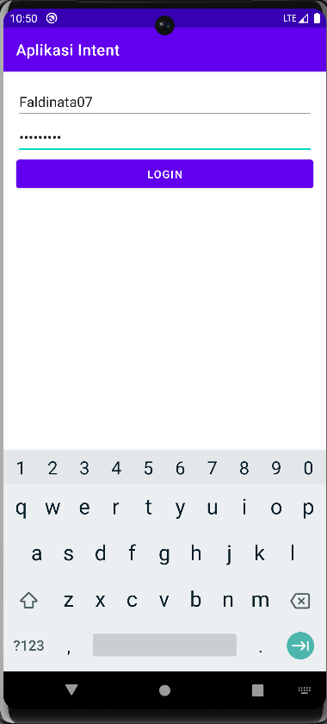
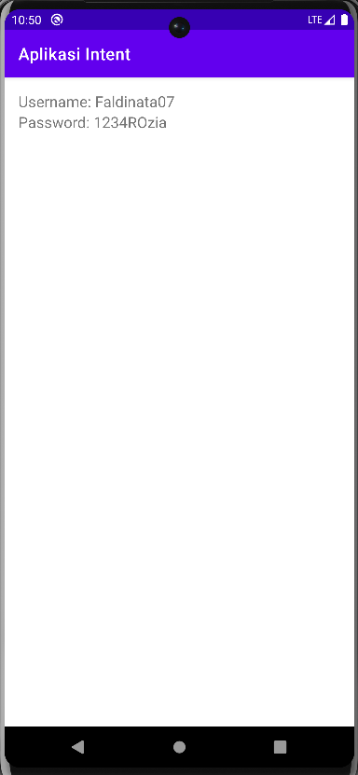

List View
- Activity_main.xml
<?xml version="1.0" encoding="utf-8"?>
<LinearLayout xmlns:android="http://schemas.android.com/apk/res/android"
xmlns:tools="http://schemas.android.com/tools"
android:layout_width="match_parent"
android:layout_height="match_parent"
tools:context=".MainActivity">
<ListView
android:id="@+id/list"
android:layout_width="match_parent"
android:layout_height="match_parent"/>
</LinearLayout>

- Androidmanifest.xml
<?xml version="1.0" encoding="utf-8"?>
<manifest xmlns:android="http://schemas.android.com/apk/res/android"
xmlns:tools="http://schemas.android.com/tools">
<application
android:allowBackup="true"
android:dataExtractionRules="@xml/data_extraction_rules"
android:fullBackupContent="@xml/backup_rules"
android:icon="@mipmap/ic_launcher"
android:roundIcon="@mipmap/ic_launcher_round"
android:supportsRtl="true"
android:theme="@style/Theme.List_view"
tools:targetApi="31">
<activity
android:name=".MainActivity"
android:exported="true">
<intent-filter>
<action android:name="android.intent.action.MAIN" />
<category android:name="android.intent.category.LAUNCHER" />
</intent-filter>
</activity>
</application>
</manifest>

- MainActivity.java
package com.example.list_view;
import androidx.appcompat.app.AppCompatActivity;
import android.os.Bundle;
import android.widget.ArrayAdapter;
import android.widget.ListView;
public class MainActivity extends AppCompatActivity {
@Override
protected void onCreate(Bundle savedInstanceState) {
super.onCreate(savedInstanceState);
setContentView(R.layout.activity_main);
ListView listView = findViewById(R.id.list);
String[] tutorials = {
"Algoritma", "Struktur Data", "Basis Data",
"Pemrograman Berbasis Mobile 2", "Web 2", "Metodologi Penelitian",
"Pemrograman Berbasis Mobile 1", "Web 1", "Bahasa Pemrograman 1"
};
ArrayAdapter<String> adapter = new ArrayAdapter<>(
this,
android.R.layout.simple_list_item_1,
tutorials
);
listView.setAdapter(adapter);
}
}

Output
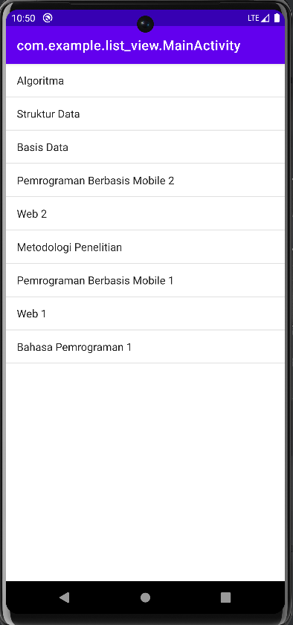

Broadcast
- Activity_main.xml
<?xml version="1.0" encoding="utf-8"?>
<LinearLayout xmlns:android="http://schemas.android.com/apk/res/android"
android:layout_width="match_parent"
android:layout_height="match_parent"
android:gravity="center"
android:orientation="vertical"
android:padding="24dp">
<Button
android:id="@+id/btnNotif"
android:layout_width="wrap_content"
android:layout_height="wrap_content"
android:text="@string/tampilkan_notifikasi"
android:layout_gravity="center"
android:layout_marginTop="50dp"/>
</LinearLayout>

- Androidmanifest.xml
<?xml version="1.0" encoding="utf-8"?>
<manifest xmlns:android="http://schemas.android.com/apk/res/android"
xmlns:tools="http://schemas.android.com/tools">
<uses-permission android:name="android.permission.POST_NOTIFICATIONS" />
<application
android:allowBackup="true"
android:dataExtractionRules="@xml/data_extraction_rules"
android:fullBackupContent="@xml/backup_rules"
android:icon="@mipmap/ic_launcher"
android:label="@string/app_name"
android:roundIcon="@mipmap/ic_launcher_round"
android:supportsRtl="true"
android:theme="@style/Theme.Broadcast_Fahrozi"
tools:targetApi="31">
<activity
android:name=".MainActivity"
android:exported="true">
<intent-filter>
<action android:name="android.intent.action.MAIN"/>
<category android:name="android.intent.category.LAUNCHER"/>
</intent-filter>
</activity>
</application>
</manifest>

- MainActivity.java
package com.example.broadcast_fahrozi;
import android.app.NotificationChannel;
import android.app.NotificationManager;
import android.app.PendingIntent;
import android.content.Intent;
import android.os.Build;
import android.os.Bundle;
import android.widget.Button;
import android.widget.Toast;
import android.content.pm.PackageManager;
import androidx.appcompat.app.AppCompatActivity;
import androidx.core.app.NotificationCompat;
public class MainActivity extends AppCompatActivity {
private static final String CHANNEL_ID = "notif_channel_id";
@Override
protected void onCreate(Bundle savedInstanceState) {
super.onCreate(savedInstanceState);
setContentView(R.layout.activity_main);
// ✅ Minta permission notifikasi jika API >= 33
if (Build.VERSION.SDK_INT >= Build.VERSION_CODES.TIRAMISU) {
if (checkSelfPermission(android.Manifest.permission.POST_NOTIFICATIONS)
!= PackageManager.PERMISSION_GRANTED) {
requestPermissions(new String[]{android.Manifest.permission.POST_NOTIFICATIONS}, 1);
}
}
createNotificationChannel();
Button btnNotif = findViewById(R.id.btnNotif);
btnNotif.setOnClickListener(v -> {
showNotification();
Toast.makeText(this, "Notifikasi Muncul", Toast.LENGTH_SHORT).show(); // ✅ Toast ditambahkan
});
}
private void createNotificationChannel() {
if (Build.VERSION.SDK_INT >= Build.VERSION_CODES.O) {
CharSequence name = "Notifikasi Channel";
String description = "Channel untuk notifikasi demo";
int importance = NotificationManager.IMPORTANCE_DEFAULT;
NotificationChannel channel = new NotificationChannel(CHANNEL_ID, name, importance);
channel.setDescription(description);
NotificationManager notificationManager = getSystemService(NotificationManager.class);
notificationManager.createNotificationChannel(channel);
}
}
private void showNotification() {
Intent intent = new Intent(this, MainActivity.class);
PendingIntent pendingIntent = PendingIntent.getActivity(
this, 0, intent, PendingIntent.FLAG_UPDATE_CURRENT | PendingIntent.FLAG_IMMUTABLE);
NotificationCompat.Builder builder = new NotificationCompat.Builder(this, CHANNEL_ID)
.setSmallIcon(R.drawable.ic_launcher_foreground)
.setContentTitle("Notifikasi Aktif")
.setContentText("Kamu menekan tombol notifikasi!")
.setPriority(NotificationCompat.PRIORITY_DEFAULT)
.setContentIntent(pendingIntent)
.setAutoCancel(true);
NotificationManager notificationManager =
(NotificationManager) getSystemService(NOTIFICATION_SERVICE);
notificationManager.notify(1, builder.build());
}
}

- String.xml
<resources>
<string name="app_name">Broadcast Fahrozi</string>
<string name="tampilkan_notifikasi">Tampilkan Notifikasi</string>
</resources>

Output
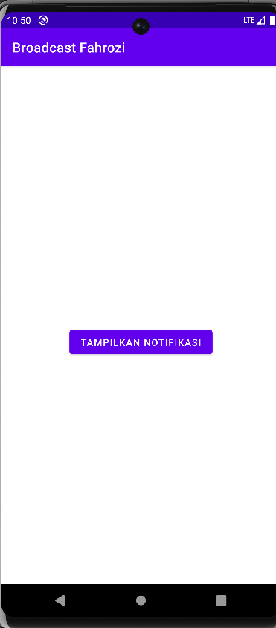
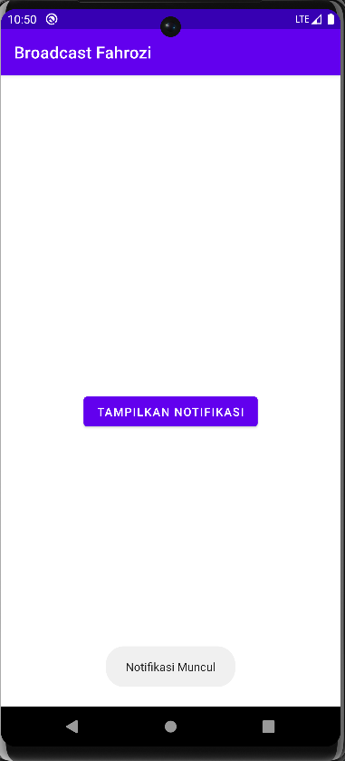
Shared References
Kode
- Activity_main.xml
- <?xml version="1.0" encoding="utf-8"?>
<androidx.constraintlayout.widget.ConstraintLayout xmlns:android="http://schemas.android.com/apk/res/android"
xmlns:app="http://schemas.android.com/apk/res-auto"
xmlns:tools="http://schemas.android.com/tools"
android:id="@+id/main"
android:layout_width="match_parent"
android:layout_height="match_parent"
tools:context=".MainActivity">
<EditText
android:id="@+id/editName"
android:layout_width="0dp"
android:layout_height="wrap_content"
android:hint="@string/hint_name"
android:inputType="textPersonName"
android:autofillHints="name"
android:padding="12dp"
app:layout_constraintTop_toTopOf="parent"
app:layout_constraintStart_toStartOf="parent"
app:layout_constraintEnd_toEndOf="parent"
android:layout_margin="16dp" />
<Button
android:id="@+id/btnSave"
android:layout_width="wrap_content"
android:layout_height="wrap_content"
android:text="@string/btn_save"
app:layout_constraintTop_toBottomOf="@id/editName"
app:layout_constraintStart_toStartOf="parent"
app:layout_constraintEnd_toEndOf="parent"
android:layout_marginTop="16dp" />
<TextView
android:id="@+id/textOutput"
android:layout_width="0dp"
android:layout_height="wrap_content"
android:text="@string/text_output"
android:textSize="18sp"
android:textStyle="bold"
android:gravity="center"
android:padding="16dp"
app:layout_constraintTop_toBottomOf="@id/btnSave"
app:layout_constraintStart_toStartOf="parent"
app:layout_constraintEnd_toEndOf="parent" />
</androidx.constraintlayout.widget.ConstraintLayout>
- MainActivity.Java
- package com.example.shared_reference;
import android.content.SharedPreferences;
import android.os.Bundle;
import android.widget.Button;
import android.widget.EditText;
import android.widget.TextView;
import androidx.activity.EdgeToEdge;
import androidx.appcompat.app.AppCompatActivity;
import androidx.core.graphics.Insets;
import androidx.core.view.ViewCompat;
import androidx.core.view.WindowInsetsCompat;
public class MainActivity extends AppCompatActivity {
private static final String PREF_NAME = "MyPrefs";
private static final String KEY_NAME = "username";
@Override
protected void onCreate(Bundle savedInstanceState) {
super.onCreate(savedInstanceState);
EdgeToEdge.enable(this);
setContentView(R.layout.activity_main);
ViewCompat.setOnApplyWindowInsetsListener(findViewById(R.id.main), (v, insets) -> {
Insets systemBars = insets.getInsets(WindowInsetsCompat.Type.systemBars());
v.setPadding(systemBars.left, systemBars.top, systemBars.right, systemBars.bottom);
return insets;
});
// Dapatkan referensi view
EditText editName = findViewById(R.id.editName);
Button btnSave = findViewById(R.id.btnSave);
TextView textOutput = findViewById(R.id.textOutput);
SharedPreferences sharedPref = getSharedPreferences(PREF_NAME, MODE_PRIVATE);
String savedName = sharedPref.getString(KEY_NAME, getString(R.string.no_name));
// Gunakan string dengan placeholder
textOutput.setText(getString(R.string.hello_name, savedName));
btnSave.setOnClickListener(v -> {
String name = editName.getText().toString();
sharedPref.edit().putString(KEY_NAME, name).apply();
textOutput.setText(getString(R.string.hello_name, name));
});
}
}

- Androidmanifest.xml

<?xml version="1.0" encoding="utf-8"?>
<manifest xmlns:android="http://schemas.android.com/apk/res/android"
xmlns:tools="http://schemas.android.com/tools">
<application
android:allowBackup="true"
android:dataExtractionRules="@xml/data_extraction_rules"
android:fullBackupContent="@xml/backup_rules"
android:icon="@mipmap/ic_launcher"
android:label="@string/app_name"
android:roundIcon="@mipmap/ic_launcher_round"
android:supportsRtl="true"
android:theme="@style/Theme.Shared_Reference"
tools:targetApi="31">
<activity
android:name=".MainActivity"
android:exported="true">
<intent-filter>
<action android:name="android.intent.action.MAIN" />
<category android:name="android.intent.category.LAUNCHER" />
</intent-filter>
</activity>
</application>
</manifest>

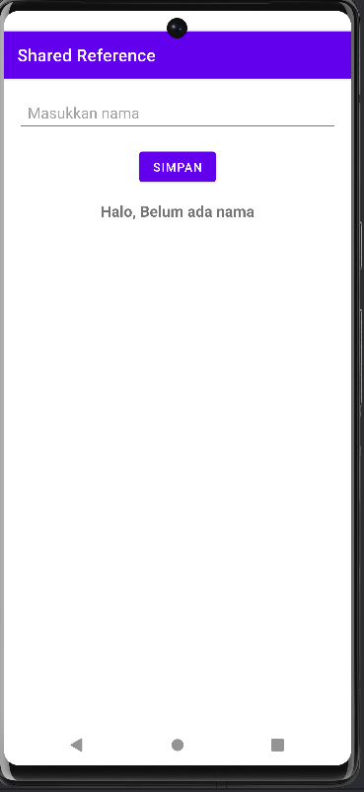
Output
