

**Assignment-1**

**Submitted to**

Mirza M. Ferdous (Mzf)

Lecturer

Department of Finance and Accounting

**Submitted by**

|  |  |
| --- | --- |
| **Name** | **ID** |
| Mohammad Faiaz Tawsif | 2012870030 |
| Mashiat Rahman | 1921018030 |
| MD. Istiaque Warese | 2021866630 |
| Jumana Hossain Mim | 2021410630 |
| MD Ashikur Rahman Bhuiyan | 2021430630 |

**Research the current, capital & financial accounts for Bangladesh. Interpret the statements and discuss the balance of trade and the BOP for Bangladesh. How have they changed over the last 5 years? How has our GDP grown and what are the contributing factors to this growth? In which sectors are we realizing the highest growth in our economy?**

**Balance of Trade:** The balance of trade refers to the difference between a country's exports and imports of goods. Bangladesh's balance of trade has been in deficit for many years, meaning the country has been importing more goods than it exports.

|  |  |
| --- | --- |
| **Year** | **Balance of Trade** |
| 12/31/2016 | -9.261363273 Billion US $ |
| 12/31/2017 | -12.80839845 Billion US $ |
| 12/31/2018 | -23.02698648 Billion US $ |
| 12/31/2019 | -18.92662313 Billion US $ |
| 12/31/2020 | -20.13788695 Billion US $ |
| 12/31/2021 | -26.63449135 Billion US $ |

According to the World Bank, Bangladesh imports increased from $17.4 billion in 2016 to 2021.

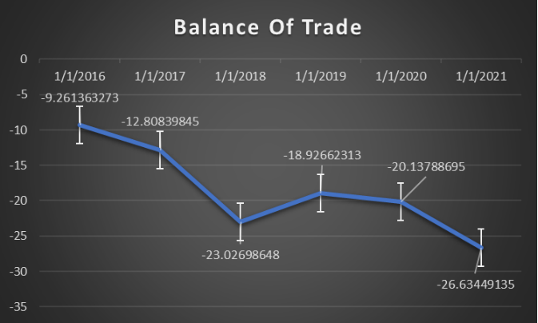

**Balance of Payments:** The balance of payments is a broader measure of a country's economic transactions with the rest of the world, including trade in goods and services, income, and transfers. Bangladesh's balance of payments has also been in deficit for many years, reflecting the country's reliance on foreign aid and remittances from workers abroad.

|  |  |
| --- | --- |
| **Year** | **Balance Of Payment** |
| 2017 | 1.33 Billion US $ |
| 2018 | -9.56 Billion US $ |
| 2019 | -4.49 Billion US $ |
| 2020 | -5.43 Billion US $ |
| 2021 | -4.47 Billion US $ |
| 2022 | -18.7 Billion US $ |

According to the World Bank, Bangladesh export decreased from $17.37 billion in 2017 to 2022.

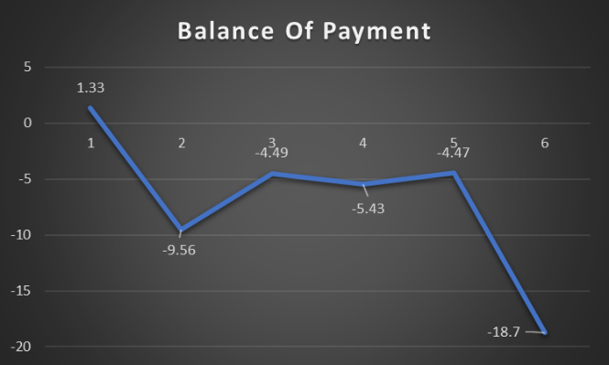

**Gross Domestic Product:** Gross Domestic Product, or GDP, is a measurement of a nation's economic output. It is the total cost of all goods and services that are produced inside the boundaries of a nation over a given time period, usually a year.

Bangladesh's GDP has grown steadily over the past five years. According to the World Bank, Bangladesh's GDP growth was 7.1% in 2016, 7.3% in 2017, 7.9% in 2018, 8.2% in 2019 and 5.2% in 2020 (due to the COVID-19 pandemic).

Before the pandemic hit, Bangladesh was one of the fastest growing economies in the world. However, the pandemic has had a major impact on the country's economy, especially the garment industry, which is a major source of employment and export earnings. Despite this setback, the country continues to recover and is expected to record a growth rate of 6.4% in 2021, according to the World Bank.

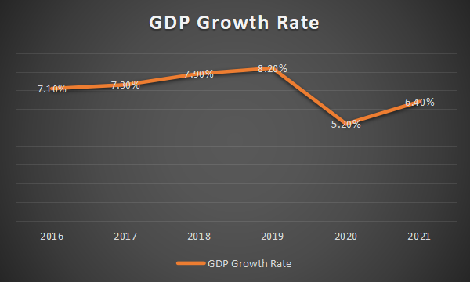

Several factors have contributed to Bangladesh's GDP growth in recent years. Some of the major factors include:

**Garment industry:** The garment industry is one of the major drivers of the Bangladesh economy, accounting for a significant portion of the country's exports and employing millions of people.

**Agriculture:** Agriculture is another important sector in Bangladesh, accounting for the majority of the country's GDP and employing a significant portion of the population.

**Service:** Service sectors such as finance, telecommunications, and retail have grown rapidly in recent years and are major drivers of economic growth.

**Infrastructure development:** Bangladesh has made significant infrastructure investments in recent years to support economic growth, including the construction of new roads, bridges and power plants. Government policy:

The Bangladesh government has implemented various measures to boost economic growth, including improving the business environment, reducing bureaucracy and increasing access to credit.

**Semiconductor manufacturing sector:** Semiconductor-manufacturing sector in Bangladesh was in its early stages of development However; Bangladesh has been making efforts to encourage the growth of its semiconductor industry. These efforts include providing tax incentives, creating technology parks, and offering worker training and education. Additionally, the government has made plans to collaborate with a foreign business to build a semiconductor chip factory in the nation.

If these initiatives are effective, Bangladesh's semiconductor manufacturing industry may experience rapid expansion. It is crucial to keep in mind that the growth of the semiconductor sector is a long-term process that necessitates substantial investment, knowledge, and infrastructure; hence, it could take some time before noticeable growth is evident.

In terms of sectors showing the highest economic growth, the garment manufacturing and services sector are two of the fastest growing sectors in Bangladesh. Moreover, the IT sector also shows great growth potential, with many startups and technology companies emerging in recent years. The agricultural sector continues to be an important contributor to the economy, but its growth rate is relatively slow compared to other sectors.

**Research our tax codes, interest rates and inflation levels. Have they grown/become more restrictive over the last 5 years or have they become less of a burden/less restricted?**

## Tax code in Bangladesh -- The Corporate Tax Rate in Bangladesh stands at 30 percent. In Bangladesh, the Corporate Income tax rate is a tax collected from companies. Its amount is based on the net income companies obtain while exercising their business activity, normally during one business year. Revenues from the Corporate Tax Rate are an important source of income for the government of Bangladesh. Local corporations are taxed on their operational business income whereas MNC’s are taxed only on Bangladesh-source income. Tax rate for MNC’s is 35% after 10 years of business in Bangladesh.in first 10 years they do no need to pay any taxes. Bangladesh is providing tax incentives for foreign companies for investing in special economic zones and hi-tech park zones (by giving tax discounts). The tax rate has become less restricted over the last 5 years allowing MNC’s and other corporations’ in investing in the economy.

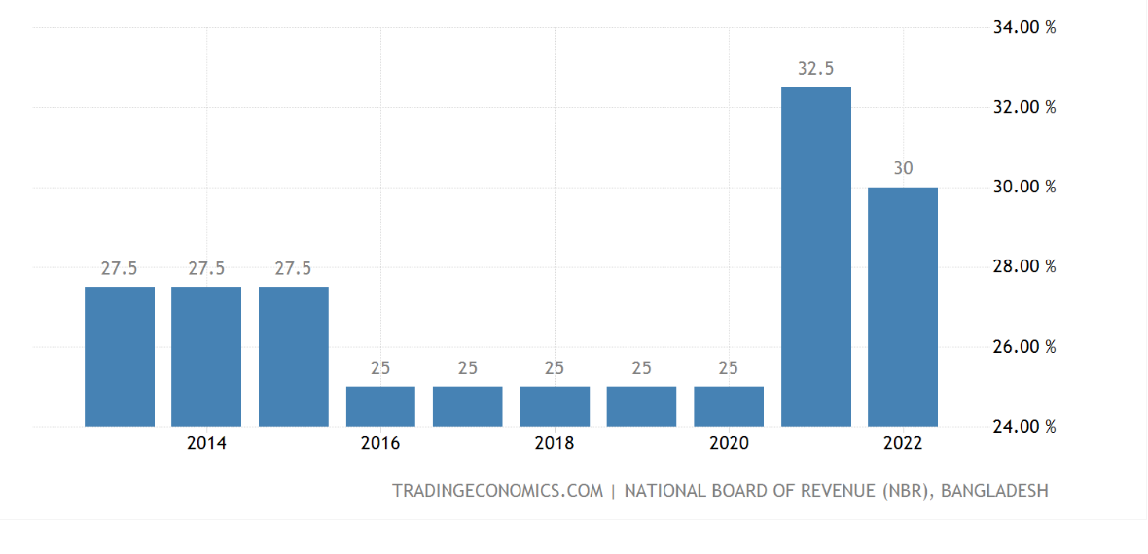

**INFLATION --** In Bangladesh, the most important categories in the consumer price index are food, non-alcoholic beverages and tobacco (59 percent of the total weight) and gross rent, fuel and lighting (17 percent). The index also includes: clothing and footwear (7 percent); transport and communication (4 percent), recreation, entertainment, education & cultural services (4 percent); miscellaneous goods and services (4 percent); medical care and health expenses (3 percent) and furnishing (3 percent). The annual inflation rate in Bangladesh increased to 9.33 percent in March 2023, accelerating from 8.78 percent in the previous month. It was the highest reading since August 2022, prompted by higher food prices (9.09 percent vs 8.13 percent in February). On the other hand, costs eased slightly for non-food products (9.72 percent vs 9.82 percent). On a monthly basis, consumer prices jumped 1.13 percent, the largest rise in six months. Cost rose slightly faster for non-food products. In Bangladesh, the most important types in the consumer price index are food, non-alcoholic beverages and tobacco with 59% of the total weight and gross rent, fuel and lighting 16.9%.

## 

## INTEREST RATE-- The benchmark interest rate in Bangladesh was last recorded at 6 percent in April 2023. In Bangladesh, interest rates decisions are taken by the Bangladesh Bank. The Bangladesh Bank controls two policy interest rates: the repo rate (repurchase rate), which it uses to inject money into the banking system, and the reverse repo rate. For that indicator, we provide data for Bangladesh from January 2015 to December 2022. The average value for Bangladesh during that period was 5.82 percent with a minimum of 3.97 percent in June 2022 and a maximum of 8.64 percent in January 2015.

## From 2015, it has been fluctuating from 6% to 4.7%. Growth jumped to an over 10-year low in 2020 in first-time reduction in merchandise exports, industrial production and remittances due to Covid-19. In this year 2021, economic conditions seem to gradually improve after the reduction of restrictions in May of the fiscal and monetary policies. Merchandise exports recovered in 2021 as the reduction of lockdown processes globally increased demand for clothing. Moreover, remittances (a large source for consumer spending)—soared 48.5% in the same period. In turn, the point in remittances and lower trade deficit led to a marked improvement in the current account balance in 2021.

## 

## 

**Finally, assume that you are representing a foreign investor looking to invest in Bangladesh. Discuss briefly how you may feel encouraged or discouraged to do so and in which sector. Based on your research and judgment, what are the advantages of investing in Bangladesh? What are the disadvantages?**

As a foreign investor I’ll be looking in BOT, BOP, GDP growth, tax benefits, governments rules on foreign investments and find out a sector which has both ability and potentiality to grow up in near future in Bangladesh.

So first of all I’ll feel **encouraged** to invest in **Semiconductor** sector in Bangladesh. Because Bangladesh has one of the highest GDP growth rate in the world which indicates a vast development in this country. With a GDP growth rate of nearly 8% this country has showed its ability to the outer world and even corona pandemic in 2020 its GDP growth rate was 5.2 %.

Besides currently Bangladesh has a -16,324,547 (negative trade balance) BOT indicating a good development of its own companies inside the company. Its BOP is shows positive indication for a foreign invest as a foreign investor I will look why and how its BOP is changing. On the other hand as per the government rules MNC’s need not to pay any taxes for the first 10 years and even the foreigners who are working here can enjoy 0% tax rate benefit. In terms of interest rate MNC’s can get a better benefit compared to other south-Asian countries.

I’m considering “Semiconductor” sector to invest in Bangladesh because in 2022 this sector had market size of 527.88 billion USD and expecting a 1.3 trillion dollar market by 2029. Besides Bangladesh government declared to build a silicon valley here. India Bangladesh’s neighbour country exporting 60 billion dollars worth of chips or semiconductors. According to some reliable market research only 1 lakh people can earn more than 4 million employed RMG sector in Bangladesh. Currently in Bangladesh 4 semiconductor manufacturing companies are existing and Walton and ACI are about invest in semiconductor sector. Bangladesh has exported 5 million dollars worth of chips last and year and this sector is growing up massively. This country has skilled engineers whom able are able to make world class semiconductor but leaving the country because lack of manufacturing companies. Currently more than 500 Bangladeshi engineers are working in intel. So, finally this sector has both ability and willingness to grow up here.

As a foreign investor the biggest advantage of investing in Bangladesh is tax benefit. As described before, MNC’s can get the benefit of 0% tax rate for first 10 years and foreigners can enjoy zero tax rate here. Besides this country is one of the highest growing economy in the world indicating sustainability . Nowadays inflation can be a big disadvantage for foreign investors as it is rising up day by day. Besides not so stable political issues, poor monitoring by government, lack of proper infrastructure, unnecessary gov. official requirements, legitimacy in services are some others disadvantages.