MOBILE GAME PROGRAMMING | ASSIGNMENT 1

VALLEY SENTINEL
  - Game Design Document
Focused Assignment Edition - MVP Scope
A fixed-gunner endless defence game designed for short, readable mobile sessions.
Student: Mohammad Faiaz Alikhail
Developer label: AFCAN Studios
Engine: Unity 6.3 LTS (6000.3.9f1), Universal Render Pipeline
Target: Android, landscape; Samsung Galaxy A26 5G test device
Document: Version 2.0 | July 22, 2026
Scope rule: Build one complete, testable vertical slice before adding any future feature. The GDD distinguishes configured, MVP, planned, and future work so it does not claim unfinished systems are complete.

Contents and requirement coverage
This edition keeps every high-value GDD requirement while removing repeated explanation. Detailed algorithms and flowcharts remain in appendices for direct grading.
Location | Evidence included
1-3 | Vision, assignment fit, audience, platform, and endless-runner justification
4-7 | Core loop, controls, player systems, content, progression, and presentation
8-10 | Assets, Unity architecture, MVP scope, production, testing, performance, and risk
Appendix A | Ten implementation algorithms in pseudocode
Appendix B | Six gameplay and system flowcharts

Document status language
- Configured - already present in the Unity project setup.
- MVP - required for the first playable prototype.
- Planned - designed for expansion but not required now.
- Future - outside Assignment 1 and not promised as completed work.
Submission focus: The grader can find the infinite-runner rationale, mobile controls, graphical asset plan, core systems, classes, implementation plan, pseudocode, flowcharts, testing, and scope boundaries without reading a 38-page design catalogue.

1. Game vision
One-sentence pitch: Use a right-side aiming stick and left-side weapon controls to defend a mountain position through an endless, procedurally escalating battlefield.
Valley Sentinel is a single-player, offline, low-poly 3D mobile game. The player operates a defensive machine gun from a fixed high-ground position above a fictional mountain valley. Enemies approach from readable routes; the player aims, fires, manually reloads, collects selected supply crates, and survives until health reaches zero.
The high concept combines the score, distance, and escalating-pressure structure of an infinite runner with the target-priority decisions of a fixed defensive gun game. It is designed for short sessions, fast onboarding, visible feedback, and a small student-production scope.

Design pillars
- Thumb-readable action - aim with the right thumb; fire and reload with the left.
- Controlled pressure - difficulty rises, but warnings, caps, and short breaks preserve fairness.
- Clear failure - defeat comes from understandable damage, reload timing, or target-priority mistakes.
- One complete loop - polish the vertical slice before expanding content.

Audience, tone, and business model
The audience is teen-and-older mobile players who enjoy short action sessions and high-score improvement. The combat is stylized: no gore, real factions, political claims, flags, logos, or recreated battles. The Assignment 1 build is an offline student prototype with no advertisements, purchases, accounts, or online services.
Working-title note: Valley Sentinel is a temporary original project title. The setting is inspired by broad mountain-valley forms, not by a specific battle or faction.

2. Platform and assignment fit
Requirement | Focused response
Infinite runner for mobile | One uninterrupted run; endless procedural waves; continuously increasing score, wave, survival time, and frontline distance; no final wave.
Mobile controls | Right virtual joystick for turret aim; left Fire and Reload buttons; Pause in the top corner; no movement stick.
Core systems | Turret, weapon/ammunition, infantry, shield/health, wave budget, score, UI, blue crate, game states, audio/feedback.
Graphical assets | MVP/future asset categories, researched source, licence, cost, style, and mobile-use plan.
Implementation | Unity class responsibilities, ScriptableObject data, pooling, input mapping, development phases, tests, performance target.
Design evidence | Ten pseudocode algorithms and six flowcharts in the appendices.

Why this is an infinite runner
The player character does not physically run, but the game retains the required run structure: one attempt continues without a final stage while procedural pressure, score, distance, time, and wave number increase. The battlefield advances through activated spawn zones and later visual section transitions. The run ends only when health reaches zero; the results screen leads directly to restart.
Frontline progress model
frontlineProgress = survivalSeconds * baseProgressRate
+ completedWaves * waveProgressBonus
+ majorAssaults * milestoneBonus

Technical baseline
Item | Decision
Engine | Unity 6.3 LTS / 6000.3.9f1 with URP
Platform | Android first; landscape orientation; single-player; offline
Input | Unity New Input System with On-Screen Controls
Target device | Samsung Galaxy A26 5G
Performance | 60 FPS target; stable frame pacing has priority over decoration

3. Player experience and game loop

Moment-to-moment
- Scan the valley and identify the nearest or most dangerous threat.
- Aim with the right thumb while firing or reloading with the left.
- Track ammunition, shield, health, wave pressure, and temporary crate opportunities.
- Finish the wave, receive a short pause, then face a larger or more varied budget.
- Reach game over, review the result, and restart to improve score and distance.

Rules and conditions
Rule | Definition
Start | Tap Play; reset run values; enable gameplay input; begin wave 1.
Player goal | Survive as long as possible and improve defence score/frontline distance.
Wave complete | All scheduled enemies are spawned and all active enemies are defeated.
Victory | No final victory; milestones are achievements inside an endless run.
Defeat | Health reaches zero after shield and health damage processing.
Restart | Reset defence, score, wave, timers, pooled objects, and UI without reopening the editor.

Modes
MVP: one Endless Defence mode. Onboarding is delivered as brief first-run prompts inside that mode. Challenge modifiers, multiple maps, and separate tutorial levels are future scope.

4. Mobile controls and usability
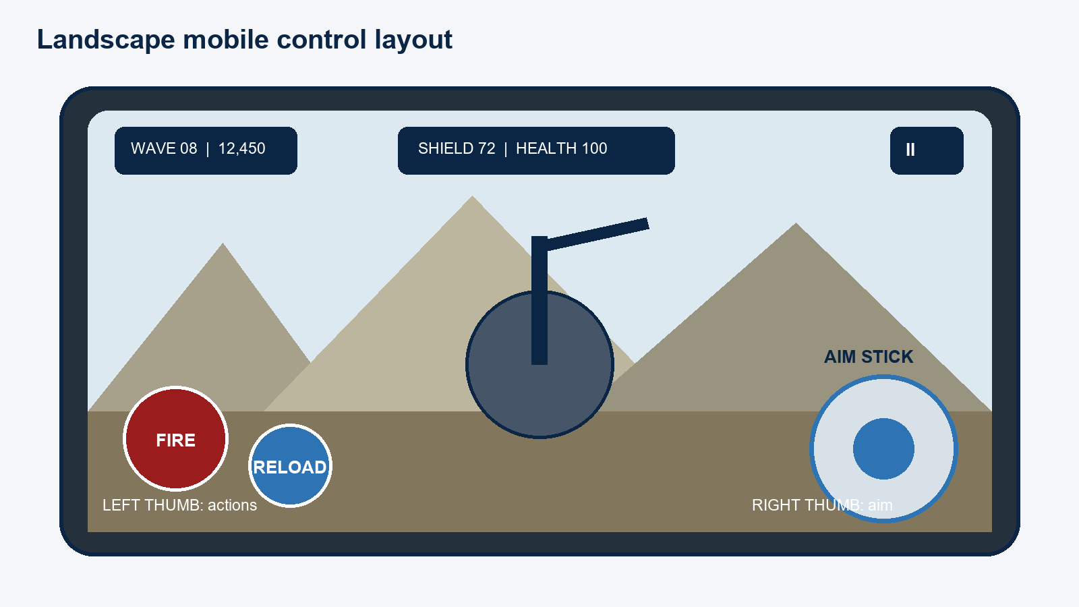
Figure 1. Landscape control plan; final controls must remain inside the device safe area.
Control | Behaviour | MVP
Aim stick | Vector2 input rotates turret yaw and weapon pitch. Release returns input to zero; the gun keeps its angle. | Yes
Fire | Hold to fire while the game is running, fire timer is ready, ammunition exists, and reload is inactive. | Yes
Reload | Manual reload; transfers only needed rounds from reserve. Blocked if full, empty reserve, or already reloading. | Yes
Pause | Pauses action and opens Resume, Settings, Restart confirmation, and Main Menu. | Yes
Switch / Special | Reserved controls; hidden until implemented so the MVP never shows dead buttons. | Future

Aim and accessibility rules
- Yaw begins at a readable forward arc near -75 to +75 degrees; pitch begins near -15 to +55 degrees.
- Rotation is degrees per second, multiplied by joystick magnitude, sensitivity, and delta time.
- Important targets must not sit behind opaque controls; all controls respect Android safe areas.
- Sensitivity and invert-Y are included if base aim is stable. Vibration and gyroscope assistance are optional future features.
- Colour is supported by labels, shapes, icons, and audio; it is never the only warning channel.

5. Core mechanics and starting balance

Stationary turret and weapon
The player cannot walk, dodge, crouch, or change position during combat. A yaw transform rotates horizontally; a pitch child rotates the weapon and camera vertically. The MVP Standard Machine Gun uses a raycast for low cost, reliable aiming, and simple testing; tracers and impacts are cosmetic pooled effects.
Setting | Starting value | Reason
Damage | 20 | Five hits defeats a 100-health test infantry unit.
Fire rate | 8 shots/s | Feels automatic without extreme audio/VFX load.
Magazine / reserve | 40 / 160 | Creates manual reload decisions without early starvation.
Reload | 2.2 s | Long enough to matter; short enough for mobile sessions.
Spread | 1.0 degree | Allows readable short bursts and later tuning.
Hit model | Raycast | Cheap, deterministic, and easy to validate on device.

Shield and health
Incoming damage is reduced by resistance, routed through shield first, then passed to health. Shield does not automatically regenerate. Health regenerates slowly only after a damage-free delay. Health reaching zero raises one destruction event and ends the run once.

Blue supply crate
A visible blue crate descends through a fixed drop zone. The player must shoot it before it reaches the ground. The MVP selects one implemented useful outcome - ammunition, shield restoration, or small health support - and applies it once. Aircraft models, red risk crates, timed upgrades, and special weapons are not required.
Balance policy: All numeric values are starting hypotheses. They become final only after device playtests record time-to-kill, reload pressure, damage rate, average wave reached, and frame stability.

6. Enemies, environment, progression, and scoring

MVP enemy
Basic Infantry uses six simple states: pooled/inactive, advancing, at attack point, attacking, dead, and returned to pool. It follows an authored route, stops at range, attacks on a timer, receives damage, raises a defeated event, and returns to the pool. Cover search, squads, prediction, and complex navigation are excluded.
Content | MVP | Expansion after MVP
Enemy | Basic Infantry | Rifle, MG, RPG, sniper, armoured, operator
Weapon | Standard Machine Gun | Heavy MG, anti-air cannon, launcher
Vehicle / air | None | Technical, APC, tanks, drones, helicopter, jet
Environment | One authored low-poly valley | Reusable sections and 20-wave transitions
Supply | One blue crate | Red risk crate, specials, drones, upgrades

Endless wave budget
Difficulty budget
waveBudget = baseBudget
+ waveNumber * difficultyGrowth
+ survivalSeconds * timeMultiplier
Each enabled enemy has a cost, minimum wave, selection weight, and permitted route. The generator spends a clamped budget on eligible entries, arranges them into readable groups, and respects a safe active-enemy cap and minimum spawn delay. Logical wave numbers can continue even after performance-sensitive values reach their caps.

Fair progression
Milestone | Design change
Every wave | Increase budget; vary spawn group and timing within safety caps.
Every 5 waves | Warn the player and create a stronger mixed formation.
Every 10 waves | Major assault with a larger budget and higher-value composition.
Every 20 waves | Reserved hook for a visual section transition; not built for MVP.

Score and defence rating
The prototype score is enemy base value multiplied by a wave factor, plus wave-completion progress. Accuracy and combo multipliers are added only when shot tracking is reliable. The results screen shows score, wave, distance, kills, time, and a readable fictional rating. Thresholds are tuned from playtest data.

7. Environment, interface, visual style, and audio

Environment and visual language
- One fictional high-ground defence position overlooking a stylized mountain valley.
- Valley floor/road, footpaths, rock walls, distant settlement silhouettes, sandbags, barriers, spawn zones, and a visible crate drop route.
- Low-poly shapes, shared materials, warm tan/grey terrain, muted structures, blue sky, and strongly contrasting enemies.
- Blue communicates shield and safe supply; red/orange communicates danger; neutral light text communicates information.
- No gore, real insignia, flags, slogans, factions, or realistic injury detail.

HUD and screens
Area | Information/action
Top left | Wave and milestone warning
Top centre | Score, multiplier if implemented, and frontline distance
Top right | Pause
Lower weapon area | Magazine/reserve and reload state
Lower edge | Shield and health bars; values if readable
Results | Score, wave, distance, kills, time, rating, Restart

Required feedback
Event | Visual | Audio / haptic
Fire / hit | Muzzle flash, recoil, tracer/impact, hit marker | Shot and hit tick; optional light pulse
Reload / empty | Progress state or prompt | Mechanical cues; rate-limited empty click
Shield / health | Bar change, flash, break warning | Distinct hit/break/low cues; optional strong pulse
Crate | Blue icon/colour and reward text | Drop announcement and reward cue
Game over | HUD fade and results panel | Short failure sting; one strong pulse

Rapid-fire sound must be rate-safe and mixed to avoid clipping or excessive AudioSources. MVP ambience is a quiet wind loop; music is optional and must never mask warnings.

8. Graphical and audio asset plan
Lowest-risk asset strategy: Prototype with Unity primitives and a small number of verified CC0 assets. Do not buy or import a large pack until the input, weapon, enemy, damage, wave, score, and restart loop works on the phone.
Category / source | Licence / cost | MVP use and decision gate
Unity primitives | Project-created / free | Turret, platform, route, crate, blockout. Validate scale and silhouette.
Kenney Nature Kit + Mobile Controls | CC0 / free or donation | Rocks, vegetation, joystick/buttons. Import only needed files and atlas UI.
Quaternius Ultimate Stylized Nature | CC0 / free core download | Alternative scenery. Recolour to the same palette before mixing.
Military Assets (Mobile), Unity Asset Store | Standard Unity EULA / free at research date | Candidate props. Recheck contents, URP materials, and current licence before import.
Low Poly Military Characters, Unity Asset Store | Standard Unity EULA / USD 15.99 at research date | Optional infantry source. Check humanoid rig, triangles, textures, and style first.
Adobe Mixamo | Adobe terms / free with Adobe ID at research date | Walk, attack, hit, death animations after one-character device test.
Kenney UI Audio / verified CC0 clips | CC0 / free or donation | UI, warning, and placeholder sound. Import selected clips only.

Source records (checked July 21, 2026; recheck on download date):
Kenney Nature Kit
Kenney Mobile Controls
Quaternius Ultimate Stylized Nature
Military Assets (Mobile)
Adobe Mixamo FAQ
Licence rule: record title, creator, exact URL, download date, licence, and local folder before import. Prefer CC0. Credit CC BY correctly. Reject Non-Commercial, Editorial, No-Derivatives, and unclear assets.

9. Unity implementation plan
System relationship
Input Actions -> InputReader -> Turret / Weapon / Pause
WeaponData -> WeaponController -> IDamageable targets
EnemyData -> WaveManager -> EnemySpawner -> EnemyBase pool
EnemyBase -> PlayerDefence -> GameManager game over
Waves / Enemies / Crates -> ScoreManager -> UIManager
System events -> AudioManager + pooled visual effects

Class responsibilities
Class/data | Single responsibility
GameManager | Run state, pause, survival time, start/end/restart.
InputReader | New Input System callbacks; current aim and action events.
PlayerTurretController | Yaw/pitch rotation, clamps, sensitivity.
WeaponController / WeaponData | Fire timer, ammo, reload, raycast hit, configurable weapon values.
PlayerDefence | Shield, health, resistance, regeneration, death event.
EnemyBase / EnemyData | Shared runtime state plus configurable enemy values/cost/score.
WaveManager / EnemySpawner | Endless budget, selection, grouping, scheduling, spawn-zone choice.
ObjectPool | Reusable enemies, impacts, tracers, and crates with complete reset.
SupplyDropManager / SupplyCrate | Drop timing, descent, hit, timeout, one result.
ScoreManager / UIManager | Run metrics and event-driven HUD/results presentation.
AudioManager | Central playback rules for weapon, enemy, defence, ambience, and UI audio.

Implementation choices
- ScriptableObjects store weapon and enemy variants; runtime classes own current state.
- OnScreenStick binds to <Gamepad>/rightStick; OnScreenButtons bind to Fire and Reload actions.
- No gameplay script reads raw screen coordinates or uses scene searches every frame.
- Events update HUD and feedback; pooling avoids repeated Instantiate/Destroy during long runs.
- Simple authored routes and colliders replace expensive AI/pathfinding in the MVP.

10. MVP scope, schedule, testing, and risk
MVP success test: On the target phone, a player can start, aim with the right thumb, fire/reload with the left, defeat infantry, take shield/health damage, survive generated waves, shoot one blue crate, reach game over, see results, and restart without reopening Unity.

Hard scope lock
Must ship | Do not start before MVP is stable
One valley and defence position | Multiple environments or 20-wave relocation
One Standard Machine Gun | Heavy/AA/launcher weapons or specials
One Basic Infantry | Vehicles, aircraft, drones, snipers, squads
Aim, Fire, Reload, Pause | Gyroscope, control remapping, unused buttons
Shield, health, regen, game over | Permanent upgrades or complex status effects
Endless budget waves, score, blue crate | Red risk crate, online leaderboard, multiplayer

Development order and exit gates
Phase | Output | Exit gate
1 | Blank Android build + safe-area UI | Runs in landscape on the Samsung phone.
2 | Aim, Fire, Reload input | Two-thumb input responds reliably.
3 | Turret + Standard MG | Clamped aim, fire rate, ammo, and reload pass tests.
4 | Basic Infantry + damage | Enemy attacks, dies, returns to pool; player can die once.
5 | Endless waves + score + restart | Continues beyond milestones and resets all run values.
6 | Blue crate + feedback | One reward applies once; timeout is safe.
7 | Device profile + submission QA | Stable demo, readable document, backed-up APK/project.

Acceptance tests
- Aim changes yaw/pitch and never moves the player.
- Fire rate cannot exceed WeaponData; ammunition never becomes negative.
- Reload transfers exactly the needed amount and cannot duplicate ammunition.
- Shield receives damage first; overflow reaches health; regeneration waits for the full delay.
- Health zero triggers one game-over event; restart resets state, UI, timers, and pools.
- Wave generation has no final wave and remains inside active-enemy and spawn-delay caps.
- A blue crate grants one result or times out with no effect.
- Two-thumb controls remain inside the safe area and do not hide important targets.
- The ten-minute phone test records frame time, memory, batches, active enemies, and thermal behaviour.

Performance plan
Use the mobile URP asset, one main directional light, limited real-time shadows, no post-processing for MVP, shared materials, simple low-poly meshes, raycast weapon hits, pooled repeat effects, controlled HUD updates, compressed audio, and measured enemy caps. Profile on the Samsung device; stable frame pacing is more important than extra decoration.

Top risks and responses
Risk | Response
Concept judged not to be an infinite runner | Show continuous run, wave, time, score, distance, automatic progress, and no final level in both game and GDD.
Scope expands | Enforce the one-gun/one-enemy/one-valley/one-blue-crate lock.
Touch aim feels weak | Test on device early; tune dead zone, sensitivity, clamp, and button size.
Enemy count hurts frame rate | Pool, cap, simplify AI/shadows, and scale composition rather than only count.
Assets clash or have unclear licence | Use one visual family, recolour support assets, and record/reject licences before import.
Android demo fails | Make a blank build early and keep a known-good APK backup.

Appendix A - Required pseudocode
These ten algorithms define the behaviours most likely to be graded or implemented first. Names are technology-neutral so they can be mapped directly into Unity C#.
A1. Generate an endless wave
FUNCTION GenerateWave(wave, seconds):
budget = CLAMP(base + wave*growth + seconds*timeGrowth, minBudget, maxBudget)
plan = []
WHILE budget >= MinimumEligibleCost(wave) AND plan.count < safeWaveLimit:
enemy = SelectEnemyForBudget(budget, wave, allowedRoutes)
IF enemy IS null: BREAK
plan.ADD(enemy); budget -= enemy.cost
RETURN CreateReadableGroups(plan)
A2. Select an enemy by cost and weight
FUNCTION SelectEnemyForBudget(budget, wave, routes):
candidates = enabled enemies where minimumWave <= wave
AND cost <= budget AND requiredRoute IN routes
IF candidates empty: RETURN null
roll = RANDOM(0, SUM candidates.weight)
FOR EACH candidate:
roll -= candidate.weight
IF roll <= 0: RETURN candidate
RETURN candidates.last
A3. Apply shield and health damage
FUNCTION ApplyDamage(raw):
IF game != Running OR raw <= 0: RETURN
remaining = raw * (1 - CLAMP(resistance, 0, resistanceCap))
lastDamageTime = now
IF shield > 0:
absorbed = MIN(shield, remaining * shieldMultiplier)
shield -= absorbed; remaining *= 1 - absorbed/(remaining*shieldMultiplier)
health = MAX(0, health - remaining)
IF health == 0: RaiseDefenceDestroyedOnce()
A4. Regenerate health
FUNCTION UpdateRegeneration(deltaTime):
IF game != Running OR health <= 0 OR health >= maxHealth: RETURN
IF now - lastDamageTime < regenerationDelay: RETURN
health = MIN(maxHealth, health + regenerationRate*deltaTime)
RaiseHealthChanged()
A5. Rotate the turret
FUNCTION UpdateAim(input, deltaTime):
IF game != Running: RETURN
yaw += input.x * yawSpeed * sensitivity * deltaTime
pitch += input.y * pitchSpeed * sensitivity * deltaTime
yaw = CLAMP(yaw, minimumYaw, maximumYaw)
pitch = CLAMP(pitch, minimumPitch, maximumPitch)
ApplyLocalRotations(yaw, pitch)
A6. Fire the Standard Machine Gun
FUNCTION TryFire():
IF game != Running OR reloading OR now < nextShot: RETURN false
IF magazine == 0: PlayRateLimitedEmptyCue(); RETURN false
magazine -= 1; nextShot = now + 1/fireRate
direction = ApplySpread(muzzle.forward, spread)
hit = Raycast(muzzle.position, direction, range, hitMask)
IF hit has IDamageable: hit.target.ApplyDamage(damage)
PlayPooledShotFeedback(hit); RaiseAmmoChanged(); RETURN true
A7. Reload without duplicating ammunition
FUNCTION StartReload():
IF reloading OR magazine == magazineSize OR reserve == 0: RETURN false
reloading = true; finishTime = now + reloadDuration; RETURN true
FUNCTION CompleteReload():
IF NOT reloading OR now < finishTime: RETURN
transfer = MIN(magazineSize - magazine, reserve)
magazine += transfer; reserve -= transfer; reloading = false
RaiseAmmoAndReloadChanged()
A8. Add enemy score
FUNCTION AddEnemyScore(enemy, wave):
waveMultiplier = 1 + wave*scoreGrowth
accuracyBonus = AccuracyBonusIfImplemented()
combo = ComboMultiplierIfImplemented()
gained = ROUND(enemy.baseScore * waveMultiplier * accuracyBonus * combo)
totalScore += gained; kills += 1
UpdateRating(totalScore); RaiseScoreChanged()
A9. Resolve a supply crate once
FUNCTION ResolveCrate(crateType, wave):
IF crate.alreadyResolved: RETURN
table = implemented results valid for crateType and wave
IF table empty: result = SafeAmmoFallback
ELSE: result = WeightedRandom(table)
crate.alreadyResolved = true
ApplyResult(result); ShowResultFeedback(result); ReturnCrateToPool()
A10. Reuse an object from a pool
FUNCTION GetFromPool(key):
pool = pools[key]
IF pool.available not empty: object = pool.available.REMOVE_FIRST()
ELSE IF pool.total < pool.safeMaximum: object = CREATE(key); pool.total += 1
ELSE: RETURN null
object.SetActive(true); object.ResetForSpawn(); pool.active.ADD(object)
RETURN object
FUNCTION Return(object): CancelTimersAndEvents(); ResetState(); SetActive(false)

Appendix B - Required flowcharts
The flowcharts below match the pseudocode and the MVP class plan. Branch labels describe the decision result; loops return to the earlier system state.
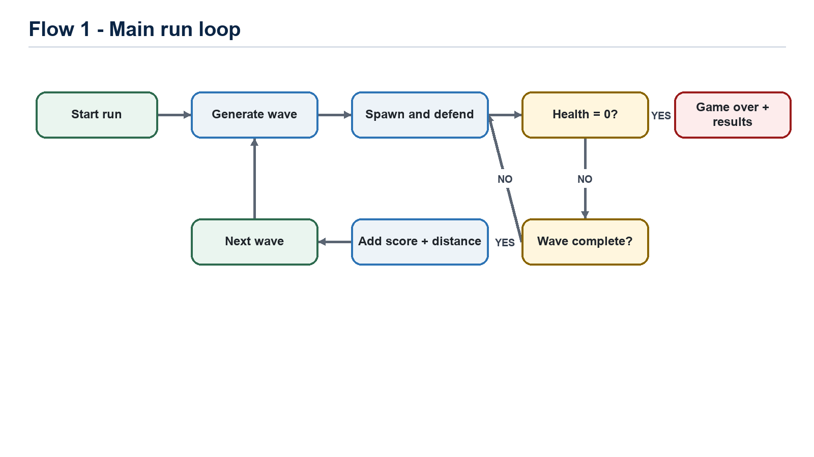
Figure 2. Main run loop.
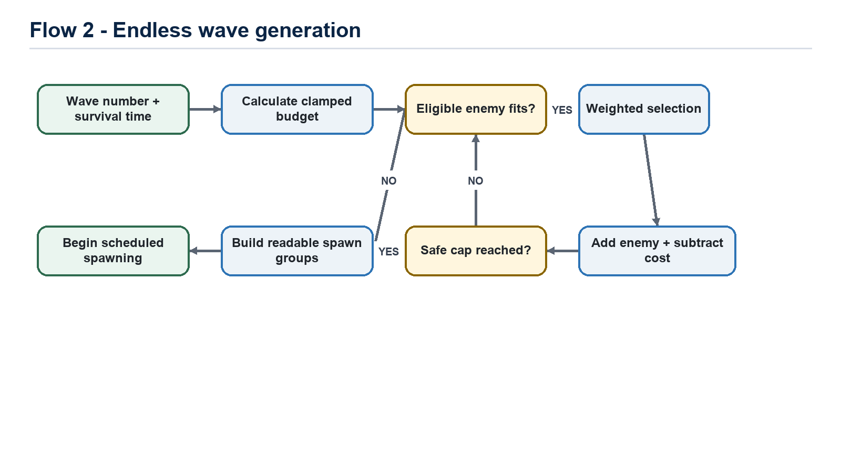
Figure 3. Endless wave generation.

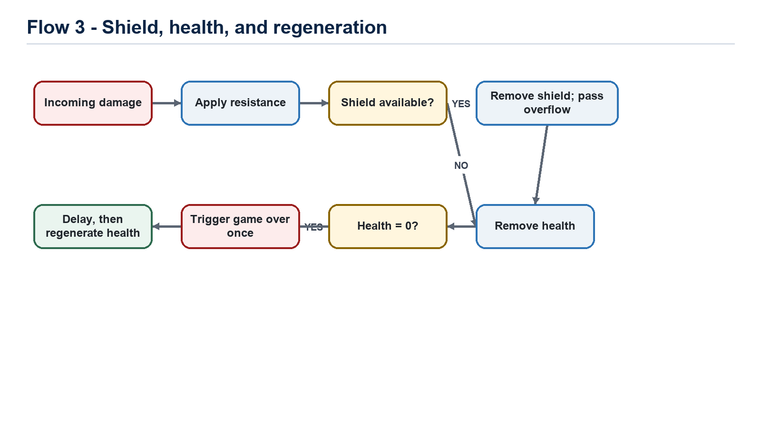
Figure 4. Shield, health, and regeneration.
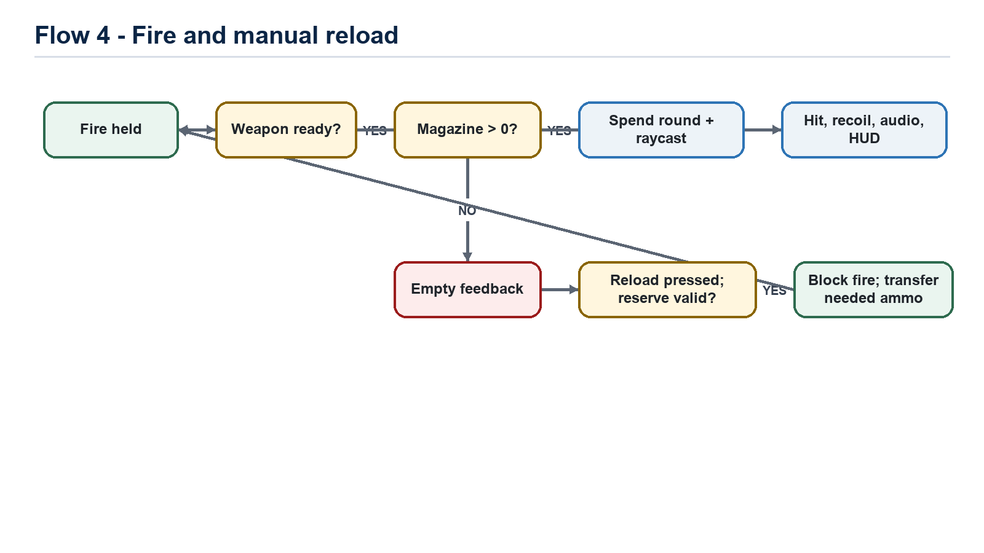
Figure 5. Weapon fire and manual reload.

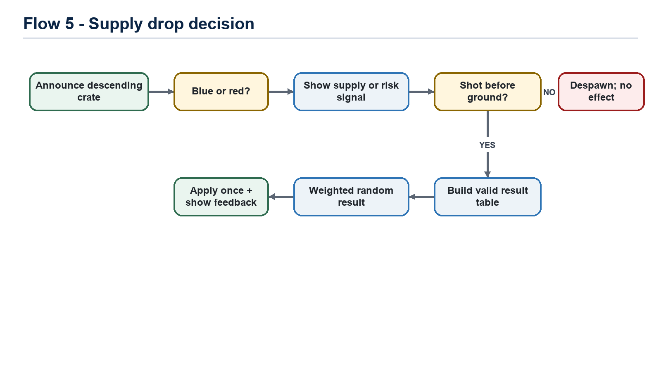
Figure 6. Supply-drop decision.
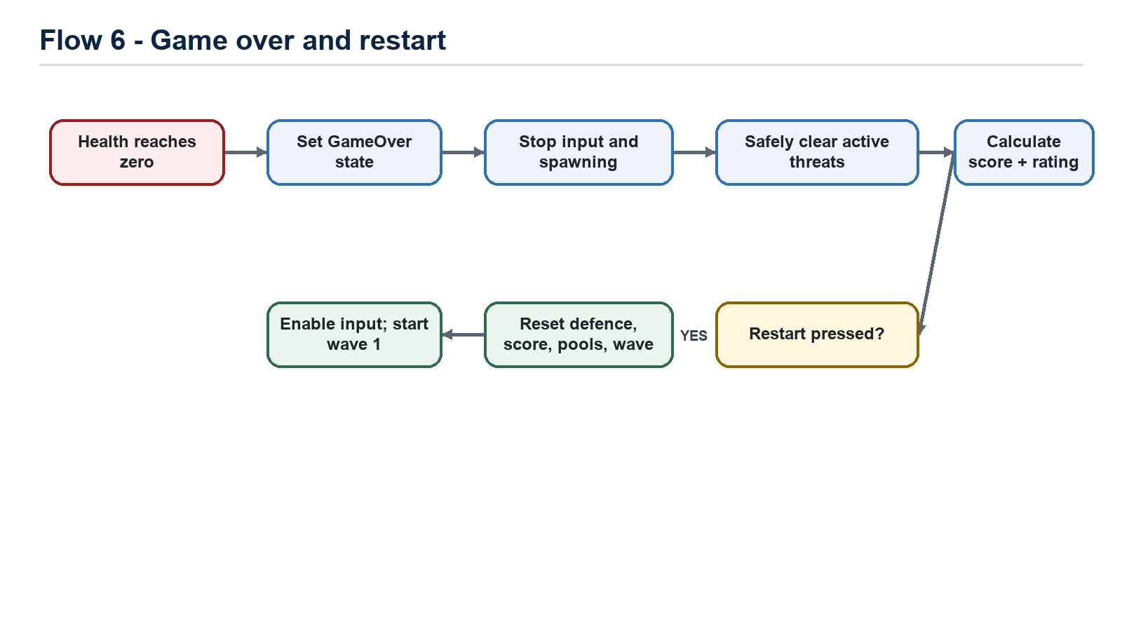
Figure 7. Game over and restart.

