**Simple Quiz Program**

**Project Report**

**Group Members:**

* Faiez Mehboob (23k-2018)
* Muneeb Azam (23k-2032)
* Muhammad Owais (23k-2041)

**Objective:**

The goal of this project is to design and implement a **Simple Quiz Program** in assembly for our coal lab project. The program will allow a user to answer a series of multiple-choice questions, keep track of their score, and display the result upon completion of the quiz. This project focuses on demonstrating how assembly language can handle basic input/output operations, manage arrays, and implement control flow.

**Introduction:**

Quizzes are a common educational tool used to evaluate knowledge. Implementing a quiz program in assembly language provides an opportunity to apply fundamental concepts in low-level programming such as memory management, input/output handling, and conditional logic. This project will enhance our understanding of core assembly concepts while building a simple yet interactive application.

**Description:**

The **Simple Quiz Program** will present a series of pre-defined questions to the user. After each question, the user will input their answer, and the program will determine whether the answer is correct or incorrect. The main features and functionalities are as follows:

1. **Main Menu:**

* All three types of quizzes (COAL, CyberSecurity and DSA) will be given as choices to user.
* User will choose any of the quizzes which he wants to take.
* If user inputs a number or character other than choices given then he will be given two choices If he want to take the quiz or exit.

1. **Procedure calling:**

* Based on the user choice of (1,2 or 3) respected Procedure of that specific course quiz will be called.

1. **Question Display**:
   * A series of multiple-choice questions will be stored in memory.
   * Each question will be displayed to the user one at a time, along with the possible answer choices (a,b,c,d).
2. **Input Handling**:
   * The user will provide input corresponding to the selected answer (e.g., pressing 'A' or ‘a’ for option a). If user pressed ‘A’ then it will be converted to lowercase automatically for efficient searching in correct option array.
   * The program will validate the input and ensure it matches one of the expected options.
   * Any input other than (a,b,c,d) will be considered wrong and no marks will be given.
3. **Answer Comparison**:
   * The program will compare the user's answer to the correct answer stored in memory.
   * If the answer is correct, a point will be added to the user’s score.
   * User’s answer will be added to an array of user answer so that later we can compare with correct answers and print wrong attempted questions.
4. **Score Calculation**:
   * A running total of the user's score will be maintained in a variable.
   * After the quiz is completed, the user will be asked to press any key and the screen will be cleared to eliminate cluster.
   * Then User’s score for that quiz will be printed and along with that a message will be printed based on how user performed in that quiz.
5. **Wrong Attempted Questions:**

* After the score and message is shown to the user. If the user did any questions wrong then all the wrong attempted questions will be printed along with the correct Answer, User Answer and their explanation. And this is done by comparing user’s answers with correct answers in memory.

1. **End-of-Quiz Output**:

* In the end, The score will be turned to 0 as the user can take that quiz again.
* Then we return from the procedure and then user is given two choices.

To take quiz again or exit, if user press 1 the screen is cleared and MAIN MENU is shown again , if 0 then program is finished.

**Project Overview:**

**Main Menu:**

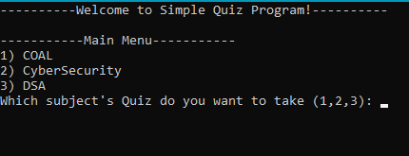

**Invalid input:**

**If press 1 screen cleared and Main Menu again:**

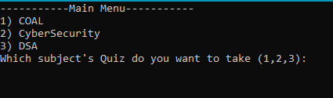

**Coal Quiz:  
**

* **Screen cleared after quiz ends after user presses any key.**
* **Score and Wrong Attempted along with user ans, correct ans and explanation printed.**

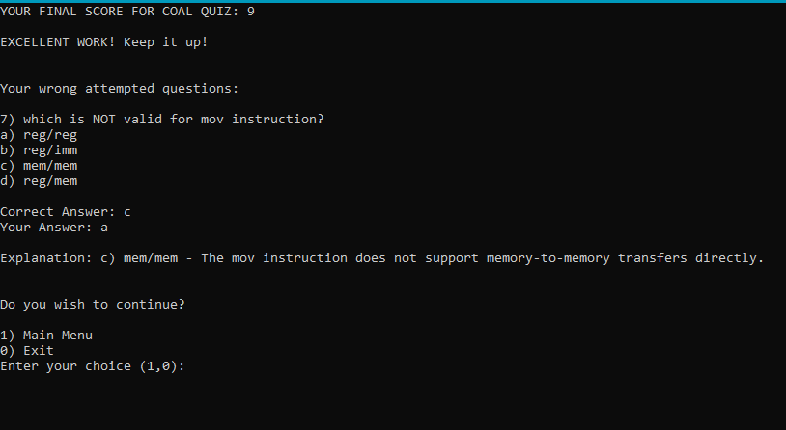

* **Then back to Main Menu and now if user wants he can take other quizzes.**

**The End**