Reliable Heart-Rate Data Delivery from a Smartwatch to a Smartphone over Bluetooth Low Energy Using a Store-and-Forward Scheme with Acknowledgement
Faik Irkham¹, [[Advisor Name]]²
¹²[[Department/Study Program, Faculty, University, City, Indonesia]]
e-mail: faikirkham@gmail.com
Abstract
Continuous heart-rate monitoring using wearable devices is a key component of the Internet of Medical Things (IoMT). A central challenge is guaranteeing data completeness when readings are transferred from a smartwatch to a smartphone over Bluetooth Low Energy (BLE), given the limited packet size (MTU), the best-effort nature of BLE notifications, and operating-system restrictions on background execution. This work designs and implements a two-application system: a smartwatch (Wear OS) application acting as a BLE peripheral/GATT server that records the heart rate every second into a local database and periodically sends it as a batch to a smartphone (Android) application acting as the central. For reliability, each batch is fragmented into opcode-tagged frames (START/DATA/END) with flow control, complemented by a store-and-forward scheme, application-level acknowledgement (ACK), an idempotent (duplicate-free) receiver, and a foreground service for background operation. In a single continuous ~36-minute test on physical devices, the smartwatch recorded 2,167 readings and 2,164 were successfully received by the smartphone (99.86% delivery ratio) with no duplicates; the remainder stayed pending as designed by the store-and-forward scheme. 99.1% of readings were at the highest sensor-accuracy level. One batch of 228 readings (10,717 bytes, 24 frames) was delivered in ~0.32 s at MTU 512. The results show the proposed mechanism is reliable under normal conditions; evaluation across varied conditions is future work.
Keywords: IoMT; Bluetooth Low Energy; wearable; heart rate; store-and-forward; delivery reliability; Wear OS
1. Introduction
The use of wearable devices for continuous health monitoring has grown rapidly along with the Internet of Medical Things (IoMT), a network of medical/health devices that collect and exchange physiological data [[add citation: IoMT survey]]. A smartwatch equipped with an optical heart-rate sensor can act as a sensor node, while a smartphone serves as a gateway that collects, stores, and forwards the data for further analysis.
Bluetooth Low Energy (BLE) is a primary choice of communication channel in this scenario because of its low power consumption [1]. However, delivering complete health data over BLE faces several challenges: the size of a single notification is bounded by the Maximum Transmission Unit (MTU); BLE notifications are best-effort (no attribute-layer acknowledgement); and operating systems—especially Wear OS and phones with aggressive power management—restrict background processes [3]. In health applications, losing part of the data can degrade analysis quality, making data completeness an essential requirement.
Many prior implementations emphasize displaying the latest value in real time (e.g., sending a single reading snapshot on request); this approach does not guarantee that all readings are stored at the receiver if the connection is briefly lost or the receiver application is stopped by the system [[add citation: related wearable BLE/mHealth study]]. A mechanism that guarantees data completeness is therefore needed, combining temporary storage (store-and-forward), delivery acknowledgement, duplicate prevention, and background operation.
The contributions of this work are: (1) the design and implementation of a two-application Wear OS–Android system for acquiring and delivering heart-rate data; (2) a batch delivery protocol over BLE notifications using opcode-based framing with flow control; (3) reliability mechanisms consisting of store-and-forward, application-level acknowledgement (ACK), and an idempotent (duplicate-free) receiver; (4) background execution via a foreground service; and (5) an initial empirical evaluation of delivery ratio, data quality, and transfer performance, together with supporting data tools for reproducibility.
2. Materials and Methods
This study follows a design-and-implementation approach, followed by testing on physical devices. This section describes the system architecture, the communication protocol, the reliability mechanisms, the application architecture, and the evaluation procedure and metrics.
2.1 System Architecture
The system comprises two devices, as shown in Figure 1. The smartwatch acts as a peripheral/GATT server: the heart-rate sensor is read by native code, forwarded to the application layer, stored in a local SQLite database, and then advertised and sent over BLE. The smartphone acts as a central/GATT client: it scans, connects, subscribes to notifications, reassembles the batch, stores it in SQLite, and provides data export. The data follows a numbered “U”-shaped flow (1–10), from acquisition on the smartwatch to export on the smartphone.
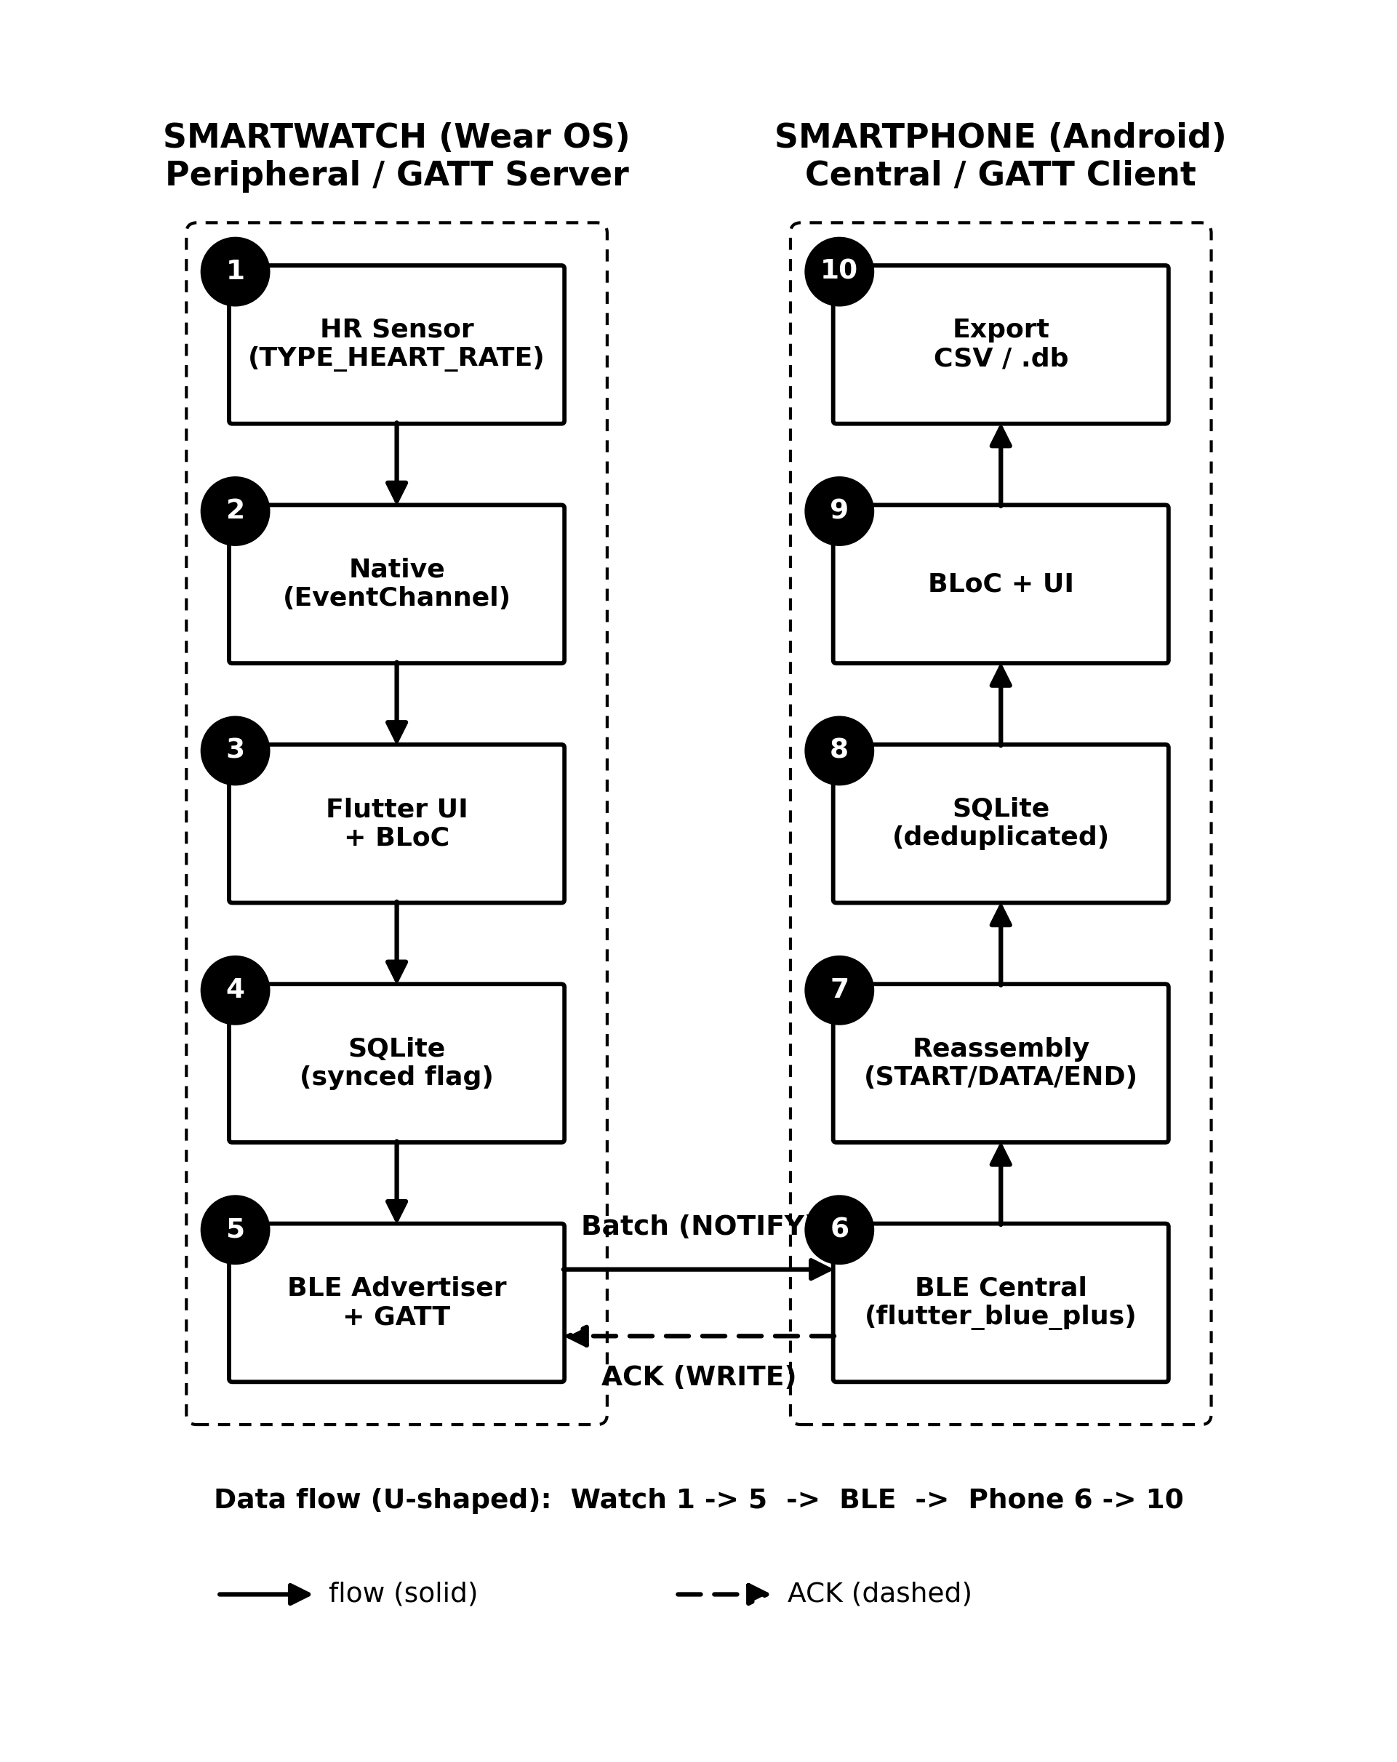
Figure 1. Two-device system architecture (data flow 1–10).
2.2 Communication Protocol and Framing
Communication uses a dedicated GATT service with a “record” characteristic of the notify type. After connecting, the smartphone requests a 512-byte MTU and enables notifications. Because one batch contains many readings whose size exceeds the capacity of a single notification, the batch is fragmented into a sequence of frames, each prefixed with an opcode: START (0x01), DATA (0x02), and END (0x03), as shown in Figure 2. The data chunk per frame is MTU minus 4 bytes (3 bytes of ATT header and 1 byte of opcode). Inter-frame transmission is flow-controlled: the next frame is sent only after the send-completion callback of the previous frame. The receiver reassembles the frames into a complete JSON payload. The full interaction sequence is shown in Figure 3.
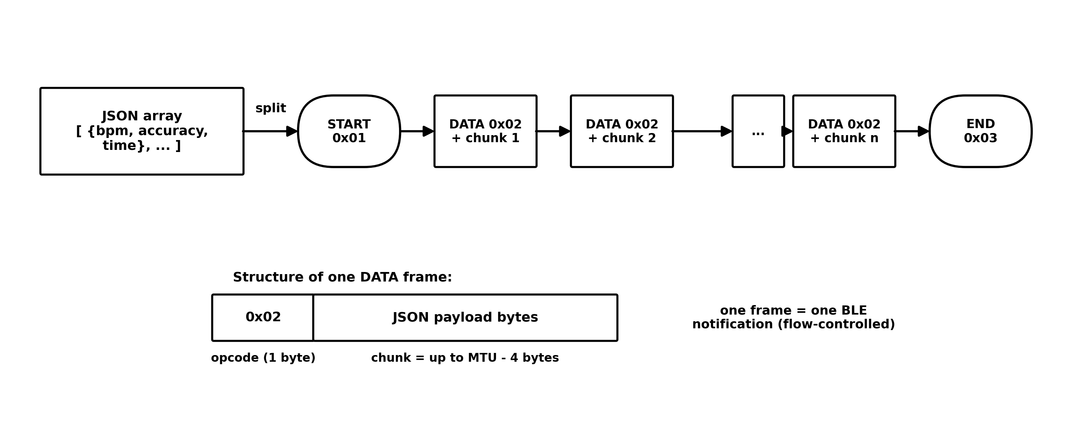
Figure 2. Fragmentation of one JSON batch into BLE frames (START/DATA/END).
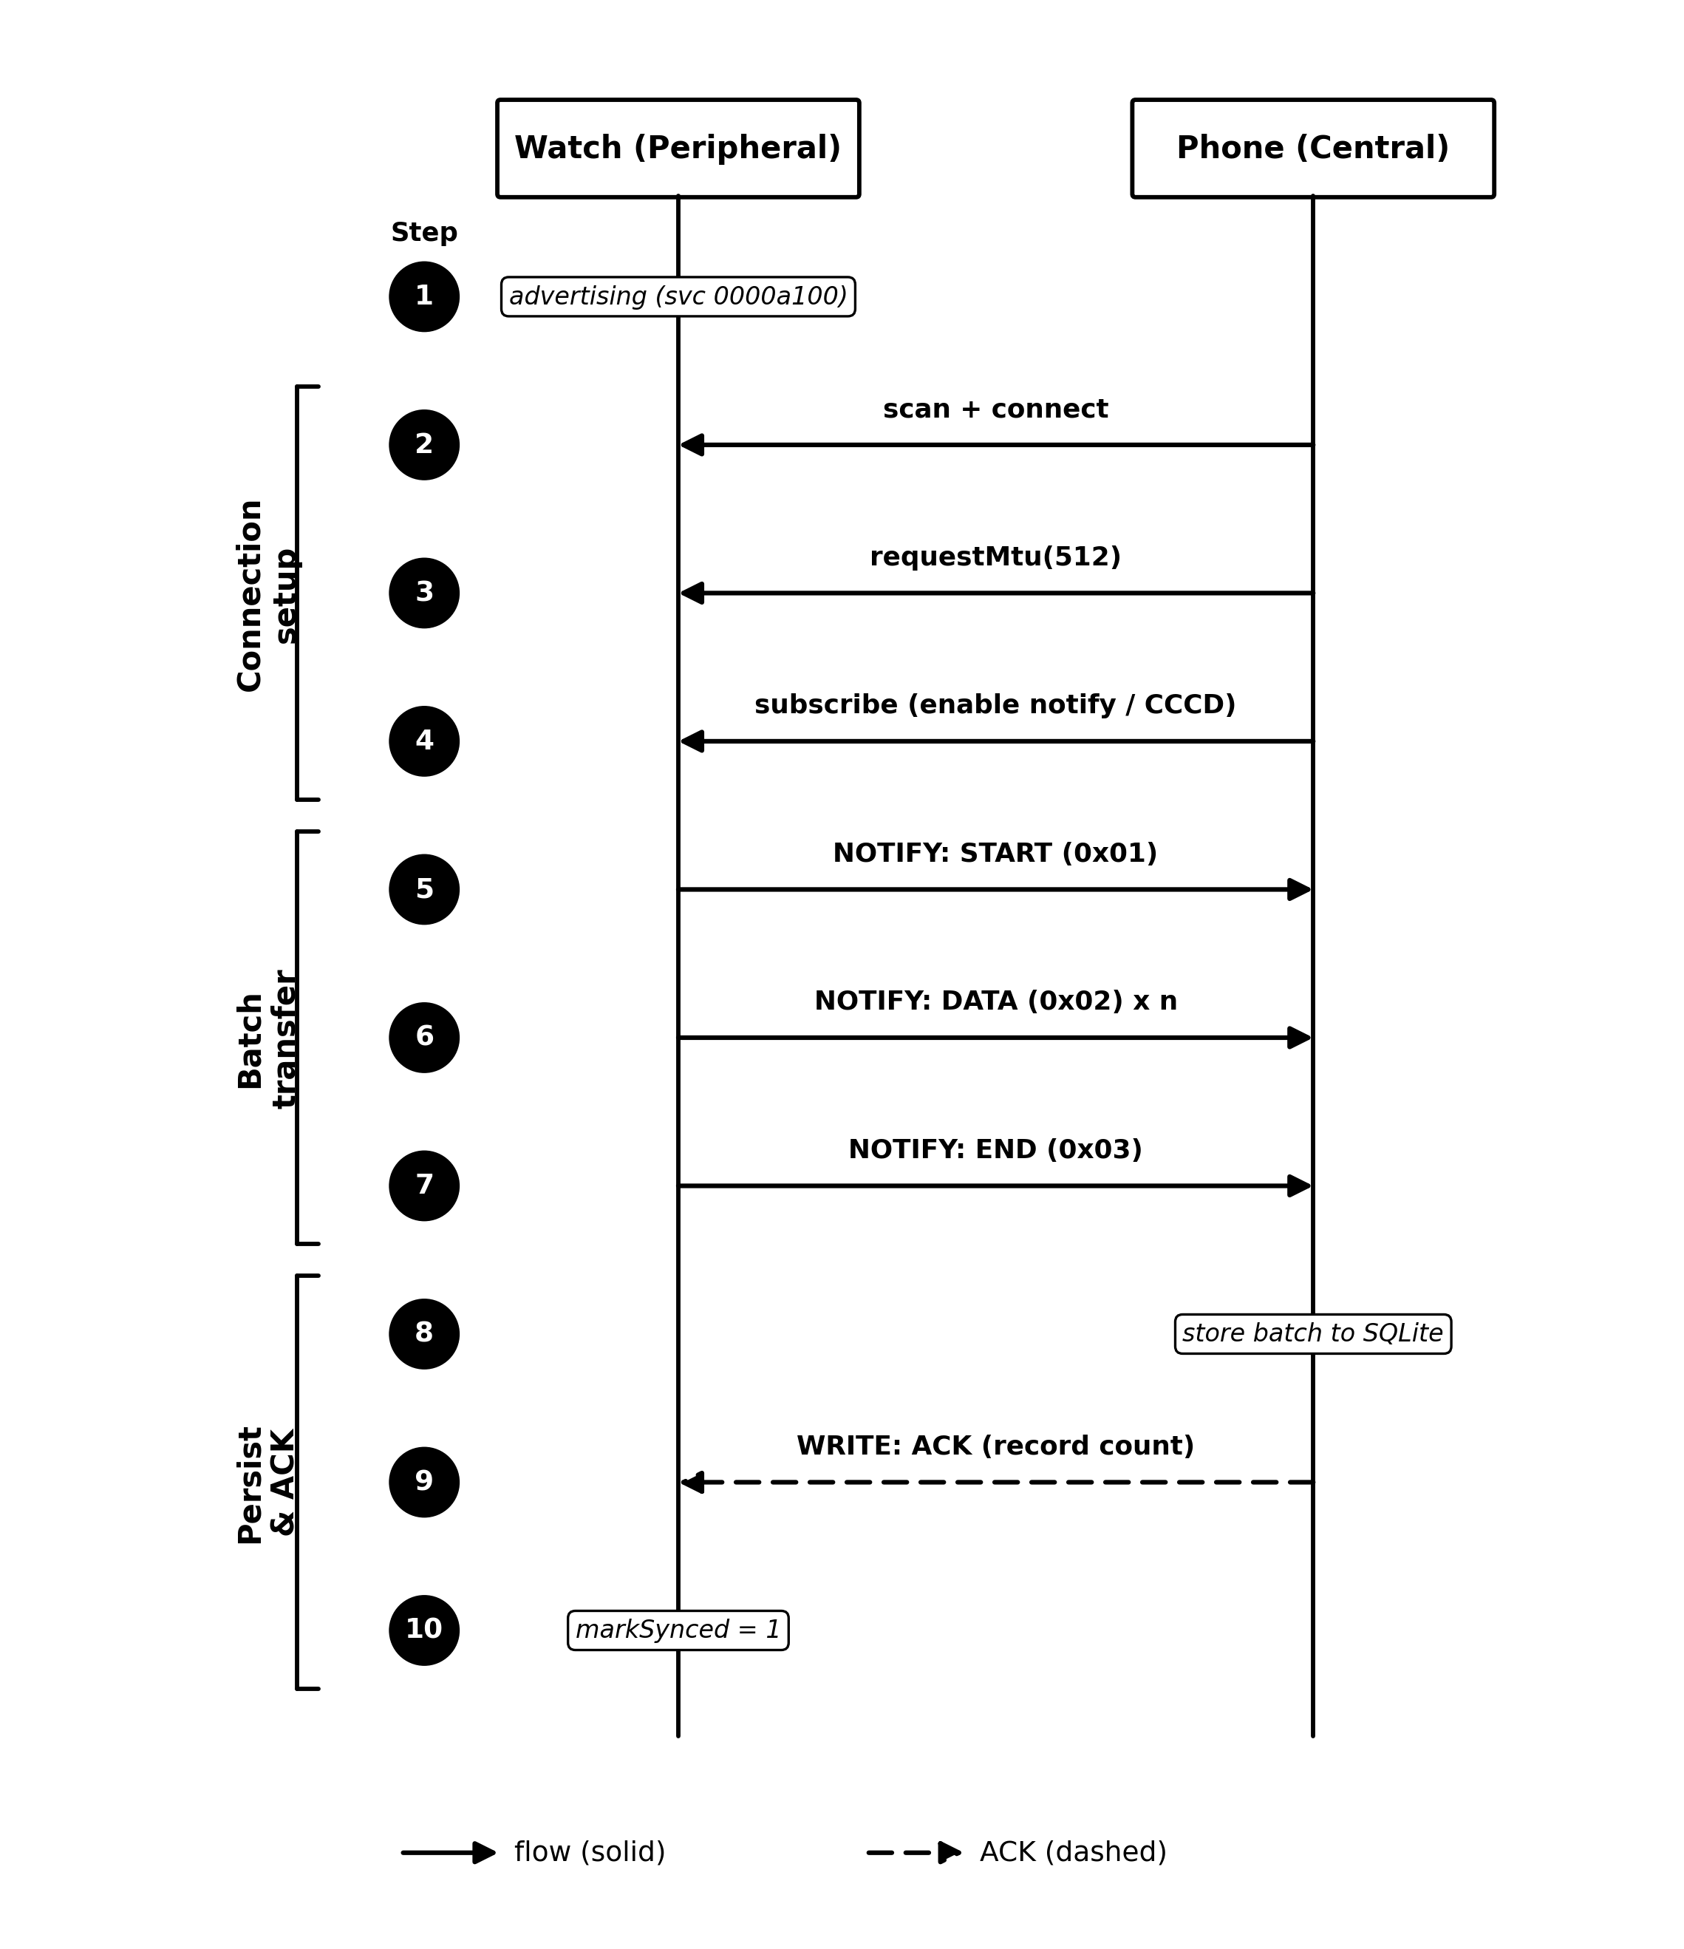
Figure 3. BLE communication sequence: setup, batch transfer, and ACK.
2.3 Store-and-Forward and Acknowledgement (ACK)
Each reading is stored on the smartwatch with a sent-status flag (synced = 0). Periodically (a selectable interval, e.g., 3 or 5 minutes), all not-yet-sent records are retrieved and transmitted as a single batch. To guarantee that data is actually received, the smartphone writes an acknowledgement (ACK) containing the number of successfully stored records to a dedicated characteristic; the smartwatch marks records as sent (synced = 1) only after the ACK is received. If no ACK arrives within a timeout (30 s), the records remain not-yet-sent and are retransmitted in the next interval. To prevent duplicates caused by retransmission, the receiver is made idempotent through a unique index on the time attribute, so repeated delivery does not create duplicate rows. The complete flow is shown in Figure 4.
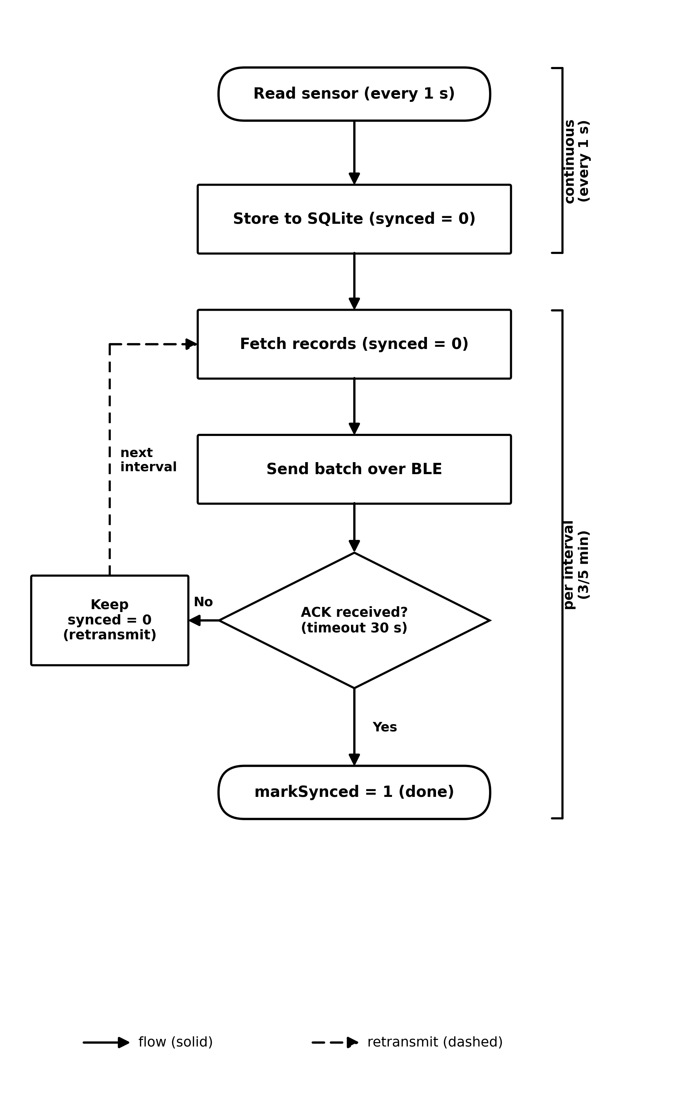
Figure 4. Store-and-forward flow with delivery acknowledgement (ACK).
2.4 Smartwatch Application Architecture
The smartwatch application is built with Flutter, with a clear separation between the Dart layer and the native (Kotlin) layer, as shown in Figure 5. The Dart layer uses the BLoC pattern: the monitoring logic (per-second sampling, per-interval sending, store-and-forward, and waiting for ACK) is separated from the user interface. The native layer hosts the sensor listener, the GATT server and advertiser, the frame queue and flow control, the ACK characteristic, and a foreground service that keeps the process alive when the application is in the background or the screen is off. The two layers communicate via platform channels.
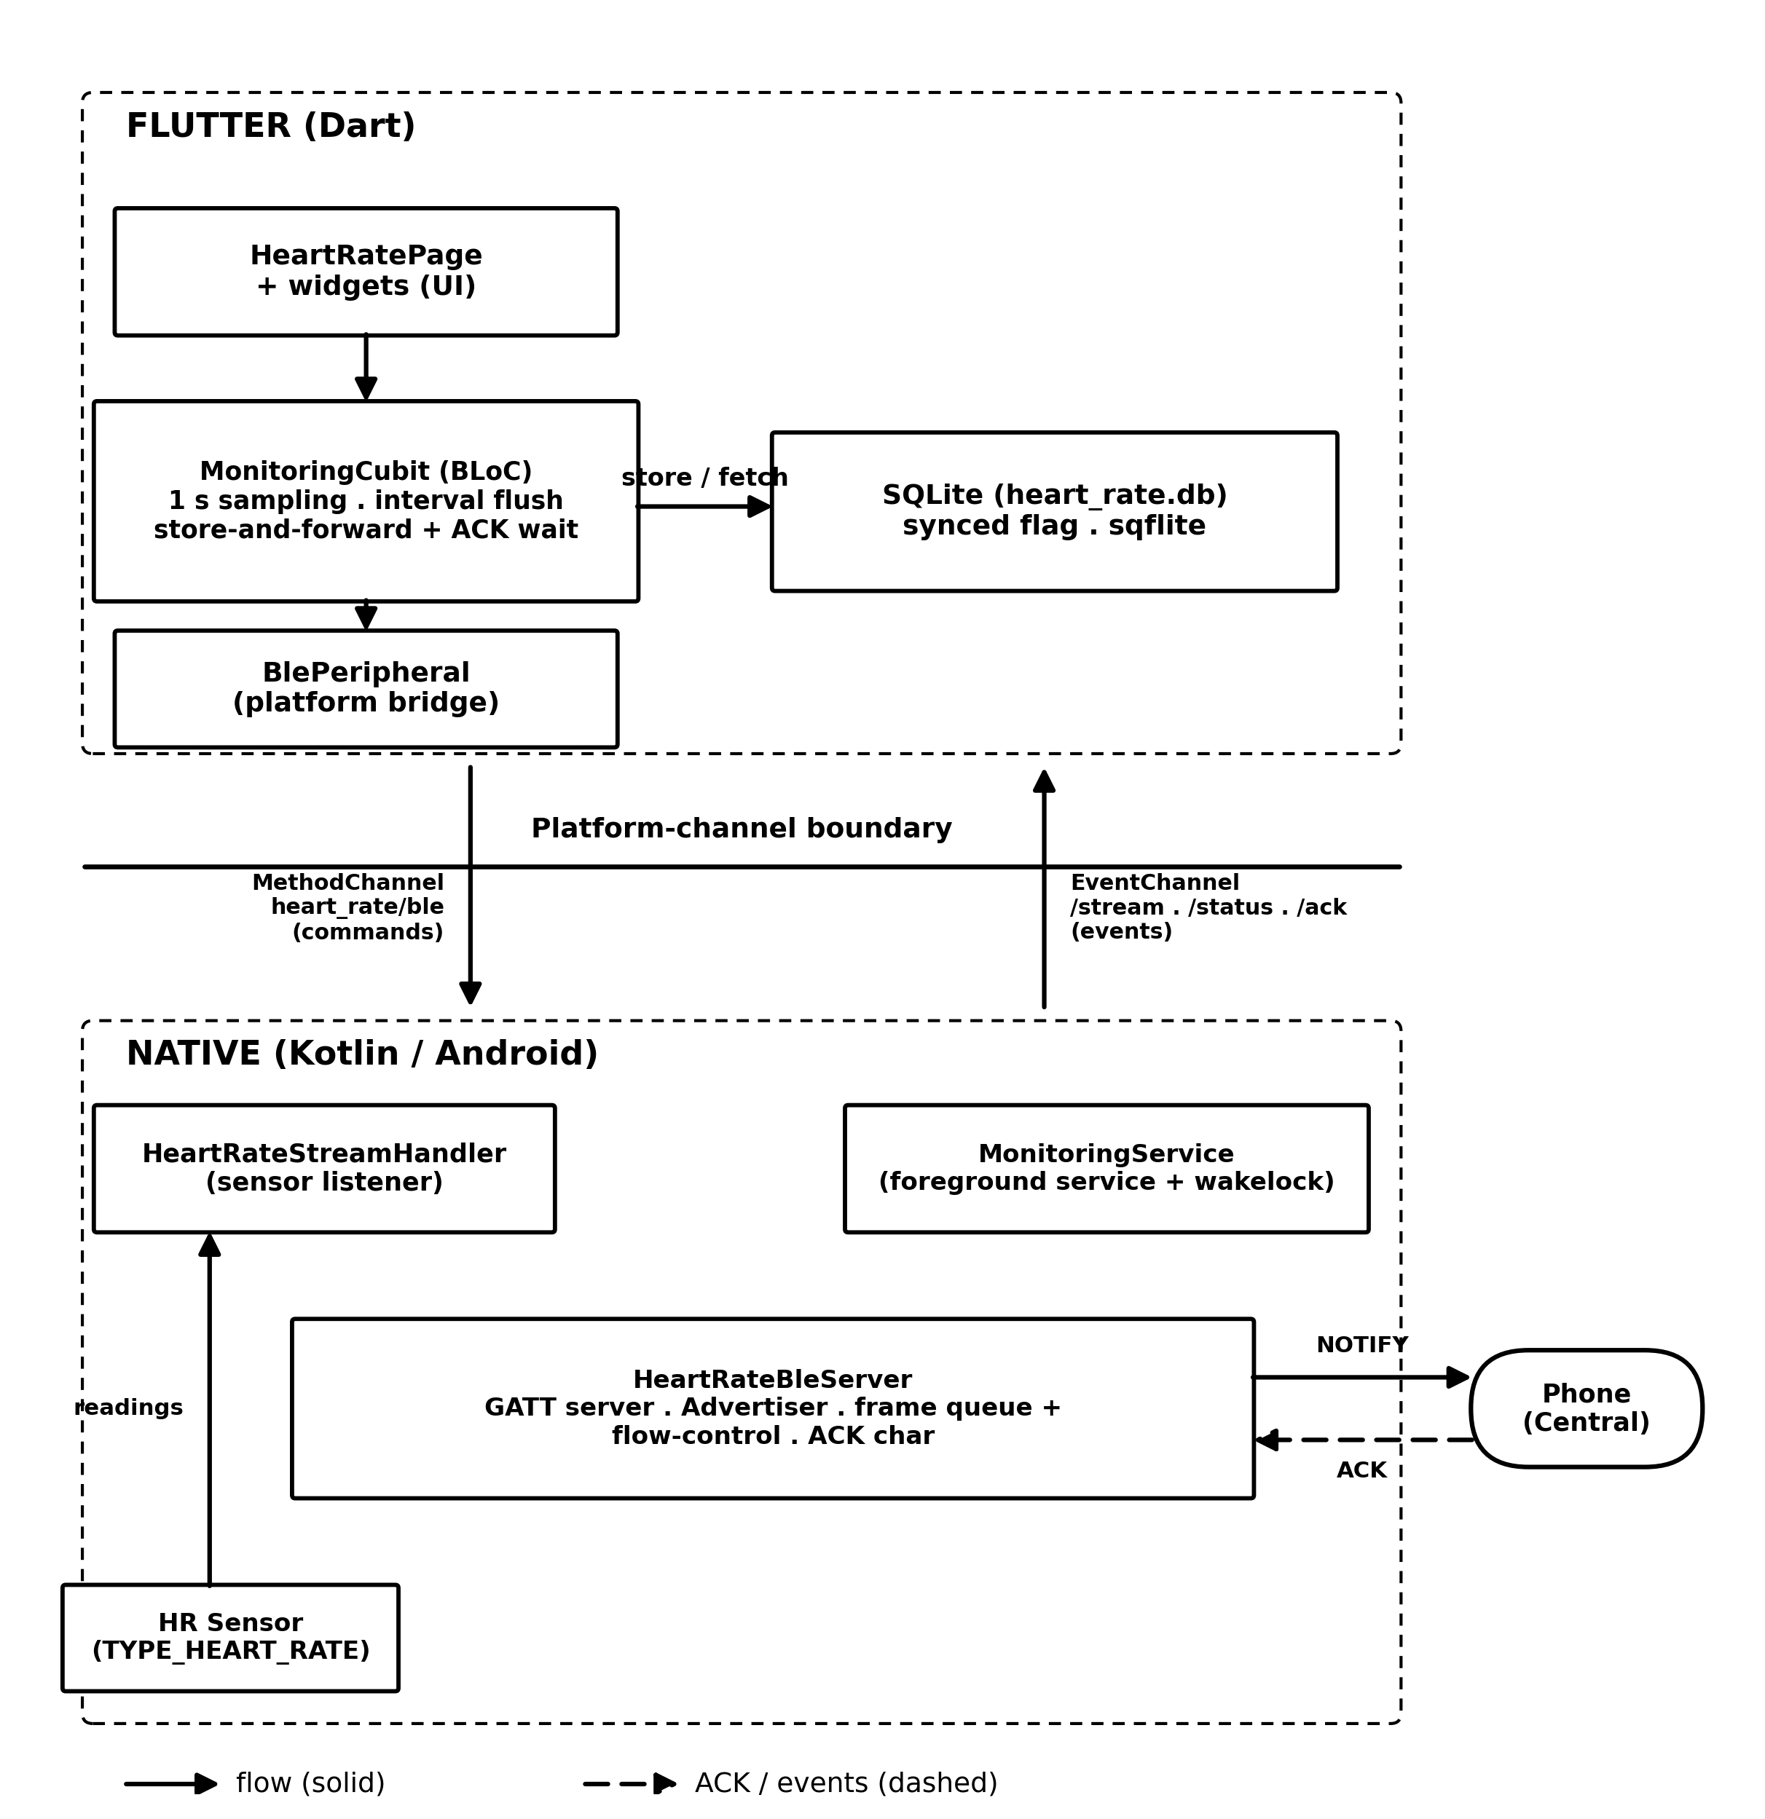
Figure 5. Internal architecture of the smartwatch application (Flutter–Native boundary).
2.5 Devices and Test Scenario
Testing was conducted on physical devices because BLE communication cannot be emulated. The device specifications are listed in Table 1. The applications were installed in release mode so that performance measurements are not biased by debug mode. In one run, the smartphone connects to the smartwatch, monitoring is started and left running for several intervals, and the data is then exported to CSV and database formats for analysis.
Table 1. Device and test-environment specifications.
Component | Specification
Smartwatch (peripheral) | Samsung Galaxy Watch (SM-R860), Wear OS
Smartphone (central) | Xiaomi Redmi Note 10 Pro (M2101K6G), Android 13
Framework | Flutter 3.41.4; Dart SDK ^3.11.1
Main libraries | flutter_blue_plus, sqflite, flutter_bloc, permission_handler
Requested MTU | 512 bytes
Sending interval | 3 / 5 minutes (selectable)

2.6 Evaluation Metrics
The measured metrics are: (1) delivery ratio, i.e., the number of records matched at the smartphone divided by the number of records recorded by the smartwatch, with matching based on the time attribute so it does not depend on clock synchronization between devices; (2) the number of duplicates at the receiver; (3) the sensor-accuracy distribution following the accuracy-status constants of the Android SensorManager (range -1 to 3) [2]; and (4) per-batch transfer latency and throughput recorded automatically by the application instrumentation. Throughput is computed as the payload size divided by the transfer duration.
3. Results and Discussion
3.1 End-to-End Functional Verification
Functional testing showed that the connection sequence works as designed: the smartwatch advertises the service, the smartphone scans and connects, the 512-byte MTU negotiation succeeds, notifications are enabled, and one batch is delivered intact and then confirmed with an ACK. This demonstrates that the framing protocol and the acknowledgement mechanism work end-to-end on real devices.
3.2 Delivery Ratio
In a single continuous ~36-minute session, the results in Table 2 were obtained. The smartwatch recorded 2,167 readings and 2,164 of them were successfully received by the smartphone, yielding a 99.86% delivery ratio with no duplicates. The three readings that did not arrive were not lost but were still pending at the time the data was captured and would be sent in the next interval—confirming that the store-and-forward mechanism works as intended. All received data was identical to the smartwatch records based on time matching, so data integrity was preserved.
Table 2. Delivery results for one test session.
Indicator | Value
Session duration | ~36 minutes
Recorded on smartwatch | 2,167 readings
Marked as sent (synced) | 2,164 readings
Received on smartphone | 2,164 readings
Duplicates on smartphone | 0
Delivery ratio | 99.86%

3.3 Sensor Data Quality
The sensor-accuracy distribution is shown in Table 3. 99.1% of readings were at the highest accuracy (value 3), and only 0.9% (20 readings) were at the no-contact condition (value -1), which commonly occurs when the sensor momentarily loses skin contact [2]. No readings were at low accuracy (0–2). The heart-rate statistics for the session were: minimum 71 bpm, maximum 96 bpm, mean 80.4 bpm, and standard deviation 5.2 bpm. The distribution being strongly dominated by the highest accuracy indicates good data quality.
Table 3. Distribution of sensor-accuracy values.
Sensor accuracy | Count | Percentage
3 (high) | 2,147 | 99.1%
-1 (no contact) | 20 | 0.9%
Total | 2,167 | 100%

3.4 Transfer Performance
As an illustration of per-batch performance, one batch of 228 readings (10,717-byte payload) was fragmented into 24 frames and delivered in ~0.32 s (323.1 ms) at MTU 512, equivalent to a throughput of ~33 KB/s. On the receiver side, frame reassembly took ~250 ms and storing the batch to the database took ~56 ms. These values show that batch transfer is fast relative to the sending interval (minutes). Aggregate measurements across varied conditions (different batch sizes due to 3- vs 5-minute intervals, device distance, and disruption scenarios) are part of future work. [[Complete with replication results table/charts.]]
3.5 Discussion and Limitations
The results show that the combination of store-and-forward, ACK, and an idempotent receiver can preserve data completeness and integrity under normal conditions, while opcode-based framing with flow control overcomes the BLE notification size limit. Time-based matching makes the delivery computation independent of clock synchronization.
This study has several limitations. First, the evaluation is still based on a single session, so replication and varied conditions are needed to obtain representative means and standard deviations. Second, background execution covers the application being in the background and the screen off, but does not yet guarantee operation when the application is force-closed or after a device reboot, which is also constrained by OS power-saving policies. Third, the BLE communication does not yet apply encryption/authentication, so the security of health data is a development agenda. Fourth, the sensor on a consumer smartwatch is not clinically validated, so the contribution focuses on communication reliability rather than the medical accuracy of the heart-rate values.
4. Conclusion
This study designed and implemented a BLE-based heart-rate data delivery system from a smartwatch to a smartphone using batch framing, store-and-forward, delivery acknowledgement (ACK), an idempotent receiver, and background execution. Testing on physical devices showed a 99.86% delivery ratio with no duplicates in a single ~36-minute session, with 99.1% of data at the highest accuracy, and fast batch transfer (~0.32 s for 228 readings at MTU 512). Future work includes formal measurement across varied conditions with replication, strengthening background execution (including auto-start after reboot), and adding encryption for data security.
Acknowledgement
[[Optional: acknowledgement to advisor/institution/funding.]]
References
[1] Bluetooth SIG, “Bluetooth Core Specification,” Bluetooth Special Interest Group. [Online]. Available: https://www.bluetooth.com/specifications/specs/
[2] Android Developers, “SensorManager,” Android API Reference. [Online]. Available: https://developer.android.com/reference/android/hardware/SensorManager
[3] Android Developers, “Foreground services,” Android Developers Guide. [Online]. Available: https://developer.android.com/develop/background-work/services/foreground-services
[4] “flutter_blue_plus,” pub.dev. [Online]. Available: https://pub.dev/packages/flutter_blue_plus
[5] “sqflite,” pub.dev. [Online]. Available: https://pub.dev/packages/sqflite
[6] “flutter_bloc,” pub.dev. [Online]. Available: https://pub.dev/packages/flutter_bloc
[7] [[Add citation: Internet of Medical Things (IoMT) survey/article.]]
[8] [[Add citation: wearable/BLE-based heart-rate monitoring study.]]
[9] [[Add citation: store-and-forward / data delivery reliability in IoT.]]
[10] [[Add citation: Wireless Body Area Network (WBAN) / mHealth.]]
Note: this is a draft. Adapt it to the target SINTA-2 journal template (column format, citation style, page limit). Items marked [[...]] must be completed by the author.

