Reliable Heart Rate Data Delivery over Bluetooth Low Energy: A Store-and-Forward and Acknowledgement Scheme for Smartwatches

Abstract.
Purpose: To guarantee data completeness and reliability when continuous heart-rate readings are transferred from a wearable device (smartwatch) to a smartphone over Bluetooth Low Energy (BLE), specifically addressing the challenges of limited packet size (MTU), the best effort nature of BLE notifications, and operating system restrictions on background execution.
Methods: The study designed and implemented a two-application system, a Wear OS smartwatch (BLE peripheral/GATT server) that records heart rate every second into a local database, and an Android smartphone (central) that receives the data in periodic batches. To ensure reliability, the system utilizes batch fragmentation into opcode-tagged frames (START/DATA/END) with flow control, a store-and-forward scheme, application-level acknowledgement (ACK), an idempotent (duplicate-free) receiver, and a foreground service for background operation. The system was evaluated on physical devices across four sessions.
Result: From a total of 23,215 valid measurement readings, data loss was near zero with 100% value fidelity and no duplicates while the BLE link was active. Transmission was fast, delivering one batch of 228 readings (10,717 bytes) in approximately 0.32 seconds at MTU 512, and 90.8% of readings achieved the highest sensor accuracy level. However, an issue emerged during disconnected periods where the backlog was not always backfilled, resulting in an aggregate delivery ratio of 88.1% across all sessions.
Novelty: The research provides a practical, application-level mechanism that successfully preserves data integrity and completeness over an inherently best effort BLE connection for Internet of Medical Things (IoMT) applications. It demonstrates a working architecture for high-fidelity data transfer while clearly identifying specific limitations in handling disconnected state backlogs, which provides a concrete direction for future protocol improvements.

Keywords: Bluetooth Low Energy, heart rate, IoMT, store-and-forward, Wear OS

INTRODUCTION
The use of wearable devices for continuous health monitoring has grown rapidly along with the Internet of Medical Things (IoMT), a network of medical/health devices that collect and exchange physiological data [1], [2]. A smartwatch equipped with an optical heart-rate sensor can act as a sensor node, while a smartphone serves as a gateway that collects, stores, and forwards the data for further analysis [3], [4].
Bluetooth Low Energy (BLE) is a primary choice of communication channel in this scenario because of its low power consumption [5], [6], [7]. However, delivering complete health data over BLE faces several challenges the size of a single notification is bounded by the Maximum Transmission Unit (MTU), BLE notifications are best effort (no attribute-layer acknowledgement), and operating systems, especially Wear OS and phones with aggressive power management, restrict background processes [8]. In health applications, losing part of the data can degrade analysis quality, making data completeness an essential requirement [9].
Many prior implementations emphasize displaying the latest value in real time [10], [11]. Wan et al. [12] developed a wearable IoT system that transmits real time health data directly to a cloud server to eliminate the need for a smartphone gateway. Similarly, Manjunath et al. [13] developed a battery-free wearable multi-sensory patch that continuously transmits real-time data via BLE. However, these systems rely entirely on continuous transmission and lack a local store-and-forward mechanism on the wearable device. For instance, if the wireless connection or power source is briefly interrupted, the system resets and continuous data logging is lost. In direct-transmission architectures, the wearable device may not implement a local store-and-forward layer, prioritizing real-time delivery over buffering [14]. Furthermore, other studies note that power consumption remains a critical issue for sensor nodes relying on constant wireless connections [15]. Fadhel and Hasan [16] demonstrated that attempting to integrate strict delivery acknowledgements (ACK) into continuous real-time data streams often exacerbates network congestion, ultimately leading to severe transmission delays and significant packet loss when monitoring multiple patients. Similarly, recent IoT-based wearable frameworks designed for early disease detection, such as the system by Arivardhini and Kayalvizhi [17], rely heavily on continuous real-time streaming to evaluate cardiovascular risks. Across these implementations: a common limitation persists, none of them guarantee that all readings are successfully stored at the receiver if the connection is briefly lost or if the receiver application is stopped or halted by the mobile operating system's strict background execution limits [18], [19]. A mechanism that guarantees data completeness is therefore needed, combining temporary storage (store-and-forward), delivery acknowledgement, duplicate prevention, and background operation [20].
This work contributes a comprehensive dual-application Wear OS and Android system designed for the robust acquisition and delivery of heart-rate data. The system operates on a batch delivery protocol over BLE notifications using opcode-based framing with flow control. By integrating a store-and-forward mechanism, application-level acknowledgments (ACK), and an idempotent receiver, we establish a highly reliable, duplicate-free data pipeline that is sustained continuously in the background via a foreground service. Ultimately, the system's effectiveness is demonstrated through an empirical evaluation across four sessions. This assessment measures delivery ratio, value fidelity, data quality, and transfer performance revealing a store-and-forward backfill limitation during temporary disconnections and provides supporting open data tools for research reproducibility.
METHODS
This study follows a design-and-implementation approach, followed by testing on physical devices. This section describes the system architecture, the communication protocol, the reliability mechanisms, the application architecture, and the evaluation procedure and metrics.
System Architecture
The system comprises two devices, as shown in Figure 1. The smartwatch acts as a peripheral/GATT server, the heartrate sensor is read by native code, forwarded to the application layer, stored in a local SQLite database, and then advertised and sent over BLE. The smartphone acts as a central/GATT client it scans, connects, subscribes to notifications, reassembles the batch, stores it in SQLite, and provides data export.
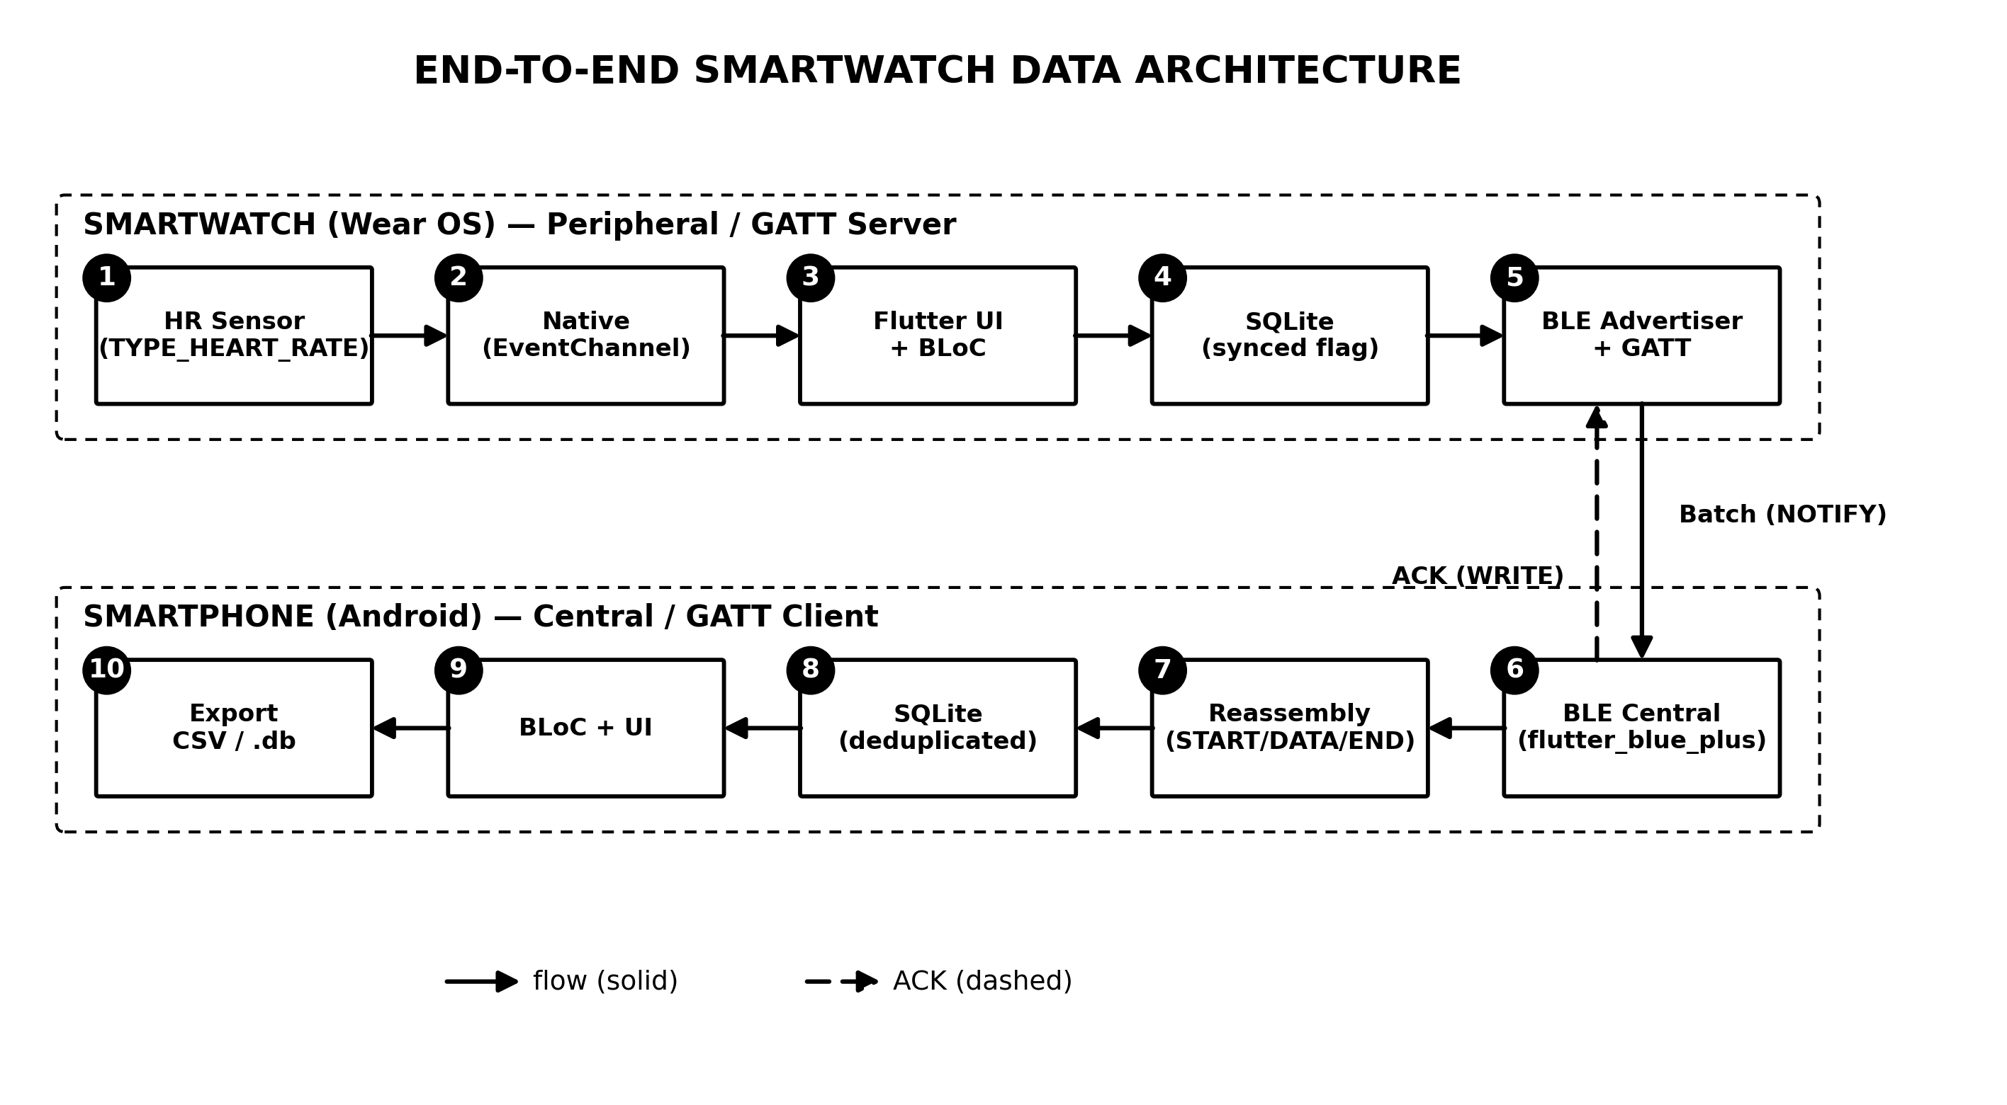
Figure 1. Two-device system architecture
In the figure, the left column shows the five smartwatch components sensor, native code, application layer, SQLite, and the BLE advertiser/GATT server flowing from acquisition to transmission, while the right column shows the five smartphone components from BLE reception to data export. The bridge on the bottom row depicts the two communication directions, data batches via NOTIFY from the smartwatch to the smartphone, and the ACK confirmation via WRITE in the opposite direction.
Communication Protocol and Framing
Communication uses a dedicated GATT service with a record characteristic of the notify type [21]. After connecting, the smartphone requests a 512-byte MTU and enables notifications. Because one batch contains many readings whose size exceeds the capacity of a single notification, the batch is fragmented into a sequence of frames, each prefixed with an opcode START (0x01), DATA (0x02), and END (0x03), as shown in Figure 2. The data chunk per frame is MTU minus 4 bytes (3 bytes of ATT header and 1 byte of opcode) [22]. Inter-frame transmission is flow-controlled the next frame is sent only after the send-completion callback of the previous frame [23]. The receiver reassembles the frames into a complete JSON payload. The full interaction sequence is shown in Figure 3.
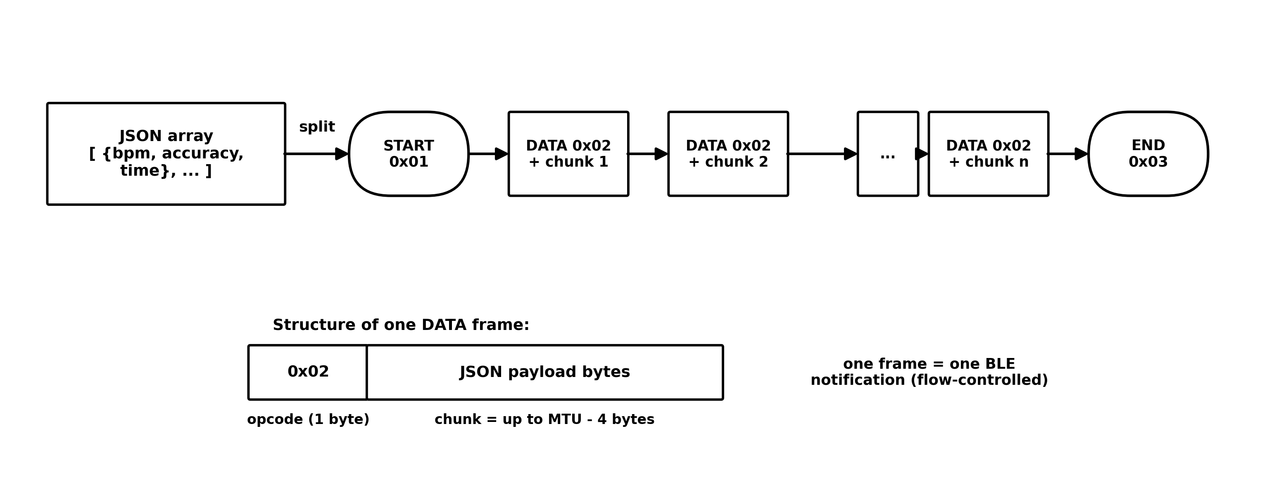
Figure 2. Fragmentation of one JSON batch into BLE frames (START/DATA/END)
The figure shows one batch a JSON array of bpm, accuracy, and time being split into a sequence of frames opened by START, followed by a few DATA frames each carrying one payload chunk, and closed by END. The inset at the bottom shows the structure of a single DATA frame a one-byte opcode followed by a chunk of at most MTU-4 bytes and each frame is sent as one BLE notification.
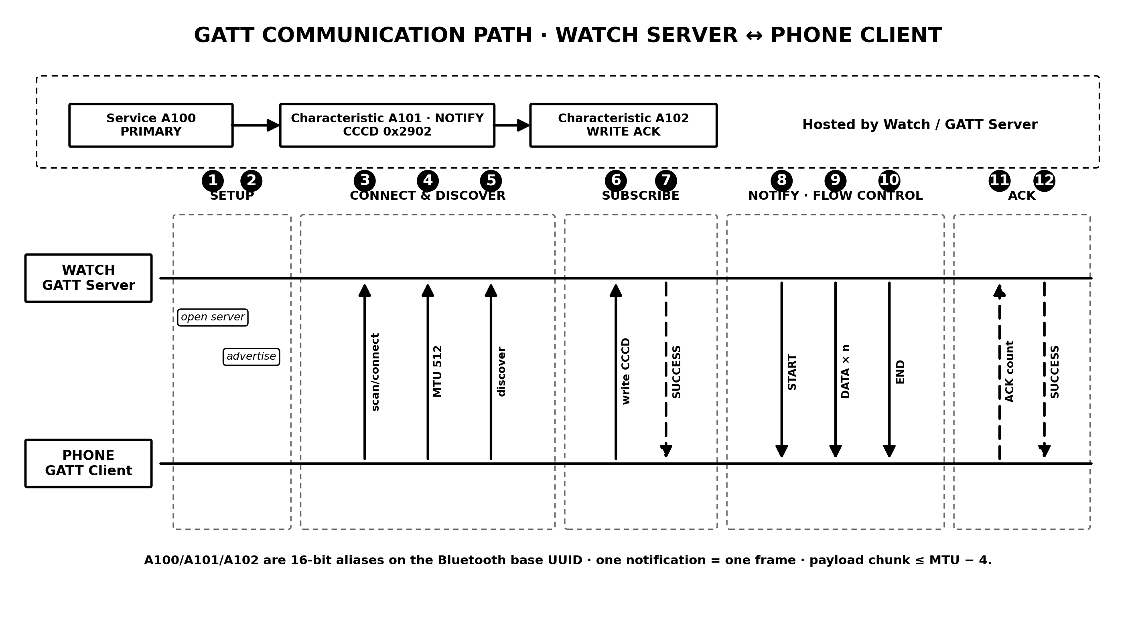
Figure 3. BLE communication sequence setup, batch transfer, and ACK
The sequence diagram reads top to bottom in three phases. Connection setup, the smartwatch advertises, the smartphone scans and connects, requests a 512-byte MTU, and enables notifications. Transfer the batch is sent as a START-DATA-END sequence. Persistence and acknowledgement the smartphone stores the batch in its database and writes the ACK, upon which the smartwatch marks the records as sent.

Store-and-Forward and Acknowledgement (ACK)
Each reading is stored on the smartwatch with a send status flag (synced = 0). Periodically (a selectable interval, e.g., 3 or 5 minutes), all not-yet-sent records are retrieved and transmitted as a single batch [24]. To guarantee that data is received, the smartphone writes an acknowledgement (ACK) containing the number of successfully stored records to a dedicated characteristic, the smartwatch marks records as sent (synced = 1) only after the ACK is received. If no ACK arrives within a timeout (30 s), the records remain not-yet-sent and are retransmitted in the next interval [25]. To prevent duplicates caused by retransmission, the receiver is made idempotent through a unique index on the time attribute, so repeated delivery does not create duplicate rows. The complete flow is shown in Figure 4.
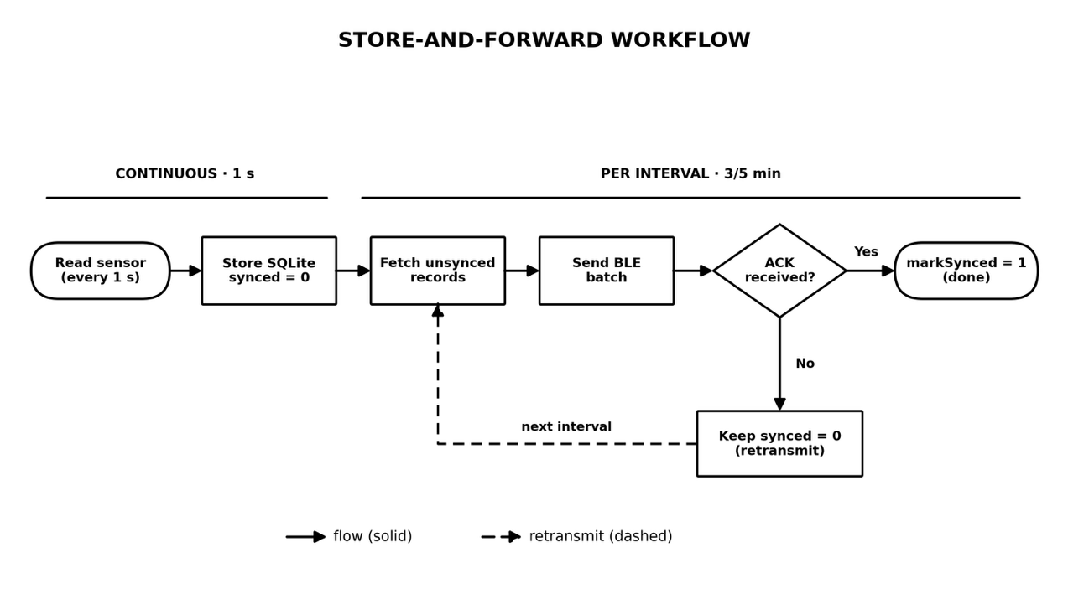
Figure 4. Store-and-forward flow with delivery ACK
The flow in the figure spans two different time scales, sensor readings are stored every second (continuous), whereas fetching unsent records, sending the batch, and awaiting the ACK run per interval (3/5 minutes). The ACK decision branch captures the core of the reliability mechanism, if the ACK is received the records are marked as sent otherwise, they remain unsent and are retransmitted in the next interval.
Smartwatch Application Architecture
The smartwatch application is built with Flutter, with a clear separation between the Dart layer and the native (Kotlin) layer, as shown in Figure 5. The Dart layer uses the BLoC pattern the monitoring logic (per-second sampling, per-interval sending, store-and-forward, and waiting for ACK) is separated from the user interface [26]. The native layer hosts the sensor listener, the GATT server and advertiser, the frame queue and flow control, the ACK characteristic, and a foreground service that keeps the process alive when the application is in the background or the screen is off. The two layers communicate via platform channels.
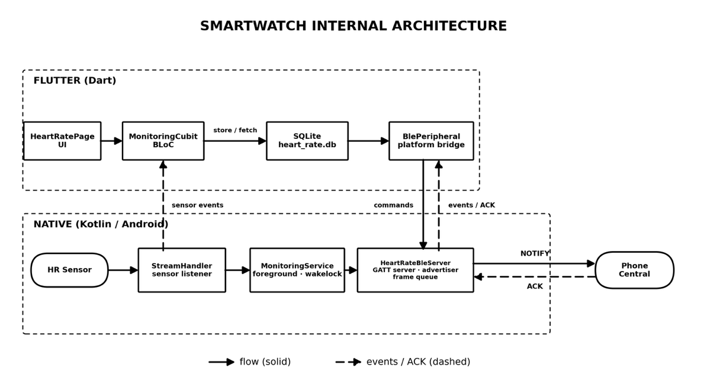
Figure 5. Internal architecture of the smartwatch application (Flutter–Native boundary)
The figure separates the two layers of the smartwatch application. The Dart layer contains the user interface, the monitoring logic in the BLoC pattern (per-second sampling, per-interval sending, ACK waiting), and SQLite access the native Kotlin layer contains the sensor listener, the GATT server with its frame queue and flow control, the ACK characteristic, and the foreground service. The two layers communicate via platform channels commands flow down through a MethodChannel and events flow up through EventChannels.
Devices and Test Scenario
Testing was conducted on physical devices because BLE communication cannot be emulated. The device specifications are listed in Table 1. The applications were installed in release mode so that performance measurements are not biased by debug mode. Testing was carried out over four sessions during 23-28 June 2026; in each run the smartphone connects to the smartwatch, monitoring is started and left running for several intervals, and the data from both applications is then exported to CSV and database formats for analysis. A total of 23,215 readings were collected during the measurement period (sensor worn).
Table 1. Device and test-environment specifications
Component | Specification
Smartwatch (peripheral) | Samsung Galaxy Watch (SM-R860), Wear OS
Smartphone (central) | Xiaomi Redmi Note 10 Pro (M2101K6G), Android 13
Framework | Flutter 3.41.4, Dart SDK ^3.11.1
Main libraries | flutter_blue_plus, sqflite, flutter_bloc, permission_handler
Requested MTU | 512 bytes
Sending interval | 3 / 5 minutes (selectable)
Test dataset | 23-28 Jun 2026, 4 sessions, 23,215 measurement readings

The table summarizes the controlled test environment, a consumer device pair Samsung Galaxy Watch SM-R860 as the peripheral and Xiaomi Redmi Note 10 Pro as the central, the Flutter framework with the applications installed in release mode, a requested MTU of 512 bytes, and a selectable 3/5-minute sending interval. The final dataset covers four sessions during 23-28 June 2026 with 23,215 measurement readings in total.
Evaluation Metrics
To comprehensively evaluate the system's performance, several key metrics were formulated. Delivery ratio quantifies the proportion of smartwatch-recorded data successfully matched at the smartphone. To eliminate dependencies on inter-device clock synchronization, this matching relies strictly on the recording timestamp. Value fidelity measures the percentage of received records that maintain identical data values (bpm and accuracy) compared to the original smartwatch logs. Furthermore, the evaluation tracks the number of duplicate records at the receiver and assesses overall data quality by mapping the sensor-accuracy distribution to the Android SensorManager status constants (range -1 to 3) [27]. Lastly, transfer performance is evaluated through per-batch latency and throughput calculated as payload size divided by transfer duration both of which are automatically logged by the application's instrumentation.
The time attribute utilized in these measurements refers to the smartwatch application's local recording timestamp, rather than the exact physiological time of a heartbeat. Operating at a sampling rate of approximately 1 Hz, the application logs the most recent sensor bpm reading alongside the device's current epoch time in milliseconds. Because this generated timestamp is strictly unique to each reading, it functions not only as the primary database key but also as the definitive baseline for watch-to-smartphone matching and duplicate prevention.
RESULT AND DISCUSSION
Functional testing showed that the connection sequence works as designed the smartwatch advertises the service, the smartphone scans and connects, the 512-byte MTU negotiation succeeds, notifications are enabled, and one batch is delivered intact and then confirmed with an ACK. This demonstrates that the framing protocol and the acknowledgement mechanism work end-to-end on real devices.
Delivery Ratio
The evaluation was carried out over four test sessions, with per-session results in Table 2 and their temporal profiles in Figure 6 and Figure 7. In aggregate, the smartwatch recorded 23,215 readings during the measurement period and 20,455 of them were recorded on the smartphone (88.1% delivery ratio) with no duplicates. However, the loss was not evenly distributed: while the BLE link was active, loss was near zero (e.g., after the smartphone connected in the main session, delivery was practically 100%), whereas all losses were concentrated in periods when the smartphone was disconnected including one short session whose smartphone never connected, so none of its readings were stored at the receiver. Importantly, every successfully received reading was identical to the smartwatch record based on time matching, both bpm and accuracy values (100% value fidelity), so no data corruption occurred on the BLE channel. The discrepancy between the sent marker on the smartwatch and the presence of records on the smartphone is discussed in Section 3.5.
Table 2. Delivery results per test session
Session | Start (WIB) | Duration | Recorded | Received | Lost | Delivery
Session 1 | 23/06 06:38 | 36 min | 2,177 | 2,164 | 13 | 99.40%
Session 2 | 23/06 08:41 | 1 min | 53 | 0 | 53 | 0.00%
Session 3 | 23/06 14:15 | 345 min | 20,702 | 18,013 | 2,689 | 87.01%
Session 4 | 28/06 21:29 | 5 min | 283 | 278 | 5 | 98.23%
Total |  | 387 min | 23,215 | 20,455 | 2,760 | 88.11%

The table shows a wide range of per-session delivery (0.00-99.40%) the two fully connected sessions are nearly complete, Session 3 (the longest) drops to 87.01% due to its initial disconnected period, and Session 2 lost all of its 53 readings because the smartphone never connected. The temporal profile of these losses is visualised in Figure 6 and Figure 7.
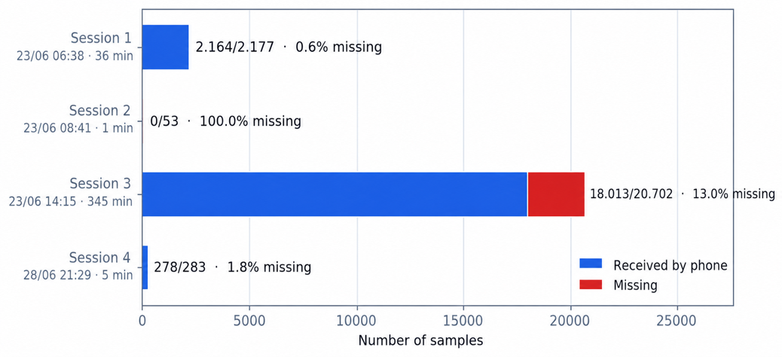
Figure 6. Data completeness per test session (received vs lost)
The chart compares the numbers of received and lost records in each session. Losses are concentrated in the longest session (Session 3) and in the session whose smartphone never connected (Session 2), while the other two sessions are nearly complete (99.40% and 98.23%, respectively).
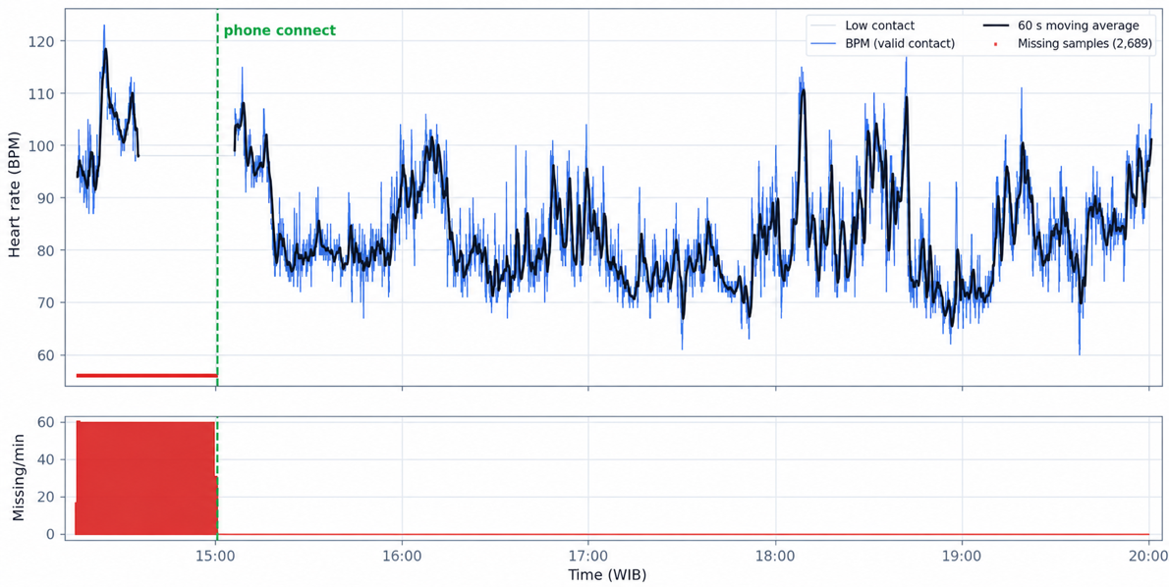
Figure 7. Heartrate signal and BLE packet loss in the main session
The figure plots the heart-rate signal of the main session together with markers of lost records. All losses occur before the smartphone connected at around 15:00 once the link was active, loss was practically zero. This pattern confirms that the losses were caused by the disconnected period rather than by the BLE channel.
Sensor Data Quality
The sensor accuracy distribution during the measurement period is shown in Table 3 and Figure 9. 90.8% of readings were at the highest accuracy (value 3), 9.1% (2,113 readings) at the no-contact condition (value -1) which commonly occurs when the sensor momentarily loses skin contact [2] and 0.1% (15 readings) at value 0. The heartrate statistics for the highest-accuracy readings (n=21,087, Figure 8) were minimum 60 bpm, maximum 123 bpm, mean 83.4 bpm, and standard deviation 9.9 bpm. Note that 22,231 samples in the tail of the recording with frozen (constant) values and accuracy ≤0 because the smartwatch was not worn were excluded from the statistics above to avoid biasing the results.
Table 3. Distribution of sensor-accuracy values (measurement period)
Sensor accuracy | Count | Percentage
3 (high) | 21,087 | 90.8%
0 (medium) | 15 | 0.1%
-1 (no contact) | 2,113 | 9.1%
Total |  | 100%

The table shows that contact quality is dominated by the highest level (90.8%), with 9.1% at no-contact and only 0.1% at the medium level. The distribution of heart-rate values for the best readings and the composition of contact quality are visualised in Figure 8 and Figure 9.
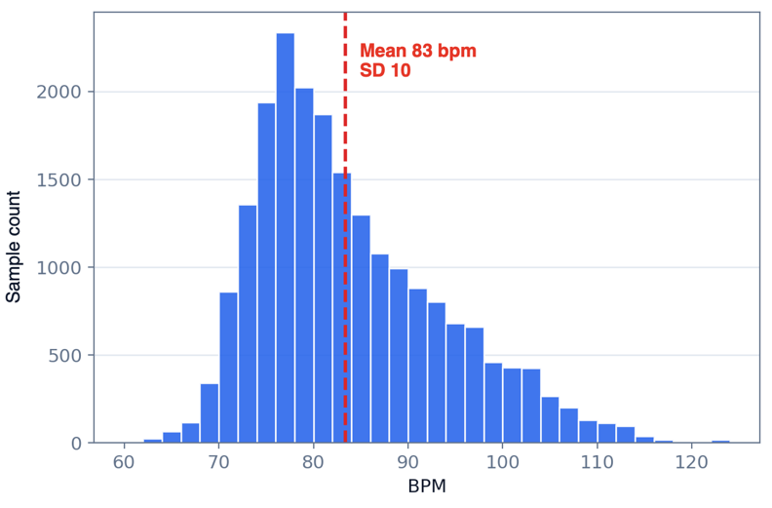
Figure 8. Distribution of heart-rate values for the highest-accuracy readings
The histogram shows the distribution of heart-rate values for the highest-accuracy readings (n = 21,087) centred around the mean of 83.4 bpm with a range of 60-123 bpm. This profile is reasonable for light activity and indicates physiologically plausible data rather than frozen values from an unworn sensor.
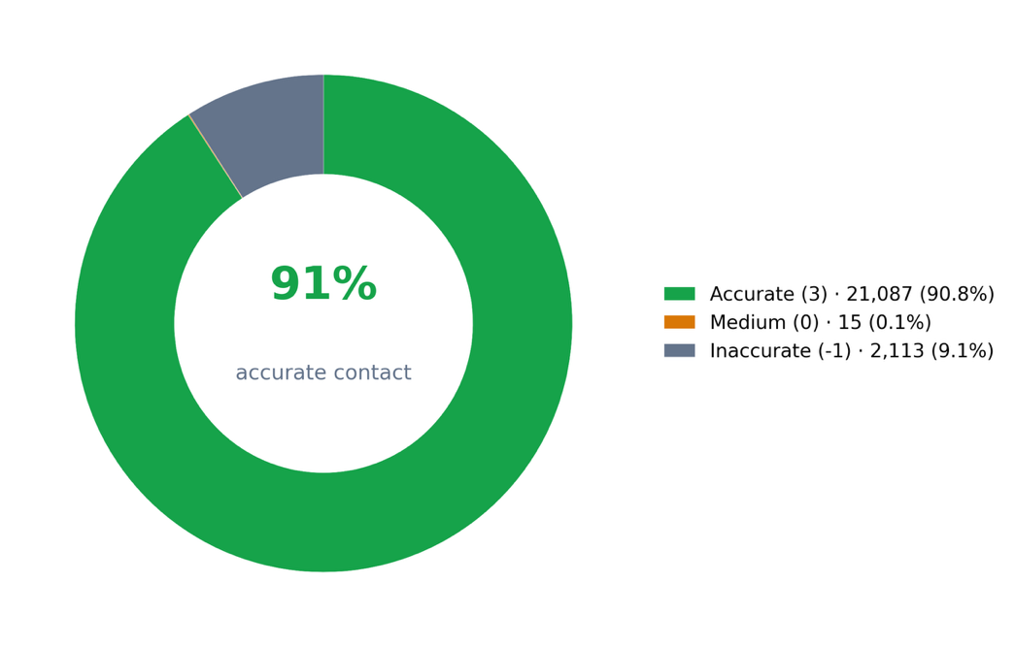
Figure 9. Sensor contact-quality distribution during the measurement period
The chart summarises the sensor contact quality during the measurement period many readings (90.8%) are at the highest accuracy level, 9.1% at no-contact, and 0.1% at the medium level reflecting the momentary contact losses that are common for wrist-worn optical sensors.
Transfer Performance
As an illustration of per-batch performance, one batch of 228 readings (10,717-byte payload) was fragmented into 24 frames and delivered in ~0.32 s (323.1 ms) at MTU 512, equivalent to a throughput of ~33 KB/s on the receiver side, frame reassembly took ~250 ms and storing the batch to the database took ~56 ms. From the same data, one serialized reading is ~47 bytes of JSON (10,717 ÷ 228), so a typical batch contains ~180 readings (~8.3 KB) for the 3-minute interval or ~300 readings (~13.8 KB) for the 5-minute interval. MTU negotiation on the tested device pair yielded the full 512 bytes (508-byte chunks), and the measured frame count matches the calculation 10,717 ÷ 508 = 21.1, rounded up to 22 DATA frames, plus START and END = 24 frames consistent with the instrumentation log. These values show that batch transfer is fast relative to the sending interval (minutes). Aggregate measurements across varied conditions (different batch sizes due to 3- vs 5-minute intervals, device distance, and disruption scenarios) are part of future work.
A cross-analysis between the send-status marker (synced) on the smartwatch and the presence of records on the smartphone computed over the same measurement period as Table 2 revealed an important finding. Of the 2,760 lost readings, 2,755 (99.8%) had been marked as sent (synced = 1) by the smartwatch yet were not found in the smartphone database; only the last 5 readings were genuinely still pending (awaiting the next interval). The loss in Table 2 therefore decomposes exactly into 2,755 falsely-marked-as-sent records plus 5 legitimately pending ones. All 2,755 records were lost during periods when the smartphone was disconnected including the 53 records of Session 2, whose smartphone never connected at all, the clearest evidence that the marking is applied prematurely. This indicates that, in the current implementation, the sent marking is applied at the notification-send level without being fully confirmed by an application-level ACK when the link is inactive, so the backlog accumulated during disconnection is not always retransmitted (backfilled) after the link recovers. Consequently, the store-and-forward mechanism preserves completeness well while the link is active but is not yet fully resilient to disconnect-reconnect scenarios. The recommended improvements are to defer the synced marking until an ACK is received and to add a backfill trigger that scans unconfirmed records whenever a connection is re-established. This finding reinforces the importance of application-level acknowledgement over relying on BLE notifications alone.
When computed over the entire smartwatch recording (45,446 rows, including the not-worn period), the number of marked-as-sent records missing from the smartphone is 2,879 (45,446 − 42,562 = 2,884, minus 5 pending records); the 2,755 figure above is the portion of these that falls within the valid measurement period, and is therefore consistent with Table 2.
The results show that the combination of store-and-forward, ACK, and an idempotent receiver can preserve data completeness and integrity while the BLE link is active evidenced by 100% value fidelity and near-zero loss when connected while opcode-based framing with flow control overcomes the BLE notification size limit. Time-based matching makes the delivery computation independent of clock synchronization. Conversely, as discussed in Section 3.5, reliability degrades in disconnect scenarios, so backlog backfill needs to be strengthened.
This study has several limitations. First, the evaluation spans four sessions on a single device pair and a single environment, so replication across devices, distances, and interference conditions is needed to obtain representative means and standard deviations. Second, it was found that the backlog during disconnection is not always backfilled (Section 3.5) strengthening the ACK and backfill trigger is a priority improvement. Third, background execution covers the application being in the background and the screen off, but does not yet guarantee operation when the application is force-closed or after a device reboot, which is also constrained by OS power-saving policies. Fourth, the BLE communication does not yet apply encryption/authentication, so the security of health data is a development agenda. Fifth, the sensor on a consumer smartwatch is not clinically validated, so the contribution focuses on communication reliability rather than the medical accuracy of the heart-rate values.
CONCLUSION
This study designed and implemented a BLE based heart-rate data delivery system from a smartwatch to a smartphone using batch framing, store-and-forward, delivery acknowledgement (ACK), an idempotent receiver, and background execution. Testing on physical devices across four sessions (23,215 readings in total) showed high data integrity 100% value fidelity and near-zero loss while the BLE link was active with 90.8% of data at the highest accuracy and fast batch transfer ~0.32 s for 228 readings at MTU 512. The evaluation also revealed a limitation: during disconnection periods the backlog was not always backfilled, so the aggregate delivery ratio was 88.1%. Future work includes strengthening the backfill and ACK mechanisms for disconnect-reconnect resilience, formal measurement across varied conditions with replication, strengthening background execution including auto-start after reboot, and adding encryption for data security.

REFERENCES
[1] P. He et al., “A survey of Internet of medical things: technology, application and future directions,” Digital Communications and Networks, vol. 12, no. 5, pp. 717–742, May 2026, doi: 10.1016/j.dcan.2024.11.013.
[2] C. Huang, J. Wang, S. Wang, and Y. Zhang, “Internet of medical things: A systematic review,” Neurocomputing, vol. 557, p. 126719, Nov. 2023, doi: 10.1016/j.neucom.2023.126719.
[3] K. T. Putra et al., “A Review on the Application of Internet of Medical Things in Wearable Personal Health Monitoring: A Cloud-Edge Artificial Intelligence Approach,” IEEE Access, vol. 12, pp. 21437–21452, 2024, doi: 10.1109/ACCESS.2024.3358827.
[4] S. F. Ahmed, Md. S. Bin Alam, S. Afrin, S. J. Rafa, N. Rafa, and A. H. Gandomi, “Insights into Internet of Medical Things (IoMT): Data fusion, security issues and potential solutions,” Information Fusion, vol. 102, p. 102060, Feb. 2024, doi: 10.1016/j.inffus.2023.102060.
[5] Z. Zhou and H.-W. Huang, “Closed-Loop Transmission Power Control for Reliable and Low-Power BLE Communication in Dynamic IoT Settings,” IEEE Internet Things J., vol. 13, no. 1, pp. 1216–1228, Jan. 2026, doi: 10.1109/JIOT.2025.3627414.
[6] R. Verma and S. Kumar, “Insights into BLE 5.x Data Transfer Modes for IoT-Empowered Remote Patient Monitoring,” IEEE Internet of Things Magazine, vol. 8, no. 4, pp. 52–59, Jul. 2025, doi: 10.1109/IOTM.001.2400267.
[7] G. Wandwi and C. Wandwi, “Intergrating IoT and Wearable Technologies in Internal Medicine for Remote Monitoring,” Journal of Sensors, IoT & Health Sciences, vol. 4, no. 1, pp. 82–97, Mar. 2026, doi: 10.69996/jsihs.2026005.
[8] F. Battaglia, G. Gugliandolo, G. Campobello, and N. Donato, “EEG-Over-BLE: A Low-Latency, Reliable, and Low-Power Architecture for Multichannel EEG Monitoring Systems,” IEEE Trans. Instrum. Meas., vol. 72, pp. 1–10, 2023, doi: 10.1109/TIM.2023.3268471.
[9] J. Van Der Donckt et al., “Mitigating data quality challenges in ambulatory wrist-worn wearable monitoring through analytical and practical approaches,” Sci. Rep., vol. 14, no. 1, p. 17545, Jul. 2024, doi: 10.1038/s41598-024-67767-3.
[10] A. González-Pérez, M. Matey-Sanz, C. Granell, L. Díaz-Sanahuja, J. Bretón-López, and S. Casteleyn, “AwarNS: A framework for developing context-aware reactive mobile applications for health and mental health,” J. Biomed. Inform., vol. 141, p. 104359, May 2023, doi: 10.1016/j.jbi.2023.104359.
[11] O. Alruwaili, A. Yousef, and A. Armghan, “Monitoring the Transmission of Data From Wearable Sensors Using Probabilistic Transfer Learning,” IEEE Access, vol. 12, pp. 97460–97475, 2024, doi: 10.1109/ACCESS.2024.3428444.
[12] J. Wan et al., “Wearable IoT enabled real-time health monitoring system,” EURASIP J. Wirel. Commun. Netw., vol. 2018, no. 1, Dec. 2018, doi: 10.1186/s13638-018-1308-x.
[13] B. B. Manjunath et al., “Battery-free, wireless, and skin-mountable multi-sensory patch for biosignal monitoring,” Sens. Actuators A Phys., vol. 404, Jul. 2026, doi: 10.1016/j.sna.2026.117751.
[14] C. Y. Kim et al., “Wireless Technologies for Wearable Electronics: A Review,” Jul. 01, 2025, John Wiley and Sons Inc. doi: 10.1002/aelm.202400884.
[15] S. Gautam and S. Kumar, “BLE Periodic Advertising-Based Energy-Efficient Sensor Node Operation for Transfer of Large Data in Monitoring Applications,” IEEE Internet Things J., vol. 11, no. 24, pp. 40070–40085, Dec. 2024, doi: 10.1109/JIOT.2024.3451698.
[16] A. A. Fadhel and H. M. Hasan, “Reducing Delay and Packets Loss in IoT-Cloud Based ECG Monitoring by Gaussian Modeling,” International journal of online and biomedical engineering, vol. 19, no. 6, pp. 97–113, 2023, doi: 10.3991/ijoe.v19i06.38581.
[17] Arivardhini and Kayalvizhi, “IoT-Based Wearable Health Monitoring System for Early Detection of Cardiovascular Disease.” [Online]. Available: https://ssrn.com/abstract=5790382
[18] M. Domingues, J. N. Faria, and D. Portugal, “Dimensioning payload size for fast retransmission of MQTT packets in the wake of network disconnections,” EURASIP J. Wirel. Commun. Netw., vol. 2024, no. 1, Dec. 2024, doi: 10.1186/s13638-023-02327-3.
[19] F. Franco, L. Lamazzi, F. Poggi, and L. Bedogni, “Evaluating Bluetooth Low Energy Connection Reliability for Mobile Health Applications,” in 2026 IEEE 23rd Consumer Communications &amp; Networking Conference (CCNC), IEEE, Jan. 2026, pp. 1–6. doi: 10.1109/CCNC65079.2026.11366362.
[20] C. Slade, Y. Sun, W. C. Chao, C.-C. Chen, R. M. Benzo, and P. Washington, “Current challenges and opportunities in active and passive data collection for mobile health sensing: a scoping review,” JAMIA Open, vol. 8, no. 4, Jul. 2025, doi: 10.1093/jamiaopen/ooaf025.
[21] C. Hirsch, L. Davoli, R. Grosu, and G. Ferrari, “DynGATT: A dynamic GATT-based data synchronization protocol for BLE networks,” Computer Networks, vol. 222, Feb. 2023, doi: 10.1016/j.comnet.2023.109560.
[22] M. Baert, B. Moons, J. Pittevils, Y. Song, N. Madhu, and J. Hoebeke, “Evaluation of BLE-based audio broadcasting under probabilistic interference,” Comput. Commun., vol. 222, pp. 130–140, Jun. 2024, doi: 10.1016/j.comcom.2024.04.034.
[23] D. F. S. Santos, M. M. Bezerra, W. D. P. da Silva, H. O. Almeida, and A. Perkusich, “CrediBLE: A Credit-Based Adaptive Flow Control Architecture for Bluetooth Low-Energy Gateways,” IEEE Access, vol. 14, pp. 92942–92965, 2026, doi: 10.1109/ACCESS.2026.3705713.
[24] Y. Li, J. Lv, B. Li, and W. Dong, “RT-BLE: Real-time Multi-Connection Scheduling for Bluetooth Low Energy,” in IEEE INFOCOM 2023 - IEEE Conference on Computer Communications, IEEE, May 2023, pp. 1–10. doi: 10.1109/INFOCOM53939.2023.10229006.
[25] N. Landra, D. Demarchi, and P. M. Ros, “SharkTooth: A Scalable Real-Time Algorithm for BLE-Based Wireless Body Sensor Networks Synchronization,” IEEE Internet Things J., vol. 12, no. 22, pp. 46174–46192, Nov. 2025, doi: 10.1109/JIOT.2025.3602162.
[26] Sanghmitra, “The State Management Dilemma: BLoC vs. Provider in Modern Flutter Development,” International Journal of Scientific Research in Computer Science, Engineering and Information Technology, vol. 10, no. 5, pp. 326–336, Oct. 2024, doi: 10.32628/cseit241051027.
[27] Google, “SensorManager,” Android Developer. Accessed: Jul. 27, 2026. [Online]. Available: https://developer.android.com/reference/android/hardware/SensorManager

