Heart-Rate Data Delivery from a Smartwatch to a Smartphone over Bluetooth Low Energy Using a Store-and-Forward Scheme with Acknowledgement
Faik Irkham¹, [[Advisor Name]]²
¹²[[Department/Study Program, Faculty, University, City, Indonesia]]
e-mail: faikirkham@gmail.com
Abstract
Continuous wearable heart-rate monitoring requires data delivery that preserves integrity despite the limited BLE notification size and intermittent connectivity. This study designs and implements a two-application system: a Wear OS smartwatch records one SQLite row per second and transmits opcode-framed batches as a peripheral/GATT server, while an Android smartphone reassembles the frames, persists the records idempotently, and returns an application-level acknowledgement (ACK). The system was tested on a consumer device pair across five sessions (23 June–5 July 2026; 25,191 measurement-period readings) spanning two software versions, so results are reported per version. The initial version, which marked records as sent without waiting for confirmation, achieved 88.31% delivery (20,455 of 23,162 records); a cross-analysis revealed that 2,702 of the 2,707 lost records (99.8%) were already flagged as synced and were therefore never rescheduled. After markSynced was revised to run only upon receiving an ACK, the revised-version session reached 99.90% (1,974 of 1,976 records) with no falsely flagged records; that session comprised eleven transmission batches and all seven instrumented batches were acknowledged. In both versions, every received record had bpm and accuracy values identical to the source (100% value fidelity) with no database duplicates. At MTU 512, a 180-record batch (8,461 bytes, 19 frames) was transferred in 121.5 ± 25.5 ms, equal to 0.07% of the 3-minute sending interval. The main contribution is the system design together with empirical evidence that marking send status ahead of confirmation is a removable source of data loss; the resilience of the revised version under controlled disconnect–reconnect scenarios still requires further testing.
Keywords: system design; IoMT; Bluetooth Low Energy; wearable; heart rate; store-and-forward; acknowledgement; Wear OS
1. Introduction
The use of wearable devices for continuous health monitoring has grown rapidly along with the Internet of Medical Things (IoMT), a network of medical and health devices that collect and exchange physiological data [1], [2]. A smartwatch equipped with an optical heart-rate sensor can act as a sensor node, while a smartphone serves as a gateway that collects, stores, and forwards the data for further analysis [3], [4].
Bluetooth Low Energy (BLE) is a primary choice of communication channel in this scenario because of its low power consumption [5], [6], [7]. However, delivering complete health data over BLE faces several challenges: the size of a single notification is bounded by the Maximum Transmission Unit (MTU) [8]; BLE notifications are best-effort, providing no attribute-layer acknowledgement [9]; and operating systems—especially Wear OS and phones with aggressive power management—restrict background processes [10]. In health applications, losing part of the data can degrade analysis quality, making data completeness an essential requirement [11].
Many prior implementations emphasise displaying the latest value in real time [12], [13]. Wan et al. [14] developed a wearable IoT system that transmits real-time health data directly to a cloud server, eliminating the smartphone gateway, and Manjunath et al. [15] presented a battery-free, skin-mountable multi-sensory patch that streams biosignals continuously over BLE. Such direct-transmission architectures prioritise real-time delivery over buffering and do not implement a local store-and-forward layer on the wearable device [16], so a brief interruption of the link or of the power source ends the continuous log. Power consumption also remains critical for sensor nodes that depend on a constantly maintained connection [17]. Moreover, Fadhel and Hasan [18] showed that adding strict delivery acknowledgements to a continuous real-time stream can aggravate congestion and produce severe delay and packet loss when several patients are monitored, while recent wearable frameworks for early cardiovascular-risk detection likewise rely on continuous streaming [19].
Other work addresses aspects adjacent to this study. At the protocol level, Balas et al. [20] observed the behaviour of BLE in a heart-rate monitoring application and showed that connection parameters affect the quality of data delivery. At the network level, Xiong and Jiang [21] developed a delay-tolerant routing protocol based on the store-carry-forward paradigm for intermittently connected networks, and the survey by Majumdar et al. [22] summarised reliability, robustness, and energy-efficiency approaches in wireless body area networks (WBANs). At the device level, the validation study by Schweizer and Gilgen-Ammann [23] confirmed that the accuracy of wrist-worn heart-rate sensors varies across activity conditions, so sensor contact quality should be reported alongside the data. Studies of disconnection handling in other protocol stacks [24] and of BLE connection reliability in mobile health [25] further indicate that link interruption, rather than payload corruption, dominates data loss.
Across these implementations a common limitation persists: none of them guarantees that every recorded reading is stored at the receiver when the connection is briefly lost or when the receiver application is stopped by the mobile operating system's background-execution limits [26]. What is needed is a mechanism that combines temporary storage (store-and-forward), delivery acknowledgement, duplicate prevention, and background operation, verified empirically on a consumer device pair — a Wear OS smartwatch and an Android smartphone — under disconnect–reconnect conditions, including confirmation that every recorded reading actually arrives at the receiver without duplication. This work fills that gap through the combination of store-and-forward, application-level acknowledgement (ACK), an idempotent receiver, and completeness evaluation based on timestamp matching.
The contributions of this work are: (1) the design and implementation of a two-application Wear OS–Android system for heart-rate acquisition and delivery; (2) an opcode-framed batch protocol over BLE notifications with flow control; (3) store-and-forward, application-level ACK, and idempotent receiver mechanisms; (4) background execution using foreground services; and (5) an empirical evaluation on physical devices that quantifies a concrete failure mode — marking send status ahead of receiver confirmation — together with the effect of removing it, supported by reproducible analysis tools.
2. Materials and Methods
This study follows a design-and-implementation approach, followed by testing on physical devices. This section describes the system architecture, the communication protocol, the reliability mechanisms, the application architecture, and the evaluation procedure and metrics.
A. System Architecture
The system comprises two devices, as shown in Figure 1. The smartwatch acts as a peripheral/GATT server: the heart-rate sensor is read by native code, forwarded to the application layer, stored in a local SQLite database, and then advertised and sent over BLE. The smartphone acts as a central/GATT client: it scans, connects, subscribes to notifications, reassembles the batch, stores it in SQLite, and provides data export. The data follows a numbered “U”-shaped flow (1–10), from acquisition on the smartwatch to export on the smartphone.
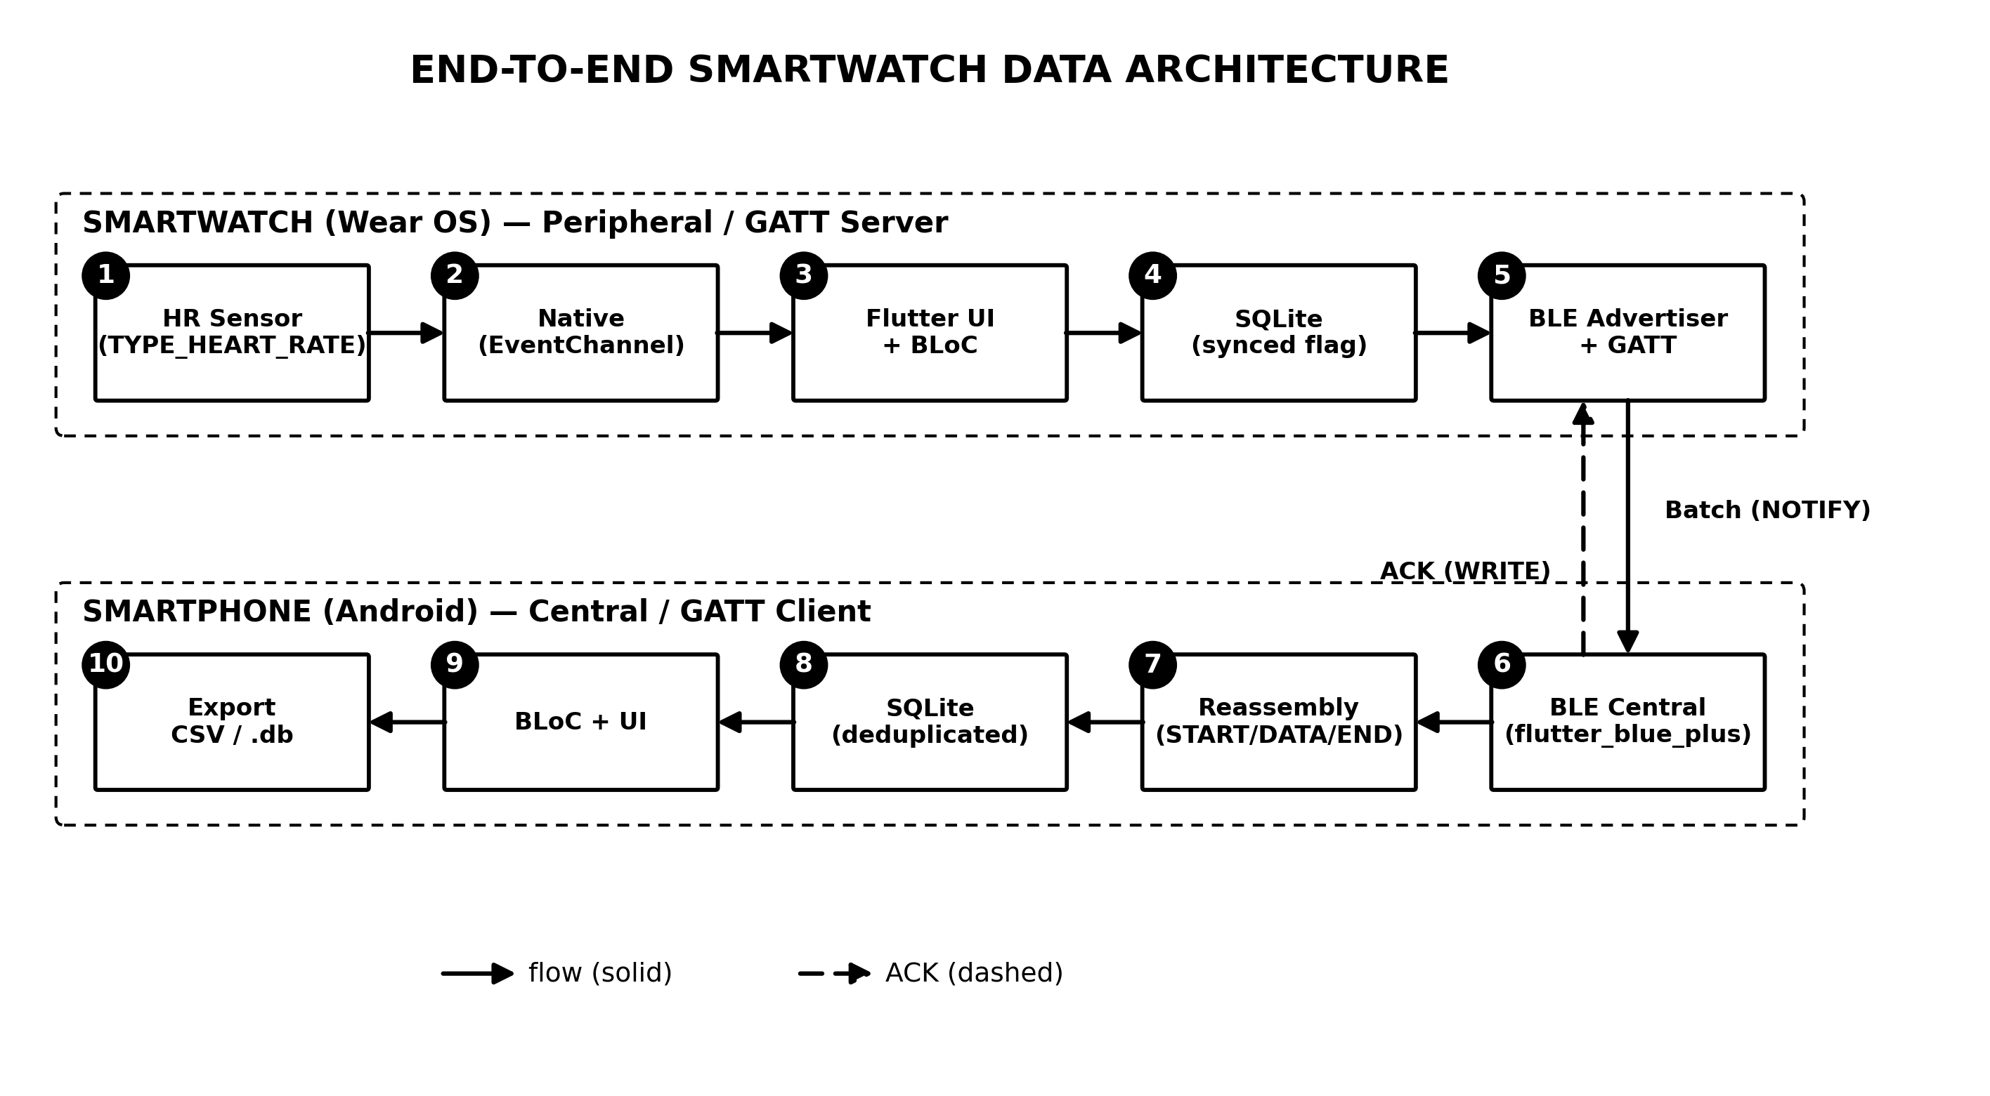
Figure 1. Two-device system architecture (data flow 1–10).
In the figure, the left column shows the five smartwatch components — sensor, native code, application layer, SQLite, and the BLE advertiser/GATT server — flowing from acquisition to transmission (steps 1–5), while the right column shows the five smartphone components from BLE reception to data export (steps 6–10). The bridge on the bottom row depicts the two communication directions: data batches via NOTIFY from the smartwatch to the smartphone, and the ACK confirmation via WRITE in the opposite direction.
B. Communication Protocol and Framing
Communication uses a dedicated GATT service with a “record” characteristic of the notify type [27]. After connecting, the smartphone requests a 512-byte MTU and enables notifications. Because one batch contains many readings whose size exceeds the capacity of a single notification, the batch is fragmented into a sequence of frames, each prefixed with an opcode: START (0x01), DATA (0x02), and END (0x03), as shown in Figure 2. The data chunk per frame is MTU minus 4 bytes (3 bytes of ATT header and 1 byte of opcode) [28]. Inter-frame transmission is flow-controlled [29]: the next frame is sent only after the send-completion callback of the previous frame. The receiver reassembles the frames into a complete JSON payload. The full interaction sequence is shown in Figure 3.
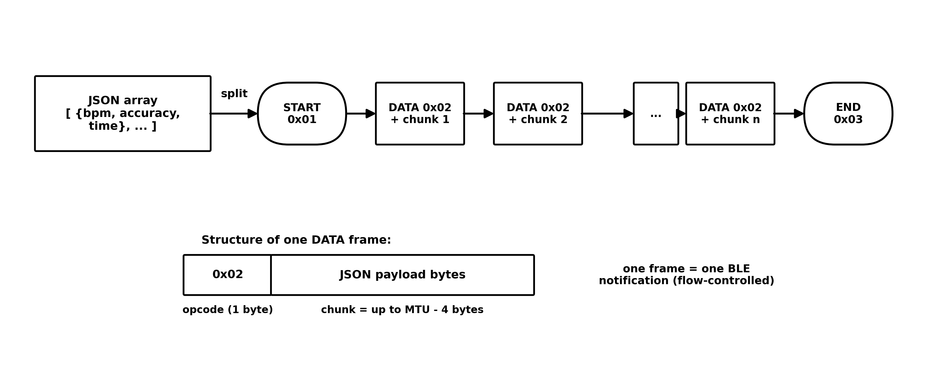
Figure 2. Fragmentation of one JSON batch into BLE frames (START/DATA/END).
The figure shows one batch (a JSON array of bpm, accuracy, and time) being split into a sequence of frames: opened by START, followed by a number of DATA frames each carrying one payload chunk, and closed by END. The inset at the bottom shows the structure of a single DATA frame — a one-byte opcode followed by a chunk of at most MTU − 4 bytes — and each frame is sent as one BLE notification.
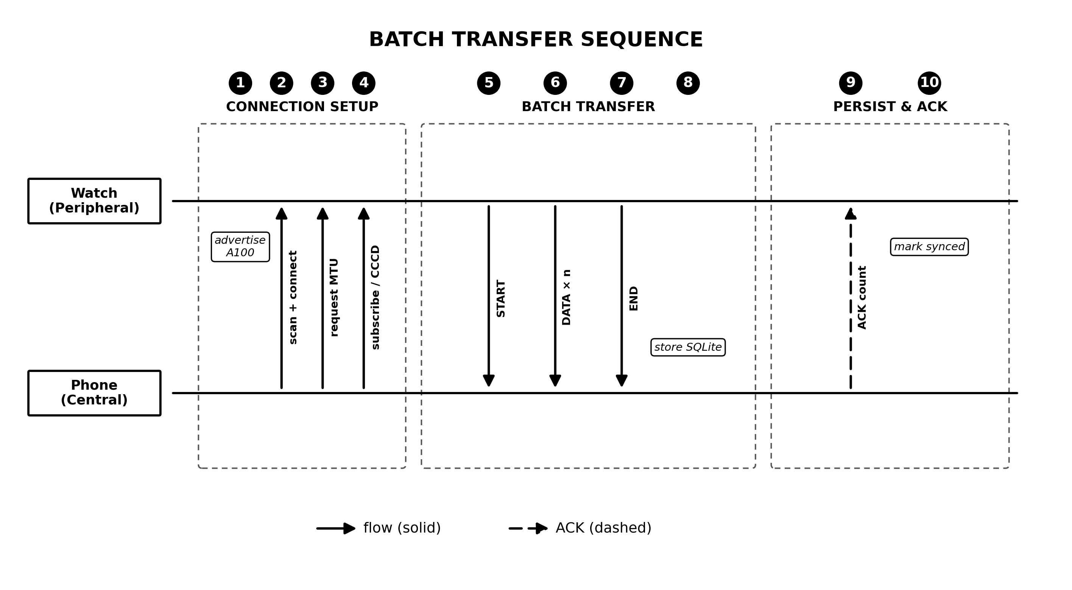
Figure 3. BLE communication sequence: setup, batch transfer, and ACK.
The sequence diagram reads top to bottom in three phases. Connection setup: the smartwatch advertises, the smartphone scans and connects, requests a 512-byte MTU, and enables notifications. Transfer: the batch is sent as a START–DATA–END sequence. Persistence and acknowledgement: the smartphone stores the batch in its database and writes the ACK, upon which the smartwatch marks the records as sent.
C. Store-and-Forward and Acknowledgement (ACK)
Each reading is stored on the smartwatch with synced = 0. At each selected sending interval, all unsent records are transmitted as one batch [30]. After the database transaction completes, the smartphone writes an ACK containing the number of records processed in that batch [31]. The smartwatch marks the records synced = 1 only after receiving an ACK; otherwise, they remain unsent and are retried at the next interval. A unique index on time with INSERT OR IGNORE makes database persistence idempotent. The current ACK confirms completion of batch processing, but it does not yet carry a batch identifier and its count is not validated against the pending batch. It therefore improves reliability rather than providing a formal failure-free guarantee.
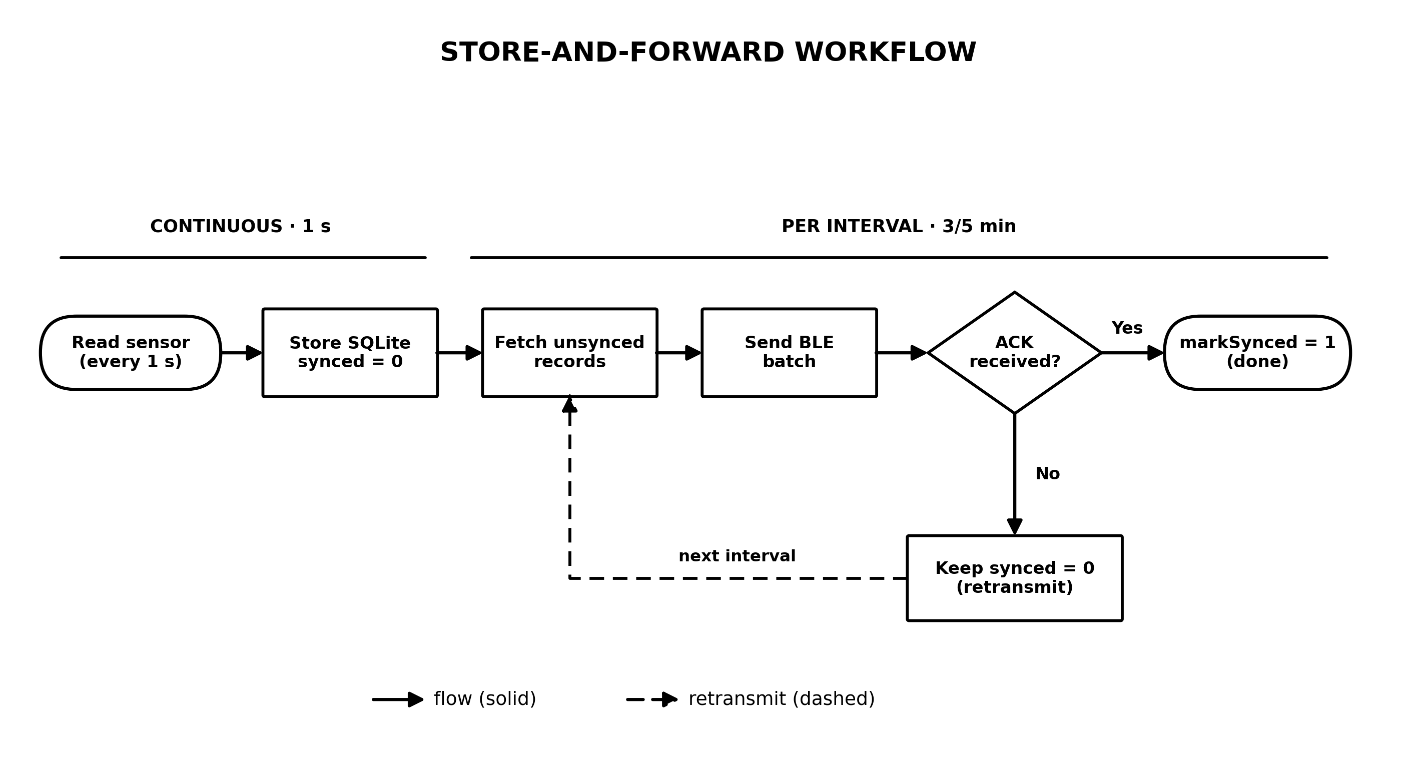
Figure 4. Store-and-forward flow with delivery acknowledgement (ACK).
The flow in the figure spans two different time scales: sensor readings are stored every second (continuous), whereas fetching unsent records, sending the batch, and awaiting the ACK run per interval (3/5 minutes). The ACK decision branch captures the core of the reliability mechanism: if the ACK is received the records are marked as sent; otherwise they remain unsent and are retransmitted in the next interval.
D. Smartwatch Application Architecture
The smartwatch application is built with Flutter, with a clear separation between the Dart layer and the native (Kotlin) layer, as shown in Figure 5. The Dart layer uses the BLoC pattern [32]: the monitoring logic (per-second sampling, per-interval sending, store-and-forward, and waiting for ACK) is separated from the user interface. The native layer hosts the sensor listener, the GATT server and advertiser, the frame queue and flow control, the ACK characteristic, and a foreground service that keeps the process alive when the application is in the background or the screen is off. The two layers communicate via platform channels.
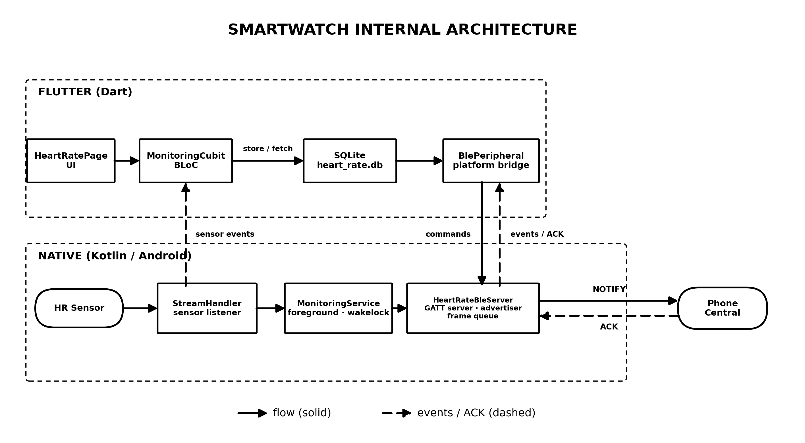
Figure 5. Internal architecture of the smartwatch application (Flutter–Native boundary).
The figure separates the two layers of the smartwatch application. The Dart layer contains the user interface, the monitoring logic in the BLoC pattern (per-second sampling, per-interval sending, ACK waiting), and SQLite access; the native Kotlin layer contains the sensor listener, the GATT server with its frame queue and flow control, the ACK characteristic, and the foreground service. The two layers communicate via platform channels: commands flow down through a MethodChannel and events flow up through EventChannels.
E. Devices and Test Scenario
Testing was conducted on physical devices. Four sessions on 23–28 June 2026 used the initial implementation, while one session on 5 July 2026 used the revised implementation that waits for an ACK before markSynced. Because the two campaigns ran different software, results are reported per version and are not summed into a single success figure.
Data inclusion was handled as follows. The smartwatch produced 47,422 recorded rows across the five sessions. Of these, 22,231 rows in the tail of the June recording were excluded because they held frozen (constant) values with accuracy ≤ 0 while the smartwatch was off the wrist; the measurement period of each session ends at its last highest-accuracy reading. The remaining 25,191 readings constitute the measurement period used for every metric in Section 3. One additional session on 23 June at 08:41 (53 readings, 1 minute) is excluded from the delivery aggregate because the smartphone never connected, so no delivery path was exercised; it is retained in the sensor-quality statistics, which do not depend on connectivity.
Table 1. Device and test-environment specifications.
Component | Specification
Smartwatch (peripheral) | Samsung Galaxy Watch (SM-R860), Wear OS
Smartphone (central) | Xiaomi Redmi Note 10 Pro (M2101K6G), Android 13
Framework | Flutter 3.41.4; Dart SDK ^3.11.1
Main libraries | flutter_blue_plus, sqflite, flutter_bloc, permission_handler
Requested MTU | 512 bytes
Sending interval | 3 / 5 minutes (selectable)
Test dataset | 23 Jun–5 Jul 2026; 5 sessions (4 initial version, 1 ACK-revised); 25,191 measurement-period readings out of 47,422 recorded rows
The table summarises the controlled test environment: a consumer device pair (Samsung Galaxy Watch SM-R860 as the peripheral and Xiaomi Redmi Note 10 Pro as the central), the Flutter framework with the applications installed in release mode, a requested MTU of 512 bytes, and a selectable 3/5-minute sending interval. The dataset covers five sessions during 23 June–5 July 2026 with 25,191 measurement-period readings filtered from 47,422 raw recorded rows.

F. Evaluation Metrics
The measured metrics are: (1) delivery ratio, i.e., the number of records matched at the smartphone divided by the number of records recorded by the smartwatch, with matching based on the time attribute so it does not depend on clock synchronization between devices; (2) value fidelity, i.e., the proportion of received records whose values (bpm and accuracy) are identical to the smartwatch records; (3) the number of duplicates at the receiver; (4) the sensor-accuracy distribution following the accuracy-status constants of the Android SensorManager (range -1 to 3) [33]; and (5) per-batch transfer latency and throughput recorded automatically by the application instrumentation. Throughput is computed as the payload size divided by the transfer duration.
The time attribute is the smartwatch application's recording timestamp rather than the physiological time of a heartbeat. Approximately once per second, the application records the latest bpm value with the device time as epoch milliseconds. In this implementation, that timestamp is used as the unique record key and as the basis for watch–smartphone matching and duplicate detection.
3. Results and Discussion
A. End-to-End Functional Verification
Functional testing showed that the connection sequence works as designed: the smartwatch advertises the service, the smartphone scans and connects, the 512-byte MTU negotiation succeeds, notifications are enabled, and one batch is delivered intact and then confirmed with an ACK. This demonstrates that the framing protocol and the acknowledgement mechanism work end-to-end on real devices.
B. Delivery Ratio
Delivery results are reported separately by software version in Table 2. The initial version was evaluated over three valid sessions totalling 386 minutes and recorded 20,455 of 23,162 records (88.31%). The revised version, which defers the synced flag until an ACK arrives, was evaluated over one 33-minute session and recorded 1,974 of 1,976 records (99.90%); the two remaining records were still unsent because they were recorded after the last scheduled flush, not because they were lost. That session comprised eleven transmission batches at the 3-minute interval; seven of them were captured by the instrumentation and all seven were acknowledged, while delivery of the remaining four is inferred from record matching because the log capture began mid-session. Neither version produced a single duplicate in the receiver database, and every matched record carried bpm and accuracy values identical to the smartwatch record (100% value fidelity).
Table 2. Delivery results per session, grouped by software version.
Session | Start (WIB) | Duration | Recorded | Received | Lost | Delivery
Initial version — markSynced executed without waiting for an ACK
Session 1 | 23/06 06:38 | 36 min | 2,177 | 2,164 | 13 | 99.40%
Session 3 | 23/06 14:15 | 345 min | 20,702 | 18,013 | 2,689 | 87.01%
Session 4 | 28/06 21:29 | 5 min | 283 | 278 | 5 | 98.23%
Subtotal, initial version | — | 386 min | 23,162 | 20,455 | 2,707 | 88.31%
Revised version — markSynced executed only after an ACK is received
Session 5 | 05/07 23:07 | 33 min | 1,976 | 1,974 | 2 | 99.90%
Subtotal, revised version | — | 33 min | 1,976 | 1,974 | 2 | 99.90%
The two subtotals are deliberately not combined into a single cross-version figure: the two groups ran different software, so any combined number would describe neither version. The session on 23 June at 08:41 (53 readings, 1 minute) is omitted from the table because the smartphone never connected during it, so no delivery path was exercised; it is reported as a failed session rather than as a 0% delivery measurement.

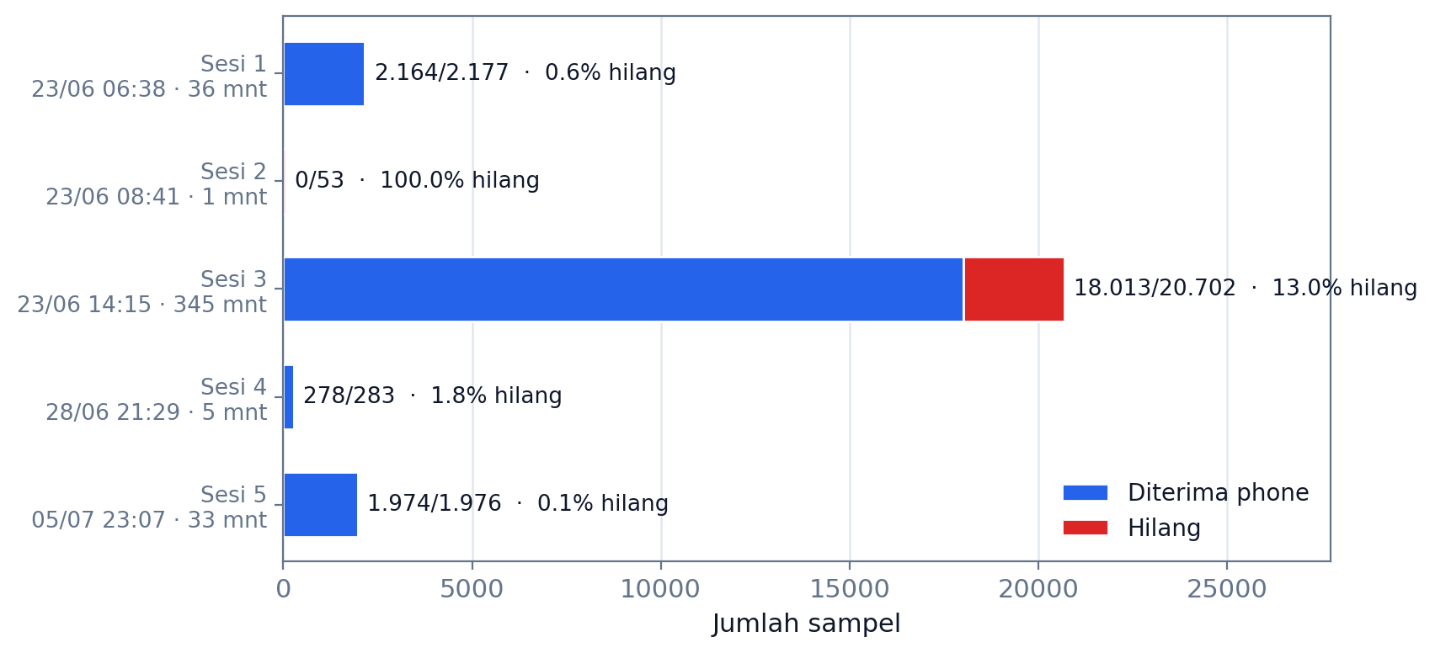
Figure 6. Data completeness across the five evaluation sessions (received vs lost).
The chart compares the numbers of received and lost records across all five sessions. Losses concentrate in the longest session (Session 3, 13.0% lost) and in the 23 June 08:41 session whose smartphone never connected, while the other three sessions are nearly complete (99.40%, 98.23%, and 99.90%). The differing bar lengths also show that most of the data volume comes from a single long session, so an unweighted average across sessions would be misleading.
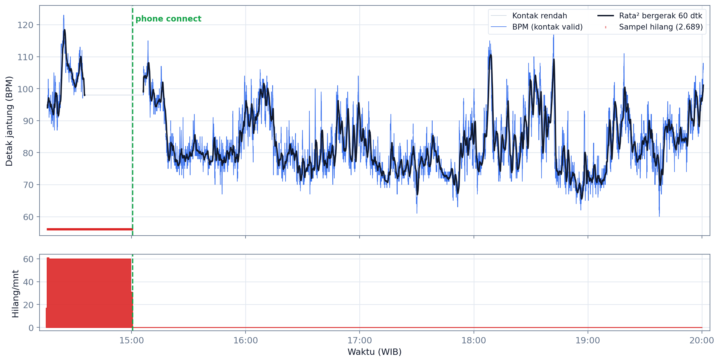
Figure 7. Heart-rate signal and BLE packet loss in the main session.
The figure plots the main-session heart-rate signal and records not found on the smartphone. Missing records are concentrated before the smartphone was observed to connect at approximately 15:00 and are practically absent afterward. This pattern shows a strong association with the disconnected period but does not, by itself, establish a single cause.
Separating the results by version exposes a pattern that the aggregate figure conceals. Under the initial version, losses were not spread evenly across a session but clustered in the period before the smartphone connected: Session 3 lost 2,689 records, almost all of them before the connection was observed at approximately 15:00 (Figure 7), whereas Sessions 1 and 4 — whose smartphones were connected from the start — lost only 13 and 5 records respectively. The 100% value fidelity across all received records reinforces this reading: not one record arrived corrupted, so the loss under the initial version was a failure to reschedule transmission rather than a failure of channel integrity. This is consistent with studies of BLE behaviour in heart-rate monitoring applications, which identify link conditions rather than payload corruption as the determinant of delivery quality [20], [25].
The gap between 88.31% and 99.90% therefore cannot be read as an improvement in radio performance; it follows from changing a single software decision, namely when a record may be declared sent. This interpretation has limits. The two figures come from non-identical test conditions — the initial version was evaluated over far longer sessions that included unconnected periods, while the revised version was evaluated over 33 minutes of continuous connectivity — so a direct comparison is indicative rather than causal. Establishing causality requires an ablation experiment in which both versions run under the same disruption scenario with several replications, which is the next item on the testing agenda.
C. Sensor Data Quality
The sensor-accuracy distribution across the measurement period of all five sessions is shown in Table 3 and Figure 8. 91.6% of readings (23,063) were at the highest accuracy (value 3), 8.4% (2,113 readings) at the no-contact condition (value -1) — which commonly occurs when the sensor momentarily loses skin contact [11], [23] — and 0.1% (15 readings) at value 0; in Session 5 every reading had good contact. The heart-rate statistics for the highest-accuracy readings (n = 23,063, visualised in Figure 9) were: minimum 60 bpm, maximum 123 bpm, mean 83.5 bpm, and standard deviation 9.6 bpm. Table 3, Figure 8, and Figure 9 all use the same scope — the measurement period of the five sessions — so their numbers are directly comparable. The 22,231 tail rows with frozen values and accuracy ≤ 0, recorded while the smartwatch was off the wrist, were excluded as described in Section 2.E.
Table 3. Distribution of sensor-accuracy values (measurement period, five sessions).
Sensor accuracy | Count | Percentage
3 (high) | 23,063 | 91.6%
0 (unreliable) | 15 | 0.1%
-1 (no contact) | 2,113 | 8.4%
Total | 25,191 | 100%
The table shows that contact quality is dominated by the highest level (91.6%), with 8.4% at no-contact and only 0.1% at the unreliable status. That composition is visualised in Figure 8, while the distribution of heart-rate values for the highest-accuracy readings is shown in Figure 9.

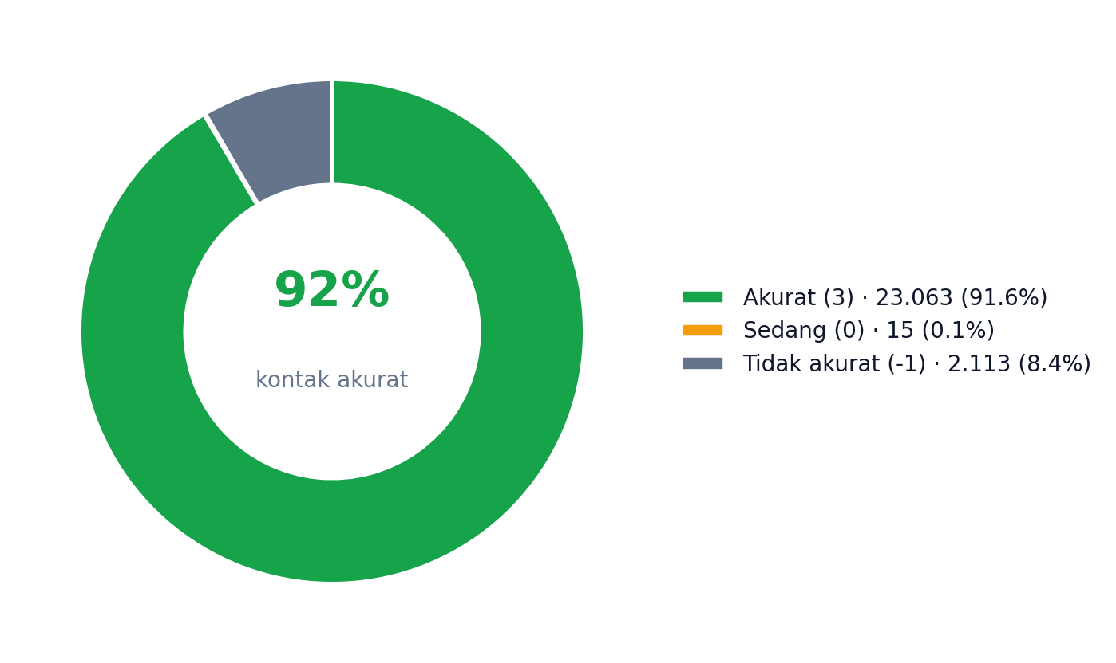
Figure 8. Sensor contact-quality distribution across the five evaluation sessions.
The chart summarises the sensor contact quality across the five sessions: the majority of readings (91.6%) are at the highest accuracy level, 8.4% at no-contact, and 0.1% at the unreliable status — reflecting the momentary contact losses that are common for wrist-worn optical sensors.
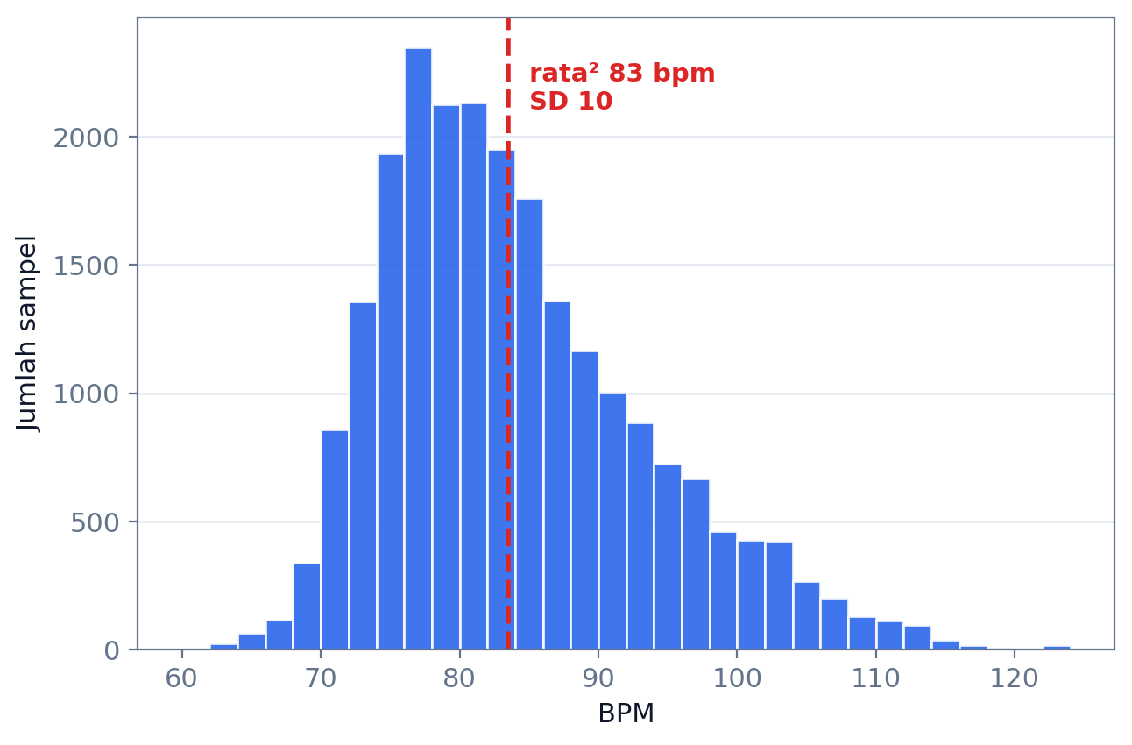
Figure 9. Distribution of heart-rate values for the highest-accuracy readings.
The histogram shows the distribution of heart-rate values for the highest-accuracy readings of all five sessions (n = 23,063): centred on a mean of 83.5 bpm with a standard deviation of 9.6 bpm and a range of 60–123 bpm. This profile is reasonable for light activity and indicates physiologically plausible data rather than frozen values from an unworn sensor.
The 8.4% no-contact share is best read as a characteristic of wrist-worn optical sensing rather than as a defect of the delivery system. Device-validation studies report that wrist-worn heart-rate accuracy varies with activity condition and skin-contact quality [23], so a single-digit proportion of no-contact readings is unremarkable for everyday wear. What matters for this design is that the accuracy status is itself transmitted and stored intact at the receiver: quality filtering can be applied at analysis time without information loss, because the system does not discard low-accuracy readings at the source — an approach consistent with recommended practice for ambulatory wearable data [11]. The marked contrast between Session 5, in which every reading had good contact, and the June sessions also shows that contact quality is governed by how the device is worn rather than by the software, so this proportion cannot serve as a cross-session performance indicator.
D. Transfer Performance
Transfer performance was measured through the HR-METRIC instrumentation on the smartwatch. Session 5 comprised eleven transmission batches at a 3-minute interval, but log capture began at the fourth batch, so the instrumented set is the last seven batches. Those seven were uniform — 180 readings, an 8,461-byte payload (47.0 bytes per reading), and 19 frames at MTU 512 — with a mean transfer duration of 121.5 ± 25.5 ms (range 92.8–166.4 ms) and a mean throughput of 70.3 ± 13.2 KiB/s; each of the seven was fully acknowledged by the smartphone. The uniform size applies to batches falling on a full interval; the first batch of the session held about 173 readings because the session started mid-interval. The measured frame count matches the chunk-size calculation (MTU − 4 = 508 bytes): 8,461 ÷ 508 = 16.7, rounded up to 17 DATA frames, plus START and END = 19 frames. As an illustration of a large batch, in the June evaluation one batch of 228 readings (10,717-byte payload; 24 frames, consistent with the same calculation) was delivered in ~0.32 s, equivalent to ~32.4 KiB/s. MTU negotiation on the tested device pair consistently yielded the full 512 bytes in both test campaigns.
In terms of channel occupancy, 121.5 ms against a 180-second sending interval means the radio is actively transmitting data for roughly 0.07% of the session. That ratio is what allows a periodic batch scheme to be combined with delivery acknowledgement without meaningful channel cost: acknowledgement happens eleven times across a 33-minute session rather than once per reading. The distinction matters, because adding strict acknowledgement to a continuous real-time stream is known to aggravate congestion and degrade delay and loss when several patients are monitored [18], and reliability–energy trade-offs of this kind are a recurring theme in body area networks [22]. In other words, a delivery delay of a few minutes — acceptable for heart-rate trend monitoring, though not for real-time alerting — is the price paid for data completeness at low channel cost.
It should be noted that throughput differed considerably between the two campaigns: 70.3 KiB/s in Session 5 against approximately 32.4 KiB/s for the June batch, even though the negotiated MTU was 512 bytes in both. Because BLE connection parameters such as the connection interval were not logged during the June campaign, this difference cannot yet be attributed to a single cause; connection parameters have been reported to affect delivery quality in heart-rate monitoring applications [20] and BLE performance generally [8]. Logging connection parameters has therefore been added to the instrumentation for subsequent testing. Measurements across other conditions — the 5-minute interval, device distance, and disruption scenarios — likewise remain future work.
E. Finding: Store-and-Forward Backfill Limitation
A cross-analysis of the three valid initial-version sessions found that of the 2,707 records absent from the smartphone, 2,702 (99.8%) were already marked synced = 1 and only 5 were legitimately pending. In other words, almost all of the missing data was not waiting its turn to be sent; the smartwatch had already considered it finished. Under the revised version, Session 5 produced no falsely flagged records at all: the seven instrumented batches each received an ACK for 180 records, and the final two records correctly remained at synced = 0. Session 5 did not, however, include a disconnect–reconnect scenario, so the revised version's resilience to link loss still requires dedicated testing.
Across the full June recording (45,446 rows including the not-worn period), 2,879 records marked synced = 1 were absent from the smartphone. The figure of 2,702 above is the subset falling within the measurement period of the three valid sessions and is therefore consistent with Table 2; the remainder comes from the off-wrist tail and from the 08:41 session excluded from the aggregate.
Direct evidence that the queue behaves as designed comes from a smartwatch database export taken mid-session during Session 5, at 23:30:35. At that moment the database held 1,405 records, 151 of which were still at synced = 0. The last transmission before the export occurred at 23:28:04, so the elapsed interval was 151 seconds — exactly the number of records waiting. The queue therefore held precisely the readings recorded since the last transmission, no more and no less, and was drained at the next one. Unlike the initial version, which marked records as sent before they were confirmed, the revised version maintained an accurate queue throughout the session.
The root cause lies in the ordering of operations. In the initial version, the synced = 1 flag was written as soon as the send call returned from the BLE layer, rather than after the receiver confirmed persistence. Because BLE notifications are best-effort and provide no attribute-layer acknowledgement [9], a successful send call means only that the frame was handed to the local protocol stack — not that it arrived and was stored. Records that were never delivered were consequently treated as complete and never re-entered the send queue, so the store-and-forward buffer lost its function precisely when it was most needed, that is, while the link was down.
The lesson generalises to any buffer design driven by a status flag: a sent flag may be advanced only by an event originating at the receiver, never by a local event at the sender. The same principle underlies store-carry-forward schemes in delay-tolerant networks, where a message may be released from the buffer only after the next hop is confirmed [21], and it mirrors retransmission handling after network disconnection in other protocol stacks [24]. The practical value of the finding is that this failure is invisible to ordinary functional testing: the system appears to run normally, the user interface reports all data as sent, and the loss surfaces only when the two databases are compared record by record. Completeness verification through timestamp matching, as used here, should therefore be a standard part of testing continuous monitoring systems rather than a supplementary analysis.
F. Discussion
1) Interpretation of the Results
The results in Sections 3.A to 3.E can be read as three mutually supporting layers of finding. The first layer concerns the channel: 100% value fidelity across every received record, the absence of duplicates under either version, and MTU negotiation that consistently settled at 512 bytes together show that the BLE link, the opcode framing, and the flow control neither corrupt nor duplicate data. Put differently, whenever a record reached the receiver, it arrived intact. The second layer concerns the application: despite that clean channel, the initial version still lost 2,707 records, 99.8% of which had already been marked as sent. The loss therefore cannot be explained by radio quality, but by a single software decision about when a record may be declared complete. The third layer is the consequence: in continuous monitoring systems that rely on a local buffer, end-to-end reliability is governed more by the semantics of the send-status flag than by the quality of the wireless link.
This reading explains why the presence of a store-and-forward buffer is not sufficient on its own. A buffer only works while unconfirmed records remain in the queue; once the flag is advanced by a local event at the sender, the buffer loses its worklist and the retransmission path never activates. That is why the failure of the initial version was most severe in the longest session — the session with the greatest opportunity to lose the link — while short sessions that were connected from the outset were barely affected. The pattern is consistent with the proposed mechanism, though it bears repeating that a consistent pattern is not causal proof so long as a controlled ablation experiment has not been performed.
The transfer-performance figures supply context that completes this picture. Because a single batch occupies only about 0.07% of its sending interval, the channel cost of adding reliability machinery to this design is close to negligible. That headroom has practical meaning: batch identity, validation of the acknowledged record count, or even selective retransmission can be added without eroding the power budget that motivated the choice of BLE in the first place. The trade-off between reliability and energy efficiency is therefore far less acute in trend-based monitoring than in real-time streaming, where every packet demands a reply.
2) Implications
For designers of wearable monitoring systems, the most immediate implication is a simple but binding design rule: a send-status flag may be advanced only by an event originating at the receiver. The rule is not specific to BLE. Any best-effort channel — and any design that places a buffer at the source — carries the same risk, so a comparable audit is warranted for systems that combine store-and-forward with other transports. A corollary is that application-level acknowledgement should be treated as part of the data-persistence contract rather than as an optional protocol embellishment.
For testing methodology, these results show that functional testing and user-interface indicators are inadequate for assessing data completeness. Under the initial version the application ran normally and reported all data as sent, while nearly three thousand records never arrived. Completeness verification by timestamp matching between the two databases should therefore become standard procedure rather than a supplementary analysis. The cost of adopting it is low — export both databases and match on the time key — and because the timestamp is created at the source and transmitted unchanged, the procedure does not depend on clock synchronisation between devices.
For protocol design in IoMT applications, the channel-occupancy finding offers a practical direction. The very small share of channel time consumed indicates that strengthening reliability in a periodic batch scheme is almost free, so design choices need not be framed as a trade-off between data completeness and power thrift. It should be stressed that this implication holds for the class of system tested here — trend-based monitoring over a single wearable–gateway link that tolerates a delay of several minutes; systems requiring real-time alerting face different constraints and are not covered by these results.
3) Limitations
This study has several limitations that bound the generality of its results. First, testing used a single device pair in a single radio environment, so the latency and throughput figures cannot be generalised across devices. Second, the revised version was evaluated in only one session, without replication and without a controlled disconnect–reconnect scenario, so its resilience claim is confined to the continuously connected condition actually tested. Third, the current ACK carries no batchId and does not validate the acknowledged record count against the pending batch, so the mechanism improves reliability without providing a formal failure-free guarantee. Fourth, no controlled variation of sending interval, distance, or MTU was performed, and energy consumption was not measured. Fifth, background execution does not guarantee continuation after force-close or reboot. Sixth, the communication adds no application-level authentication or encryption. Seventh, the consumer smartwatch sensor was not assessed as a clinical device; the contribution of this work concerns delivery reliability, not the medical validity of the BPM values.
4. Conclusion
This study designed and implemented a BLE heart-rate delivery system using opcode batch framing, local persistence, application-level ACKs, an idempotent receiver, and foreground services, and evaluated it on a consumer device pair across five sessions. The initial version achieved 88.31% delivery and revealed that 2,702 of its 2,707 lost records had already been falsely marked as sent and were therefore never rescheduled; the revised version, which defers that marking until an ACK arrives, reached 99.90% with no falsely marked records. Under both versions value fidelity was 100% with no duplicates, and 180-record batches at MTU 512 transferred in 121.5 ms on average, or 0.07% of their sending interval. The central finding is that a send-status flag must be advanced by receiver confirmation rather than by the success of a local send call. Future work should replicate the revised version under controlled disconnect–reconnect scenarios, add batch identity to the ACK, measure energy consumption, and extend testing across devices and radio conditions.
Data and Code Availability
The source code of both applications, the analysis scripts, and the exported CSV files of all five test sessions are available in the public repository of this study at [[repository URL]], so that every figure in Table 2, Table 3, and Figures 6–9 can be reproduced.
Acknowledgement
[[Optional: acknowledgement to advisor/institution/funding.]]
References
[1] P. He et al., “A survey of Internet of medical things: technology, application and future directions,” Digital Communications and Networks, vol. 12, no. 5, pp. 717–742, May 2026, doi: 10.1016/j.dcan.2024.11.013.
[2] C. Huang, J. Wang, S. Wang, and Y. Zhang, “Internet of medical things: A systematic review,” Neurocomputing, vol. 557, p. 126719, Nov. 2023, doi: 10.1016/j.neucom.2023.126719.
[3] K. T. Putra et al., “A review on the application of Internet of Medical Things in wearable personal health monitoring: A cloud-edge artificial intelligence approach,” IEEE Access, vol. 12, pp. 21437–21452, 2024, doi: 10.1109/ACCESS.2024.3358827.
[4] S. F. Ahmed, Md. S. Bin Alam, S. Afrin, S. J. Rafa, N. Rafa, and A. H. Gandomi, “Insights into Internet of Medical Things (IoMT): Data fusion, security issues and potential solutions,” Information Fusion, vol. 102, p. 102060, Feb. 2024, doi: 10.1016/j.inffus.2023.102060.
[5] Z. Zhou and H.-W. Huang, “Closed-loop transmission power control for reliable and low-power BLE communication in dynamic IoT settings,” IEEE Internet of Things Journal, vol. 13, no. 1, pp. 1216–1228, Jan. 2026, doi: 10.1109/JIOT.2025.3627414.
[6] R. Verma and S. Kumar, “Insights into BLE 5.x data transfer modes for IoT-empowered remote patient monitoring,” IEEE Internet of Things Magazine, vol. 8, no. 4, pp. 52–59, Jul. 2025, doi: 10.1109/IOTM.001.2400267.
[7] G. Wandwi and C. Wandwi, “Integrating IoT and wearable technologies in internal medicine for remote monitoring,” Journal of Sensors, IoT & Health Sciences, vol. 4, no. 1, pp. 82–97, Mar. 2026, doi: 10.69996/jsihs.2026005.
[8] H. Xu, Z. Yan, B. Li, and M. Yang, “Modeling and analysis of the performance for Bluetooth Low Energy,” IEEE Communications Letters, vol. 28, no. 3, pp. 732–736, Mar. 2024, doi: 10.1109/LCOMM.2024.3352545.
[9] F. Battaglia, G. Gugliandolo, G. Campobello, and N. Donato, “EEG-over-BLE: A low-latency, reliable, and low-power architecture for multichannel EEG monitoring systems,” IEEE Transactions on Instrumentation and Measurement, vol. 72, pp. 1–10, 2023, doi: 10.1109/TIM.2023.3268471.
[10] Android Developers, “Foreground services,” Android Developers Guide. Accessed: Jul. 30, 2026. [Online]. Available: https://developer.android.com/develop/background-work/services/foreground-services
[11] J. Van Der Donckt et al., “Mitigating data quality challenges in ambulatory wrist-worn wearable monitoring through analytical and practical approaches,” Scientific Reports, vol. 14, no. 1, p. 17545, Jul. 2024, doi: 10.1038/s41598-024-67767-3.
[12] A. González-Pérez, M. Matey-Sanz, C. Granell, L. Díaz-Sanahuja, J. Bretón-López, and S. Casteleyn, “AwarNS: A framework for developing context-aware reactive mobile applications for health and mental health,” Journal of Biomedical Informatics, vol. 141, p. 104359, May 2023, doi: 10.1016/j.jbi.2023.104359.
[13] O. Alruwaili, A. Yousef, and A. Armghan, “Monitoring the transmission of data from wearable sensors using probabilistic transfer learning,” IEEE Access, vol. 12, pp. 97460–97475, 2024, doi: 10.1109/ACCESS.2024.3428444.
[14] J. Wan et al., “Wearable IoT enabled real-time health monitoring system,” EURASIP Journal on Wireless Communications and Networking, vol. 2018, no. 1, Dec. 2018, doi: 10.1186/s13638-018-1308-x.
[15] B. B. Manjunath et al., “Battery-free, wireless, and skin-mountable multi-sensory patch for biosignal monitoring,” Sensors and Actuators A: Physical, vol. 404, Jul. 2026, doi: 10.1016/j.sna.2026.117751.
[16] C. Y. Kim et al., “Wireless technologies for wearable electronics: A review,” Advanced Electronic Materials, Jul. 2025, doi: 10.1002/aelm.202400884.
[17] S. Gautam and S. Kumar, “BLE periodic advertising-based energy-efficient sensor node operation for transfer of large data in monitoring applications,” IEEE Internet of Things Journal, vol. 11, no. 24, pp. 40070–40085, Dec. 2024, doi: 10.1109/JIOT.2024.3451698.
[18] A. A. Fadhel and H. M. Hasan, “Reducing delay and packets loss in IoT-cloud based ECG monitoring by Gaussian modeling,” International Journal of Online and Biomedical Engineering, vol. 19, no. 6, pp. 97–113, 2023, doi: 10.3991/ijoe.v19i06.38581.
[19] Arivardhini and Kayalvizhi, “IoT-based wearable health monitoring system for early detection of cardiovascular disease,” SSRN preprint. [Online]. Available: https://ssrn.com/abstract=5790382
[20] Z. Balas, K. Tokarz, B. Zieliński, and T. Guźniczak, “Research on the behaviour of Bluetooth Low Energy protocol in the heart rate monitoring application,” Procedia Computer Science, vol. 225, pp. 63–69, 2023, doi: 10.1016/j.procs.2023.09.092.
[21] Y. Xiong and S. Jiang, “Multi-decision dynamic intelligent routing protocol for delay-tolerant networks,” Electronics, vol. 12, no. 21, art. 4528, 2023, doi: 10.3390/electronics12214528.
[22] P. Majumdar, S. Roy, S. Sikdar, P. Ghosh, and N. Ghosh, “A survey on data-driven approaches for reliability, robustness, and energy efficiency in wireless body area networks,” Sensors, vol. 24, no. 20, art. 6531, 2024, doi: 10.3390/s24206531.
[23] T. Schweizer and R. Gilgen-Ammann, “Wrist-worn and arm-worn wearables for monitoring heart rate during sedentary and light-to-vigorous physical activities: Device validation study,” JMIR Cardio, vol. 9, art. e67110, 2025, doi: 10.2196/67110.
[24] M. Domingues, J. N. Faria, and D. Portugal, “Dimensioning payload size for fast retransmission of MQTT packets in the wake of network disconnections,” EURASIP Journal on Wireless Communications and Networking, vol. 2024, no. 1, Dec. 2024, doi: 10.1186/s13638-023-02327-3.
[25] F. Franco, L. Lamazzi, F. Poggi, and L. Bedogni, “Evaluating Bluetooth Low Energy connection reliability for mobile health applications,” in Proc. 2026 IEEE 23rd Consumer Communications & Networking Conference (CCNC), Jan. 2026, pp. 1–6, doi: 10.1109/CCNC65079.2026.11366362.
[26] C. Slade, Y. Sun, W. C. Chao, C.-C. Chen, R. M. Benzo, and P. Washington, “Current challenges and opportunities in active and passive data collection for mobile health sensing: A scoping review,” JAMIA Open, vol. 8, no. 4, Jul. 2025, doi: 10.1093/jamiaopen/ooaf025.
[27] C. Hirsch, L. Davoli, R. Grosu, and G. Ferrari, “DynGATT: A dynamic GATT-based data synchronization protocol for BLE networks,” Computer Networks, vol. 222, Feb. 2023, doi: 10.1016/j.comnet.2023.109560.
[28] M. Baert, B. Moons, J. Pittevils, Y. Song, N. Madhu, and J. Hoebeke, “Evaluation of BLE-based audio broadcasting under probabilistic interference,” Computer Communications, vol. 222, pp. 130–140, Jun. 2024, doi: 10.1016/j.comcom.2024.04.034.
[29] D. F. S. Santos, M. M. Bezerra, W. D. P. da Silva, H. O. Almeida, and A. Perkusich, “CrediBLE: A credit-based adaptive flow control architecture for Bluetooth Low-Energy gateways,” IEEE Access, vol. 14, pp. 92942–92965, 2026, doi: 10.1109/ACCESS.2026.3705713.
[30] Y. Li, J. Lv, B. Li, and W. Dong, “RT-BLE: Real-time multi-connection scheduling for Bluetooth Low Energy,” in Proc. IEEE INFOCOM 2023 – IEEE Conference on Computer Communications, May 2023, pp. 1–10, doi: 10.1109/INFOCOM53939.2023.10229006.
[31] N. Landra, D. Demarchi, and P. M. Ros, “SharkTooth: A scalable real-time algorithm for BLE-based wireless body sensor networks synchronization,” IEEE Internet of Things Journal, vol. 12, no. 22, pp. 46174–46192, Nov. 2025, doi: 10.1109/JIOT.2025.3602162.
[32] Sanghmitra, “The state management dilemma: BLoC vs. Provider in modern Flutter development,” International Journal of Scientific Research in Computer Science, Engineering and Information Technology, vol. 10, no. 5, pp. 326–336, Oct. 2024, doi: 10.32628/cseit241051027.
[33] Google, “SensorManager,” Android Developer Reference. Accessed: Jul. 27, 2026. [Online]. Available: https://developer.android.com/reference/android/hardware/SensorManager
Note: this is a draft. Adapt it to the target journal template (column format, citation style, page limit). References are numbered in IEEE order of first citation; reference [19] is an SSRN preprint whose year and venue must be completed. Items marked [[...]] must be completed by the author, including the repository URL in the Data and Code Availability section.

