KUBERNETES KUBEADM INSTALLATION

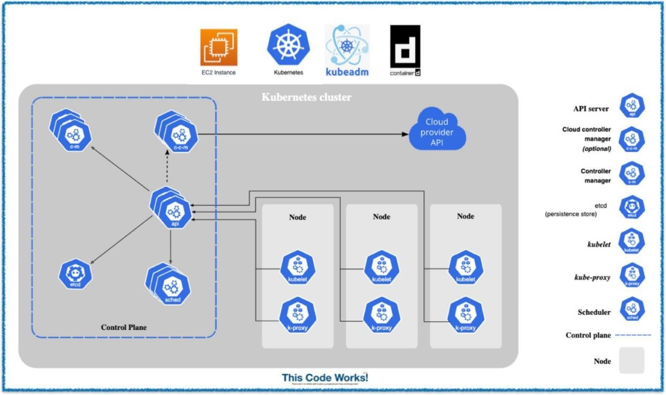

**Kubernetes kubeadm cluster** ek **Kubernetes cluster** hota hai jo **kubeadm tool** se banaya gaya ho.Ye **cluster manually** banate hain apne **VMs** ya **physical machines** pe.

**Yeh rahi step-by-step Kubeadm Cluster creation ki guide Roman Urdu mein**

# Step 1: Sabhi nodes pe Docker aur Kubernetes components install karo

# Update packages sudo apt update -y

# Install Docker sudo apt install -y docker.io

# Enable and start Docker service sudo systemctl enable docker sudo systemctl start docker

# Install required dependencies

sudo apt-get install -y apt-transport-https ca-certificates curl gpg

# Add Kubernetes key and repository sudo mkdir -p -m 755 /etc/apt/keyrings

curl -fsSL https://pkgs.k8s.io/core:/stable:/v1.30/deb/Release.key | sudo gpg --dearmor -o /etc/apt/keyrings/kubernetes-apt-keyring.gpg echo 'deb [signed-by=/etc/apt/keyrings/kubernetes-apt-keyring.gpg] https://pkgs.k8s.io/core:/stable:/v1.30/deb/ /' | sudo tee

/etc/apt/sources.list.d/kubernetes.list

# Update package index sudo apt-get update

# Install kubelet, kubeadm, and kubectl

sudo apt-get install -y kubelet kubeadm kubectl

#Prevent automatic updates

sudo apt-mark hold kubelet kubeadm kubectl

# Step 2: Har node par hostname set karo

## Har node par alag se yeh command run karo taake uska hostname set ho jaye

sudo hostnamectl set-hostname manager # Run on Master Node sudo hostnamectl set-hostname worker-1 # Run on Worker Node 1 sudo hostnamectl set-hostname worker-2 # Run on Worker Node 2

# Step 3: Har node par installation verify karo

## Docker aur kubeadm sahi se install hue hain ya nahi, check karo har node par yeh commands run karo

docker --version kubeadm version kubectl version --client

# Step 4: Kubernetes cluster ko initialize karo (sirf Master Node par run karo)

## Sirf Master Node par ye command run karo

sudo kubeadm init --pod-network-cidr=10.244.0.0/16

# Step 5: Master node par kubectl configure karo

## Master Node par ye commands run kariye

mkdir -p $HOME/.kube sudo cp -i

/etc/kubernetes/admin.conf $HOME/.kube/config sudo chown $(id -u):$(id -g) $HOME/.kube/config

# Step 6: Cluster ka status check karo

kubectl get nodes kubectl get namespace

# Step 7: Master node par Pod Network (Flannel) install karo

## Master Node ye command and URL run karo

kubectl apply -f

https://github.com/flannelio/flannel/releases/latest/download/kube- flannel.yml

**Note: This setup we doing in AWS EC-2 terminal first we need to create one instance make it as master and remaining instances for nodes or workers**