Star Wars: Return of the Jedi
Scene 28: Meeting Jabba
Greetings Exalted One. Allow me to introduce myself. I am Luke Skywalker, Jedi Knight and friend to Captain Solo. I know that you are powerful, mighty Jabba, and that your anger with Solo must be equally powerful. Learn more about Luke’s Story (link to http://en.wikipedia.org/wiki/Luke_Skywalker)

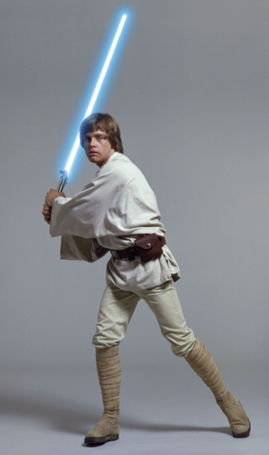
I seek an audience with Your Greatness to bargain for Solo's life. With your wisdom, I'm sure that we can work out an arrangement, which will be mutually beneficial and enable us to avoid any unpleasant confrontation. As a token of my goodwill, I present to you a gift: these two droids. What did he say? Both are hardworking and will serve you well.
Class One Droid Types
- Mechanical
- Biological
- Physical
- Mathematics

Of course I'm worried. And you should be, too. Lando Calrissian and poor Chewbacca never returned from this awful place. Artoo whistles timidly. Don't be so sure. If I told you half the things I've heard about this Jabba the Hutt, you'd probably short-circuit. Artoo, are you sure this is the right place? I better knock, I suppose. There doesn't seem to be anyone there. Let's go back and tell Master Luke.
Scene 45: Freed from the Carbonite
You're free of the carbonite. Shhh. You have hibernation sickness. I can't see. Your eyesight will return in time. Where am I? Jabba's palace. Who are you? Someone who loves you. Leia! I gotta get you out of here. What's that? I know that laugh. Hey, Jabba. Look, Jabba, I was just on my way to pay you back, but I got a little sidetracked. It's not my fault. It's too late for that, Solo.
You may have been a good smuggler, but now you're Bantha fodder.
Look... Take him away! Jabba...
I'll pay you triple!
You're throwing away a fortune here.
Classes of Droids
There are five classes of droids that are used to classify droids. Droids were divided based upon creativity, intelligence, and capacity for independent thought. It also depended on the nature of work they were built for. Learn more about from the Star Wars Wikipedia Site (link to http://en.wikipedia.org/wiki/Star_Wars)

- Class One droids were programmed to work in the fields of mathematics, physics, physical sciences, and medicine.
- Class Two droids were programmed in engineering and other technical sciences.
- Class Three droids are programmed to interact with humans. They were said to be the most advanced droids ever invented.
- Class Four droids were programmed to fight. Almost all class four droids carried weapons. Armed combat droids were among the first droids ever created.
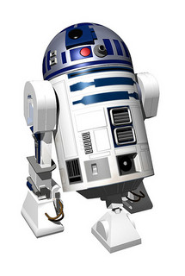
Where is that shuttle going? Shuttle Tydirium, what is your cargo and destination? Parts and technical crew for the forest moon. Do they have a code clearance? It's an older code, sir, but it checks out. I was about to clear them. Shall I hold them? No. Leave them to me. I will deal with them myself. As you wish, my lord. Carry on. They're not goin' for it, Chewie.
Shuttle Tydirium, deactivation of the shield will commence immediately.
Follow your present course. Okay! I told you it was gonna work. No problem.
RED Academy. Web Developer Essentials: Intro to HTML Lab Exercise.
For Educational Purposes Only.

