**DW&DM**

**MS. NUSRAT SHAHEEN**

**LAB PROJECT**

22/06/2022



**Submitted By:**

***Faiq Shahzad (FA19-BCS-021)***

***Muhammad Ahmed (FA19-BCS-041)***

***Muhammad Mubir Shami (FA19-BCS-051)***

***BCS-6A***

**Business Questions:**

* **What are the total number of movies in the specific genre?**
* **What are the total number of Movies produced in a specific country?**
* **What are the total number of Movies a person has participated in?**
* **What is the list of movies released in a specific year?**
* **What is the list of movies under a specific budget?**

**Dimension Model:**

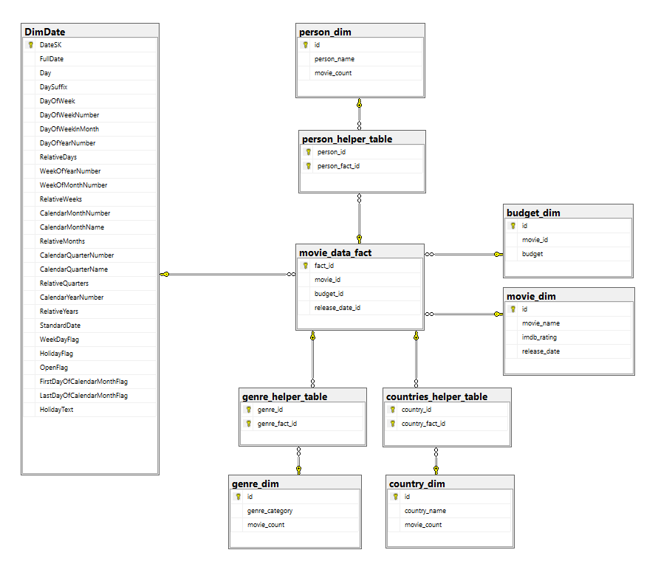

**ETL:**

**Step 1: Creating Operational Database Connection:**

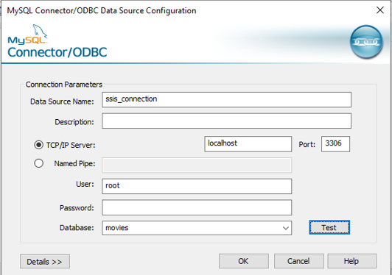

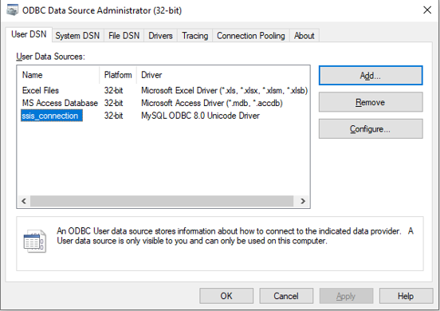

**Step 2: Extraction:**

1. Create Connections:

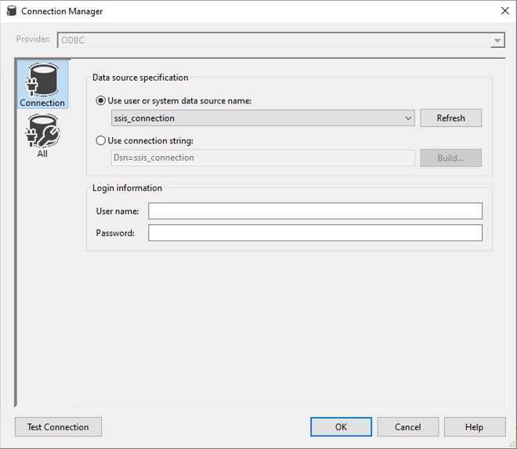

1. Extracting Table from Operation Database:

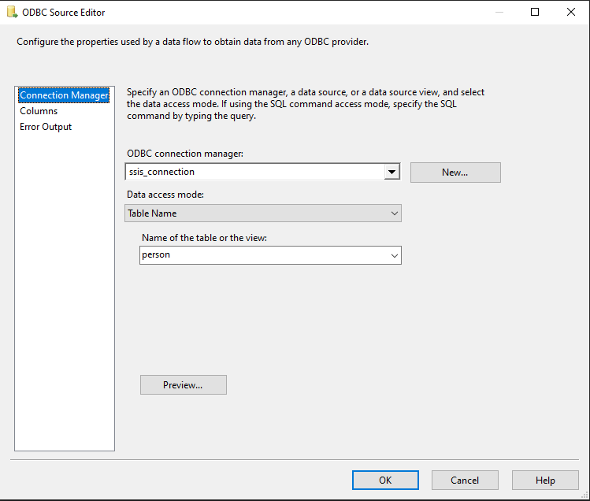

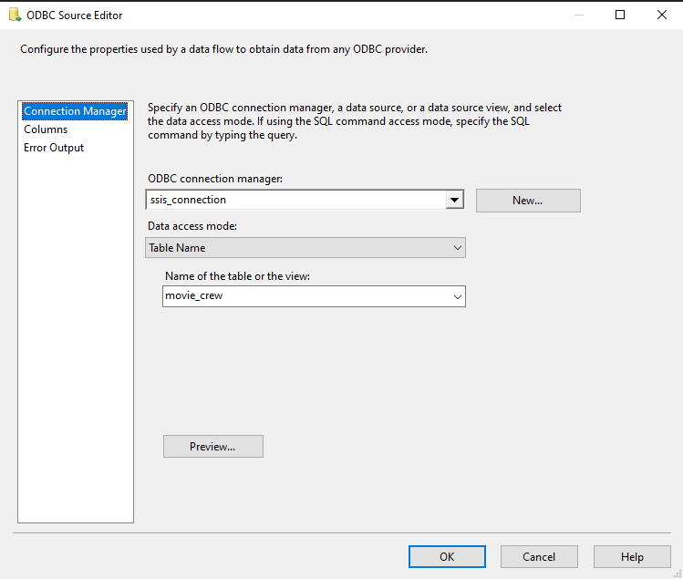

**Step 3: Transformations:**

1. Choose a Transformation to be performed on the Extracted Data such as:

* **Aggregate (Group By)**

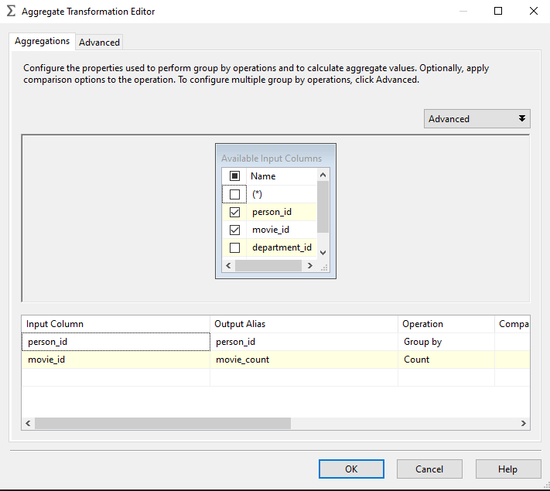

* **Sort**

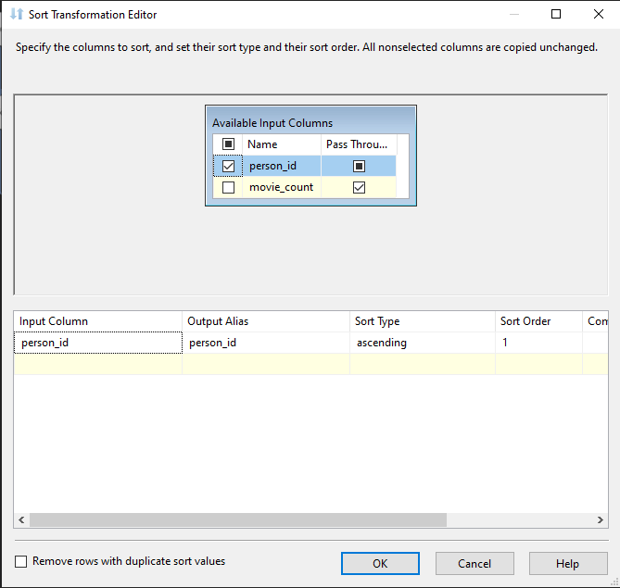

* **Merge Join**

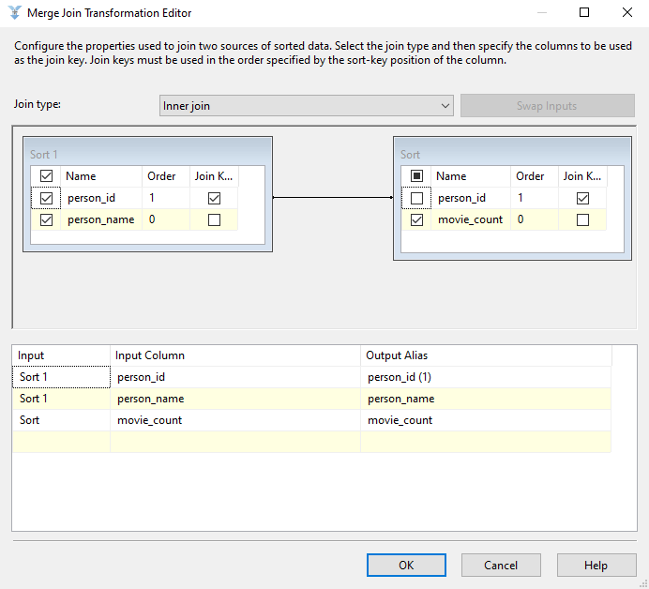

* **Data Conversion**

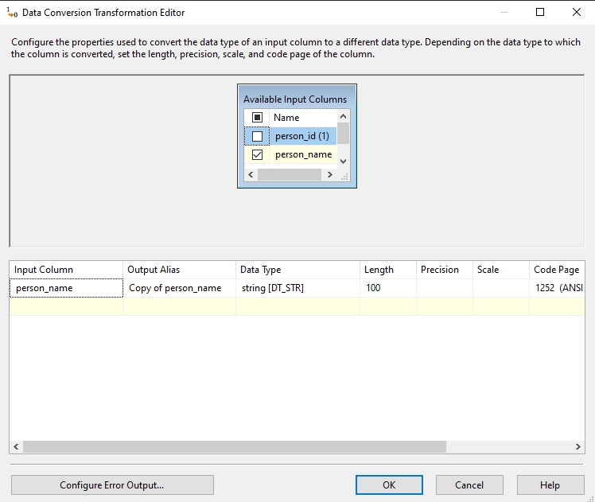

* **Row Sampling**

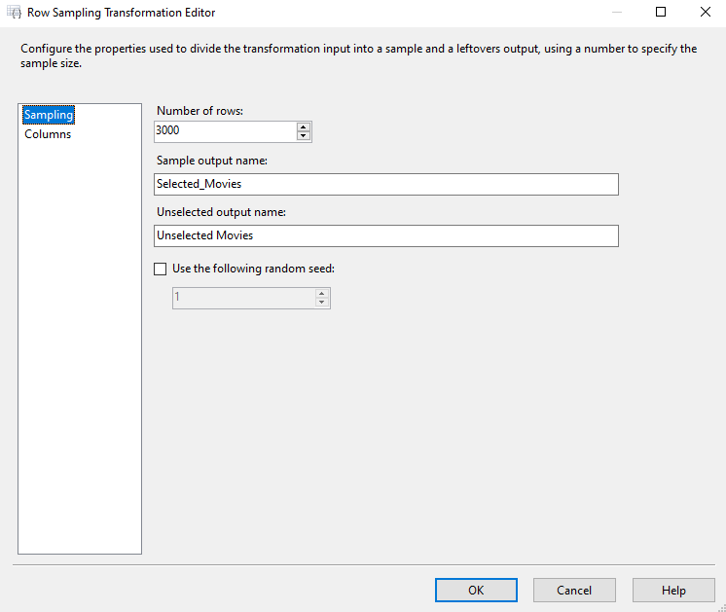

* **Conditional Split:**

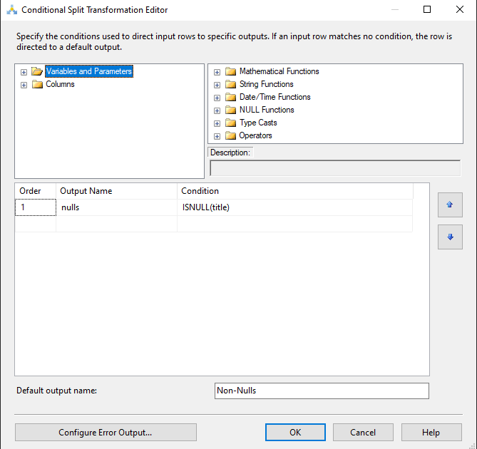

1. Perform the Transformations:

* **Person_Dim:**

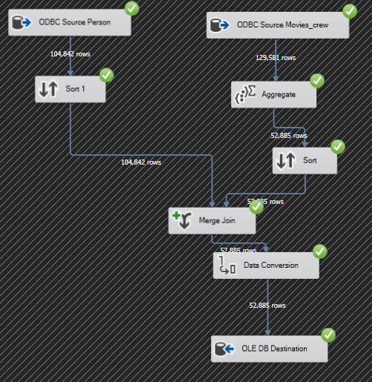

* **Countries_dim:**

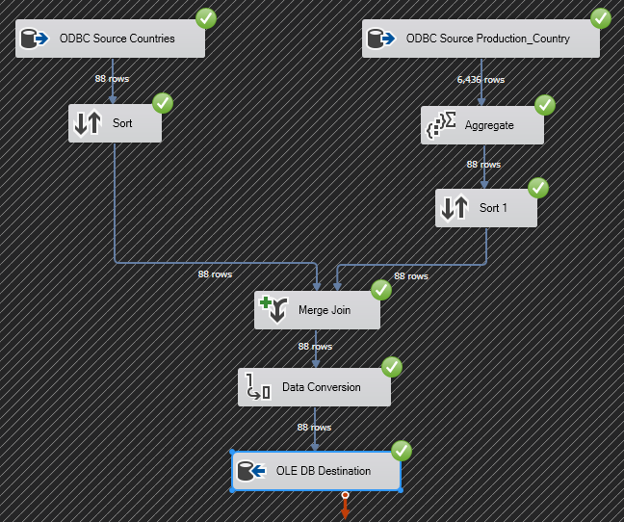

* **Genre_dim**

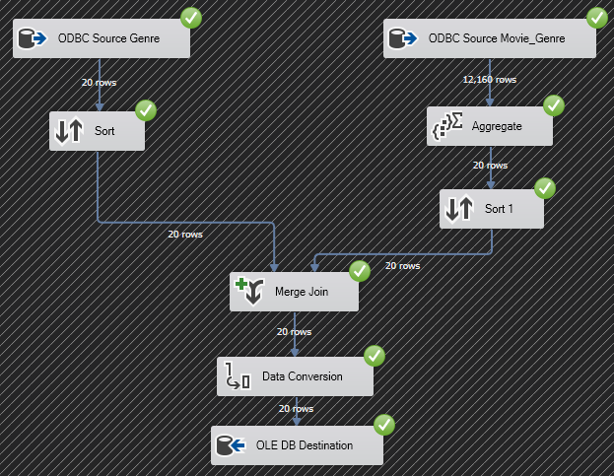

* **Movies_dim**

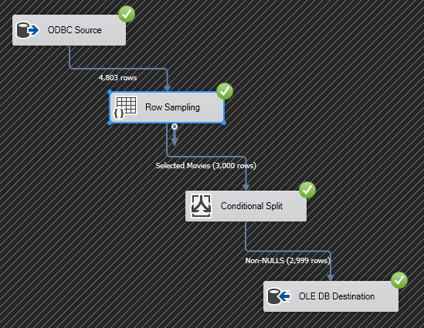**.**

* **Budget_dim**

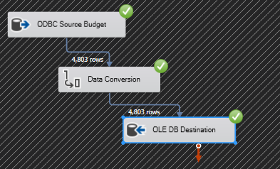

* **Movie_Data_Fact**

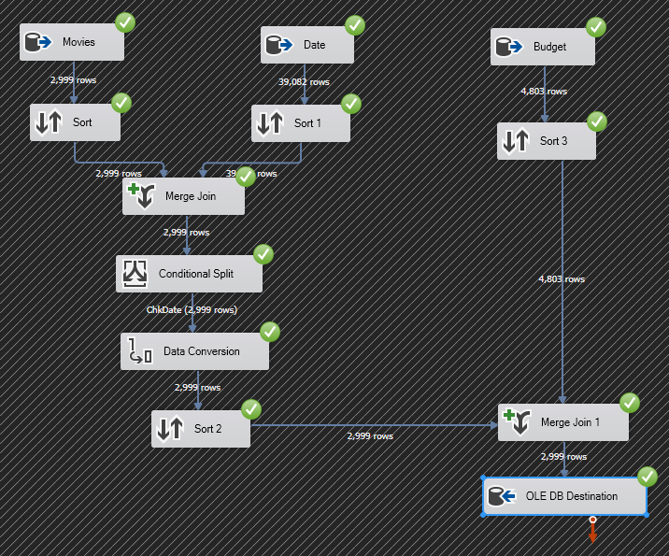

* **Person_Helper_Table**

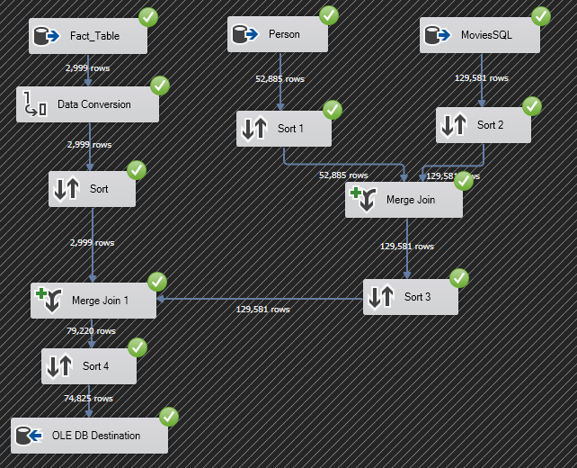

* **Genre_Helper_Table**

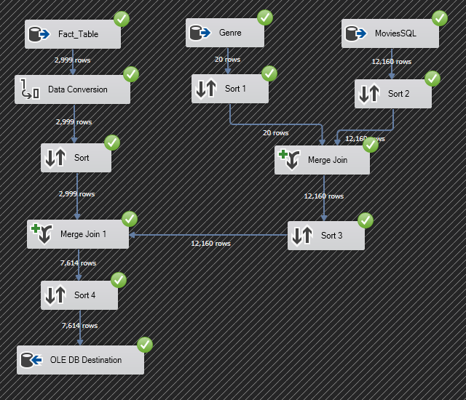

* **Country_Helper_Table**

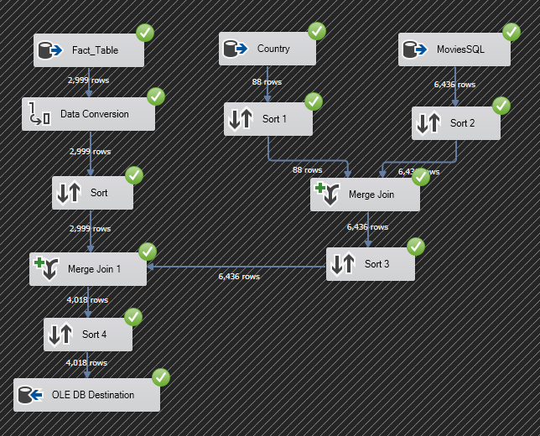

**Step 4: Loading:**

1. Select the OLE DB from the destination panel
2. Connect to the desired table in the database

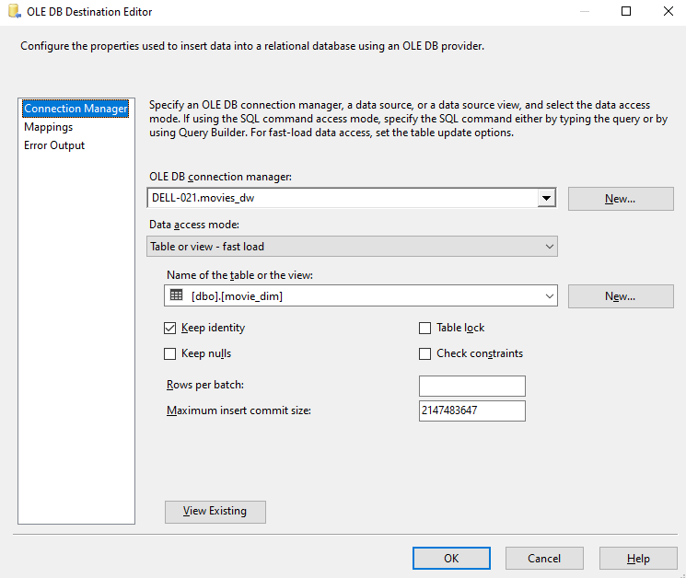

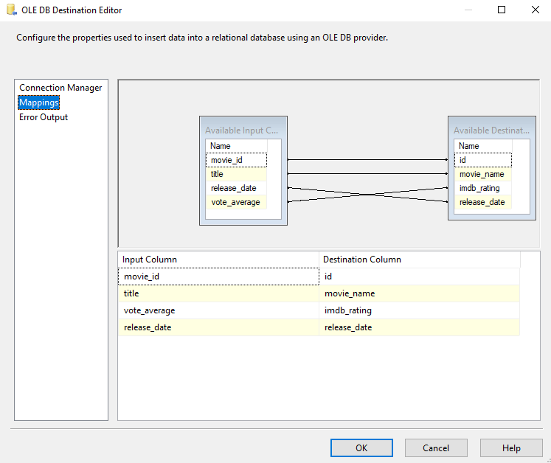

**Business Queries:**

* **No of Movies in a Genre:**

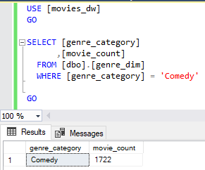

* **No of Movies Produced in a Country:**

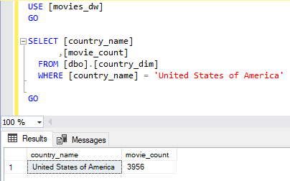

* **No of Movies respective of Cast:**

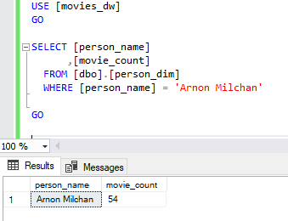

* **Movies in a Specific Range of Budget:**

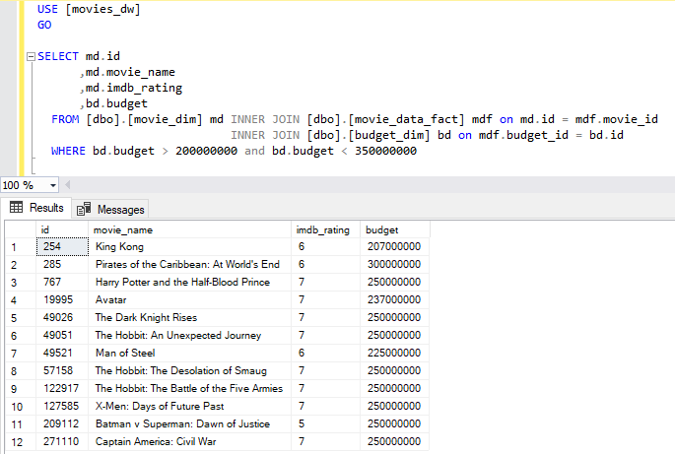

* **Movies Released in a Specific Year:**

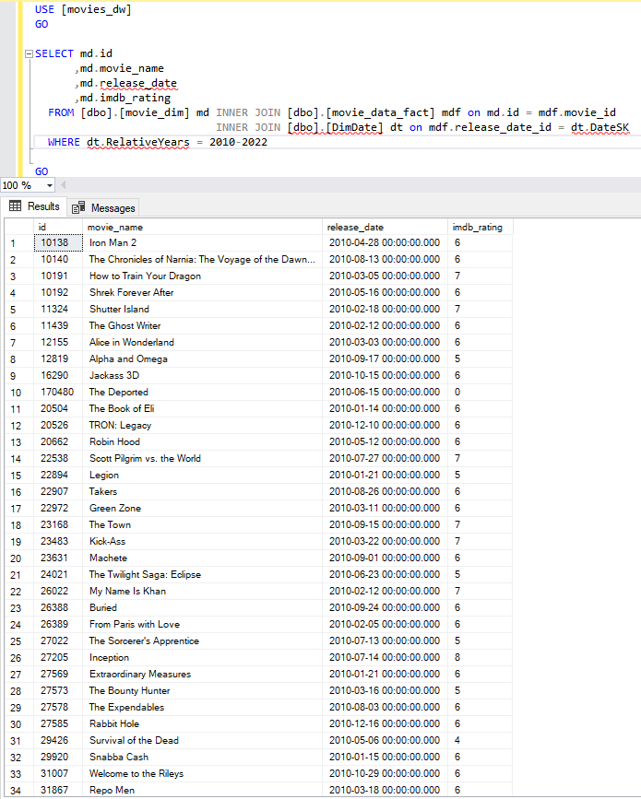

**NAÏVE BAYES:**

