Bahria University

Karachi Campus



LAB EXPERIMENT NO.

01

LIST OF TASKS

|  |  |
| --- | --- |
| **TASK NO** | **OBJECTIVE** |
|  | Get Order id, Product id, Unit price from Order Details. |
|  | Find Title of employee Nancy. |
|  | Display data of all employees those working as Sales Representative from London |
|  | Display product name whose unit price are greater than 90$ |
|  | Write a query to get current Product list (Product ID and name). |
|  | Fetch data of customers where country is "Germany" AND city must be "Berlin" OR "München" (use parenthesis to form complex expressions) |
|  | Fetch data of customers from all countries except Germany and USA |
|  | Fetch Discontinued products who’s price is greater than 20 |
|  |  |

Submitted On:

**01-03-2023**

(Date: DD/MM/YY)

**Task # 01:**

**Solution:**

select OrderID,ProductID,UnitPrice from [Order Details]

**Output:**

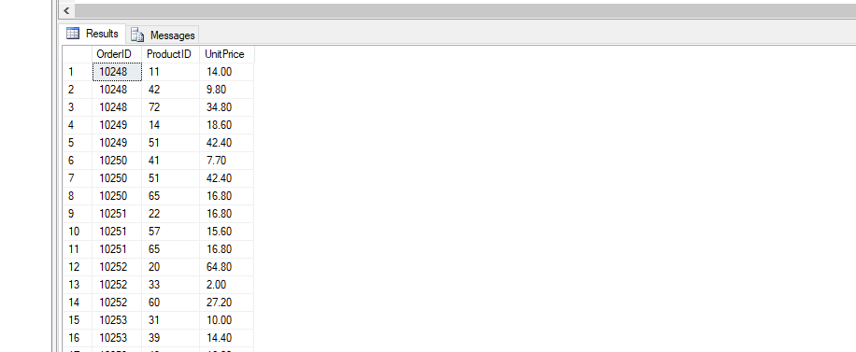

**Task # 02:**

**Solution:**

select Title from Employees where FirstName ='Nancy'

**Output:**

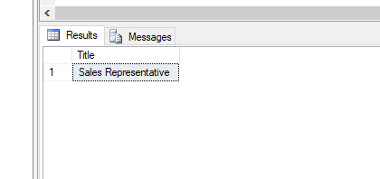

**Task # 03:**

**Solution:**

select * from Employees where City ='London' and Title = 'Sales Representative'

**Output:**

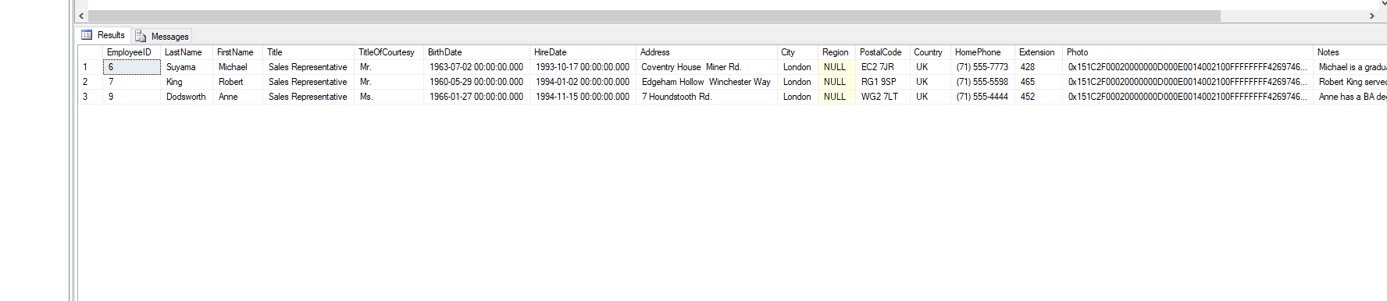

**Task # 04:**

**Solution:**

select ProductName from Products where UnitPrice > '90'

**Output:**

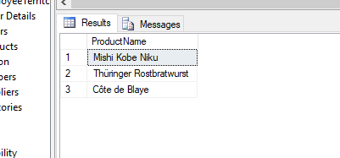

**Task # 05:**

**Solution:**

select ProductID,ProductName from Products where Discontinued ='0'

**Output:**

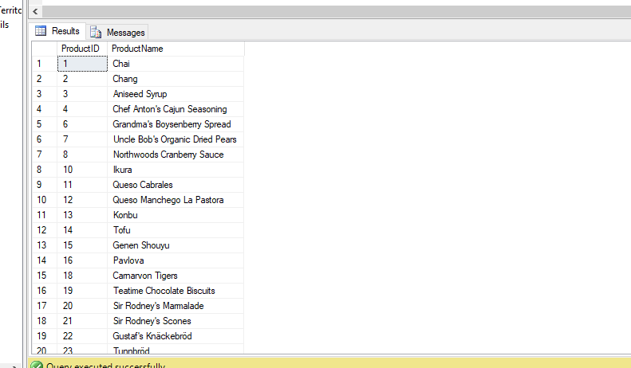

**Task # 06:**

**Solution:**

select * from Customers where Country = 'Germany' and (City = 'Berlin' or City = 'München')

**Output:**

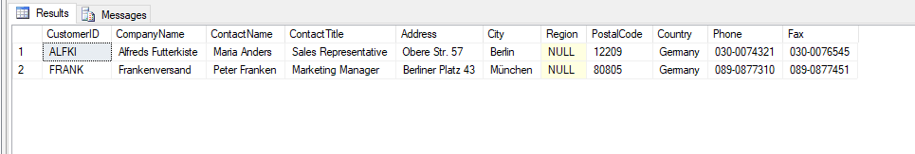

**Task # 07:**

**Solution:**

select * from Customers where (Country <> 'Germany') and (Country <> 'USA')

**Output:**

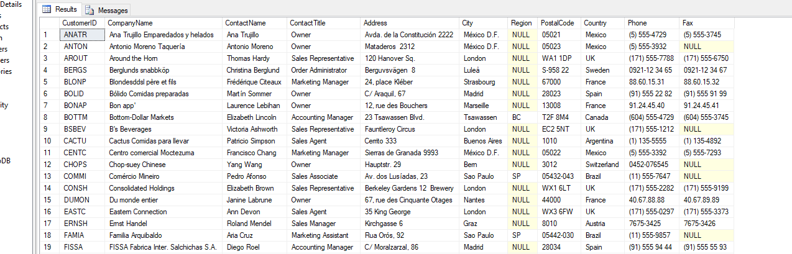

**Task # 08:**

**Solution:**

select * from Products where (Discontinued ='1' and UnitPrice > 20)

**Output:**

