Bahria University

Karachi Campus



LAB EXPERIMENT NO.

10

LIST OF TASKS

|  |  |
| --- | --- |
| **TASK NO** | **OBJECTIVE** |
|  | Create   * After Insert * After Update * After Delete   Triggers on Shippers Table in Northwind Database. Record query and their respective results in output |
| 2 | Create   * Instead of Insert * Instead of Update * Instead of Delete   Triggers on Orders Table in Northwind Database. Record query and their respective results in output. |

Submitted On:

**07-06-2023**

(Date: DD/MM/YY)

**Task # 01:**

**soluton:**

create table Shippers_Audit(

ShipperID int not null,

CompanyName nvarchar(40) not null,

Phone nvarchar(24),

ActionPerformed nvarchar(20),

date datetime,

Description nvarchar(max))

create trigger TR_InsertAfter_For_Shipper on [Shippers]

after insert

as begin

declare @id int,@companyname nvarchar(50),@phone nvarchar(50)

select @id=[ShipperID],@companyname=[CompanyName],@phone=[Phone] from inserted

insert into Shippers_Audit values(@id,@companyname,@phone,'Insert',GETDATE(),

cast(SUSER_SNAME() as varchar(50))+' Inserted The Value In Shipper Table' )

print ('Trigger Fire Successfully For Insert Operation')

end

create trigger TR_InsertUpdate_For_Shipper on [Shippers]

after update

as begin

declare @id int,@companyname nvarchar(50),@phone nvarchar(50),

@companyname1 nvarchar(50),@phone1 nvarchar(50)

select @id=[ShipperID],@companyname=[CompanyName],@phone=[Phone] from inserted

select @companyname1=[CompanyName],@phone1=[Phone] from deleted

insert into Shippers_Audit values(@id,@companyname,@phone,'Update',GETDATE(),

cast(SUSER_SNAME() as varchar(50))+' Update The Value '+cast(@companyname1 as varchar(50))

+' to '+cast(@companyname as varchar(50)) +' And '+@phone1 +' To '+

@phone+' In Shipper Table' )

print ('Trigger Fire Successfully For Upate Operation')

end

create trigger TR_InsertDelete_For_Shipper on [Shippers]

after delete

as begin

declare @id int,@companyname nvarchar(50),@phone nvarchar(50)

select @id=[ShipperID],@companyname=[CompanyName],@phone=[Phone] from deleted

insert into Shippers_Audit values(@id,@companyname,@phone,'Delete',GETDATE(),

cast(SUSER_SNAME() as varchar(50))+' Delete The Row Where ID = '+cast(@id as varchar(10))+' In Shipper Table' )

print ('Trigger Fire Successfully For Delete Operation')

end

**Output:**

**Insert:**

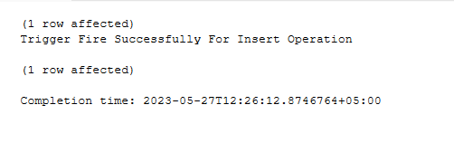

**Update:**

**Delete:**

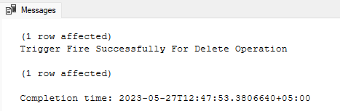

**Task # 02:**

**soluton**

create table Orders_Audit(

[OrderID] int NOT NULL,

[CustomerID] nchar(5) NULL,

[EmployeeID] int NULL,

[ShipVia] int NULL,

[Freight] money NULL,

[ShipName] nvarchar(40) NULL,

ActionPerformed nvarchar(50)

)

create trigger TR_InsteadOfInsert on Orders

instead of insert

as begin

declare @orderid int,@customerid nchar(5),@employeeid int,@shipvia int,

@freight money, @shipname varchar(40),@action varchar(50);

select @orderid=[OrderID],@customerid=[CustomerID],@employeeid=[EmployeeID],

@shipvia=[ShipVia],@freight=[Freight],@shipname=[ShipName] from inserted ;

set @action='Insert';

begin transaction

if @employeeid > 8

begin

PRINT 'You have entered incorrect employeeid. Please insert the correct information';

Rollback;

end

else

BEGIN

insert into Orders_Audit values(@orderid,@customerid,@employeeid,@shipvia,@freight,@shipname,@action);

commit;

print 'Values Inserted - Trigger Instead of Insert Fired Successfully'

end

end

select @orderid=[OrderID],@customerid=[CustomerID],@employeeid=[EmployeeID],

@shipvia=[ShipVia],@freight=[Freight],@shipname=[ShipName] from inserted ;

set @action='Update - Instead of Trigger';

begin transaction

if @freight < 50

begin

PRINT 'Too low freight. Data cannot be updated';

Rollback;

end

else

BEGIN

insert into Orders_Audit values(@orderid,@customerid,@employeeid,@shipvia,@freight,@shipname,@action);

commit;

print 'Values Inserted - Trigger Instead of Insert Fired Successfully';

END

End

create trigger TR_InsteadOfDelete on Orders

instead of delete

as begin

declare @orderid int,@customerid nchar(5),@employeeid int,@shipvia int,

@freight money, @shipname varchar(40),@action varchar(50);

select @orderid=[OrderID],@customerid=[CustomerID],@employeeid=[EmployeeID],

@shipvia=[ShipVia],@freight=[Freight],@shipname=[ShipName] from deleted ;

set @action='Delete - Instead of Trigger';

begin transaction

if @freight > 70

begin

PRINT 'Too high freight. Data cannot be deleted';

Rollback;

end

else

BEGIN

insert into Orders_Audit values(@orderid,@customerid,@employeeid,@shipvia,@freight,@shipname,@action);

commit;

print 'Values Deleted - Trigger Instead of Delete Fired Successfully';

END

end

**Output:**

**Instead of insert:**

insert into Orders (CustomerID,EmployeeID,ShipVia,Freight,ShipName) values

('Wolza','10','10','00.00','Karachi Express')

As error will shown

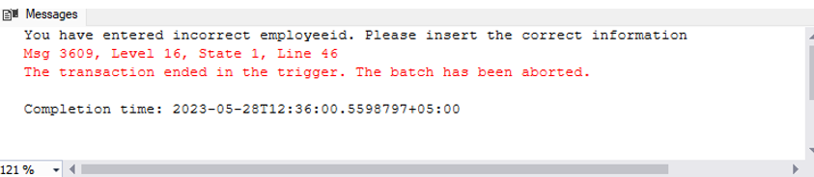

**Instead of Update:**

update Orders set Freight=51 where OrderID=11044

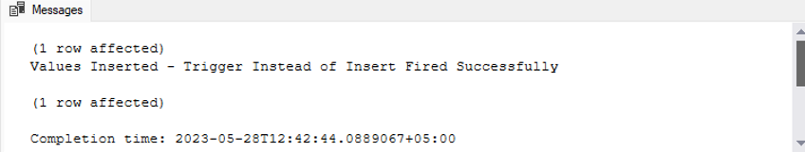

**Instead of Delete:**

delete from Orders where OrderID=10250

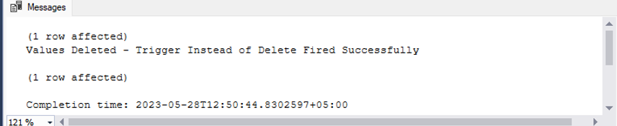

**Audit table:**

