Bahria University

Karachi Campus



LAB EXPERIMENT NO.

02

LIST OF TASKS

|  |  |
| --- | --- |
| **TASK NO** | **OBJECTIVE** |
|  | Get the price of an order (by multiplying unit price by quantity). |
|  | Display all cities that employees belong to but don’t allow repetition. |
|  | Find complete name of all employees. |
|  | List the name of all employees whose first name starts with the letter ‘A’. |
|  | In Customer table, display all cities that ends with the letter ‘a’. |
|  | Display names of all employees whose name contain ‘an’. |
|  | Display all the orders where unit price lies in the range of 10$ to 40$. |
|  | Display the company name where Region is NULL in Customer Table |
|  | Write a query to list employees whose address does not contain Rd. |
|  | List all products where UnitPrice is not in 10,12,15,17 or 19 |
|  | Display the highest, lowest, sum and average UnitPrice of each Category, where highest UnitPrice lies in the range of 50$ to 100$. Label column as CategoryId, Maximum, Minimum, Sum and Average, respectively. |
|  | From customers table, Count all customers is each region where region is not null |
|  | Write a query to display the number of ContactName with same ContactTitle. Sort contact title in descending order. (Table: Customers) |
|  | Write a query that count all orders against each product id. No of orders should be greater than 50. (Table: [Order Details]) |
|  | List only those cities in which more than or equals to 2 employees are living |

Submitted On:

**08-03-2023**

(Date: DD/MM/YY)

**Task # 01:**

**Solution:**

select UnitPrice*Quantity as price from [Order Details]

**Output:**

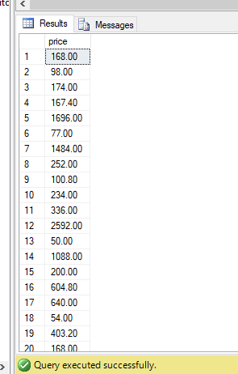

**Task # 02:**

**Solution:**

select distinct City from Employee

**Output:**

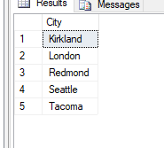

**Task # 03:**

**Solution:**

select FirstName+ LastName as name from Employees

**Output:**

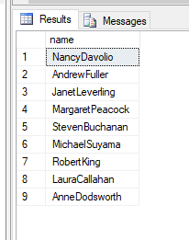

**Task # 04:**

**Solution:**

select FirstName from Employees where FirstName like 'A%'

**Output:**

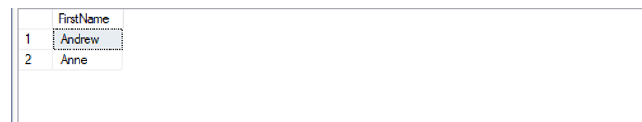

**Task # 05:**

**Solution:**

select city from Customers where City like '%A'

**Output:**

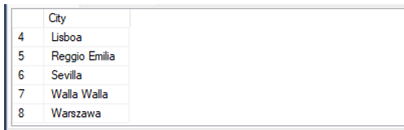

**Task # 06:**

**Solution:**

select FirstName from Employees where FirstName like '%An%'

**Output:**

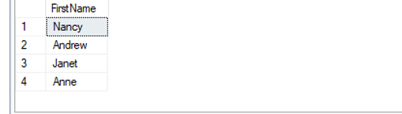

**Task # 07:**

**Solution:**

select * from [Order Details] where UnitPrice between 10 and 40

**Output:**

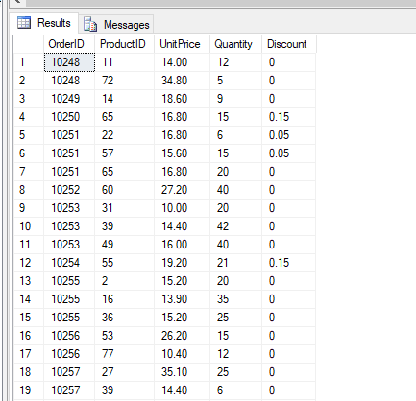

**Task # 08:**

**Solution:**

select CompanyName from Customers where Region is null

**Output:**

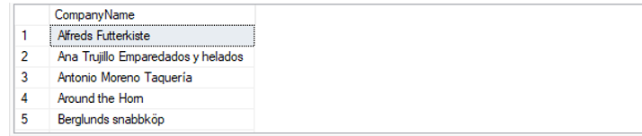

**Task # 09:**

**Solution:**

select * from Employees where Address not like '%rd%'

**Output:**

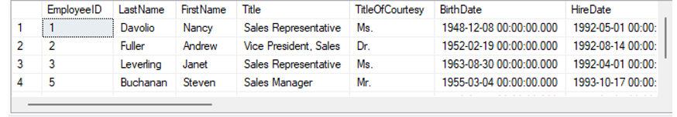

**Task # 10:**

**Solution:**

select * from Products where UnitPrice not in (10,12,15,17,19)

**Output:**

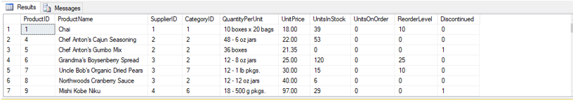

**Task # 11:**

**Solution:**

select MAX(unitprice) as maximum ,MIN(UnitPrice) as minumum,SUM(unitprice) as sumprice, AVG(unitprice) as average from Products group by CategoryID having MAX(unitprice) between 50 and 100;

**Output:**

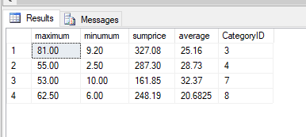

**Task # 12:**

**Solution:**

select COUNT(Region) from Customers where region <> 'null' group by Region;

**Output:**

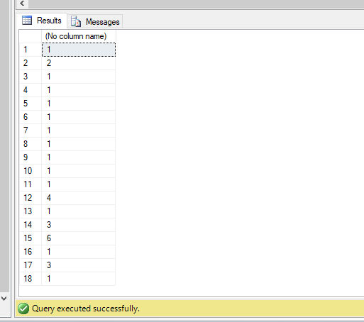

**Task # 13:**

**Solution:**

select count(ContactName) from Customers group by ContactTitle order by ContactTitle desc;

**Output:**

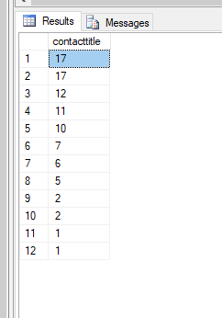

**Task # 14:**

**Solution:**

select productid,COUNT(*) as countt from [Order Details] group by ProductID having count(*) >50;

**Output:**

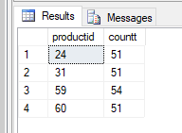

**Task # 15:**

**Solution:**

select City,Count(City) as [Number Of Employee Living] from Employees group by City having COUNT(City) >=2

**Output:**

