Bahria University

Karachi Campus



LAB EXPERIMENT NO.

04

LIST OF TASKS

|  |  |
| --- | --- |
| **TASK NO** | **OBJECTIVE** |
|  | Display Product Name and its Category Name where Category Name starts with B |
|  | Display Titles and their quantity (Hint Pubs database, table title and sales, left join) |
|  | Use Right join to display Book Title and publisher Names (Hint pubs Database, Table Title and Publisher) Write down the reason for any null values if coming in title column. |
|  | User Right join to display those publishers where title is null. |
|  | Use self-join to display Publishers name where city is same (Publisher id should be different) |
|  | Use cross join (Cartesian join) to Display Book Title and Publisher Name. |
|  | Use two full joins to Display Product Name, Category Name and Supplier Name |
|  | Use full join to display the name of Supplier for the product starting with letter C ( |
|  | Get shipper’s Company Name for an order using inner join. (Display only orderID from orders and comapnayName from Customers table) |
|  | Count no of Products’s against each suppliers name. list only those products whose count is greater than 3 |
|  | Display Region ID, Region Description, Territories Description and (inner join with table Territories and Region) |
|  | Display Company Name and Total orders placed by the company (Table: orders, customer, use inner join, group by) |

Submitted On:

**22-03-2023**

(Date: DD/MM/YY)

**Task # 01:**

**Solution:**

select ProductName,CategoryName from Categories left join Products on

Categories.CategoryID=Products.CategoryID where CategoryName like 'B%'

**Output:**

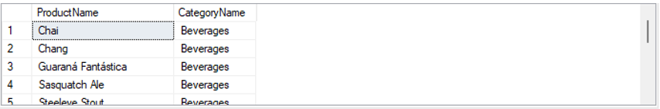

**Task # 02:**

**Solution:**

select A.title,B.qty from titles as A left join sales as B on

A.title_id=b.title_id

**Output:**

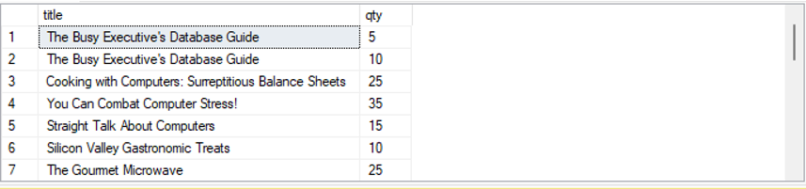

**Task # 03:**

**Solution:**

select A.title,B.pub_name from titles as A right join publishers as B on A.pub_id=b.pub_id

**Output:**



**Task # 04:**

**Solution:**

select A.title,B.pub_name from titles as A right join publishers as B on A.pub_id=b.pub_id where A.title is null

**Reason**

The reason for null values in the title column is because there may be publishers without any titles, and a right join will still include those publisher rows but the title column will have null values.

**Output:**

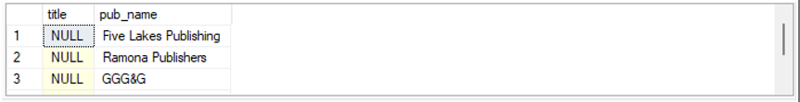

**Task # 05:**

**Solution:**

select B.pub_name,a.pub_name,A.country from publishers as A , publishers as B where A.pub_id<>b.pub_id and A.country=b.country

**Output:**

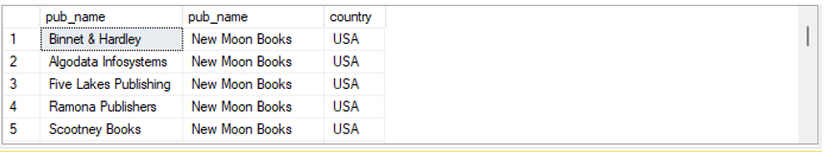

**Task # 06:**

**Solution:**

select A.title,b.pub_name from titles as A ,publishers as B

**Output:**

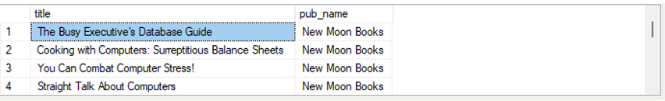

**Task # 07:**

**Solution:**

select ProductName,CategoryName,ContactName from Products full join Categories

on Products.CategoryID=Categories.CategoryID full join Suppliers on

Suppliers.SupplierID=Products.SupplierID

**Output:**

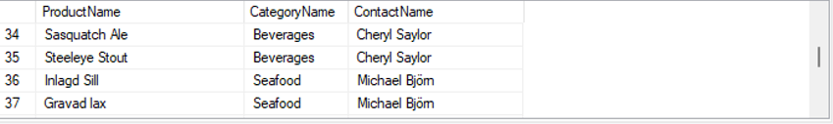

**Task # 08:**

**Solution:**

select ProductName,ContactName from Products full join Suppliers on

Suppliers.SupplierID=Products.SupplierID where ProductName like 'C%'

**Output:**

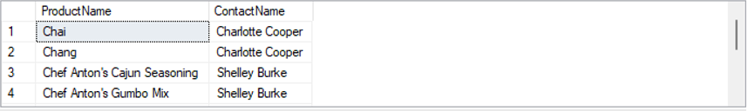

**Task # 09:**

**Solution:**

select Orders.OrderID, CompanyName from Orders inner join Customers on

Orders.CustomerID=Customers.CustomerID

**Output:**

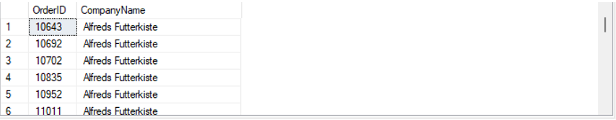

**Task # 10:**

**Solution:**

select COUNT(ProductName)as [No Of Products],Suppliers.ContactName from Products inner join Suppliers on Products.SupplierID= Suppliers.SupplierID group by ContactName having COUNT(ProductName)>3

**Output:**

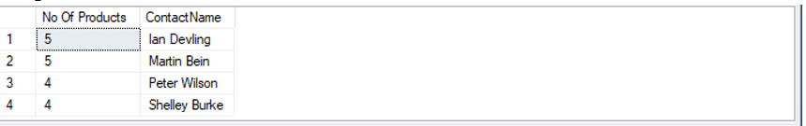

**Task # 11:**

**Solution:**

select Region.RegionID,Region.RegionDescription,Territories.TerritoryDescription from Region inner join Territories on Region.RegionID=Territories.RegionID

**Output:**

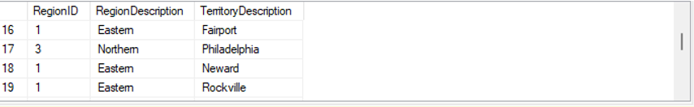

**Task # 12:**

**Solution:**

select Customers.CompanyName, count(orders.OrderID) as [Total Order Placed] from Customers inner join Orders on Customers.CustomerID=orders.CustomerID group by Customers.CompanyName

**Output:**

