Bahria University

Karachi Campus



LAB EXPERIMENT NO.

05

LIST OF TASKS

|  |  |
| --- | --- |
| **TASK NO** | **OBJECTIVE** |
|  | Find the company’s name that placed order 10290. |
|  | Find the Companies that placed orders in 1997. |
|  | Create a report that shows the product name and supplier id for all products supplied by Exotic Liquids, Grandma Kelly's Homestead, and Tokyo Traders. |
|  | Create a report that shows all products by name that are in the Seafood category. |
|  | Create a report that shows all companies by name that sell products in CategoryID. |
|  | Create a report that shows all 5companies by name that sell products in the Seafood category. |
|  | Write query using a “sub query” to display which Customers were served by which Employee use Northwind. |
|  | Write query using a “sub query” to list of all the stores that have discount records . |
|  | Write query using a “sub query” to name publishers have got titles in store in Seattle? Use pubs |
|  | Write query using a “sub query” to list all the authors available in Barnum’s store use pubs. |
|  | Write query using a “sub query” to give the customer id and amount spent of the customer who spent the most using Northwind |
|  | Write query using a “sub query” to list all Northwind customers who have not placed an order. |

Submitted On:

**05-04-2023**

(Date: DD/MM/YY)

**Task # 01:**

**Solution:**

SELECT CompanyName from Customers where CustomerID =

(select CustomerID from Orders where OrderID=10290)

**Output:**

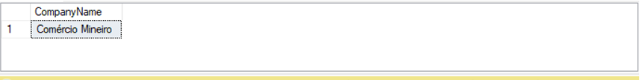

**Task # 02:**

**Solution:**

SELECT CompanyName from Customers where CustomerID in

(select CustomerID from Orders where year(OrderDate)=1997)

**Output:**

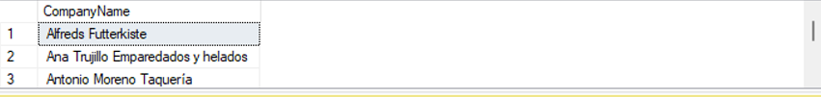

**Task # 03:**

**Solution:**

SELECT SupplierID,ProductName from Products as p where SupplierID in (select SupplierID from Suppliers as s where CompanyName in ('Exotic Liquids','Grandma Kelly''s Homestead'

,'Tokyo Traders'))

**Output:**

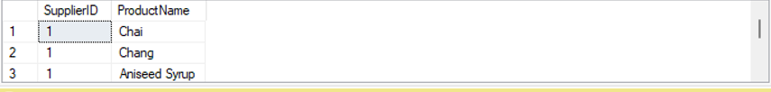

**Task # 04:**

**Solution:**

select ProductName,CategoryID from Products where CategoryID in

(select CategoryID from Categories where CategoryName ='Seafood')

**Output:**

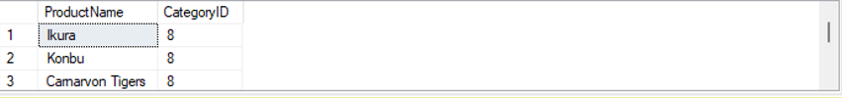

**Task # 05:**

**Solution:**

select CompanyName from Suppliers where SupplierID in

(select SupplierID from Products where CategoryID = 8)

**Output:**

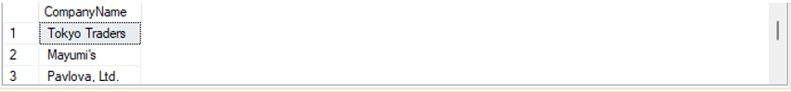

**Task # 06:**

**Solution:**

select CompanyName from Suppliers where SupplierID in

(select SupplierID from Products where CategoryID =

(select CategoryID from Categories where CategoryName='Seafood'))

**Output:**

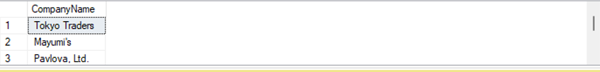

**Task # 07:**

**Solution:**

Select ContactName, A.OrderID, firstname+' '+Lastname as Employee FROM (select Orderid,ContactName from orders left join Customers on Orders.CustomerID=Customers.CustomerID) A inner join ( select OrderID,FirstName,LastName from Orders left join employees on Orders.EmployeeID=Employees.EmployeeID)B on A.Orderid=B.Orderid

**Output:**

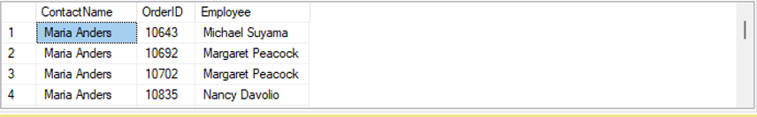

**Task # 08:**

**Solution:**

select a.stor_id,a.stor_name ,b.discount from stores as a,discounts as b where a.stor_id in (select b.stor_id from discounts)

**Output:**



**Task # 09:**

**Solution:**

select pub_id,pub_name from publishers where pub_id in

(select pub_id from titles where title_id in (select title_id from sales where stor_id in (select stor_id from stores where city ='Seattle')))

**Output:**



**Task # 10:**

**Solution:**

select au_fname+' '+au_lname as [Full Name] from authors where au_id in (select au_id from titleauthor where title_id in (select title_id from sales where stor_id in (select stor_id from stores where stor_name like 'ba%')))

**Output:**

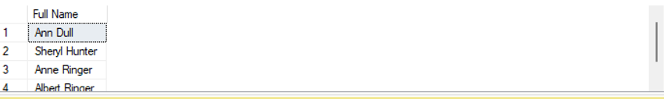

**Task # 11:**

**Solution:**

select CustomerID,max(Quantity*UnitPrice) as [Highest Price] from Customers,[Order Details] where CustomerID in (select CustomerID from Orders where OrderID in (select OrderID from [Order Details] WHERE UnitPrice*Quantity in (select MAX(UnitPrice*Quantity) from [Order Details] ))) group by CustomerID

**Output:**

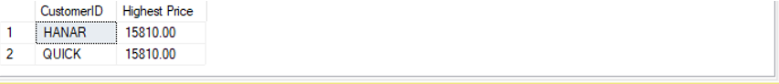

**Task # 12:**

**Solution:**

(select CustomerID,ContactName from customers) except (select CustomerID,ContactName from customers where customerid in (select Orders.CustomerID from Orders))

**Output:**

