Bahria University

Karachi Campus



LAB EXPERIMENT NO.

06

LIST OF TASKS

|  |  |
| --- | --- |
| **TASK NO** | **OBJECTIVE** |
|  | Create Department table based on the following design (in task). |
|  | Create Employee table based on the following design. |
|  | Modify Employee table and add three more columns. |
|  | Drop Column loc from Department table |
|  | Delete all record from Employee table |
|  | Drop Department Table. |
|  | Create database Authorization  Add a column ‘Address’ in Starsin table in database Authorization.CREATE TABLE StarsIn ( movieTitle char(30), movieYear int,starName char(30) ); |
|  | Solve the Queries given below according to the following tables given below   1. Apply Not Null Constraint on all columns . 2. Apply primary key constraint in OrderID and customer ID. 3. Apply foreign key constraint on Customer _ID in Order table. 4. Apply check constraint on city (allow Karachi, Islamabad, Lahore only). 5. Set the default value of City as ‘Karachi’. 6. Add CNIC column in Customer table with unique constraint. |
|  | Create the following tables given in diagram with constraints (PK-FK relationship). |

Submitted On:

**05-04-2023**

(Date: DD/MM/YY)

**Task # 01:**

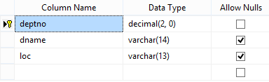

**Solution:**

create database department_DB

create table Department (

deptno decimal(2,0) not null primary key,

dname varchar(14),

loc varchar(13)

)

**output:**

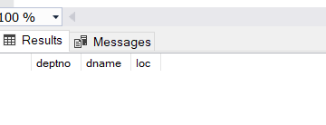

**Task # 02:**

**Solution:**

create table Employee (

empno decimal(4,0) not null primary key ,

ename varchar(10) not null,

job varchar(9),

mgr decimal(4,0),

hiredate date

)

**Output:**

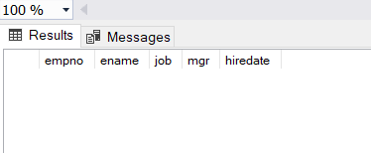

**Task # 03:**

**Solution:**

alter table Employee add sal money,comm money,deptno decimal(4,0)

**Output:**

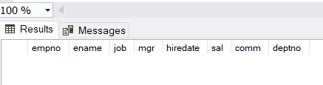

**Task # 04:**

**Solution:**

alter table Department drop column loc

**Output:**

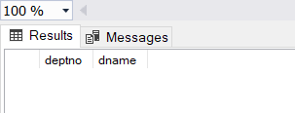

**Task # 05:**

**Solution:**

delete Employee

**Output:**

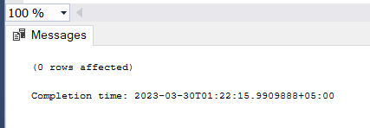

**Task # 06:**

**Solution:**

drop table department

**Output:**

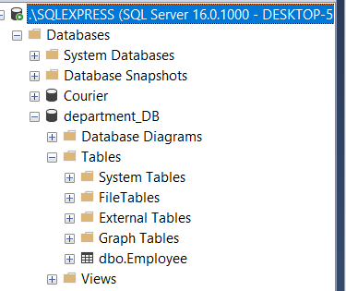

**Task # 07:**

**Solution:**

create database AuthorizationDB

create table starsin(

id int not null primary key identity(1,1),

movieTitle char (30),

movieYear int,

starName char (30)

)

alter table starsin add Address varchar (255)

select * from starsin

**Output:**

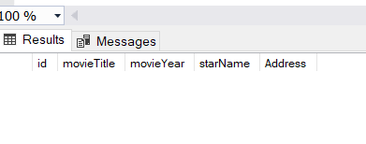

**Task # 08:**

**Solution:**

create database MartSystem

create table Table_Customer (

Customer_ID int not null primary key identity(1,1),

FirstName int not null,

LastName varchar(255) not null,

City varchar(255) not null default ('karachi') check (City in('karachi','islamabad','lahore')),

Address varchar(255) not null,

)

create table Table_Order (

Order_ID int not null primary key identity(1,1),

Customer_ID int not null,

Order_Details varchar(255) not null,

Order_Date varchar(255) not null,

required_Date varchar(255) not null,

foreign key(Customer_ID) references Table_Customer(Customer_ID)

)

alter table Table_Customer add CNIC varchar(12) unique

select * from Table_Customer

select * from Table_Order

**Output:**

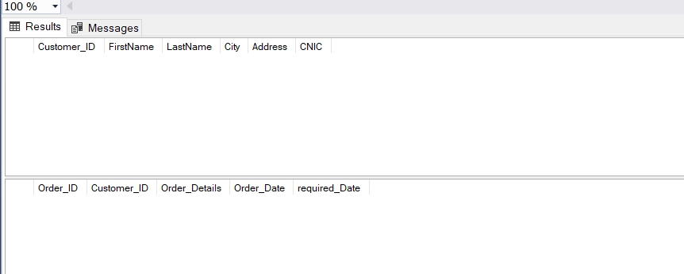

**Task # 09:**

**Solution:**

create table product(

maker varchar(10) not null,

model varchar(50) not null primary key ,

type varchar(50) not null

)

create table pc(

code int not null primary key identity(1,1),

model varchar(50) not null,

speed smallint not null,

ram smallint not null,

hd real not null,

price money,

screen tinyint not null,

foreign key(model) references product(model)

)

create table laptop(

code int not null primary key identity(1,1),

model varchar(50) not null,

speed smallint not null,

ram smallint not null,

hd real not null,

cd varchar(10) not null,

price money ,

foreign key(model) references product(model)

)

create table printer(

code int not null primary key identity(1,1),

model varchar(50) not null,

color char(1) not null,

type varchar(10) not null,

price money,

foreign key(model) references product(model)

)

**Output:**

