Bahria University

Karachi Campus



LAB EXPERIMENT NO.

08

LIST OF TASKS

|  |  |
| --- | --- |
| **TASK NO** | **OBJECTIVE** |
| 1 |  |
| 2 |  |
| 3 |  |
|  |  |

Submitted On:

**11-05-2023**

(Date: DD/MM/YY)

**Task # 01:**

**Solution:**

**Step 1:**

Open the official oracle website and click on download button for downloading virtual box.



Download it by clicking on windows link.

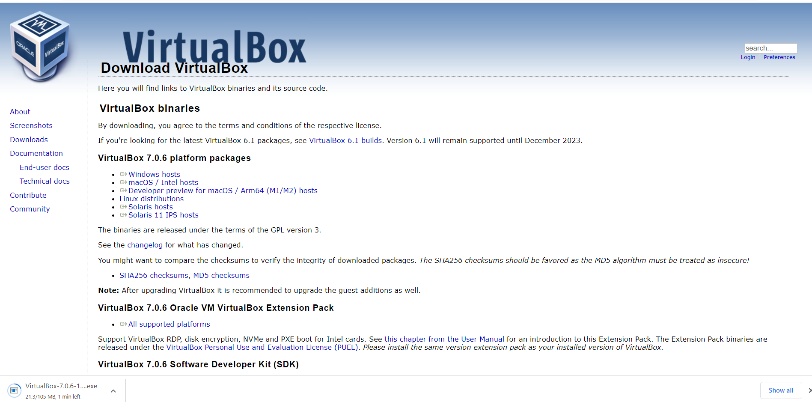

**Step 2:**

After it install its setup.

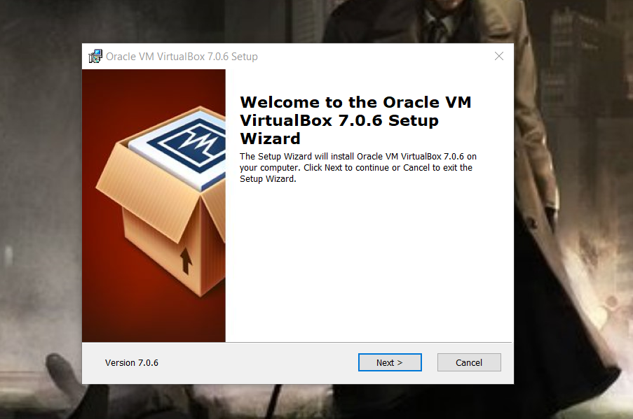

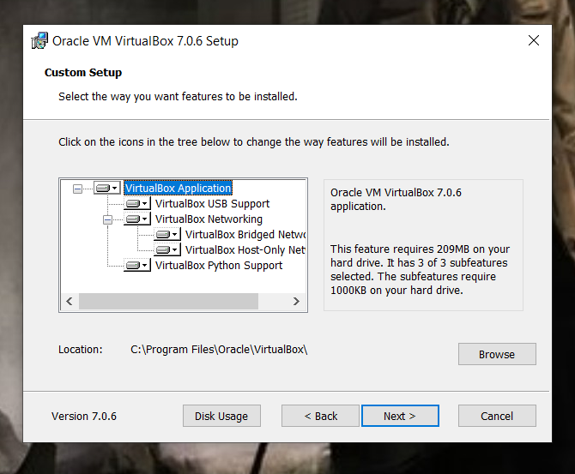

**Step 3:**

After installation a screen will appear like below not download ubuntu for it.

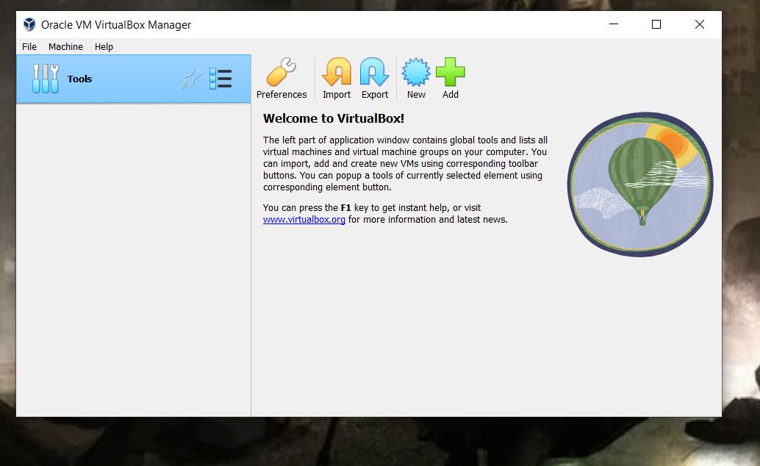

**Step 4:**

Download ubuntu from its website as below.

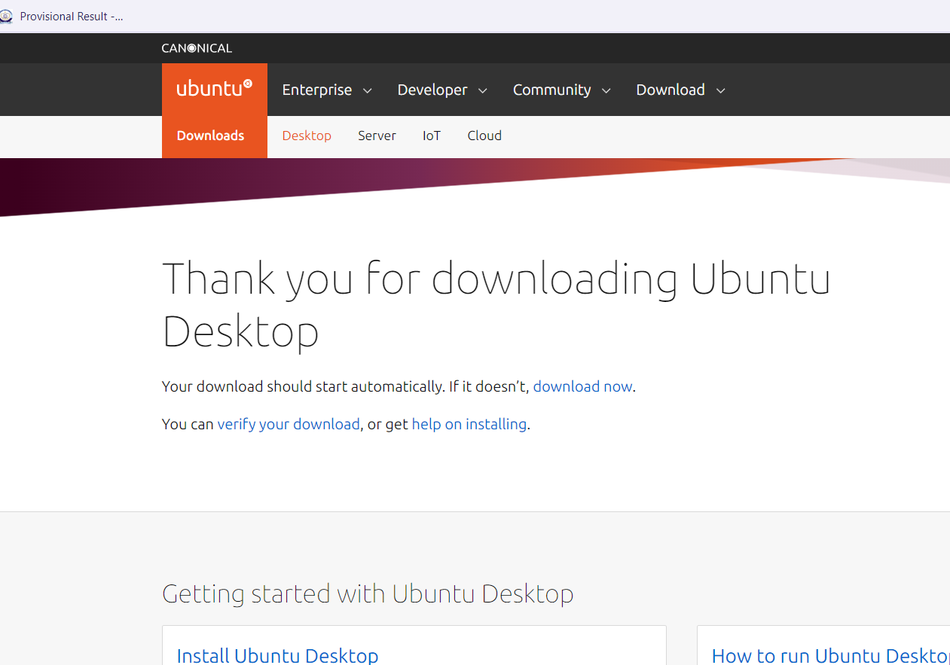

**Step 5:**

Open oracle virtual box and add ubuntu in it by clicking on new button and give its path.

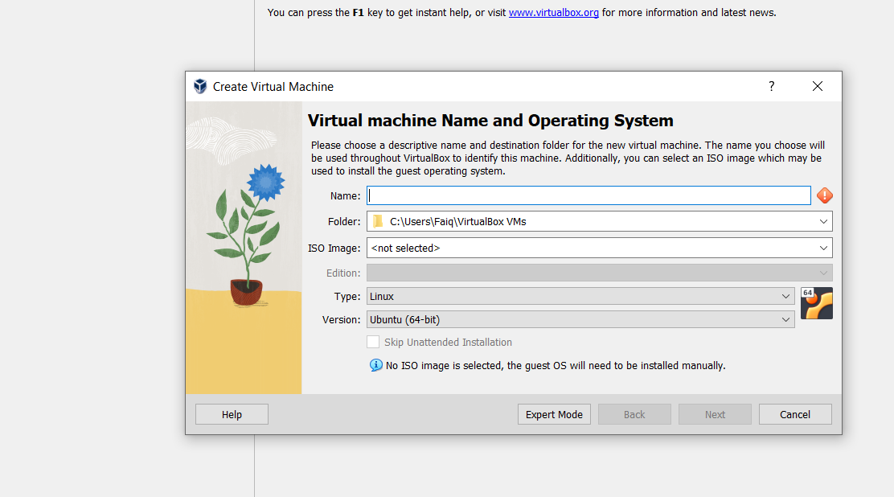

Let it done its process.

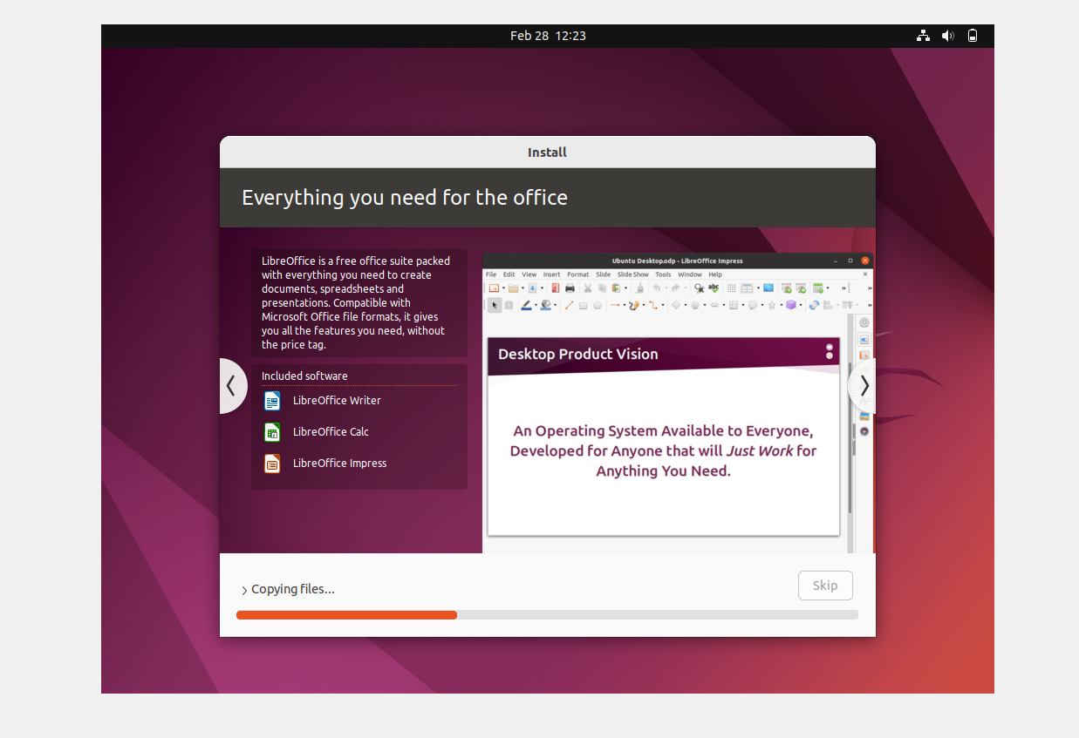

After it click on terminator for commands as below.

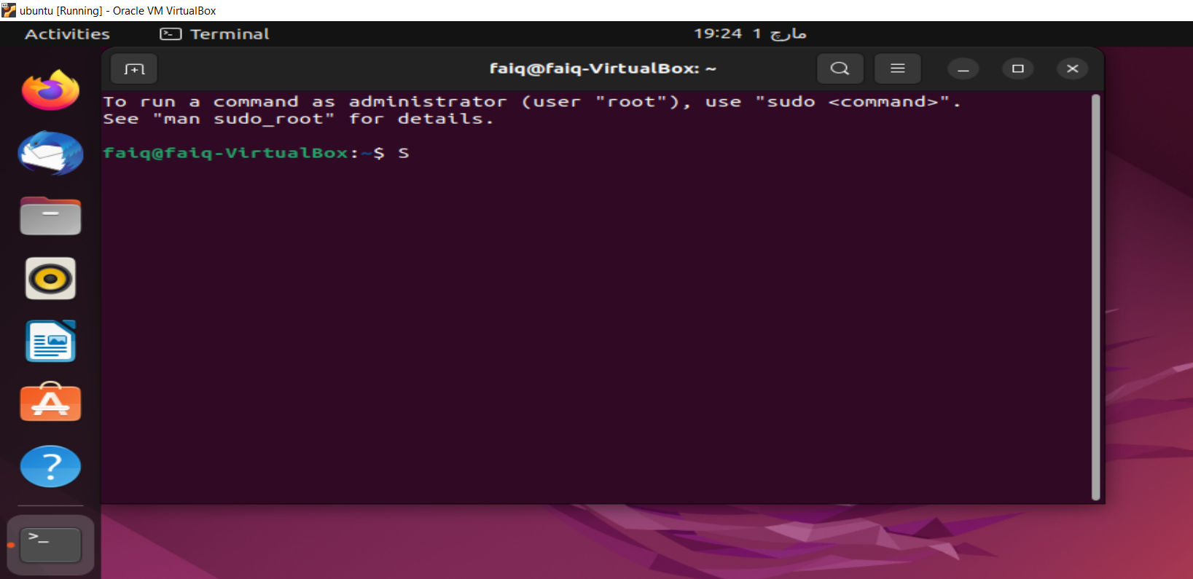

**Task#02**

**Solution:**

Followings below are some of the lab practice commands.

**Output:**

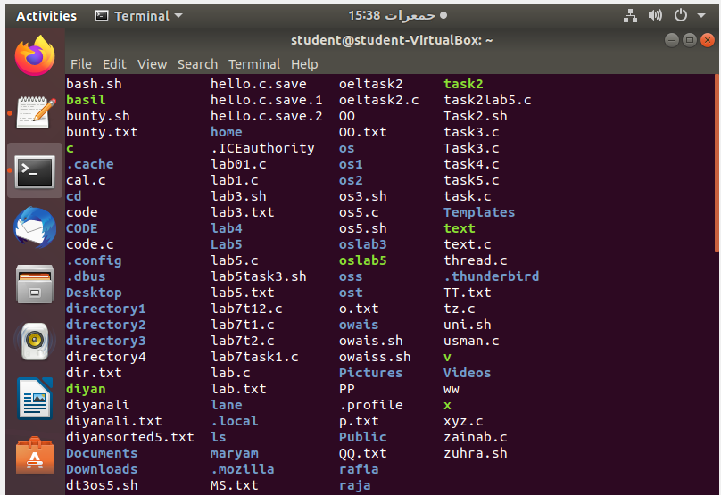





**Task#03**

**Solution:**



File is created.

**Task#04**

**Solution:**

Code in c language .

#include <stdio.h>

int main() {

printf("Hello World! I am studying Operating Systems.\n");

printf("My name is Faiq Bin Sabir.\n");

printf("My registration number is 79317.\n");

printf("I belong to Bahria University Karachi Campus.\n");

return 0;

}

**Output:**

