Bahria University

Karachi Campus



LAB EXPERIMENT NO.

10

LIST OF TASKS

|  |  |
| --- | --- |
| **TASK NO** | **OBJECTIVE** |
| 1 | Semaphore is one of the concurrency mechanisms available. Find out about more concurrency mechanisms. How do these mechanisms protect critical sections? Compare their implementations with *wait()* and *signal()* operations of semaphores. |
| 2 | Implement the algorithm of Producer-Consumer problem given above, in C language. |
|  |  |
|  |  |

Submitted On:

**01-06-2023**

(Date: DD/MM/YY)

**Task # 01:**

**Solution:**

Semaphores are a synchronization mechanism that uses two operations, wait() and signal(), to control access to shared resources. A semaphore maintains a count that represents the number of resources available. When a process wants to access a shared resource, it calls wait() on the semaphore. If the count is zero, the process is blocked until the count becomes positive. When a process is done using a shared resource, it calls signal() on the semaphore to increment the count.

**Task#02**

**Solution:**

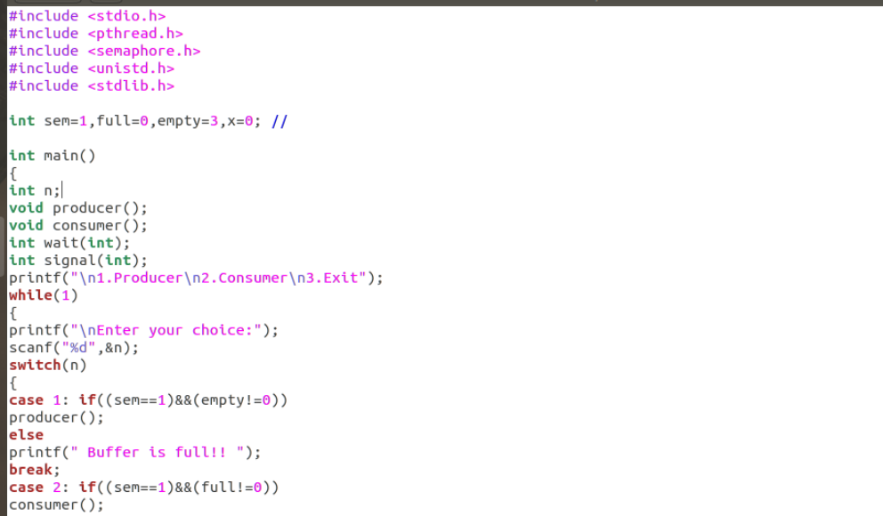

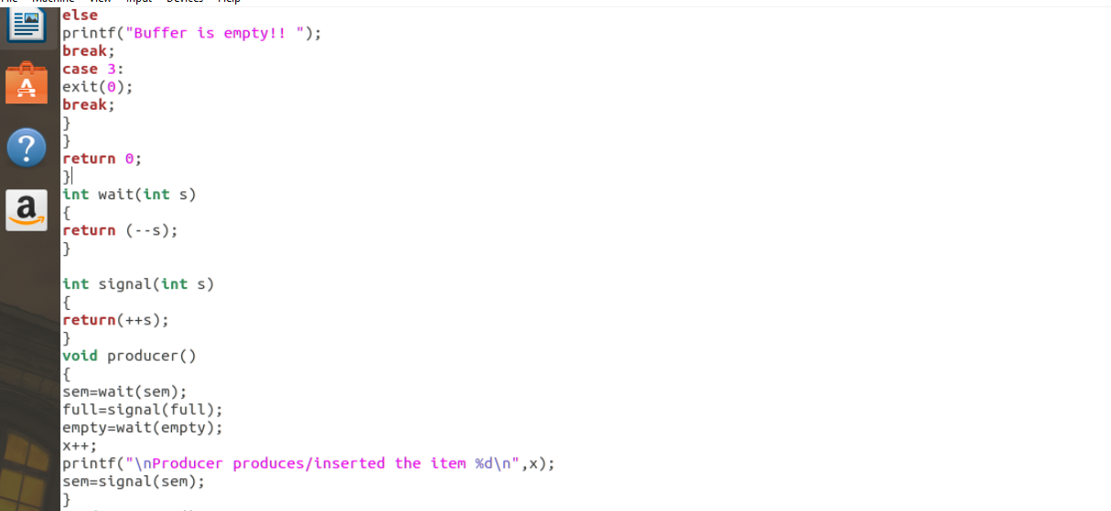

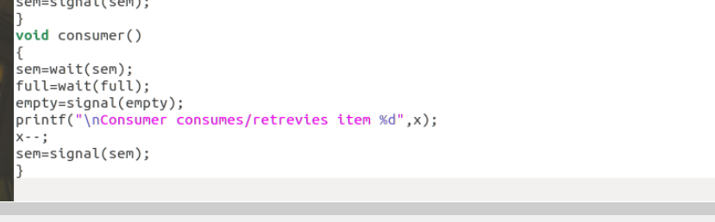

**Output:**

