Bahria University

Karachi Campus



LAB EXPERIMENT NO.

03

LIST OF TASKS

|  |  |
| --- | --- |
| **TASK NO** | **OBJECTIVE** |
| 1 | Perform all the commands provided in the lab manual |
| 2 | Create an empty file with a .txt extension. Write a shell script that would write the current date, student’s name and registration number into that file, while using variables for all three entries. |
| 3 | Create a .txt file and input ten lines of entry while mixing it with both alphanumeric characters. Sort the contents of the created file in an ascending order and write the sorted output into another file. |
| 4 | write a Program to Sum of Natural Numbers Using for Loop |

Submitted On:

**30-03-2023**

(Date: DD/MM/YY)

**Task # 01:**

**Solution:**

**Lab practice:**

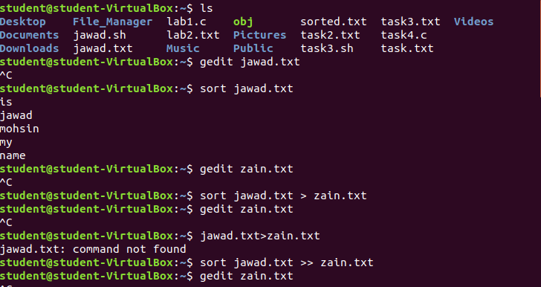

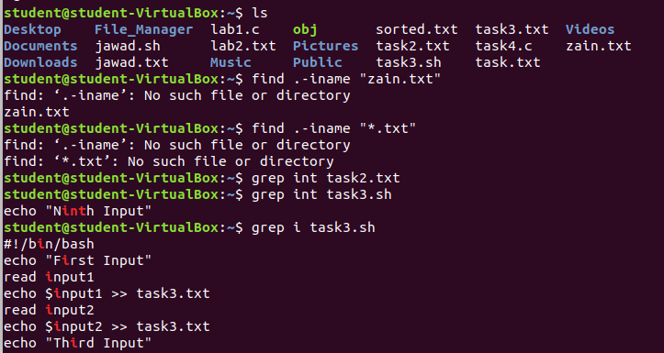

**Task # 02:**

**Solution:**



**Output:**



**Task # 03:**

**Solution:**

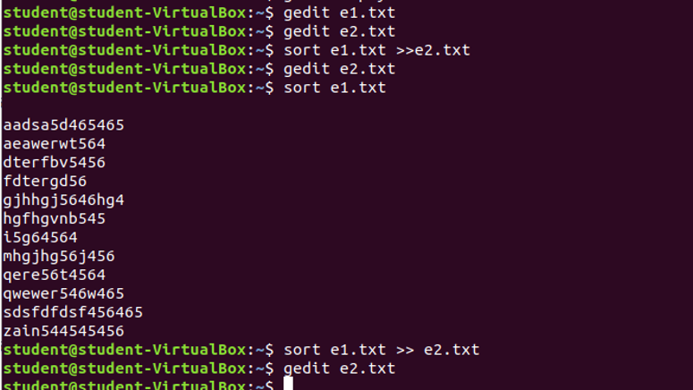

**Output:**

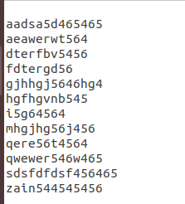

**Task # 04:**

**Solution:**

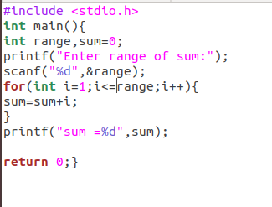

**Output:**

