Bahria University

Karachi Campus



LAB EXPERIMENT NO.

05

LIST OF TASKS

|  |  |
| --- | --- |
| **TASK NO** | **OBJECTIVE** |
| 1 | While utilizing the Linux commands studied so far, provide an example (other than the one shown in this Lab) of a combination of several Linux commands in which pipes are used more than once. Also provide a snapshot of the generated output. |
| 2 | Write C program to print all alphabets from a to z using while loop.(using ASCII). |
| 3 | Write a shell script that records the full path of all the files present within a directory into a record.txt file. Along with full path name, the script should also record the number of words, characters and lines within each file. |
| 4 | Write a C program that asks the user to provide an integer input in the main() function. The program would call a function even_odd() from the main() function, where the function even_odd() accepts an integer as an argument, determine and display if the passed integer is either even or odd. |

Submitted On:

**04-05-2023**

(Date: DD/MM/YY)

**Task # 01:**

**Solution:**

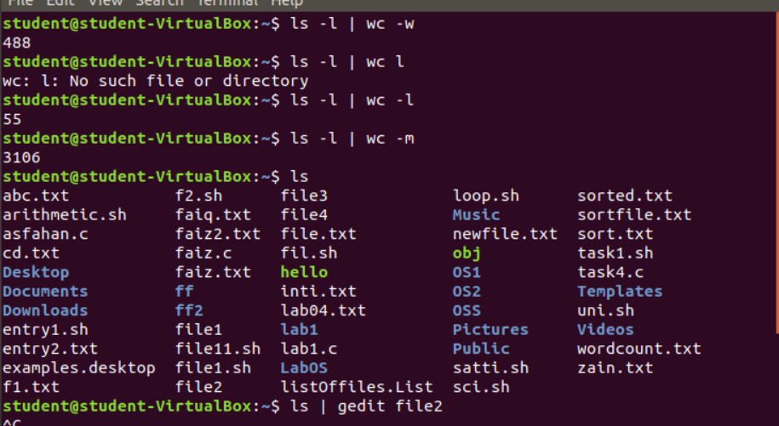

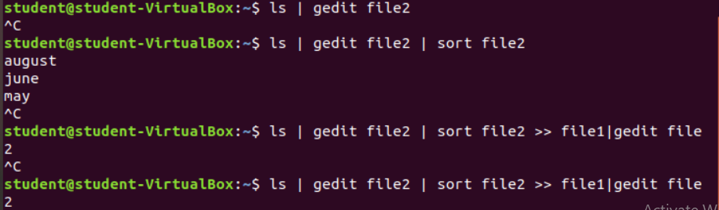

**Task#02**

**Solution:**

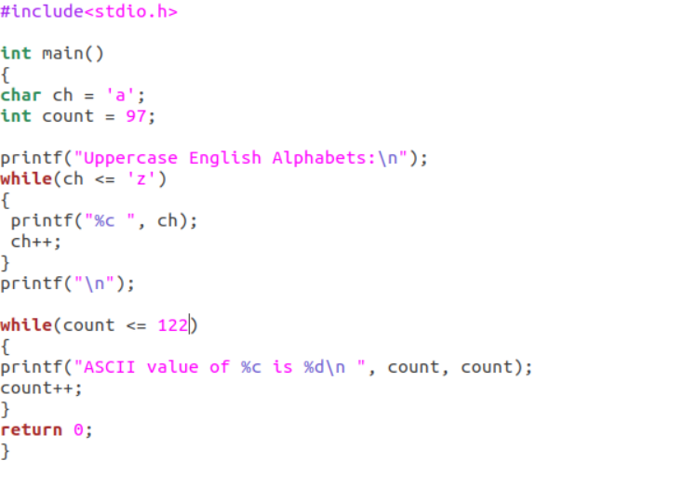

**Output:**

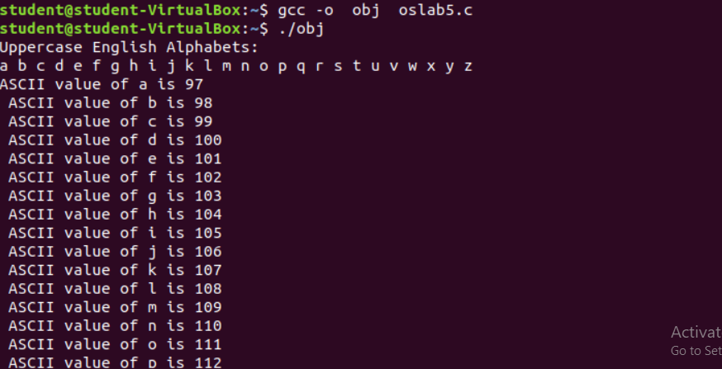 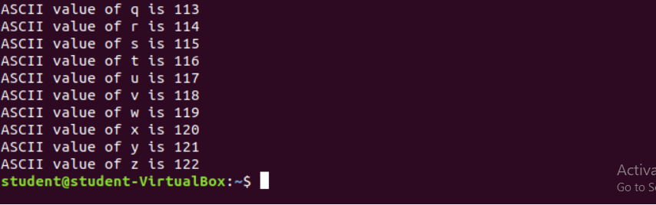

**Task#03**

**Solution:**

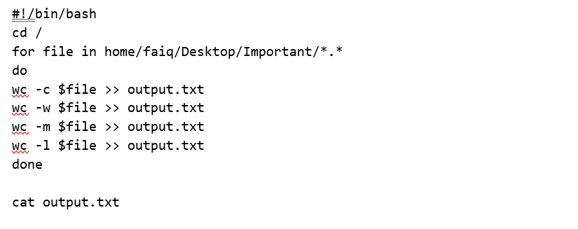

**Output:**

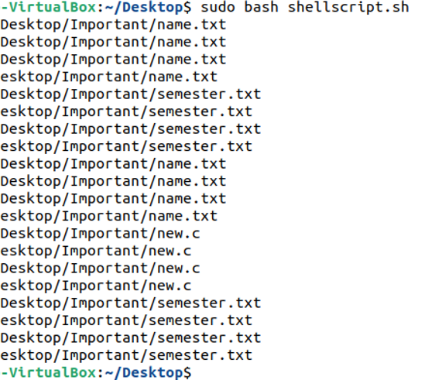

**Task#04**

**Solution:**

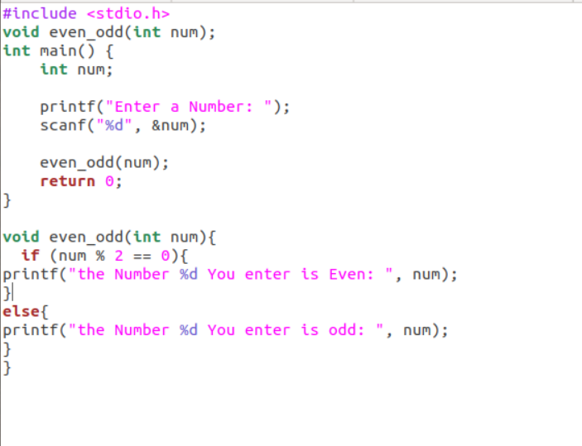

**Output:**

