Bahria University

Karachi Campus



LAB EXPERIMENT NO.

06

LIST OF TASKS

|  |  |
| --- | --- |
| **TASK NO** | **OBJECTIVE** |
| 1 | Write what you have learned in few lines on each of the three programs that were using the ***fork()*** system call. |
| 2 | Write a C program that uses ***fork()*** system call to print a single line eight times without using ***for*** loop and repeated ***printf*** command. |
| 3 | Code the C program given below and explain what it does along with providing a snapshot of the output. Investigate and write about the usage of ***execlp()*** system call. |
| 4 | Write a program to declare a counter variable initialized by zero. After fork() system call two processes will run in parallel both incrementing their own version of counter and print numbers 1 -5 . After printing numbers child process will sleep for three second, then print process id of its grandparent and terminates by invoking a gedit editor. Meanwhile, its parent waits for its termination. |

Submitted On:

**04-05-2023**

(Date: DD/MM/YY)

**Task # 01:**

**Solution:**

int main() {  
printf(“before forking \n”); fork();  
printf(“after forking \n”); return 0;}

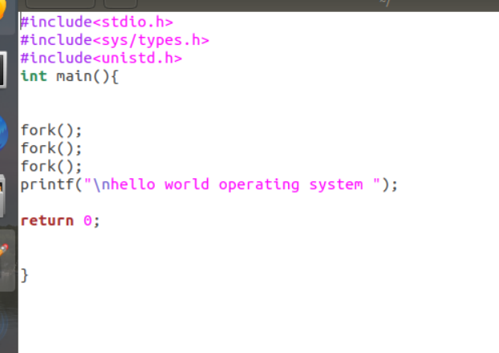

**

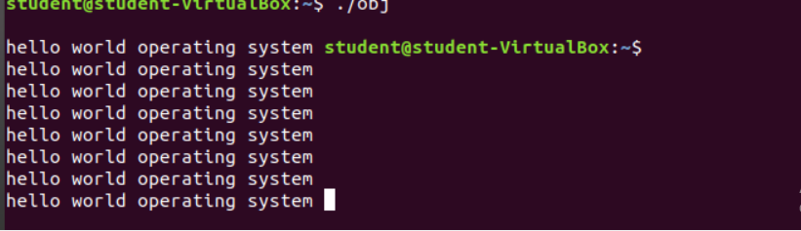

**Task # 02:**

**Solution:**



**Output:**



**Task # 03:**

**Code:**

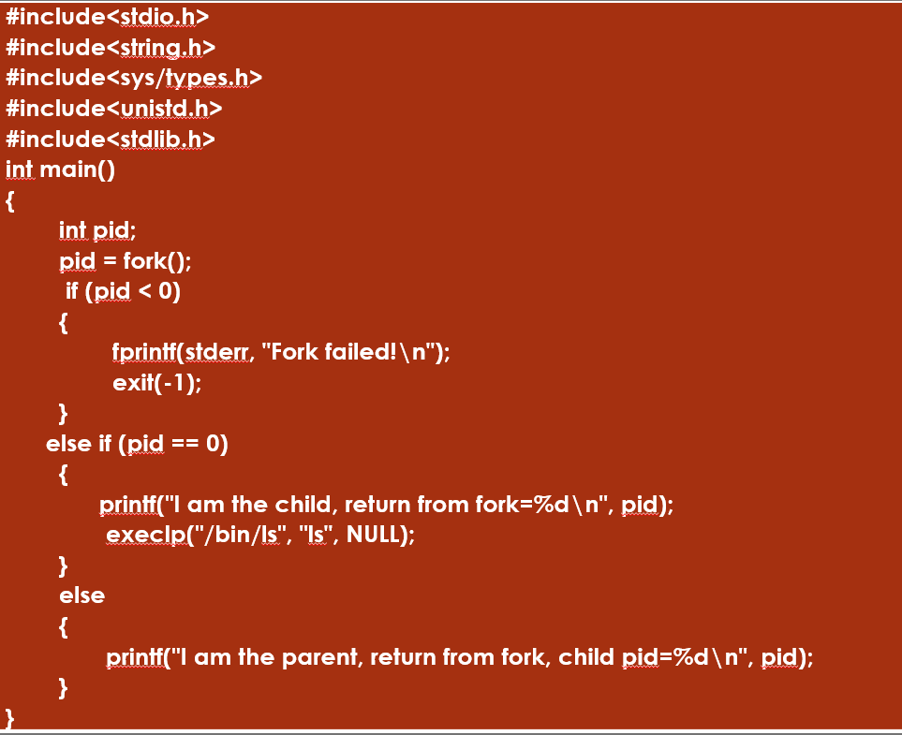

**Solution:**

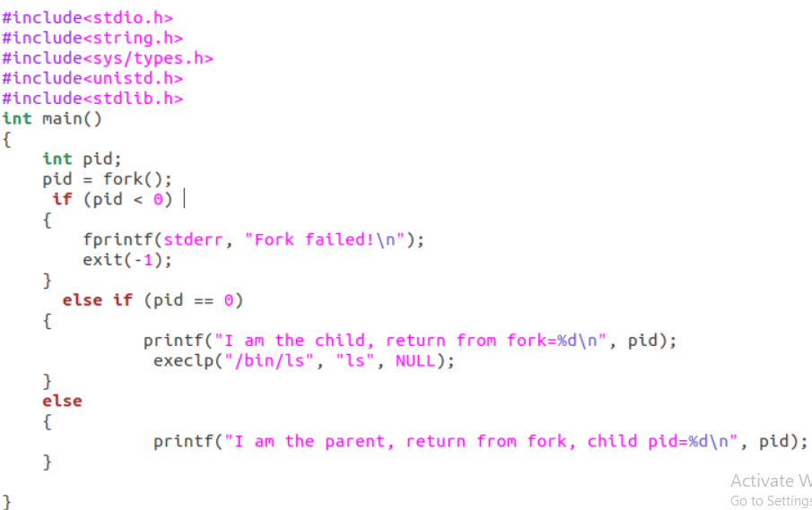

**Output:**

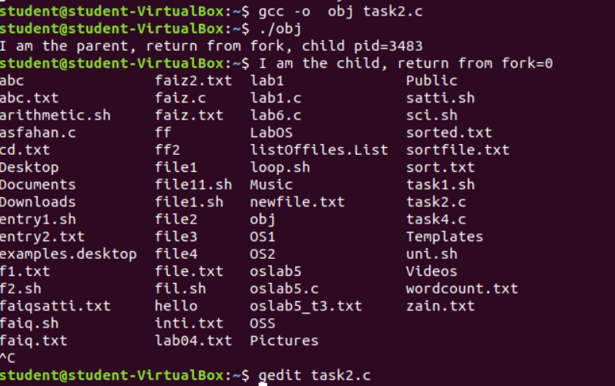

**Task # 04:**

**Solution:**

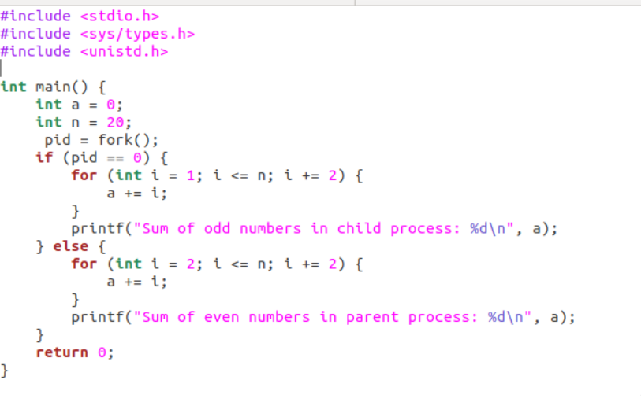

**Output:**

