Bahria University

Karachi Campus



LAB EXPERIMENT NO.

07

LIST OF TASKS

|  |  |
| --- | --- |
| **TASK NO** | **OBJECTIVE** |
| 1 | The FCFS source code given above assumes that the arrival times for processes are provided in ascending order of time. Modify the code in C language for random process arrival times. |
| 2 | Modify the FCFS code of example#02 to be able to calculate the mean of Normalized Turnaround Time. Also the modified code should display the Normalized Turnaround Time of each process. |
| 3 | Implement the Shortest Job First algorithm with the help of 4 non-preemptive processes. |
|  |  |

Submitted On:

**04-05-2023**

(Date: DD/MM/YY)

**Task # 01:**

**Solution:**

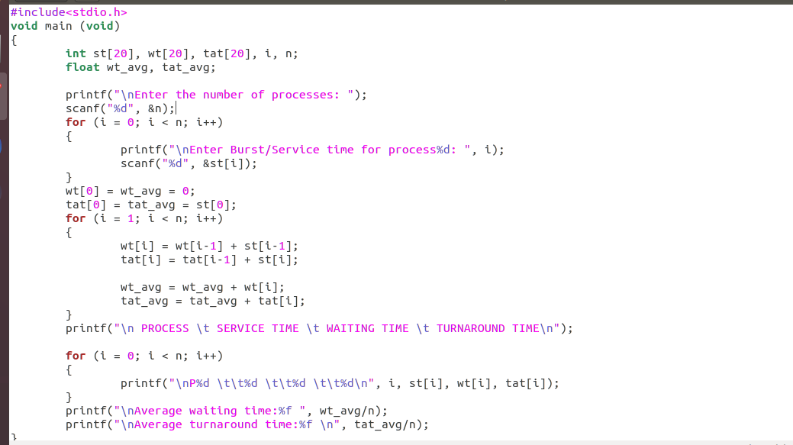

**OUTPUT:**

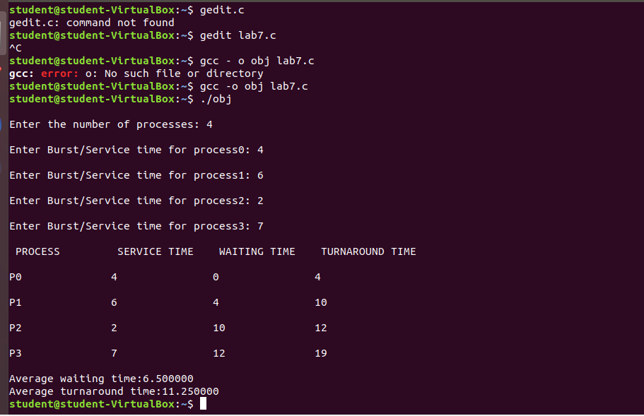

**Task#02**

**Solution:**

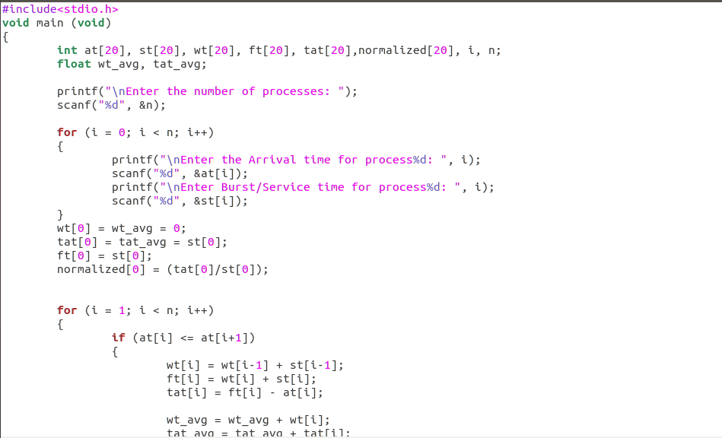

**Output:**

