Bahria University

Karachi Campus



LAB EXPERIMENT NO.

08

LIST OF TASKS

|  |  |
| --- | --- |
| **TASK NO** | **OBJECTIVE** |
| 1 | Explore HTOP, including its options. Attach outputs for the same. |
| 2 | Write a multithreaded C program for performing a summation of numbers. |
| 3 | Write a program that makes 4 threads. Each thread will print one table out of [5678] up to 1000. |
|  |  |

Submitted On:

**11-05-2023**

(Date: DD/MM/YY)

**Task # 01:**

**Solution:**

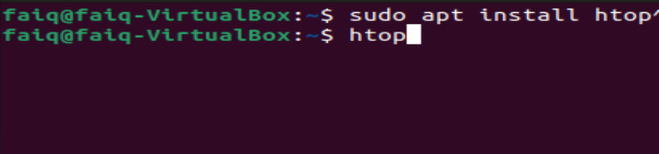

**Output:**

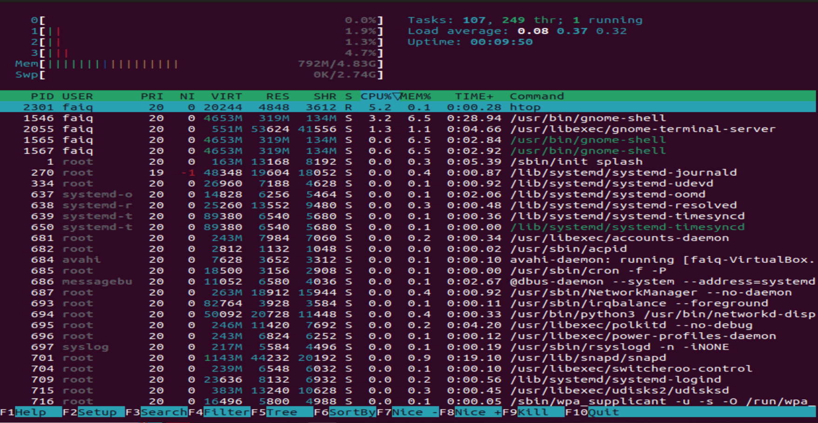

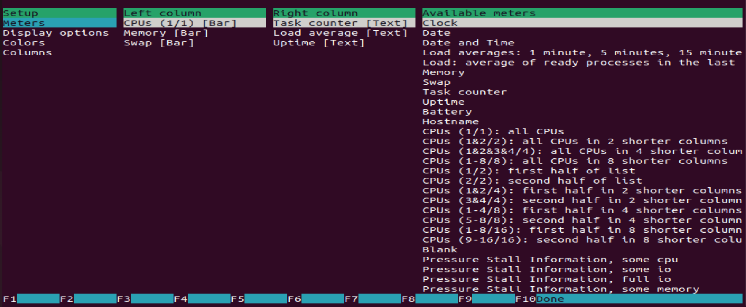

**Task#02**

**Solution:**

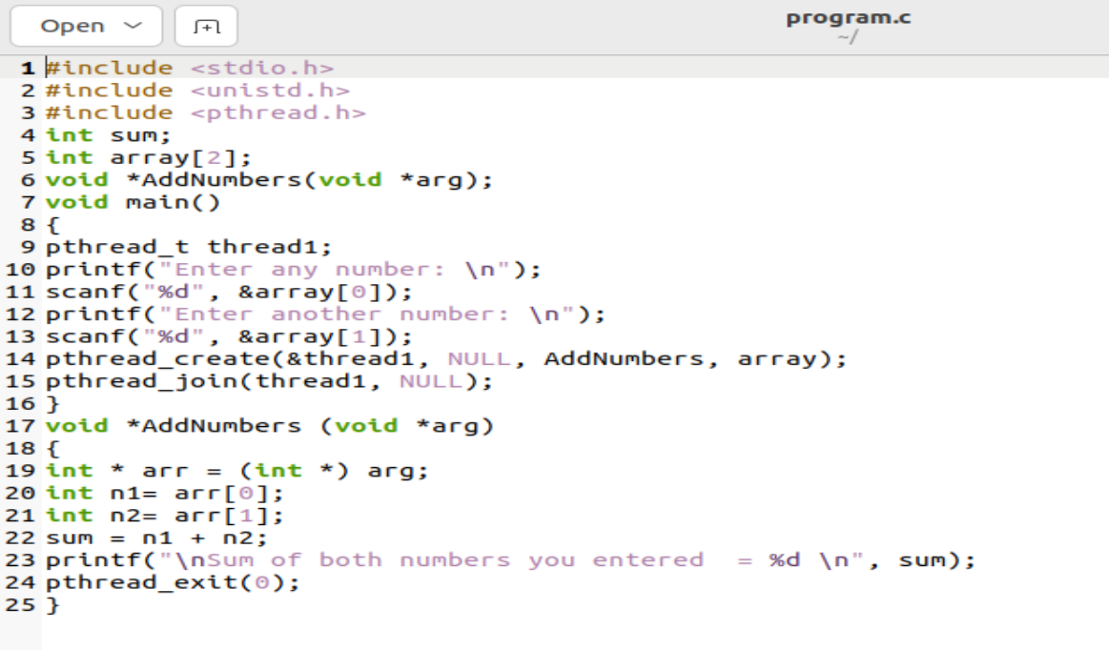**Output:**

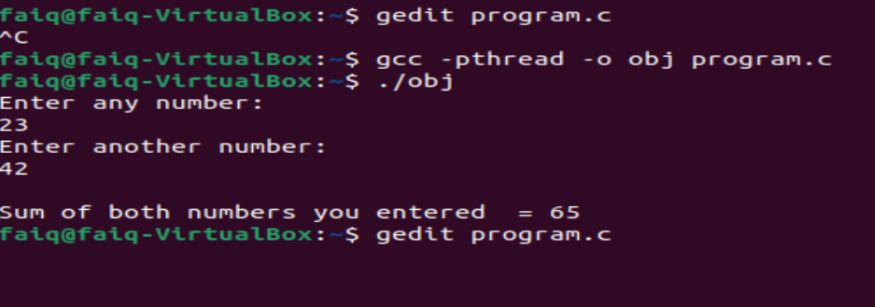

**Task#03**

**Solution:**

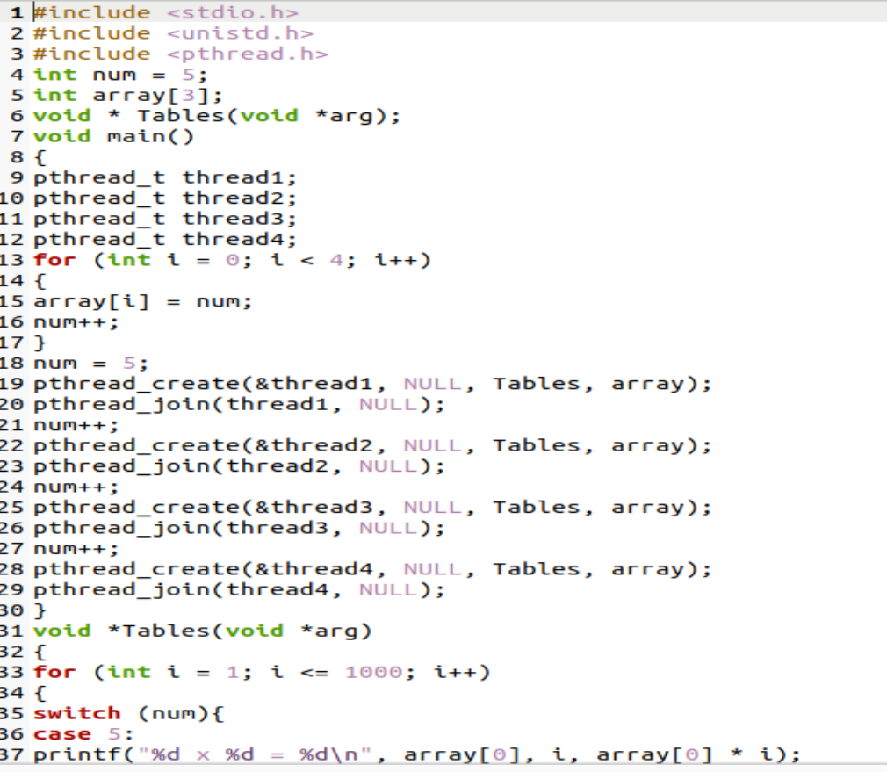

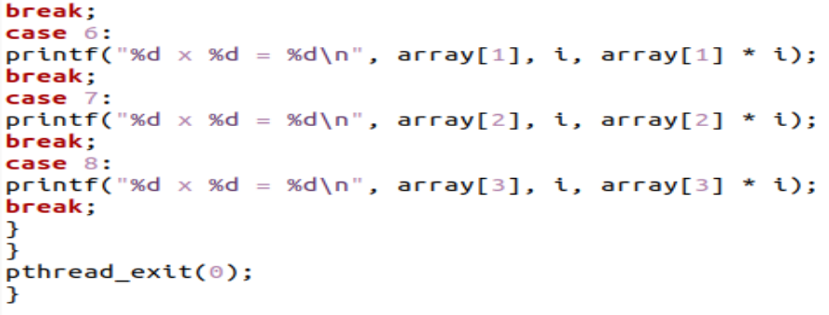

**Output:**

