Bahria University

Karachi Campus



LAB EXPERIMENT NO.

09

LIST OF TASKS

|  |  |
| --- | --- |
| **TASK NO** | **OBJECTIVE** |
| 1 | Write a multithreaded OpenMP C program for performing summation of numbers. |
| 2 | Write a OpenMP C program in which you have a range of numbers, and you want to find all the even numbers in the range. The search operation can be parallelized using OpenMP to improve performance. |
|  |  |
|  |  |

Submitted On:

**25-05-2023**

(Date: DD/MM/YY)

**Task # 01:**

**Solution:**

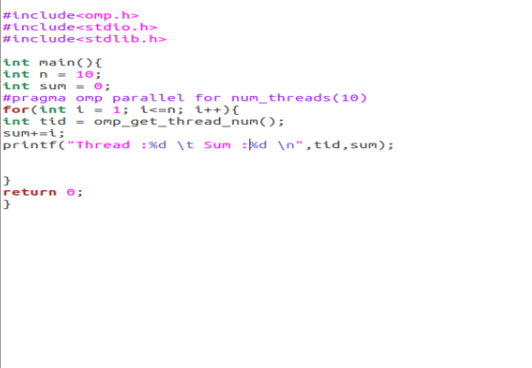

**Output:**

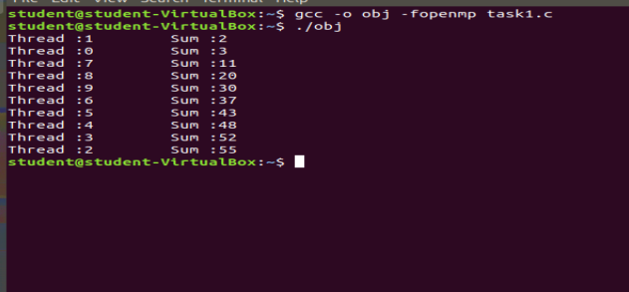

**Task#02**

**Solution:**

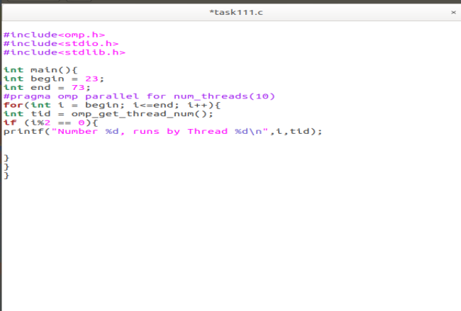**Output:**

