Bahria University,

Karachi Campus



LAB ASSIGNMENT NO.

**10**

LIST OF TASKS

|  |  |
| --- | --- |
| TASK NO | OBJECTIVE |
| 1. | **Create complete calculator program using MVC.** |
| 2. | **Create Basic CRUD Application using MVC.** |
|  |  |
|  |  |
|  |  |
|  |  |

Submitted On:

02-06-2023

**Task No 1: Create complete calculator program using MVC.**

**Controller:** public class CalcController : Controller{

// GET: Calc

public ActionResult Index(){

return View(new calc());}

[HttpPost]

public ActionResult Index(calc c, string calculate) {

if (calculate == "add"){

c.tot = c.no1 + c.no2;}

else if (calculate == "min") {

c.tot = c.no1 - c.no2;}

else if (calculate == "sub"){

c.tot = c.no1 * c.no2;}

else if (calculate == "divv"){

c.tot = c.no1 / c.no2;}

return View(c);}}}

**Model:** public class calc{  
 public int no1 { get; set; }

public int no2 { get; set; }

public int tot { get; set; }}}

**Index:**

<h2>Simple Calculator Using MVC</h2>

<div class="row">

@using (Html.BeginForm("/Index", "calc", FormMethod.Post)){

<div class="form-group">

<label for="no1">Number 1 : </label>

<input type="text" class="form-control" id="no1" name="no1" value="@Model.no1" /></div>

<div class="form-group">

<label for="no2">Number 2 : </label>

<input type="text" class="form-control" id="no2" name="no2" value="@Model.no2" /></div>

<div class="form-group">

<label for="total">Total : </label>

<input type="text" class="form-control" id="tot" name="tot" value="@Model.tot" /></div>

<button type="submit" class="btn btn-info" id="add" value="add" name="calculate">+</button>

<button type="submit" class="btn btn-danger" id="min" value="min" name="calculate"></button>

<button type="submit" class="btn btn-warning" id="sub" value="sub" name="calculate">*</button>

<button type="submit" class="btn btn-default" id="divv" value="divv" name="calculate">/</button> }

</div>

</body>

</html>

**Output**

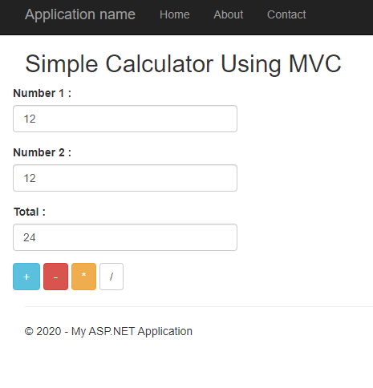

**Task No 2: Create Basic CRUD Application using MVC.**

**Model:**

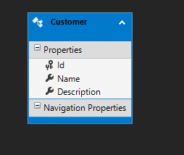

**Controller:**

public class CustomersController : Controller{

private MvcCrudEntities db = new MvcCrudEntities();

// GET: Customers

public async Task<ActionResult> Index(){

return View(await db.Customers.ToListAsync());}

// GET: Customers/Details/5

public async Task<ActionResult> Details(int? id){

if (id == null){

return new HttpStatusCodeResult(HttpStatusCode.BadRequest);

Customer customer = await db.Customers.FindAsync(id);}

if (customer == null){

return HttpNotFound();}

return View(customer);}

// GET: Customers/Create

public ActionResult Create(){

return View();

// POST: Customers/Create

// To protect from overposting attacks, please enable the specific properties you want to bind to, for

// more details see https://go.microsoft.com/fwlink/?LinkId=317598.

[HttpPost]

[ValidateAntiForgeryToken]

public async Task<ActionResult> Create([Bind(Include = "Id,Name,Description")] Customer customer){

if (ModelState.IsValid){

db.Customers.Add(customer);

await db.SaveChangesAsync();

return RedirectToAction("Index");}

return View(customer);}

// GET: Customers/Edit/5

public async Task<ActionResult> Edit(int? id){

if (id == null){

return new HttpStatusCodeResult(HttpStatusCode.BadRequest);}

Customer customer = await db.Customers.FindAsync(id);

if (customer == null){

return HttpNotFound();}

return View(customer);}

// POST: Customers/Edit/5

// To protect from overposting attacks, please enable the specific properties you want to bind to, for

// more details see https://go.microsoft.com/fwlink/?LinkId=317598.

[HttpPost]

[ValidateAntiForgeryToken]

public async Task<ActionResult> Edit([Bind(Include = "Id,Name,Description")] Customer customer){

if (ModelState.IsValid) {

db.Entry(customer).State = EntityState.Modified;

await db.SaveChangesAsync();

return RedirectToAction("Index");}

return View(customer);}

// GET: Customers/Delete/5

public async Task<ActionResult> Delete(int? id){

if (id == null){

return new HttpStatusCodeResult(HttpStatusCode.BadRequest);}

Customer customer = await db.Customers.FindAsync(id);

if (customer == null){

return HttpNotFound();}

return View(customer);}

// POST: Customers/Delete/5

[HttpPost, ActionName("Delete")]

[ValidateAntiForgeryToken]

public async Task<ActionResult> DeleteConfirmed(int id){

Customer customer = await db.Customers.FindAsync(id);

db.Customers.Remove(customer);

await db.SaveChangesAsync();

return RedirectToAction("Index");}

protected override void Dispose(bool disposing){

if (disposing){

db.Dispose();}

base.Dispose(disposing);}}}

**CREATE:**

@model CRUD.Models.Customer

@{

ViewBag.Title = "Create";}

<h2>Create</h2>

@using (Html.BeginForm()) {

@Html.AntiForgeryToken(

<div class="form-horizontal">

<h4>Customer</h4>

<hr />

@Html.ValidationSummary(true, "", new { @class = "text-danger" })

<div class="form-group">

@Html.LabelFor(model => model.Name, htmlAttributes: new { @class = "control-label col-md2"})

<div class="col-md-10">

@Html.EditorFor(model => model.Name, new { htmlAttributes = new { @class = "form-control" } })

@Html.ValidationMessageFor(model => model.Name, "", new { @class = "text-danger" })

</div> </div>

<div class="form-group">

@Html.LabelFor(model => model.Description, htmlAttributes: new { @class = "control-label col-md-2" })

<div class="col-md-10">

@Html.EditorFor(model => model.Description, new { htmlAttributes = new { @class = "form-control" } })

@Html.ValidationMessageFor(model => model.Description, "", new { @class = "text-danger"})</div> </div>

<div class="form-group">

<div class="col-md-offset-2 col-md-10">

<input type="submit" value="Create" class="btn btn-default" /> </div></div></div>}

<div>

@Html.ActionLink("Back to List", "Index")</div>

@section Scripts {

@Scripts.Render("~/bundles/jqueryval")}

**EDIT:**@model CRUD.Models.Customer

@{

ViewBag.Title = "Edit";}

<h2>Edit</h2>

@using (Html.BeginForm()){

@Html.AntiForgeryToken()

<div class="form-horizontal">

<h4>Customer</h4>

<hr />

@Html.ValidationSummary(true, "", new { @class = "text-danger" })

@Html.HiddenFor(model => model.Id)

<div class="form-group">

@Html.LabelFor(model => model.Name, htmlAttributes: new { @class = "control-label col-md-2"})

<div class="col-md-10">

@Html.EditorFor(model => model.Name, new { htmlAttributes = new { @class = "form-control" } })

@Html.ValidationMessageFor(model => model.Name, "", new { @class = "text-danger" } </div> </div>

<div class="form-group">

@Html.LabelFor(model => model.Description, htmlAttributes: new { @class = "control-label col-md-2" })

<div class="col-md-10">

@Html.EditorFor(model => model.Description, new { htmlAttributes = new { @class = "form-control" } })

@Html.ValidationMessageFor(model => model.Description, "", new { @class = "text-danger}) </div></div>

<div class="form-group">

<div class="col-md-offset-2 col-md-10">

<input type="submit" value="Save" class="btn btn-default" /> </div></div></div>}

<div>

@Html.ActionLink("Back to List", "Index")</div>

@section Scripts {

@Scripts.Render("~/bundles/jqueryval")}

**DELETE:**

@model CRUD.Models.Customer

@{

ViewBag.Title = "Delete";}

<h2>Delete</h2>

<h3>Are you sure you want to delete this?</h3>

<div>

<h4>Customer</h4>

<hr />

<dl class="dl-horizontal">

<dt>

@Html.DisplayNameFor(model => model.Name)</dt>

<dd>

@Html.DisplayFor(model => model.Name)</dd>

<dt>

@Html.DisplayNameFor(model => model.Description)</dt>

<dd>

@Html.DisplayFor(model => model.Description)</dd>

</dl>

@using (Html.BeginForm()) {

@Html.AntiForgeryToken()

<div class="form-actions no-color">

<input type="submit" value="Delete" class="btn btn-default" /> |

@Html.ActionLink("Back to List", "Index")

</div>}

</div>

**DETAILS:**

@model CRUD.Models.Customer

@{

ViewBag.Title = "Details";}

<h2>Details</h2>

<div>

<h4>Customer</h4>

<hr />

<dl class="dl-horizontal">

<dt>

@Html.DisplayNameFor(model => model.Name)</dt>

<dd>

@Html.DisplayFor(model => model.Name)</dd>

<dt>

@Html.DisplayNameFor(model => model.Description)

</dt>

<dd>

@Html.DisplayFor(model => model.Description)</dd>

</dl>

</div>

<p>

@Html.ActionLink("Edit", "Edit", new { id = Model.Id }) |

@Html.ActionLink("Back to List", "Index")

</p>

**INDEX:**

@model IEnumerable<CRUD.Models.Customer>

@{

ViewBag.Title = "Index";}

<h2>Index</h2>

<p>

@Html.ActionLink("Create New", "Create")

</p>

<table class="table">

<tr>

<th>

@Html.DisplayNameFor(model => model.Name)

</th>

<th>

@Html.DisplayNameFor(model => model.Description)

</th>

<th></th></tr>

@foreach (var item in Model) {

<tr>

@Html.DisplayFor(modelItem => item.Name)

</td>

<td>

@Html.DisplayFor(modelItem => item.Description)

</td>

<td>

@Html.ActionLink("Edit", "Edit", new { id=item.Id }) |

@Html.ActionLink("Details", "Details", new { id=item.Id }) |

@Html.ActionLink("Delete", "Delete", new { id=item.Id })</td> </tr>}</table>

**Output:**

**Create:**

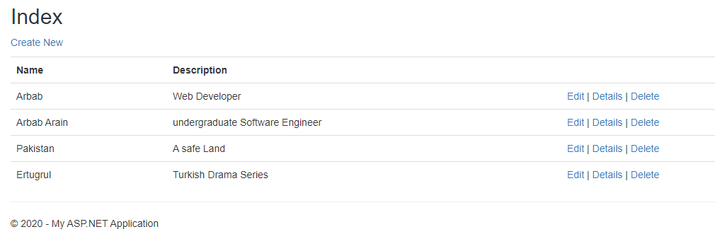

Muaz

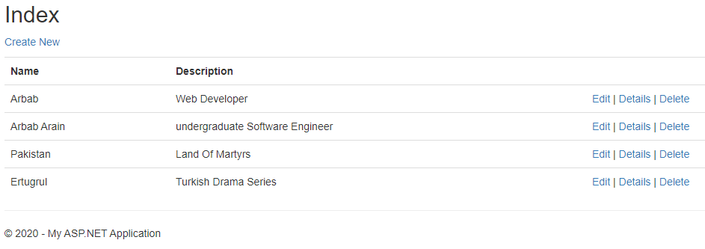

Muaz

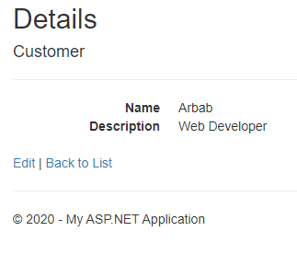

Muaz

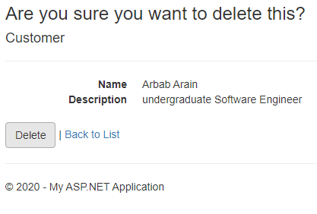

**Database:**

