Bahria University,

Karachi Campus



LAB EXPERIMENT NO.

**13**

LIST OF TASKS

|  |  |
| --- | --- |
| TASK NO | OBJECTIVE |
| **1** | **Create webapi for restaurant named Alibaba the restaurant can be able to Post new item in menu, Get All items that restaurant offers, Put existing items, Delete items** |
| **2** | **Create webapi that uses all verbs of Rest Api’s for employee management Create new employee, Update Current employee, Get Employees, Delete employees with their respective Id’s -> (Optional)For best professional practices use layered architecture for getting data from data access layer and applies logic with business logic layer then controller will get data and http will consume it.** |
|  |  |
|  |  |
|  |  |
|  |  |

Submitted On:

**16-June-2023**

**Task No. 1: Create webapi for restaurant named Alibaba the restaurant can be able to Post new item in menu, Get All items that restaurant offers, Put existing items, Delete items**

**Solution:**

**Output:**

namespace _13t1.Service

{

/// <summary>

/// Summary description for WebService1

/// </summary>

[WebService(Namespace = "http://tempuri.org/")]

[WebServiceBinding(ConformsTo = WsiProfiles.BasicProfile1_1)]

[System.ComponentModel.ToolboxItem(false)]

// To allow this Web Service to be called from script, using ASP.NET AJAX, uncomment the following line.

// [System.Web.Script.Services.ScriptService]

public class WebService1 : System.Web.Services.WebService

{

[WebMethod]

public string HelloWorld()

{

return "Hello World";

}

[WebMethod]

public int Square(int num)

{

return num * num;

}

// Add two integers and returns the sum

[WebMethod]

public int Add(int num1, int num2)

{

return num1 + num2;

}

[WebMethod]

// Multiply two integers and retuns the result

public int Multiply(int num1, int num2)

{

return num1 * num2;

}

[WebMethod]

// Subtracts small number from big number

public int Subtract(int num1, int num2)

{

if (num1 > num2)

{

return num1 - num2;

}

return num2 - num1;

}

[WebMethod]

//performing Division on two float variables.

public float Division(float num1, float num2)

{

return num1 / num2;

}

}

**Output:**

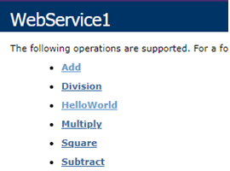

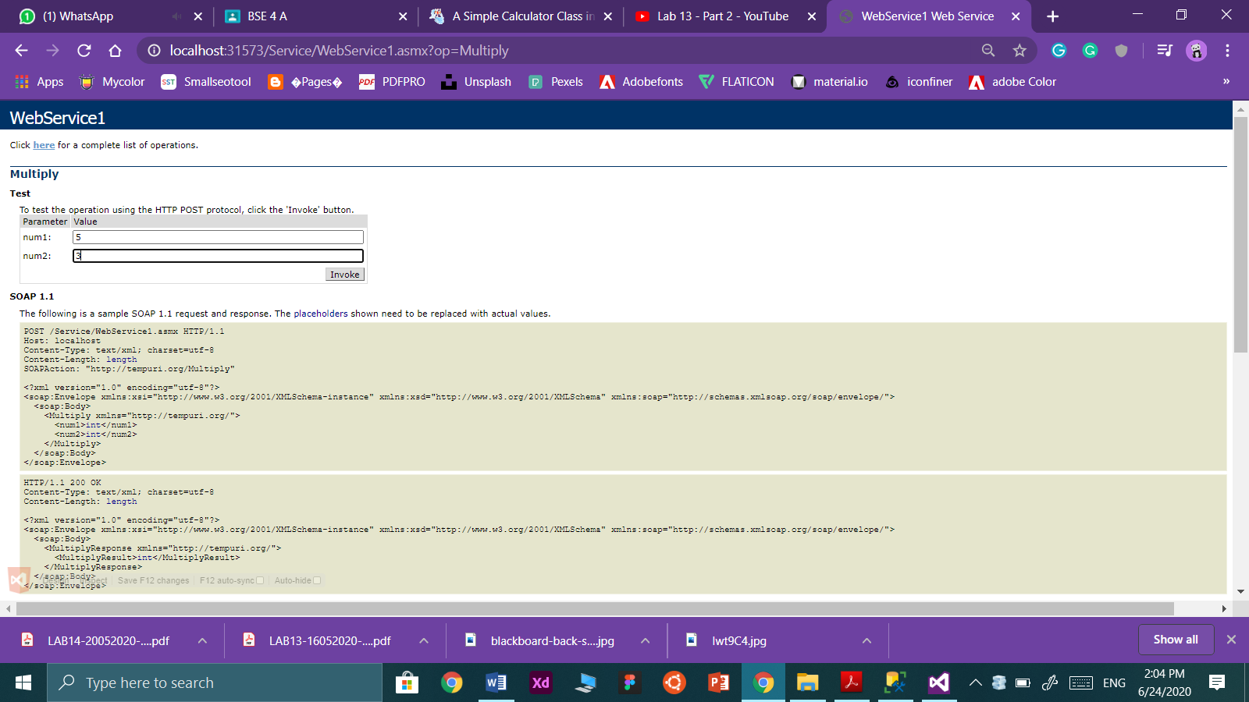

**Task No. 2: Createwebservicefor converting xml to json→the service take input xml as a string and return jsonconverted output of that xml.**

**Solution:**

namespace CalculatorServiceWEB.Services

{

[WebService(Namespace = "http://tempuri.orgr)]

[WebServiceBinding(ConformsTo = WsiProfiles.BasicProfile1_1)]

[System.ComponentModel.ToolboxItem(false)]

public class JSONtoXML : System.Web.Services.WebService

{

public object JsonConvert { get; private set; }

[WebMethod]

public string XMLConverter(string xml)

{

XmlDocument doc = new XmlDocument();

doc.LoadXml(xml);

string jsonText = JsonConvert.SerializeXmlNode(doc);

return jsonText;

}

}

}

**Output:**

