Bahria University

Karachi Campus



LAB EXPERIMENT NO.

02

LIST OF TASKS

|  |  |
| --- | --- |
| **TASK NO** | **OBJECTIVE** |
| 1 | Create 4 Components Each Component contains at least 5 Classes |
| 2 | Add Attributes and Operations in Classes for Forward Engineering |
| 3 | Add more operations and Attributes via Coding in JAVA language for All Classes and Apply Reverse Engineering for changing Class Diagram |
|  |  |

Submitted On:

**17-03-2023**

(Date: DD/MM/YY)

**Tasks:**

**Solution:**

***1:***

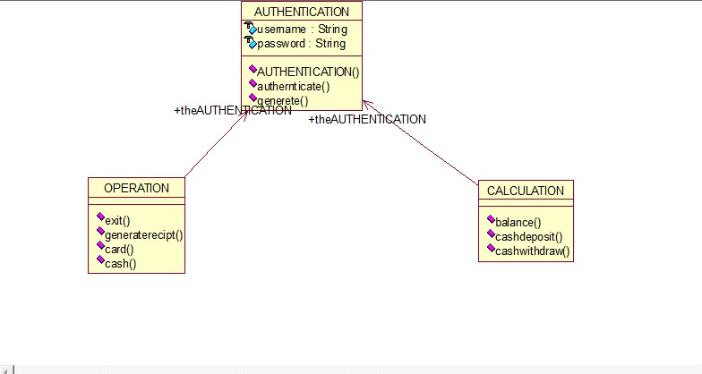

**CODE :**

//Source file: C:\\faiq\\AUTHENTICATION.java

public class AUTHENTICATION

{

String username;

String password;

public AUTHENTICATION()

}}

public boolean authernticate(String pass,String uset ){

return true;

}

public void generete(){}

}

private class CALCULATION

{

public AUTHENTICATION theAUTHENTICATION;

public void balance(){}

public void cashdeposit(){}

public void cashwithdraw(){}

private class OPERATION

{

public AUTHENTICATION theAUTHENTICATION;

public void exit(){

}

public void generaterecipt(){

}

public void card(){

}

public void cash(){}}

***2:***

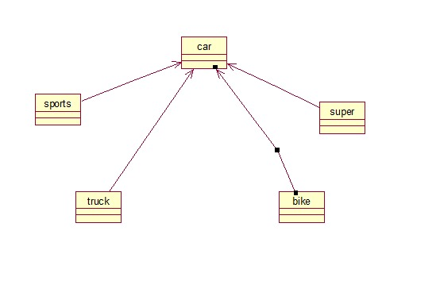

**CODE :**

//Source file: C:\\faiq\\car.java

public class car {

public car(){

}

public int model;

public int price;

public void modeldetail(){}

}

private class sports

{

public car theCar;

public int model;

public int price;

public void details(){}

public sports()

{

}

}private class supercar

{

public car theCar;

public supercar()

{

}

}

private class truck

{

public car theCar;

public truck()

{}}

private class bike

{

public car theCar;

public bike()

{}}

AFTER REVERSE:

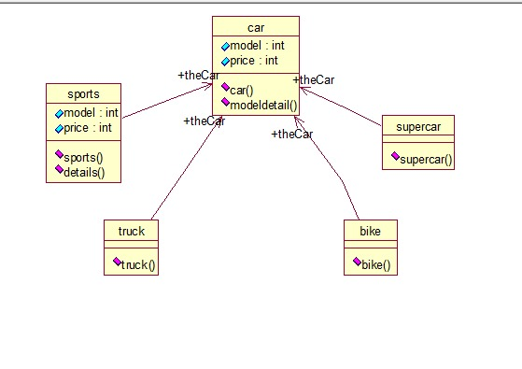

***3:***

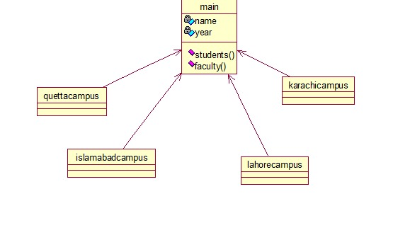

**CODE :**

//Source file: C:\\faiq\\main.java

public class main

{

private int name;

private int year;

public main()

{}

public void students()

{}

public void faculty()

{

} public void studentsdata(){}

}

private class quettacampus

{

public main theMain;

public quettacampus()

{

private int name;

private int year;

}}

private class karachicampus

{

public main theMain;

public karachicampus()

{}

private int name;

private int year;

public void studentsdata(){}

private class lahorecampus

{

private int name;

private int year;

public main theMain;

public void studentsdata(){}

public lahorecampus()

{}}

private class islamabadcampus

{

public main theMain;

public islamabadcampus()

{

private int name;

private int year;

public void studentsdata(){}}

AFTER REVERSE:

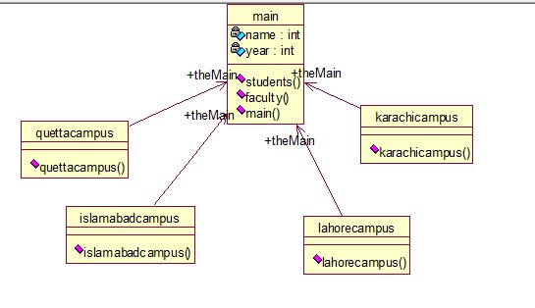

***4:***

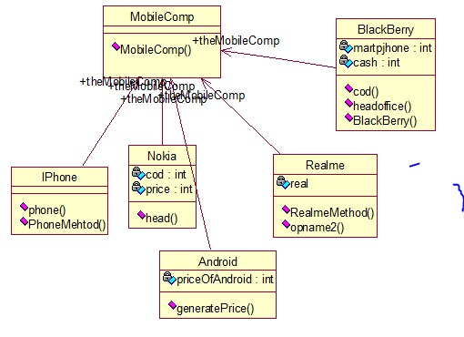

**CODE :**

//Source file: C:\\faiq\\mobile.java

public class mobile

{ public mobile()

{

}

public void mobilecompany(){}}

private class iphone{

public void phonemethod(){

}

public void phone(){

}

public nokia()

{

Public int code;

Public int price;

Public void head(){

}

}}

private class realme

{

public mobile themobile;

public opcode(){

}

public realmethod()

{

}

}

Public int real;

private class android

{

public mobile themobile;

/**

@roseuid 5AA037FA035B

*/

public adroid()

{}}

private class blackbery

{

Public int price;

public blackbery()

{}}