

**BAHRIA UNIVERSITY, Karachi Campus**

*Department of Software Engineering*

REPORT

**Course Title:** Computer Communication & Networking  **Course Code**:CEN 223

**Course Instructor:** Dr. Hussain **Class**: BSE- (B)

**Lab Instructor:** Engr. Asma Shaheen  **Name: ______________________**

PROJECT TITLE:

**SALES MANAGEMENT SYSTEM WITH IOT**

GROUP MEMBERS LIST:

|  |  |  |  |
| --- | --- | --- | --- |
| S.NO | Enrollment | Name | Email |
| 01 | 02-131212-067 | FAIQ BIN SABIR | faiqbinsbir786@gmail.com |
| 02 | 02-131212-012 | ZAIN UL ABIDEEN |  |
| 03 | 02-131212-013 | M INTAKHAB MALIK |  |

**Submission Date: __________________**

Contents

**1.** **INTRODUCTION** 2

**Introduction** 3

**Proposed Solution** 3

**Problem Statement** 3

**Technologies Used** 4

**2.** **DESIGN DESCRIPTION** 4

**Workflow Diagram** 4

**User Interfaces** 5

**Commands** 6

**Conclusions and further work** 12

**3.** **REFERENCES** 12

# **INTRODUCTION**

## **Introduction**

The project is to understand the advantages of using VLAN in a network, how broadcasting is controlled. Understand the configuration which is required to setup a VLAN based network using Cisco routers and switches. Moreover, It is a sales management system with IOT. Where we have multiple departments located at 4 Cities. Each department is Operatable at different VLANS. And using routers we are managing all the department exectively.

## **Proposed Solution**

It is a sales management system with security. Where we have multiple departments located at 3 Cities. Each department is operatable at different VLANS. The Local Area Network (LAN) is widely used because a large number of applications imply some user in the same broadcast domain. There is kind of LAN named virtual LAN (VLAN), in this sort of network a group of hosts with a set of common requirements provides communication. It is important to emphasize that the group of hosts should be in the same broadcast domain, despite the same place. In addition, in our all campus we have also implemented IOT through which we can control office appliances through our phone or laptop. Moreover, we have also implemented RIP server to align Ip addresses and mail server to make coordination better.

## **Problem Statement**

The overarching objective of this project is to establish a robust and efficient network infrastructure to seamlessly connect multiple offices within our organization. The deployment of a comprehensive networking solution aims to enhance communication, facilitate resource sharing, and streamline collaborative efforts among geographically dispersed teams. The integration of network technologies will contribute to increased productivity and operational efficiency. Some technical aspects such as security, reliability, scalability etc. are also considered as key aspects of system. In conclusion, this project abstract outlines our commitment to establishing a network that not only fulfills the immediate connectivity needs of our organization but also lays the foundation for future growth and technological advancements. For the Smart Sales Management System, the network infrastructure design and implementation can be done using Cisco Packet Tracer. The network consists of four servers (DHCP, EMAIL, WEB, IOT) located at the server-side site, and all servers are shared between all users.

## **Technologies Used**

* CISCO PACKET TRACER
* IOT
* Servers (Email,web,IOTETC..)

# **DESIGN DESCRIPTION**

## **Workflow Diagram**

**Finance dept from multan to finance dept karachi:**

**Pc-multan 🡪 switch4 🡪 router 0 🡪 router 1 🡪 switch 8 🡪 pc-karachi**

**HR dept from multan to HR dept karachi:**

**Pc-multan 🡪 switch4 🡪 router 0 🡪 router 1 🡪 switch 8 🡪 pc-karachi**

**Sales dept from multan to Sales dept karachi:**

**Pc-multan 🡪 switch4 🡪 router 0 🡪 router 1 🡪 switch 8 🡪 pc-karachi**

**Finance dept from Karachi to finance dept Multan:**

**Pc-karachi 🡪 switch8 🡪 router 1 🡪 router 0 🡪 switch 4🡪 pc-multan**

**…etc.**

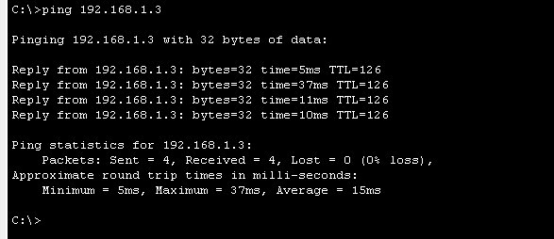

## **User Interfaces**

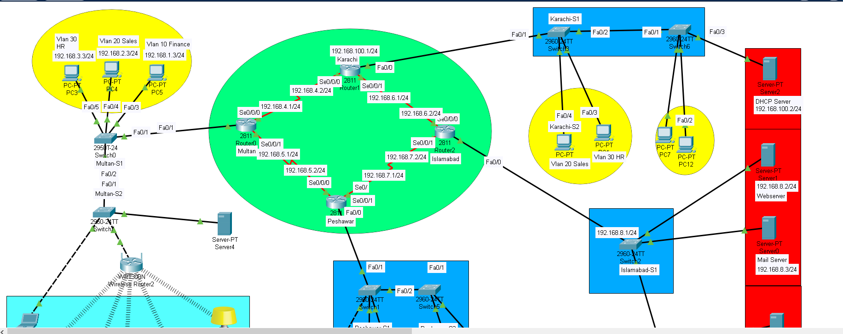

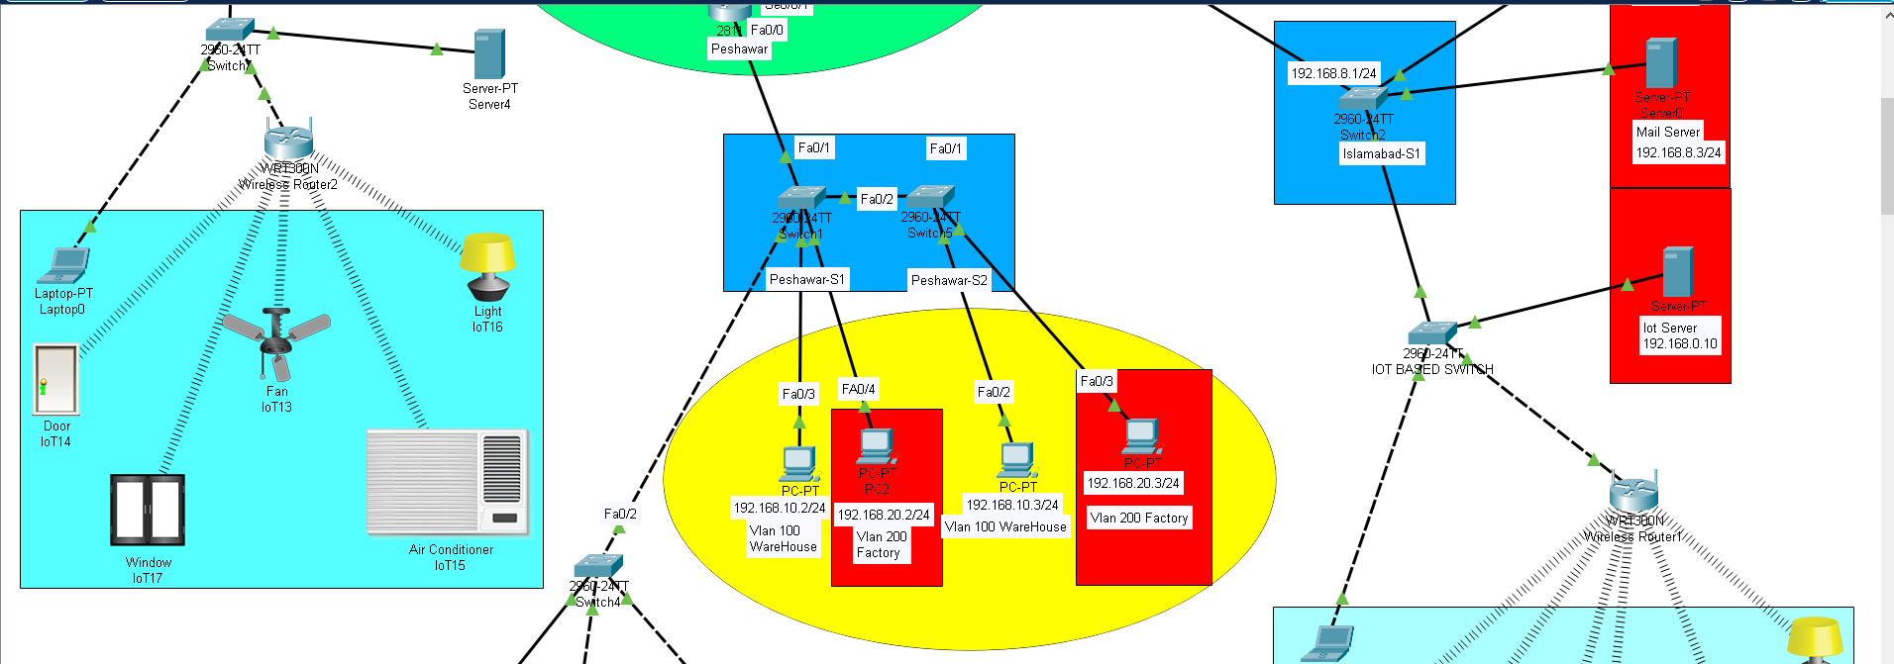

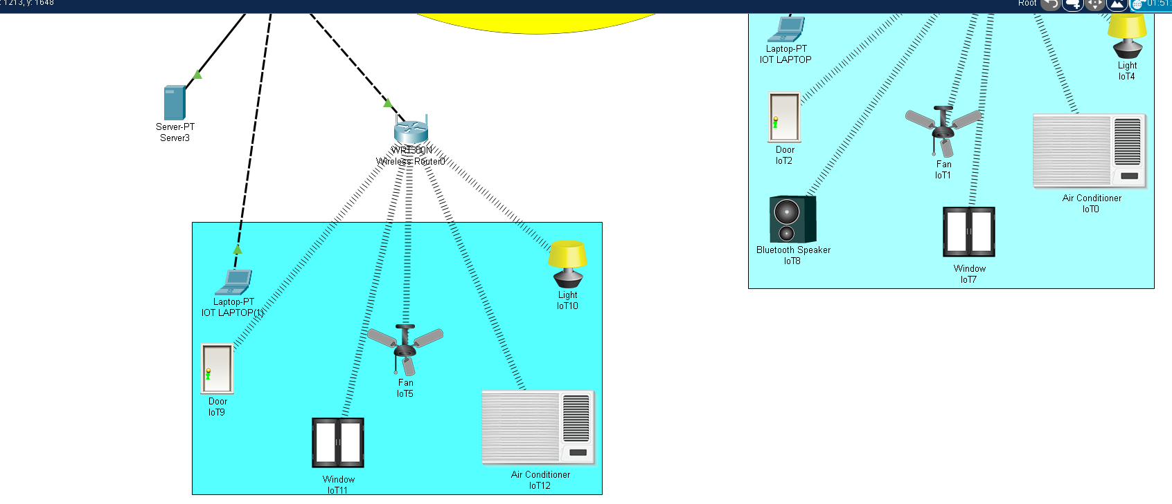

## **Commands**

**Multan Configuration:**

Multan#show running-config

Building configuration...

Current configuration : 1395 bytes

!

version 12.4

no service timestamps log datetime msec

no service timestamps debug datetime msec

service password-encryption

hostname Multan

enable secret 5 $1$mERr$z/f2vKz1eL.ar8.vkgXx3/

ip cef

no ipv6 cef

username Karachi password 7 08701E1D5D4C

spanning-tree mode pvst

interface FastEthernet0/0

no ip address

duplex auto

speed auto

interface FastEthernet0/1

no ip address

duplex auto

speed auto

interface FastEthernet0/1.1

encapsulation dot1Q 10

ip address 192.168.1.1 255.255.255.0

!

interface FastEthernet0/1.2

encapsulation dot1Q 20

ip address 192.168.2.1 255.255.255.0

!

interface FastEthernet0/1.3

encapsulation dot1Q 30

ip address 192.168.3.1 255.255.255.0

!

interface Serial0/0/0

ip address 192.168.4.1 255.255.255.0

clock rate 2000000

!

interface Serial0/0/1

ip address 192.168.5.1 255.255.255.0

clock rate 2000000

!

interface Serial0/1/0

no ip address

clock rate 2000000

shutdown

!

interface Serial0/1/1

no ip address

clock rate 2000000

shutdown

!

interface Vlan1

no ip address

shutdown

!

router rip

version 2

network 192.168.1.0

network 192.168.2.0

network 192.168.3.0

network 192.168.4.0

network 192.168.5.0

!

ip classless

!

ip flow-export version 9

banner motd ^C

This is the Multan Router^C

line con 0

!

line aux 0

!

line vty 0 4

password 7 0822455D0A16

login

**Peshawar Configuration:**

Peshawar#show running-config

Building configuration...

Current configuration : 1249 bytes

!

version 12.4

no service timestamps log datetime msec

no service timestamps debug datetime msec

service password-encryption

!

hostname Peshawar

!

!

!

enable secret 5 $1$mERr$.rfN9UOfAbAe8.Tilqn0Q.

!

ip cef

no ipv6 cef

spanning-tree mode pvst

!

!

interface FastEthernet0/0

no ip address

duplex auto

speed auto

!

interface FastEthernet0/0.1

encapsulation dot1Q 100

ip address 192.168.10.1 255.255.255.0

!

interface FastEthernet0/0.2

encapsulation dot1Q 200

ip address 192.168.20.1 255.255.255.0

!

interface FastEthernet0/1

no ip address

duplex auto

speed auto

shutdown

!

interface Serial0/0/0

ip address 192.168.5.2 255.255.255.0

!

interface Serial0/0/1

ip address 192.168.7.1 255.255.255.0

clock rate 2000000

!

interface Serial0/1/0

no ip address

clock rate 2000000

shutdown

!

interface Serial0/1/1

no ip address

clock rate 2000000

shutdown

!

interface Vlan1

no ip address

shutdown

!

router rip

version 2

network 192.168.5.0

network 192.168.7.0

network 192.168.10.0

network 192.168.20.0

!

ip classless

!

ip flow-export version 9

!

!

!

no cdp run

!

banner motd ^C

This is the Peshawar router^C

line con 0

!

line aux 0

!

line vty 0 4

password 7 0822455D0A16

login

end

**Karachi Configuration:**

Karachi#show running-config

Building configuration...

Current configuration : 1147 bytes

!

version 12.4

no service timestamps log datetime msec

no service timestamps debug datetime msec

service password-encryption

!

hostname Karachi

!

!

!

enable secret 5 $1$mERr$B7l.NIum/Onfb6huqxne9.

!

!

ip cef

no ipv6 cef

!

!

username Islamabad password 7 08701E1D5D4C

username Multan password 7 08701E1D5D4C

!

!

spanning-tree mode pvst

!

!

interface FastEthernet0/0

ip address 192.168.100.1 255.255.255.0

duplex auto

speed auto

!

interface FastEthernet0/1

no ip address

duplex auto

speed auto

shutdown

!

interface Serial0/0/0

ip address 192.168.4.2 255.255.255.0

!

interface Serial0/0/1

ip address 192.168.6.1 255.255.255.0

clock rate 64000

!

interface Serial0/1/0

no ip address

clock rate 2000000

shutdown

!

interface Serial0/1/1

no ip address

clock rate 2000000

shutdown

!

interface Vlan1

no ip address

shutdown

!

router rip

version 2

network 192.168.4.0

network 192.168.6.0

network 192.168.100.0

!

ip classless

!

ip flow-export version 9

!

!

!

no cdp run

!

banner motd ^C

This is the Karachi Router^C

!

line con 0

!

line aux 0

!

line vty 0 4

password 7 0822455D0A16

login

!

!

!

end

**Islamabad Configuration:**

Islamabad#show running-config

Building configuration...

Current configuration : 1166 bytes

!

version 12.4

no service timestamps log datetime msec

no service timestamps debug datetime msec

no service password-encryption

!

hostname Islamabad

!

!

!

enable secret 5 $1$mERr$5B4cN0v3.V97MSAzkJqao.

!

!

ip cef

no ipv6 cef

!

username Karachi password 0 12345

!

spanning-tree mode pvst

!

!

interface FastEthernet0/0

ip address 192.168.8.1 255.255.255.0

ip access-group 50 out

duplex auto

speed auto

!

interface FastEthernet0/1

no ip address

duplex auto

speed auto

shutdown

!

interface Serial0/0/0

ip address 192.168.6.2 255.255.255.0

!

interface Serial0/0/1

ip address 192.168.7.2 255.255.255.0

!

interface Serial0/1/0

no ip address

clock rate 2000000

shutdown

!

interface Serial0/1/1

no ip address

clock rate 2000000

shutdown

!

interface Vlan1

no ip address

shutdown

!

router rip

version 2

network 192.168.6.0

network 192.168.7.0

network 192.168.8.0

!

ip classless

!

ip flow-export version 9

!

!

access-list 50 deny 192.168.20.0 0.0.0.255

access-list 50 permit any

!

no cdp run

!

banner motd ^C

This is the Islamabad router^C

!

!

line con 0

!

line aux 0

!

line vty 0 4

password cisco

login

!

end

## **Conclusions and further work**

All offices in cities have there on server for smart IOT based office control so that they can control their office appliances using their mobile phones and laptops. In addition, anyone can send email to other using the same network. Further enhancement will be made as on expansion of offices in other cities.

# **REFERENCES**

* CISCO PACKET TRACER
* https://readthedocs.org/projects/ciscopackettracer/