Bahria University

Karachi Campus



LAB EXPERIMENT NO.

01

LIST OF TASKS

|  |  |
| --- | --- |
| **TASK NO** | **OBJECTIVE** |
| 1 | Implement the given network on packet tracer.  Ping,   1. PC0 from PC5, 2. PC6 from PC2, 3. PC3 from PC1,   Also, display the above results in the simulation mode of packet tracer. Attach snapshots of the pinging results and the network created. |
|  |  |
|  |  |
|  |  |

Submitted On:

**27-09-2023**

(Date: DD/MM/YY)

**Task # 01:**

**Solution:**

DIAGRAM:

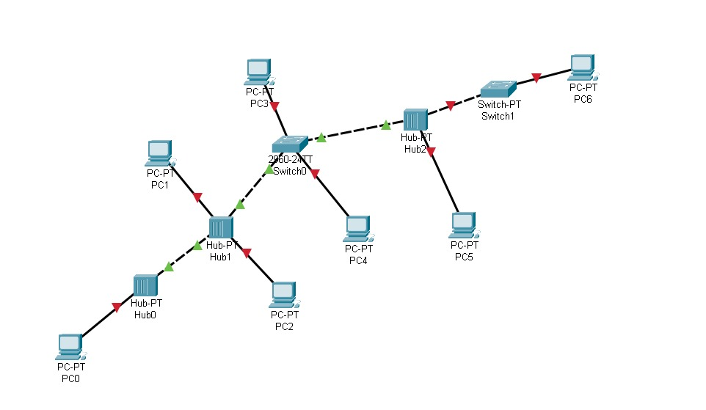

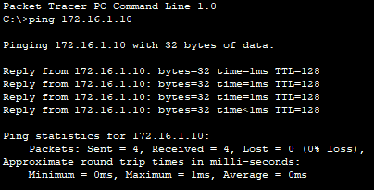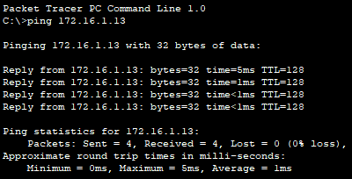

|  |  |
| --- | --- |
| **End Device** | **IP Used** |
| PC0 | 172.16.1.10 |
| PC1 | 172.16.1.11 |
| PC2 | 172.16.1.12 |
| PC3 | 172.16.1.13 |
| PC4 | 172.16.1.14 |
| PC5 | 172.16.1.15 |
| PC6 | 172.16.1.16 |