Bahria University

Karachi Campus



LAB EXPERIMENT NO.

11

LIST OF TASKS

|  |  |
| --- | --- |
| **TASK NO** | **OBJECTIVE** |
| 1 | Configure static route on the following network and show all necessary  configuration steps for each router. |
| 2 | Configure static route on the following network and show all necessary  configuration steps for each router. |
|  |  |

Submitted On:

**22-12-2023**

(Date: DD/MM/YY)

**Task#1:**

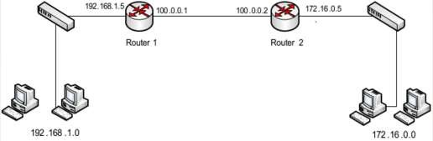

**Router1:**

Configure Fast Ethernet Port

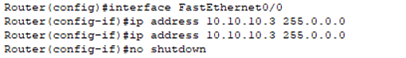

Configure Serial Port

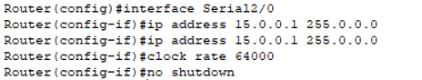

Locate network rip:



Configure DHCP:

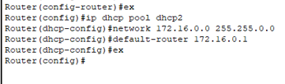

**Router 2:**

Configure Fast Ethernet Port

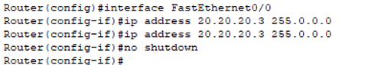

Configure Serial Port

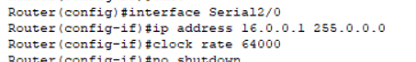



Locate network rip:



Configure DHCP:

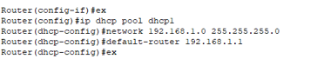

**Ping from PC0 to PC2 Ping from PC0 to PC3**

**Ping from PC2 to PC0 Ping from PC2 to PC1**

**Ping from PC1 to PC2 Ping from PC1 to PC3**

**Ping from PC3 to PC0 Ping from PC3 to PC1**

**Task#2:**

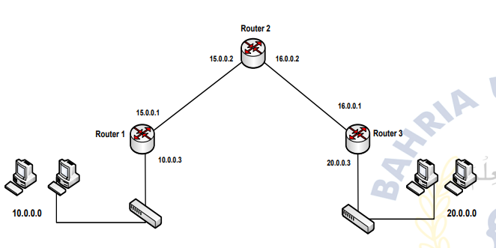

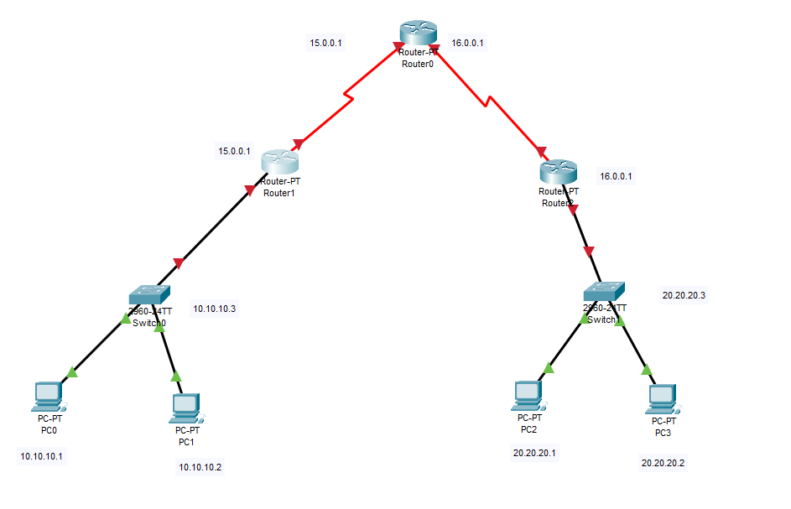

**Router1:**

Configure Fast Ethernet Port



Configure Serial Port



Locate network rip:



Configure DHCP:



**Router 2:**

Configure Fast Ethernet Port



Configure Serial Port





Locate network rip:



Configure DHCP:



**Router 0:**

Configure Serial Port

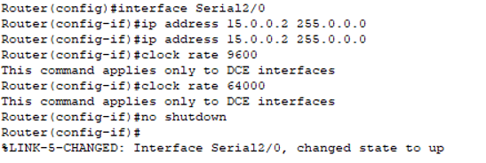

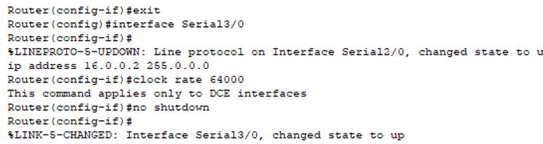

Ip route:

**Ping from PC0 to PC2 Ping from PC0 to PC3**

**Ping from PC2 to PC0 Ping from PC2 to PC1**

**Ping from PC1 to PC2 Ping from PC1 to PC3**

**Ping from PC3 to PC0 Ping from PC3 to PC1**

