Bahria University

Karachi Campus



LAB EXPERIMENT NO.

12

LIST OF TASKS

|  |  |
| --- | --- |
| **TASK NO** | **OBJECTIVE** |
| 1 | Configure OSPF on the following network and show all necessary configuration steps for each router. |
|  | Configure OSPF on the following network and show all necessary configuration steps for each router |
|  |  |

Submitted On:

**22-12-2023**

(Date: DD/MM/YY)

**Task#1:**

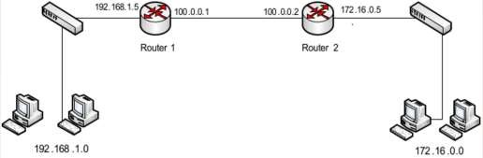

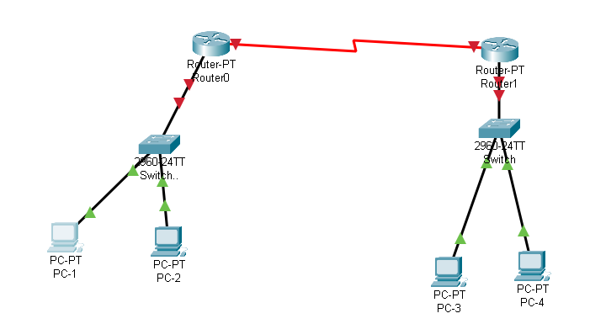

**Router1:**

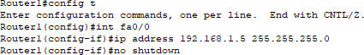Configure Fast Ethernet Port

Configure Serial Port



Locate to OSPF Protocol



Configure OSPF Protocol



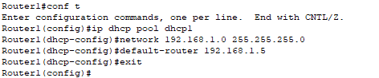Configure DHCP Protocol

**Router 2:**

Configure Fast Ethernet Port

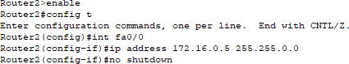

Configure Serial Port

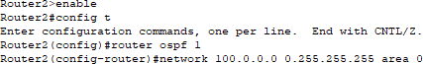

 Locate to OSPF Protocol

**Configure OSPF protocol**



**Configure DHCP Protocol**

**PC1:**

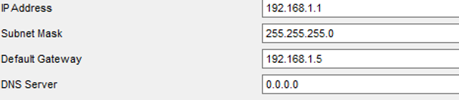

**PC2:**

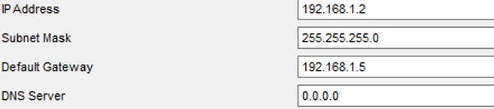

**PC3:**

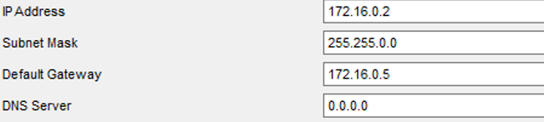

**PC4:**

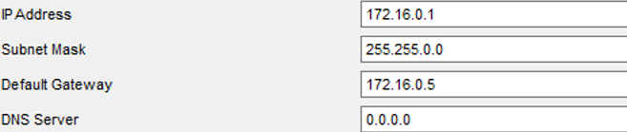

**Ping from PC1 to PC3:**

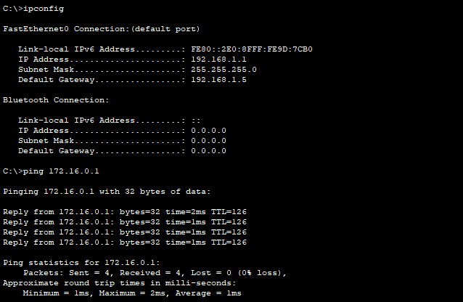

Ping from PC4 to PC2:

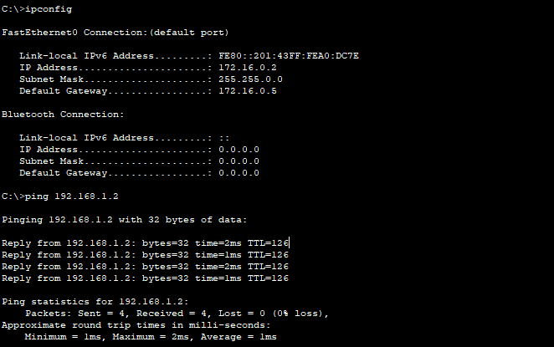

**Task#2:**

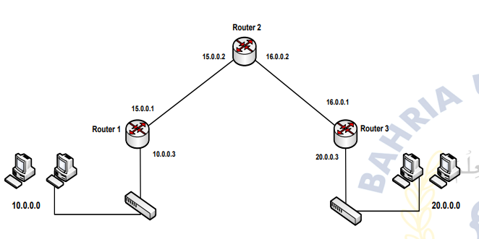

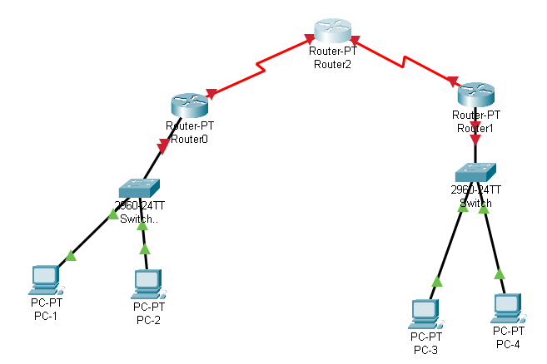

**Router 0:**

Configure Serial Port 2

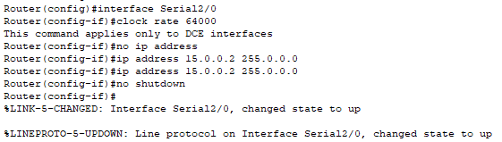

Configure Serial Port 3

Locate to OSPF Protocol

Configure OSPF Protocol



**Router1:**

Configure Fast Ethernet Port

Configure Serial Port

Locate to OSPF Protocol

Configure OSPF Protocol



Configure DHCP Protocol

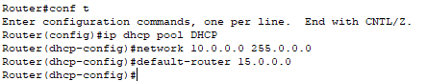

**Router 2:**

Configure Fast Ethernet Port

Configure Serial Port

Locate to OSPF Protocol

Configure OSPF Protocol



Configure DHCP Protocol



**PC 1:**

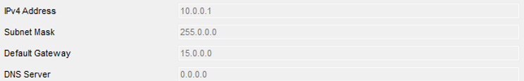

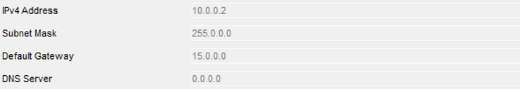**PC 2:**

**PC 3:**

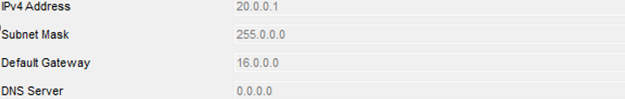

**PC 4:**

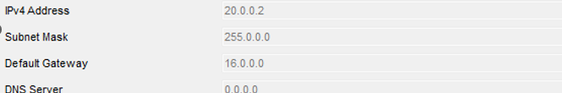

**Ping from PC 1 to PC 3:**

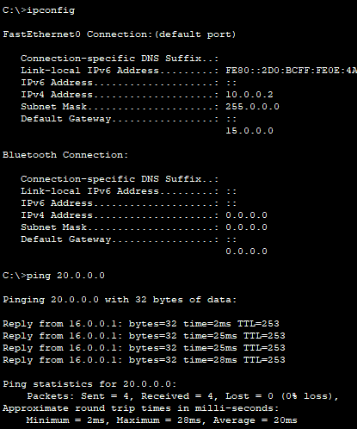

* **Ping from PC4 to PC2:**

