Bahria University

Karachi Campus



LAB EXPERIMENT NO.

13

LIST OF TASKS

|  |  |
| --- | --- |
| **TASK NO** | **OBJECTIVE** |
| 1 | Discuss routing, neighbors and topology tables.. |
| 2 | What is successor and feasible successor? |
| 3 | Configure the example network using different IPs for each network and then configure EIGRP on it. Attach all coding and screenshots. |

Submitted On:

**27-12-2023**

(Date: DD/MM/YY)

**Task#1:**

**Routing:**

The process of determining the path that data packets should take from their source to their destination in a network. It involves making decisions based on routing algorithms, which consider factors such as network topology, traffic load, and link costs.

**Neighbors:**

In networking refer to devices that are directly connected to a particular network node, typically a router. Neighbors share a direct link or interface with the node, and information about these neighbors is crucial for routing decisions.

**Topology tables:**

They are data structures maintained by routers to store information about the network's physical and logical layout. These tables contain details about neighboring devices, network links, and routing information.

**Task#2:**

**Successor:**

* A successor is the primary or best route to a specific destination from the perspective of a router.
* The router selects the successor route based on the lowest metric (path cost) to reach the destination. The metric is typically calculated using factors like bandwidth, delay, reliability, and load along the path.
* The router uses the successor route to forward traffic to the destination.

**Feasible Successor:**

* A feasible successor is an alternative route to a destination that can be considered as a backup or secondary route.
* For a route to be considered a feasible successor, it must meet certain criteria. One crucial criterion is that the reported metric of the feasible successor must be lower than the metric of the current successor route.
* The existence of feasible successors is a key feature of EIGRP and contributes to the protocol's fast convergence and loop prevention mechanisms.

**Task#1:**

**Router 1 configuration:**

Configure Fast Ethernet Port

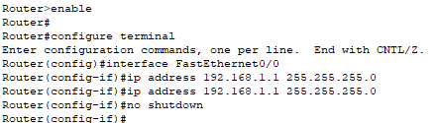

Configure Serial Port 2

Configure Serial Port 3

Locate to EIGRP Protocol



Configure EIGRP Protocol

Configure DHCP Protocol

**Router 2 configuration:**

Configure Fast Ethernet Port

Configure Serial Port 2

Configure Serial Port 3

Locate to EIGRP Protocol



Configure EIGRP Protocol

Configure DHCP Protocol



**Router 0 configuration:**

Configure Fast Ethernet Port

Configure Serial Port 2

Configure Serial Port 3

Locate to EIGRP Protocol



Configure EIGRP Protocol

* **PC 1:**

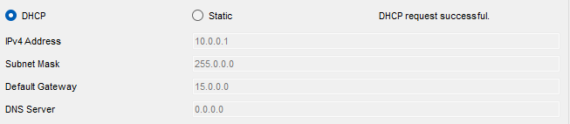

* **PC 2:**

* **PC 3:**

* **Ping from PC 1 to PC 2:**

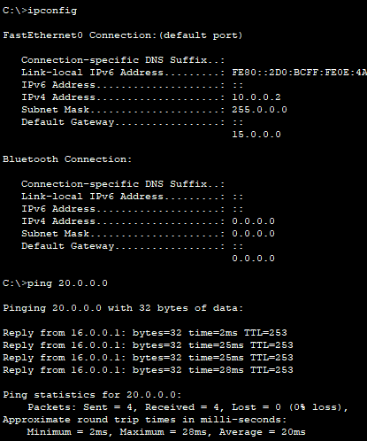

* **Ping from PC2 to PC3:**

