Bahria University

Karachi Campus



LAB EXPERIMENT NO.

03

LIST OF TASKS

|  |  |
| --- | --- |
| **TASK NO** | **OBJECTIVE** |
| 1 | Run the following commands on the command prompt of your PCs and attach snapshots of the result:   1. ping [www.google.com](http://www.google.com) 2. tracert www.yahoo.com 3. ping -i 6 www.facebook.com, did you receive the correct reply? If not, explain why. 4. nslookup www.live.com, did you result show ‘Non-authoritative answer’? If yes, explain what does it indicate, you are advised to browse the internet to attain this answer. |
| 2 | Differentiate between Ping and PathPing commands. |
| 3 | Find all Active/ Used IP addresses on your network |
| 4 | How to verify connection with remote computer? |

Submitted On:

**11-10-2023**

(Date: DD/MM/YY)

**Task # 01:**

**(part-i)**

**Solution:**

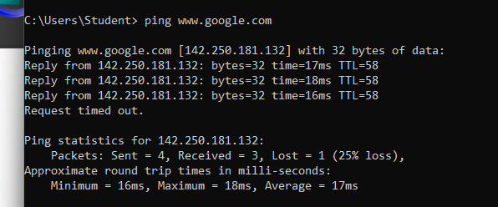

**(part-ii)**

**Solution:**

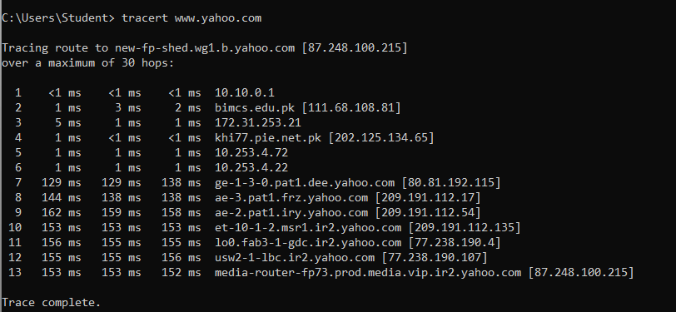

**(part-iii)**

**Solution:**

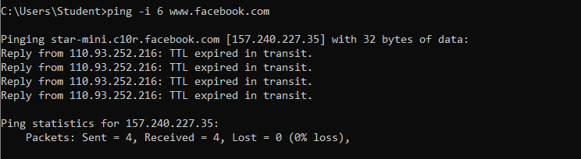

**(part-iv)**

**Solution:**

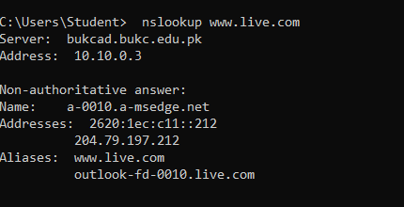

It simply means that the DNS server you're asking can't ensure that it has the official, up-to-date information for the domain name or IP address you're seeking up and is instead giving you a cached response that it got from another DNS server.

**Task # 02:**

**Ping:**

Sends ICMP Echo Request packets to the target device and waits for an ICMP Echo Reply & reports errors, packet loss, and a statistical summary of the results. It also shows ICMP availability of the end point, which consists of the availability of hops in the middle and health of the endpoint. And shows the time it takes to get from you to the destination.

**PathPing:**

Combines the functionality of tracert and ping.Traces all the intermediate hops between a source and a destination, and like ping, it gives you latency and packet loss data. It shows more detailed results as it can detect which routers are having problems and where they are located.

**Task # 03:**

**Solution:**

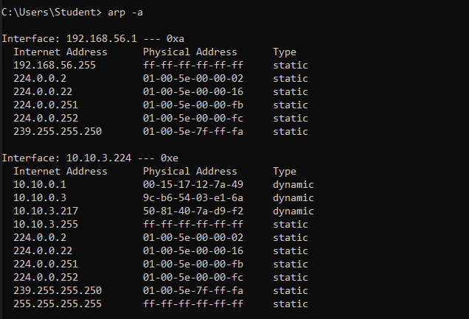

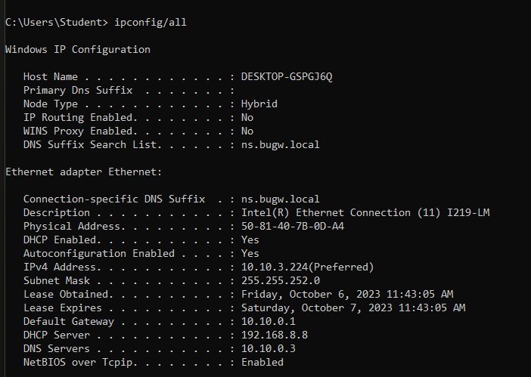

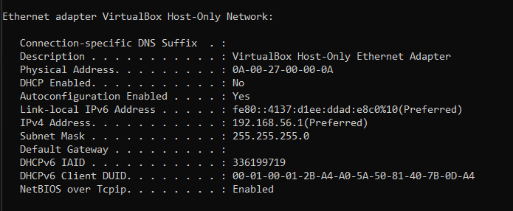

**Task # 04:**

**Solution:**

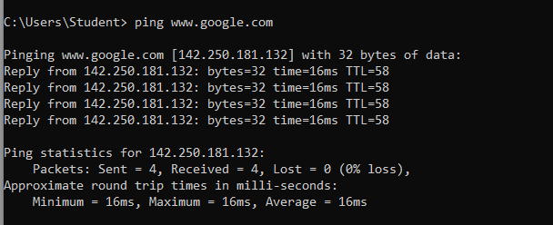

**COMMANDS FOR CLASS ASSEMENTS/EVALAUTIONS:**

**-w timeout command:**

In -w time out cmd after Ip address we give a specific time in millisecond after which command will execute. As below command was executed after 9 seconds.

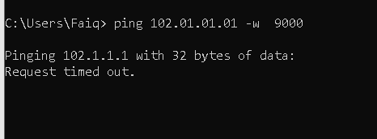

**destination-listcommand:**

The destination list is a type of command in which we specify the address of device we want to ping as in below case.



Here 102.01.01.01 is specific destination address we want to send any sort of packet.

**-k computer-list:**

The -k command is used for source routing in Windows, specifically for routing packets through a list of computers specified in the "computer-list." In addition note that we can specify up to 9 computers in the list and not more than it.

