Bahria University

Karachi Campus



LAB EXPERIMENT NO.

04

LIST OF TASKS

|  |  |
| --- | --- |
| **TASK NO** | **OBJECTIVE** |
| 1 | • On Cisco switches, where is the running configuration loaded from?  • What does the flash memory on a switches store?  • When you are logged into a switch, which prompt indicatesthat you are in privileged mode?  • On which modes in Cisco's IOS you can issue show commands? |
| 2 | Create two users Admin_'yourfirstname' and Admin_'yourlastname' grant all privileges to them then login by using Admin_'yourfirstname' then remove (Admin_'yourlastname'). Clearly show command for every step. |
| 3 | Show the encrypted console password, Privilege mode passwords and all user’s passwords |
|  |  |

Submitted On:

**18-10-2023**

(Date: DD/MM/YY)

**Task # 01:**

**(part-i)**

**Solution:**

The running configuration is loaded from the RAM (Random Access Memory).

**(part-ii)**

**Solution:**

The flash memory on a switch stores the IOS image, which is the operating system that runs on the switch, as well as configuration files, such as startup-config etc.

**(part-iii)**

**Solution:**

The prompt that indicates that you are in privileged mode is the "#" prompt.



**(part-iv)**

**Solution:**

We can issue show commands in both user EXEC mode and privileged EXEC mode.

**Task # 02:**

**Solution:**

Switch(config)#username Admin_faiq password faiq123

Switch(config)#username Admin_sabirpassword admin123

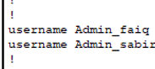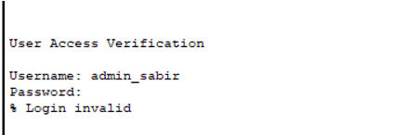

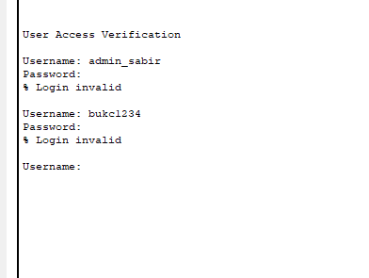

**REMOVE USER:**

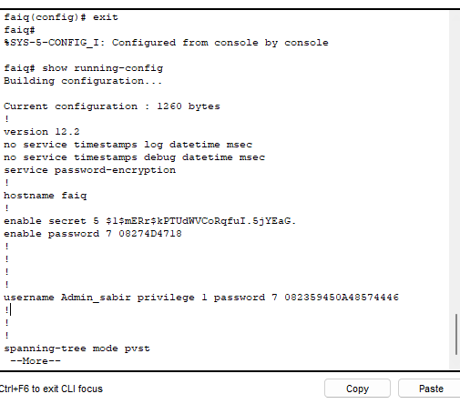

**Task # 03:**

**Solution:**

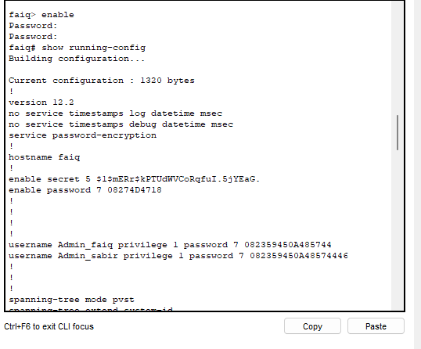

**CLASS EVALUATION TASKS:**

**clock**

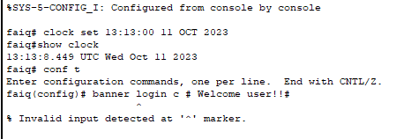

**BANNER**



