Bahria University

Karachi Campus



LAB EXPERIMENT NO.

05

LIST OF TASKS

|  |  |
| --- | --- |
| **TASK NO** | **OBJECTIVE** |
| 1 | Connect 4 switches A, B, C and D, all switches must be password protected (encrypted password) and apply the following configuration, show network topology and configuration in your lab task.   * Switch B, C, D must be connected to switch A * Switch B with VLAN name Faculty & Students having 5 logical ports each * Switch C with VLAN name Management having 3 logical ports * Switch D with VLAN name SRC & NCMPR having 3 logical ports each * e. Choose network IP from Class B for LAN like 172.16.X.X for hosts to test your LAN network |
| 2 | Complete the connection accordigly and show ping results of:   * Any PC of VLAN Faculty from any PC connected to switch D VLAN SRC (Ping) * Any PC of VLAN student from any PC connected to switch D VLAN SRC (Failed) * Any PC of VLAN Student from any PC connected to switch C VLAN Management (Ping) * Any PC of VLAN Management from same VLAN (ping) * VLAN NCMPR from VLAN Student (Failed) |

Submitted On:

**25-10-2023**

(Date: DD/MM/YY)

**Task:**

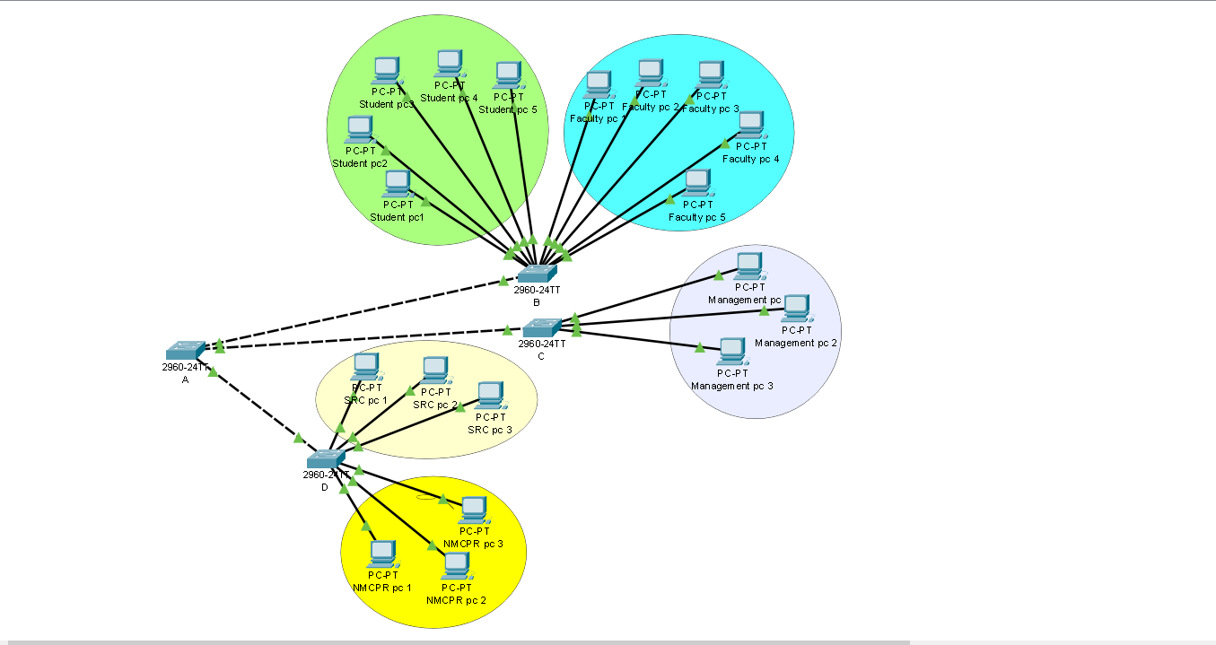

**NAME AND PASSWORD WITH ENCRYTION:**

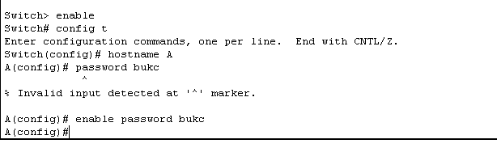

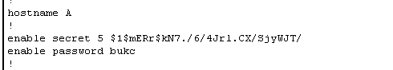

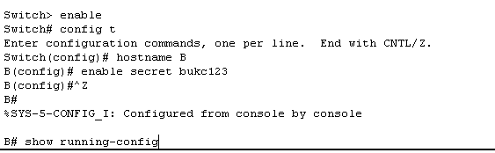

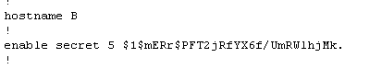

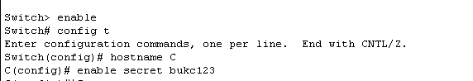

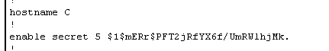

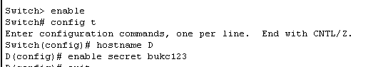

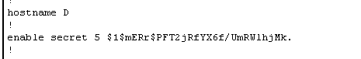

**Setting up vlan:**

**For switch b:**

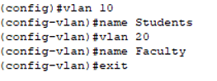

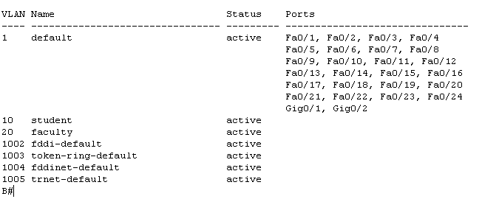

**Vlan range for students:**

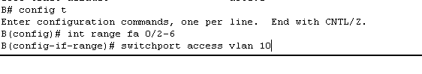

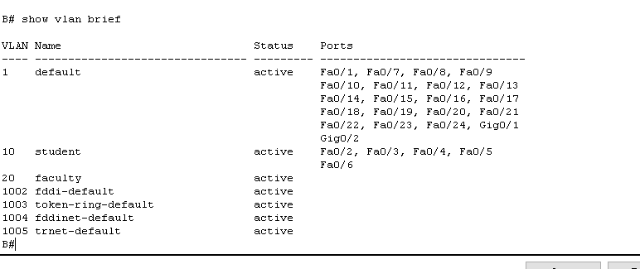

**Vlan range for faculty:**

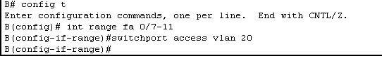

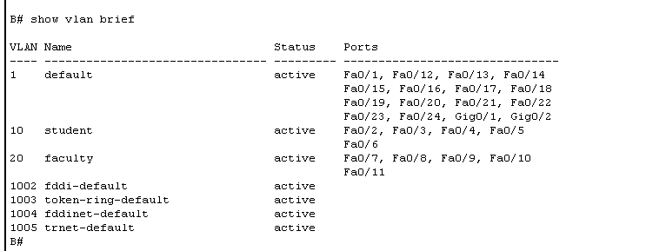

**For switch c :**

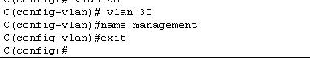

**Vlan range for management:**

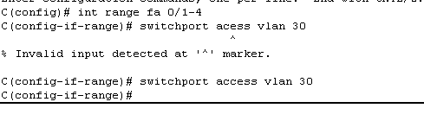

**For switch c :**

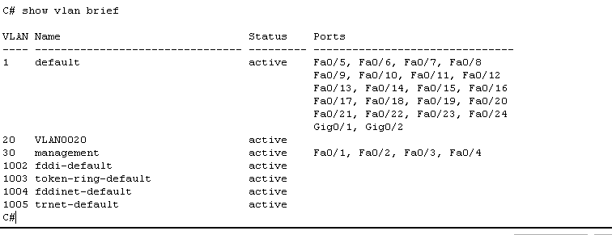

**For switch D :**

**For src:**

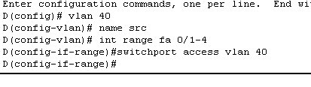

**For ncmpr:**

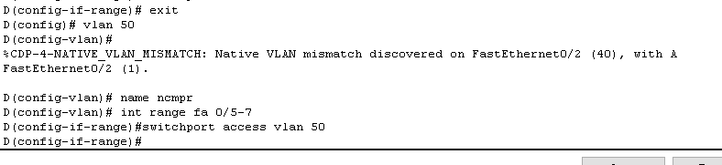

**Overall:**

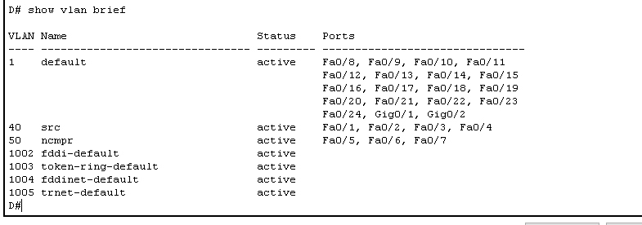

**From Student to Student**

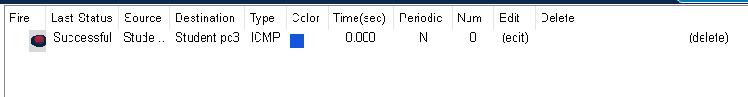

**From faculty to faculty**

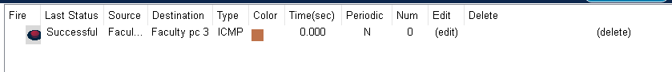

**From management to management**

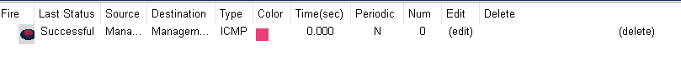

**Within SRC:**



**Within NMCPR:**

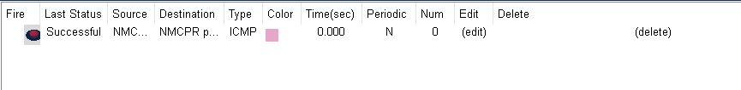

**Ping tasks**

**Any PC of VLAN Faculty from any PC connected to switch D VLAN SRC (Ping)**

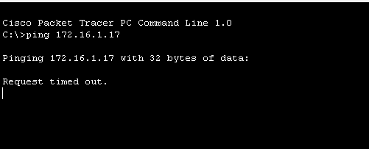

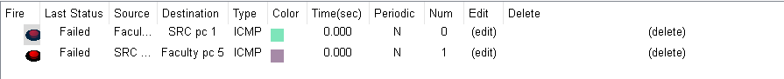

**Any PC of VLAN student from any PC connected to switch D VLAN SRC (Failed)**

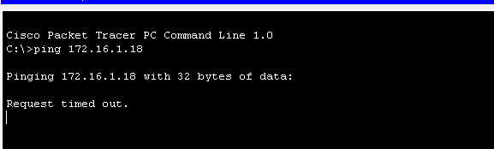

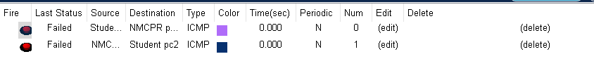

**Any PC of VLAN Student from any PC connected to switch C VLAN Management (Ping)**

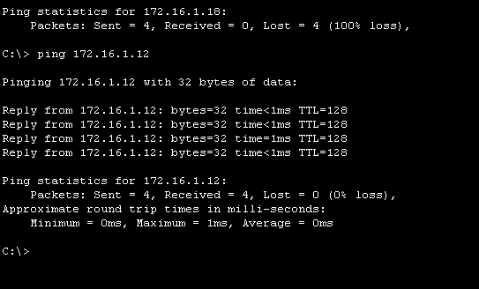

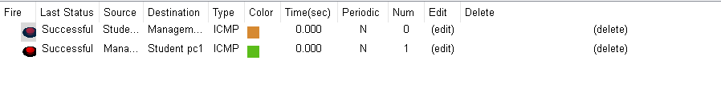

**Any PC of VLAN Management from same VLAN (ping)**

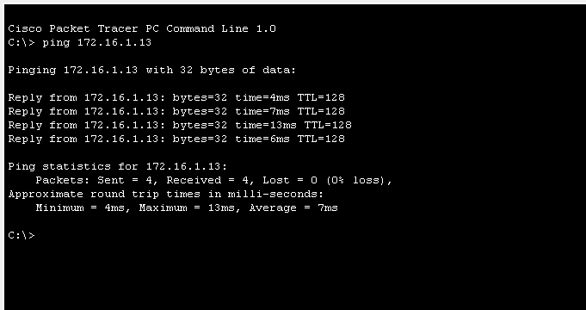



**VLAN NCMPR from VLAN Student (Failed)**



