Bahria University

Karachi Campus



LAB EXPERIMENT NO.

06

LIST OF TASKS

|  |  |
| --- | --- |
| **TASK NO** | **OBJECTIVE** |
| 1 | Take 4 switches named as: A, B, C, D and connect them in alphabetical order. Perform and show the following configurations in your lab task:  a. Switch A with VLANs faculty and students having 1 logical port each.  b. Now assign 1 logical port each to VLANs faculty and students in Switch B and D.  c. Now make switch A in server mode, whereas B and D in client mode and switch C in transparent mode.  d. Assign IP addresses to PCs connected to Switch A, B and D.  e. Now ping within the same VLAN and outside the same VLAN and show your results |
|  |  |

Submitted On:

**22-11-2023**

(Date: DD/MM/YY)

**Task:**

**Create VLANs:**

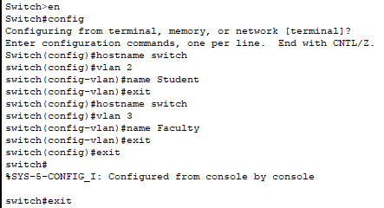

**Assign Ports**

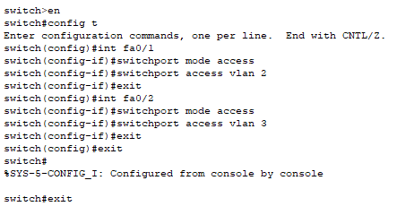

**Show VLANs**

**Switch B**

**Create VLANs**

**Show VLANs**

**Assign Ports**

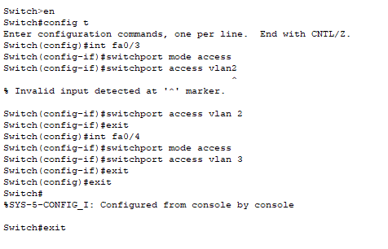

**Show VLANs**

**Switch D  
Create VLANs**

**Assign Ports**

**Show VLANs**

**Trunk Between the Switch A & B**

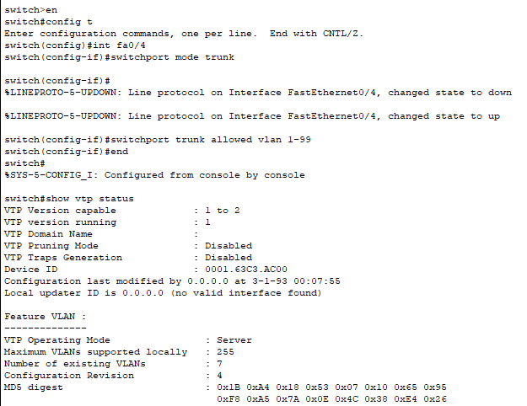

**Create Switch A Server**

**Trunk Between the Switch B & C**

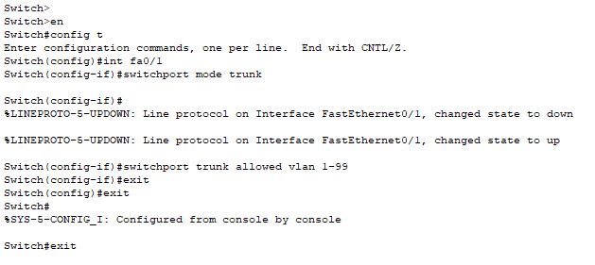

**Create SwitchB Client**

**Trunk Between the Switch C & D**

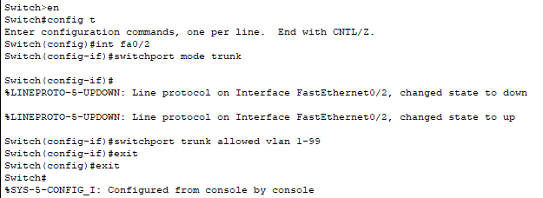

**Create SwitchC Transparent**

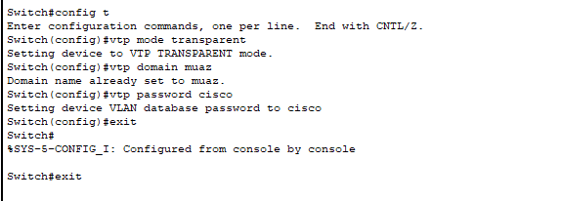

**Create SwitchD Client**

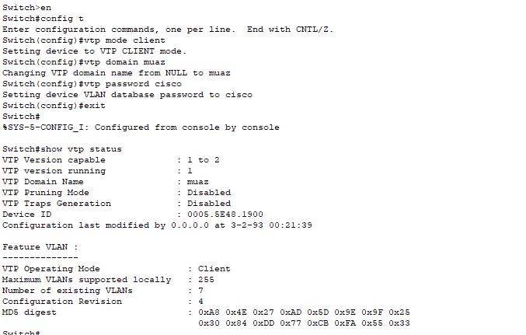

**Ip-Addresses**

|  |  |  |
| --- | --- | --- |
| **Switch** | **PC’s** | **IP** |
| **S1** | **Faculty** | 192.168.0.1 |
| **S1** | **Student** | 192.168.0.2 |
| **S2** | **Student** | 192.168.0.3 |
| **S2** | **Faculty** | 192.168.0.4 |
| **S3** | **Faculty** | 192.168.0.5 |
| **S3** | **Student** | 192.168.0.6 |

**Ping cmds:**

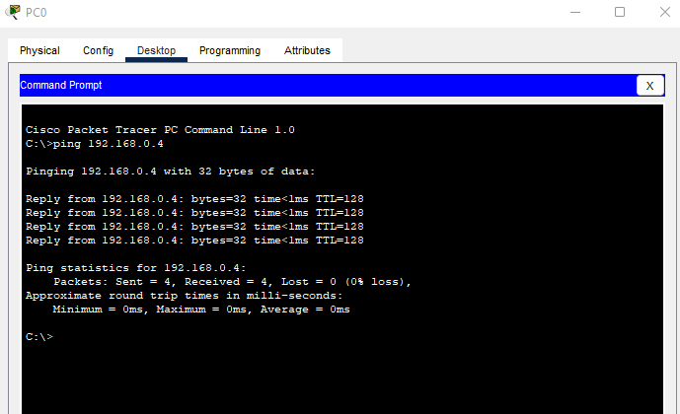

**Outside VLAN(different vlan ping)**

