Bahria University

Karachi Campus



LAB EXPERIMENT NO.

07

LIST OF TASKS

|  |  |
| --- | --- |
| **TASK NO** | **OBJECTIVE** |
| 1 | Analyze the network, deactivate another working interface and monitor the shift to the redundant interface. Also, change the root switch to a switch of your choice and implement the rapid STP and finally show the pinging results. |
|  |  |

Submitted On:

**13-12-2023**

(Date: DD/MM/YY)

**Task:**

**Network:**

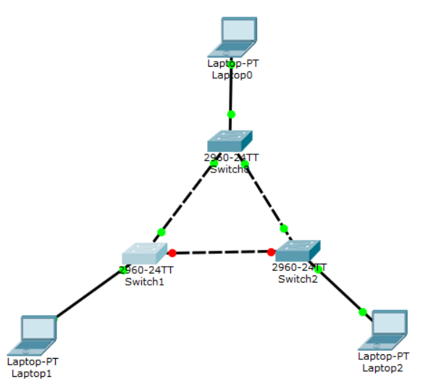

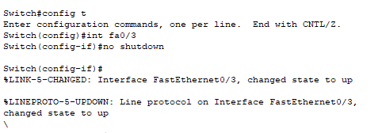

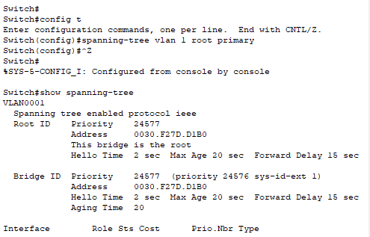’

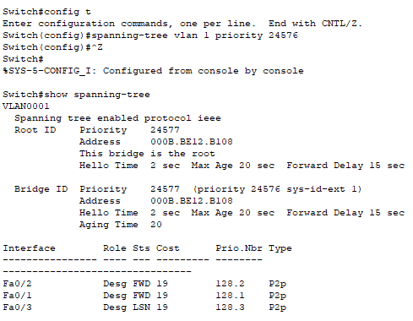

PING:

