Bahria University

Karachi Campus



LAB EXPERIMENT NO.

08

LIST OF TASKS

|  |  |
| --- | --- |
| **TASK NO** | **OBJECTIVE** |
| 1 | Configure static route on the following network and show all necessary configuration steps for each router. (USING 2 ROUTERS) |
| 2 | Configure static route on the following network and show all necessary configuration steps for each router.(USING 3 ROUTERS) |

Submitted On:

**13-12-2023**

(Date: DD/MM/YY)

**Task#1:**

**USING 2 ROUTERS:**

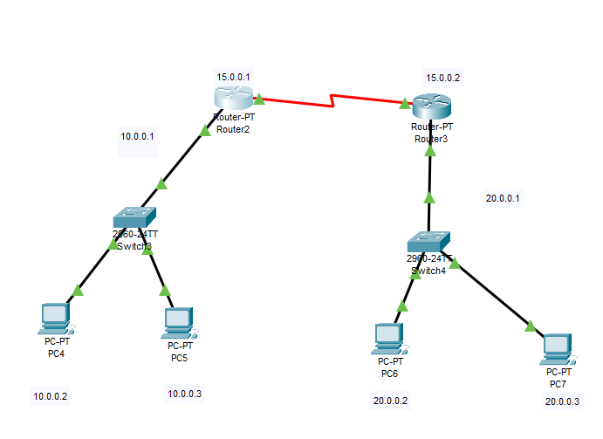

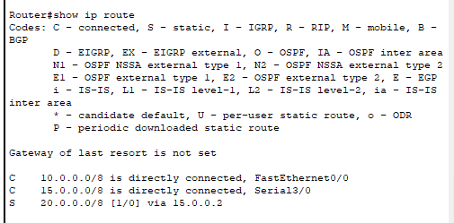

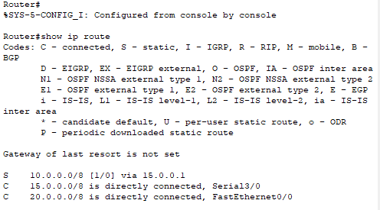





PING:

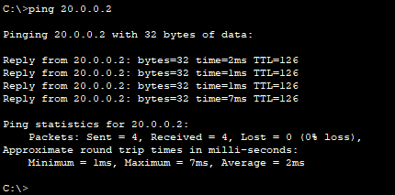

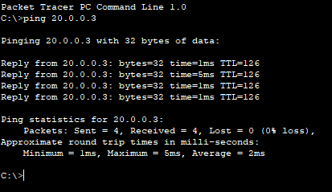

RESULT:

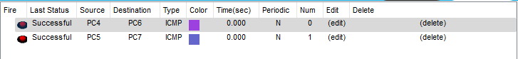

**USING 3 ROUTERS:**

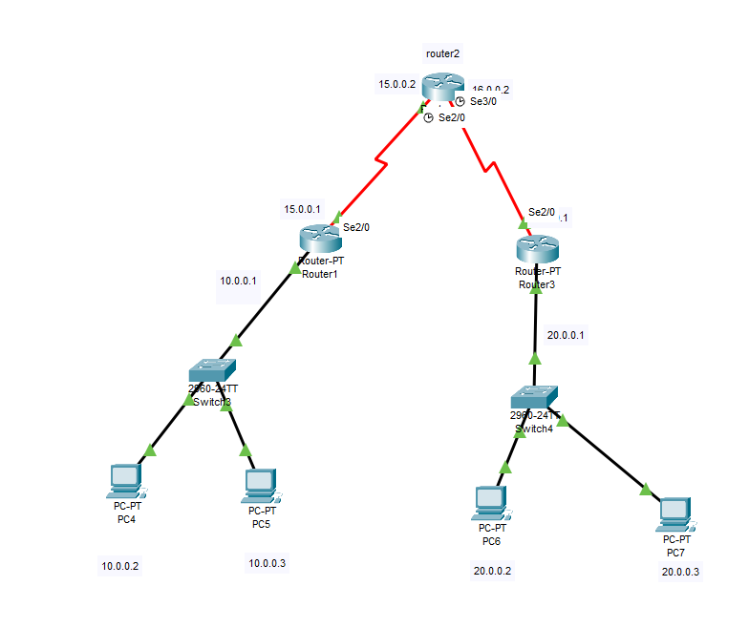





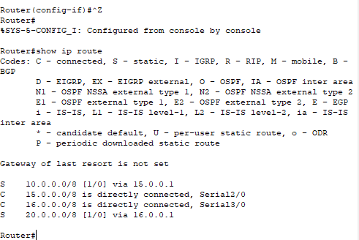

*SAME PROCEDURE FOR ALL…

PING:

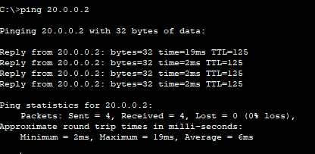

OUTPUT:

