Bahria University

Karachi Campus



LAB EXPERIMENT NO.

09

LIST OF TASKS

|  |  |
| --- | --- |
| **TASK NO** | **OBJECTIVE** |
| 1 | What is the Internet address of the gaia.cs.umass.edu (also known as www- net.cs.umass.edu)? What is the Internet address of your computer? |
| 2 | Fill the below tables |
| 3 | Access your university website and list IP address of your computer, DNS address and default gateway. |

Submitted On:

**13-12-2023**

(Date: DD/MM/YY)

**Task#1:**

The Internet address of gaia.cs.umass.edu (also known as www-net.cs.umass.edu) is 128.119.245.12. It is located in Amherst, Massachusetts, United States. The domain is associated with the Computer Networks Research Group in the School of Information and Computer Sciences at the University of Massachusetts, Amherst.

**My ip address:**

192.168.2.102

**Task#2:**

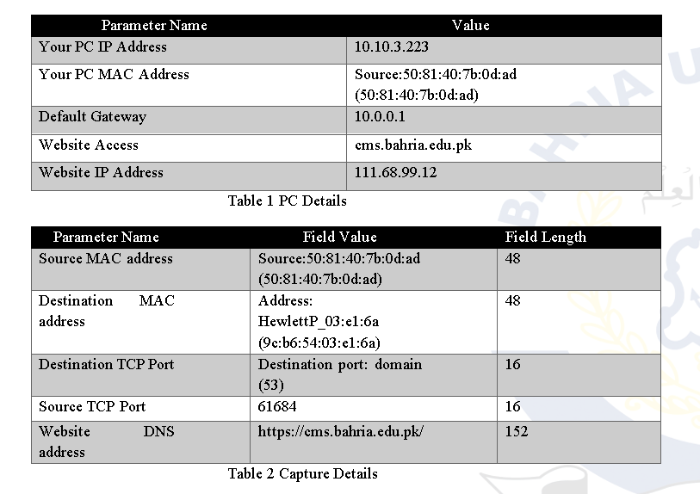

**Task#3:**

**My ip address:**  192.168.2.102

**DNS ADDRESS:**  -

**DEFAULT GATEWAY:**  192.168.2.1