

**BAHRIA UNIVERSITY, (Karachi Campus)**

*Department of Software Engineering*

PROPOSAL

**Course Title:**   **Course Code**:

**Course Instructor: Class**: BSE- (A/B)

**Lab Instructor:** Engr. Asma Shaheen  **Name: ______________________**

PROJECT TITLE:

**SMART SALES MANAGEMENT SYSTEM**

GROUP MEMBERS LIST:

Faiq Bin Sabir (LEAD)

Zain ul Abideen

M Intakhab Malik

Submission Date**: __dec/1/2023________________**

Contents

**1.** **INTRODUCTION:** 3

**2.** **PROJECT SCOPE:** 3

**3.** **PROJECT ABSTRACT:** 3

**4.** **PROJECT FUNCTIONALITIES:** 3

**5.** **FLOW DIAGRAM:** 3

**6.** **MODULE DISTRIBUTION:** 3

**7.** **REFRENCES:** 3

# Introduction:

The project is to understand the advantages of using VLAN in a network, how broadcasting is controlled. Understand the configuration which is required to setup a VLAN based network using Cisco routers and switches.Moreover, It is a sales management system with security. Where we have multiple departments located at 4 Cities. Each department is Operatable at different VLANS. And using routers we are managing all the department exectively.

# Project Scope:

In it, we are using Enterprises Network Model to show the use case of Vlan and how Real Scenario works when Different Branches of Enterprises are located in Different Cities. A complete prototype on how the sales management system works & a bit inclusion of IOT in it is as well.

# Project Abstract:

The overarching objective of this project is to establish a robust and efficient network infrastructure to seamlessly connect multiple offices within our organization. The deployment of a comprehensive networking solution aims to enhance communication, facilitate resource sharing, and streamline collaborative efforts among geographically dispersed teams. The integration of network technologies will contribute to increased productivity and operational efficiency. Some technical aspects such as security, reliability, scalability etc. are also considered as key aspects of system. In conclusion, this project abstract outlines our commitment to establishing a network that not only fulfills the immediate connectivity needs of our organization but also lays the foundation for future growth and technological advancements.

# Project Functionalities:

We are using Enterprises Network Model to show the use case of VLAN and how Real Scenario works when Different Branches of Enterprises are located in Different Cities. Some of key functionalities includes the networking between different cities having a main head office. In addition, the communication will be reliable, safe & secure. In addition, the IOT part is also implemented in the main head office in which the lights, fans, security camera etc. are controlled digitally. In each city office we have multiple department that can connect with each other such as sales, administration, warehouse etc. The main goal of this work is to increase the security level of the LAN, in order to reduce the access to undesirable sites and to avoid the presence of hackers in the internet.

# Flow Diagram:

Department are same in every office and are having same vlans. In addition, each one can communicate with other department and they can be increased during implementation.

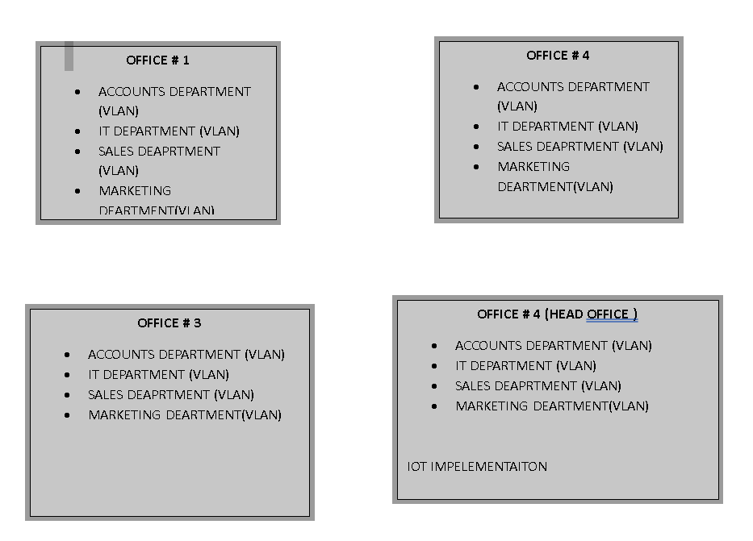

1. Module Distribution:

|  |  |
| --- | --- |
| ***Name*** | ***Role*** |
| ***FAIQ BIN SABIR*** | ***Main head office work*** |
| ***M INTAKHAB MALIK*** | ***IOT work*** |
| ***ZAIN UL ABIDEEN*** | ***Cities office Works*** |

* No as such module division is done & it can be change accordingly.

1. References:

* Wikipedia
* https://readthedocs.org/projects/ciscopackettracer/

**Teacher Signature**: ______________________________________________

**Remarks**: ______________________________________________

**Submission Date**: ______________________________________________