Bahria University

Karachi Campus



LAB EXPERIMENT NO.

02

LIST OF TASKS

|  |  |
| --- | --- |
| **TASK NO** | **OBJECTIVE** |
| 1 | Write a Function to capitalize the first and last letters of each word that is input |
| 2 | Write a function to find common values within two lists and append in new list named "common_items". Use List comprehension for this |
| 3 | Write code for the task that will take user input of names of three students, along with marks of three courses . Calculate Marks obtained, Percentage and grade of each student. Append obt marks, percentage and grade in the list |
| 4 | On the basis of employees list mentioned above calculate average age of first two employees and insert that age in next two employees |
| 5 | using the employees list mention gender wise count of employees |

Submitted On:

**09-10-2023**

(Date: DD/MM/YY)

**Task # 01:**

**Solution:**

**CODE:**

input_data =input("enter word to capitalize first & last letter\n");

input_data.split();

for i in input_data:

if(a < 1):

arr.append(i.upper());

elif(a == len(input_data)-1):

arr.append(i.upper());

else:

arr.append(i);

a+=1;

print( "The updated word is :","".join(arr))

**OUTPUT:**

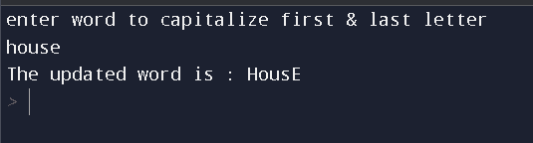

**Task#02:**

**Solution:**

**CODE:**

list1 = [1, 2, 3, 4, 5]

list2 = [3, 4, 5, 6, 7,2,9]

common_items = [item for item in list1 if item in list2]

print("The common items are:" , common_items)

**output:**

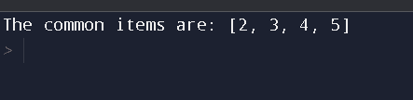

**Task # 03:**

**Solution:**

**CODE:**

students = []

for i in range(3):

name = input("Enter name of student {}: ".format(i+1))

marks = []

for j in range(3):

marks.append(int(input("Enter marks for course {}: ".format(j+1))))

obt_marks = sum(marks)

percentage = obt_marks / 3

if percentage >= 90:

grade = 'A+'

elif percentage >= 80:

grade = 'A'

elif percentage >= 70:

grade = 'B'

elif percentage >= 60:

grade = 'C'

else:

grade = 'F'

students.append([name, marks, obt_marks, percentage, grade])

print("Name \t MARKS \t TOTAL MARKS \t PERCENTAGE \t GRADE")

for i in students:

print(i)

**output:**

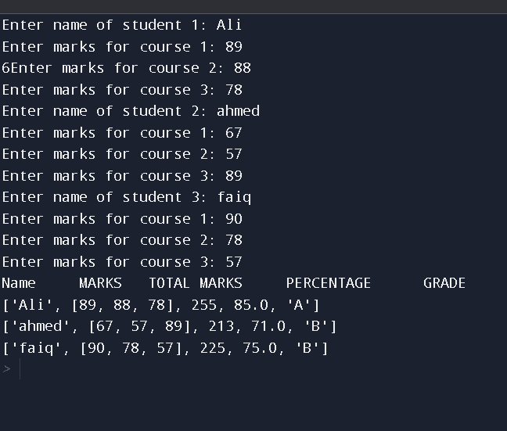

**Task#04:**

**Solution:**

**CODE:**

employee = [ ['Ayesha',24,10000.0,'F'],

['duad',22,35500.0,'M'],

['Aliza',65000.0,'F'],

['Ali',60000.0,'M']]

val = (employee[0][1] + employee[1][1])/2;

employee[2].insert(1,val)

employee[3].insert(1,val)

print(employee)

for i in employee:

print("hi ",i[0],"you will be 32 in " , 32- i[1],'years')

**OUTPUT:**

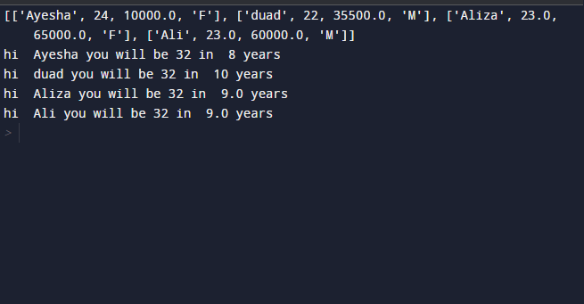

**Task # 05:**

**Solution:**

**CODE:**

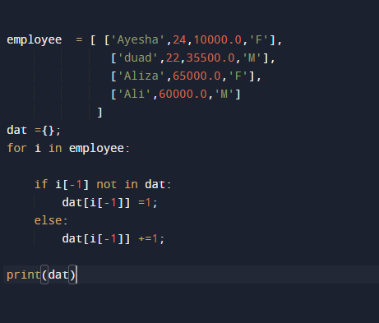

**OUTPUT:**

