Bahria University

Karachi Campus



LAB EXPERIMENT NO.

05

LIST OF TASKS

|  |  |
| --- | --- |
| **TASK NO** | **OBJECTIVE** |
|  | Import File using Pandas. |
|  | Drop Duplicates |
|  | Remove ‘..’ & ‘/’ in Last-Name Column. |
|  | Replace ‘|’ & ‘/’,’N-a’ with ‘-’ in Phone_Number Column and fill the null value with 0. |
|  | Drop Unused Columns. |
|  | Replace y/n value with yess/no in Paying Customer, Do_Not_Contact and fill null values with 0 |
|  | Insert ‘-’ to every 3 digits in Phone Number Column |

Submitted On:

**29-12-2023**

(Date: DD/MM/YY)

**Task # 01:**

**Solution:**

**CODE:**

import pandas as pd

df=pd.read_csv('Downloads/Customer Call List.csv')

df

**OUTPUT:**

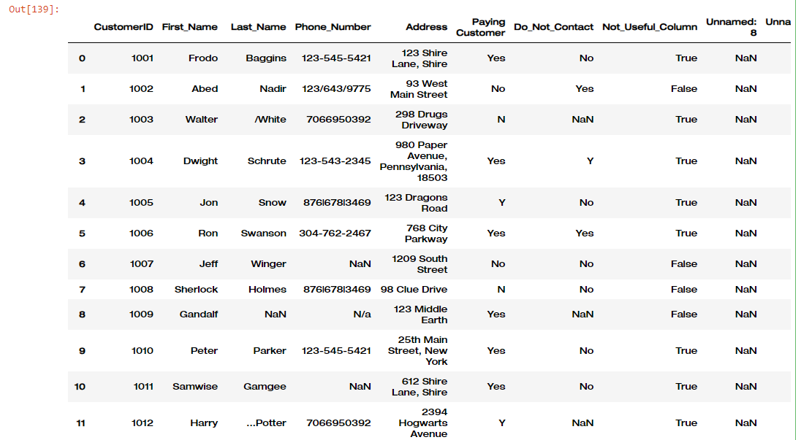

**Task#02:**

**Solution:**

**CODE:**

df.drop_duplicates()

df

**output:** 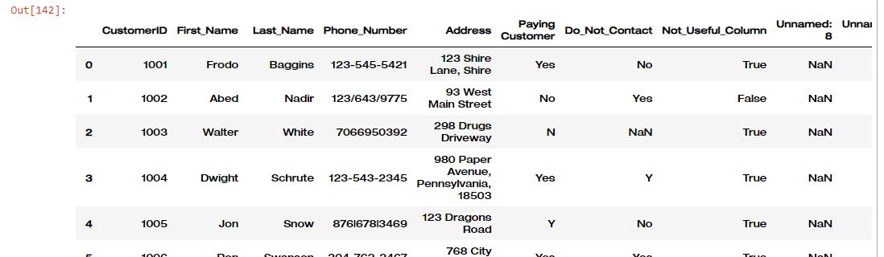

**Task # 03:**

**Solution:**

**CODE:**

df['Last_Name']=df['Last_Name'].str.strip('/')

df['Last_Name']=df['Last_Name'].str.strip('..')

**output:**

**Task#04:**

**Solution:**

**CODE:**

df['Phone_Number']=df['Phone_Number'].str.replace('|', '-').str.replace('/', '-').str.replace('N-a', '0')

df['Phone_Number']=df['Phone_Number'].fillna(0)

**OUTPUT:**

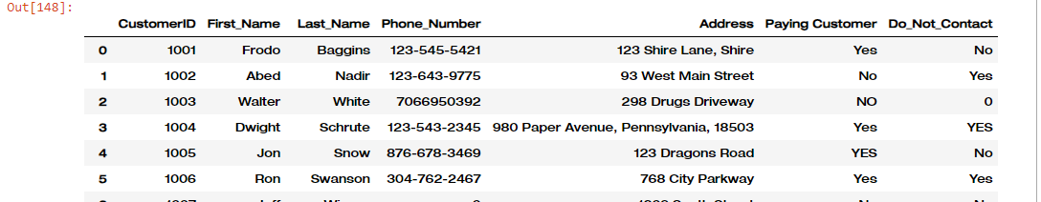

**Task # 05:**

**Solution:**

**CODE:**

df=df.drop(['Unnamed: 8','Unnamed: 9','Not_Useful_Column'],axis=1)

**OUTPUT:**



**Task # 06:**

**Solution:**

**CODE:**

df['Paying Customer']=df['Paying Customer'].replace({"N":"NO","Y":"YES",'N/a':'0'})

df['Do_Not_Contact']=df['Do_Not_Contact'].replace({"N":"NO","Y":"YES"})

df['Do_Not_Contact']=df['Do_Not_Contact'].fillna(0)

df['Address']=df['Address'].fillna(0)

**OUTPUT:**

**Task # 07:**

**Solution:**

**CODE:**

if pd.isna(phone):

return phone

phone = str(phone)

if '-' not in phone:

return f"{phone[:3]}-{phone[3:6]}-{phone[6:]}" if len(phone) >= 6 else phone

else:

return phone

df['Phone_Number'].apply(format_phone_number)

**OUTPUT:**

