Bahria University

Karachi Campus



LAB EXPERIMENT NO.

06

LIST OF TASKS

|  |  |
| --- | --- |
| **TASK NO** | **OBJECTIVE** |
|  | Dropping columns not in use and having maximum number of null values. |
|  | Group the data frame by values in Survived column, and count the number. |
|  | Group the data frame by classes in the pclass column, and count the number. |
|  | Group the data frame by classes in the Embarked column and count the number. |
|  | Survival number according to gender or sex i.e. Male and Female |
|  | Define your data Assuming you have data similar to the 'df_cleaned' DataFrame values. |
|  |  |

Submitted On:

**29-12-2023**

(Date: DD/MM/YY)

**Task # 01:**

**Solution:**

**CODE:**

import pandas as pd

import seaborn as sns

import matplotlib.pyplot as plt

df=pd.read_csv("train.csv")

df_CLeaned=df.drop(["Cabin","Name","PassengerId","Ticket"],axis=1)

df_Cleaned

**OUTPUT:**

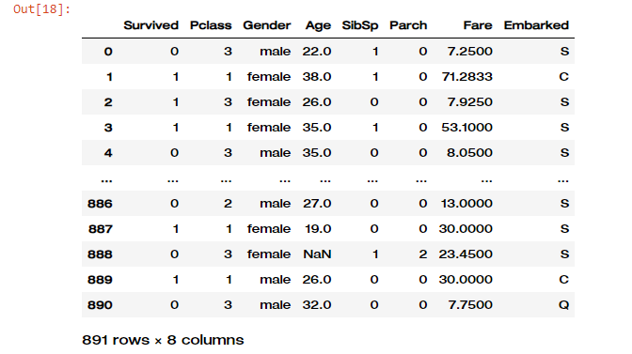

**Task#02:**

**Solution:**

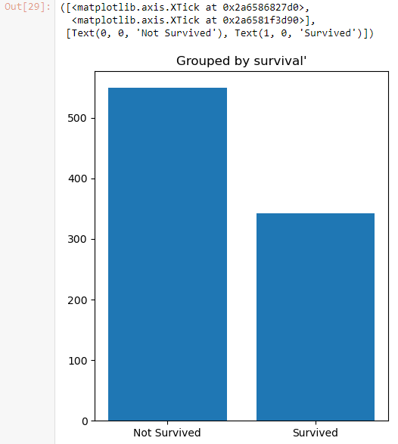**CODE:**

survived=df.groupby("Survived")["Survived"].count()

plt.figure(figsize=(5,6))

plt.bar(survived.index,survived.values)

plt.title("Grouped by survival'")

plt.xticks([0,1],["Not Survived","Survived"])

**output:**

**Task # 03:**

**Solution:**

**CODE:**

PClass=df.groupby("Pclass")["Pclass"].count()

plt.figure(figsize=(5,7))

plt.pie(PClass.values,labels=["Class 1","Class 2","Class 3"],autopct="%1.1f%%",textprops={'fontsize':10})

plt.title("Grouped by pclass")

plt.show()

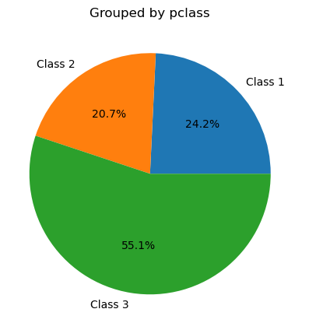**output:**

**Task#04:**

**Solution:**

**CODE:**

plt.figure(figsize=(7,7))

plt.title('Grouped by embarkation')

plt.pie(Embark.values, labels=['Cherbourg', 'Queenstown', 'Southampto'],

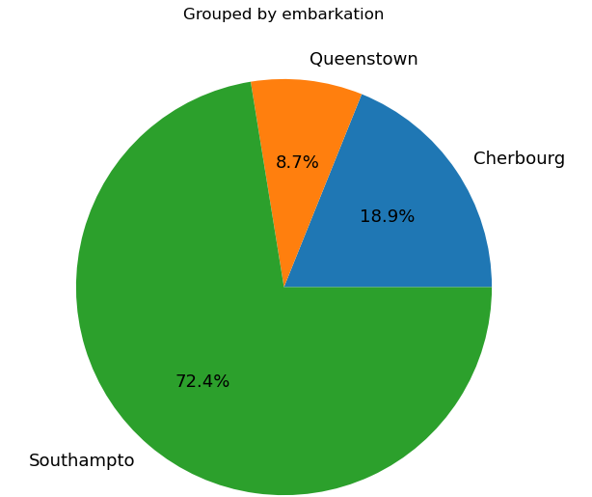autopct='%1.1f%%', textprops={'fontsize':13})

plt.show()

**OUTPUT:**

**Task # 05:**

**Solution:**

**CODE:**

SurvivedGender=df.groupby("Gender")["Survived"].sum()

plt.figure(figsize=(4,5))

plt.bar(SurvivedGender.index, SurvivedGender.values)

plt.title('Survived female and male')

for i, value in enumerate(SurvivedGender.values):

plt.text(i, value-20, str(value), fontsize=12, color='white',

horizontalalignment='center', verticalalignment='center')

plt.show()

**OUTPUT:**

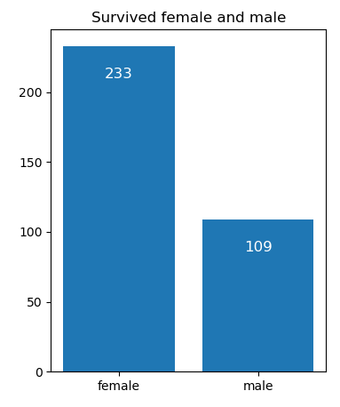

**Task # 06:**

**Solution:**

**CODE:**

fig, axes = plt.subplots(1, 3, figsize=(20, 8), sharey=True)

# Iterate through passenger classes

for i, pclass in enumerate([1, 2, 3]):

# Filter data for the specific class

class_data = df_CLeaned[df_CLeaned['Pclass'] == pclass]

# Create a subplot for the current class

ax = axes[i]

# Create the counts for Survived and Sex

counts = class_data.groupby(['Survived', 'Gender']).size().unstack()

# Plot the counts

counts.plot(kind='bar', stacked=True, ax=ax)

# Set labels and title

ax.set_title(f'Pclass {pclass}')

ax.set_xlabel('Survived')

ax.set_ylabel('Count')

# Adjust the layout

plt.subplots_adjust(top=0.9)

plt.suptitle('Class and gender wise segregation of passengers', fontsize=16)

# Show the plot

plt.show()

**OUTPUT:**

