Bahria University

Karachi Campus



LAB EXPERIMENT NO.

09

LIST OF TASKS

|  |  |
| --- | --- |
| **TASK NO** | **OBJECTIVE** |
| 1 | Remove outliers using IQR method from csv file |
|  |  |
|  |  |
|  |  |
|  |  |
|  |  |
|  |  |

Submitted On:

**05-01-2024**

(Date: DD/MM/YY)

**Task # 01:**

**Solution:**

**CODE:**

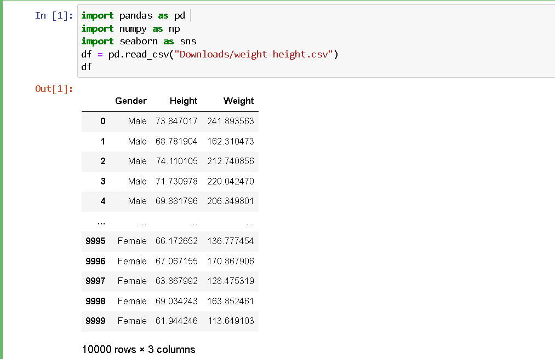

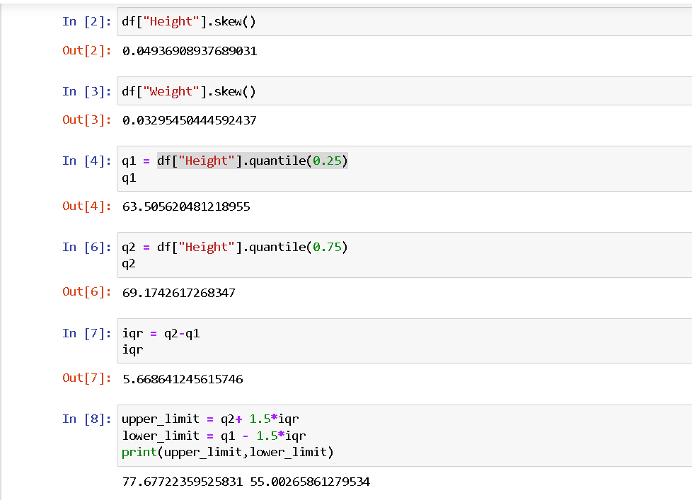

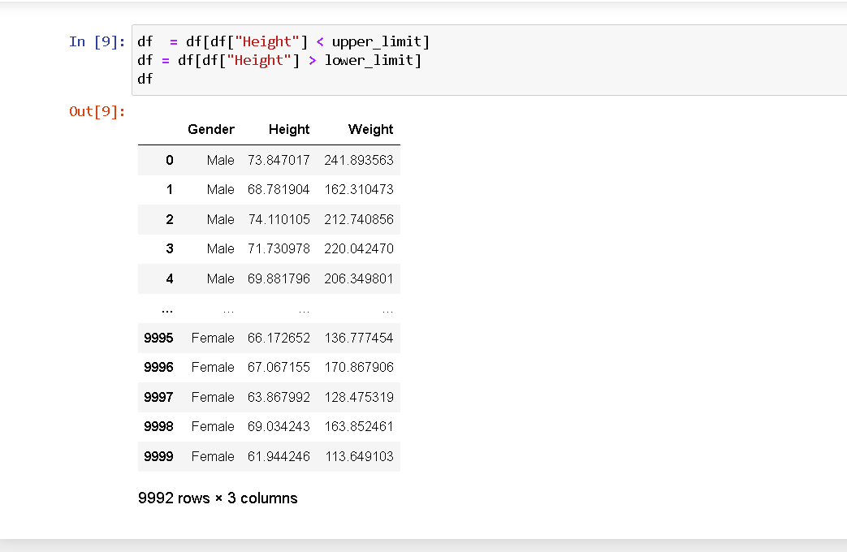

**8-9 OUTLIERS WERE DETECTED AND REMOVED.**