Bahria University

Karachi Campus

LAB EXPERIMENT NO.

**10**

LIST OF TASKS

|  |  |
| --- | --- |
| TASK NO | OBJECTIVE |
| 1 | Develop a Program which provides the use of Inter integrated 12C Interface programming. |

Submitted On:

29 December 2023

____________

(Date: DD/MM/YY)

**Task 1**

Develop a Program which provides the use of Inter integrated 12C Interface programming.

**MASTER CODE**

#include <Wire.h>

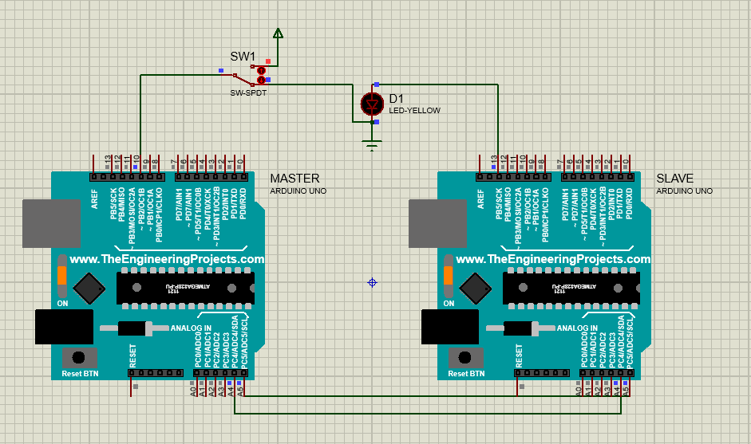int x = 0;

void setup() {

 Wire.begin();

 pinMode(10,INPUT);

}

void loop() {

 x = digitalRead(10);

 Wire.beginTransmission(2);

 Wire.write(x);

 Wire.endTransmission();

}

**SLAVE CODE**

#include <Wire.h>

int LED = 13;

int x = 0;

void setup() {

 pinMode (LED, OUTPUT);

 Wire.begin(2);

 Wire.onReceive(receiveEvent);

}

void receiveEvent(int bytes) {

 x = Wire.read();

}

void loop() {

 if (x == 1) {

 digitalWrite(LED, HIGH);

 }

 else

{

 digitalWrite(LED,LOW);

}}