Bahria University

Karachi Campus

LAB EXPERIMENT NO.

**12**

LIST OF TASKS

|  |  |
| --- | --- |
| TASK NO | OBJECTIVE |
| **1** | Write a simple Python script in IDLE to calculate the Percentage by taking the Marks of the courses as input. |
| **2** | Write a simple Python script to check that the input number is either even or odd |
| **3** | Write Python Script for Calculator which can perform simple operations of Addition, Subtraction, Multiplication and Division |
| 4 | Write ten main Raspberry-Pi application projects. Briefly discuss their details. |

Submitted On:

29 December 2023

____________

(Date: DD/MM/YY)

**Task 1**

Write a simple Python script in IDLE to calculate the Percentage by taking the Marks of the courses as input.

print('Welcome to BUKC')

a= float(input('enter marks obtained in ENA:'))

b= float(input('enter marks obtained in signal & systems:'))

c= float(input('enter marks obtained in comp architecture:'))

obt = a+b+c

prct = float(obt/300*100)

print('total marks obt: ',obt)

print('percentage: ',prct)

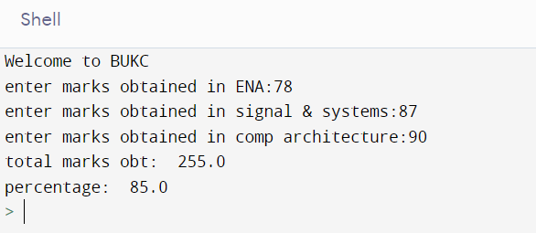

**Task 2**

Write a simple Python script to check that the input number is either even or odd.

d= int(input('Enter a number:'))

if(d==0):

print('Number is 0')

elif(d%2 == 0):

print('Number is Even')

else:

print('Number is Odd')

**Task 3**

Write a simple Python script to check that the input number is either even or odd.

num1=float(input('Enter number:'))

num2=float(input('Enter number:'))

print('Enter a operation(+,-,*,/)')

op = input()

if(op=='+'):

print(num1+num2)

elif(op=='-'):

print(num1-num2)

elif(op=='*'):

print(num1*num2)

elif(op=='/'):

try:

print(num1/num2)

except:

print('Denominator cannot be zero')

else:

print('Wrong input')

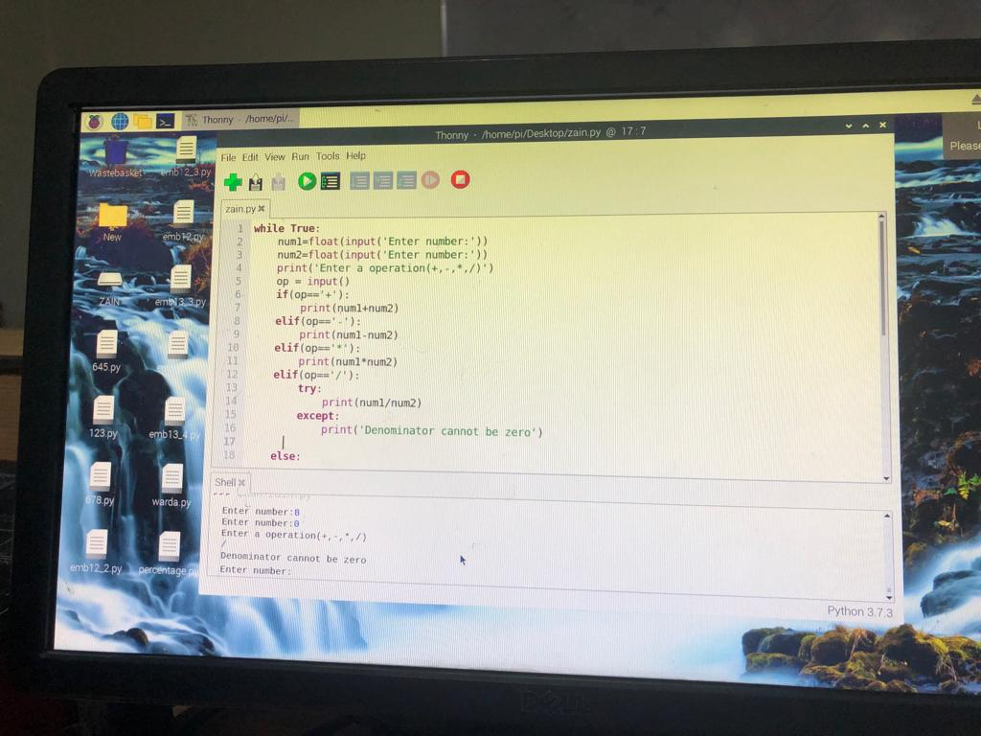

**Task 4**

Write ten main Raspberry-Pi application projects. Briefly discuss their details.

Here are ten examples of Raspberry Pi application projects, along with brief descriptions and references:

1. **Media Server**: You can use Raspberry Pi to stream media files from your local network or the internet to your TV or speakers. [You can use software like Kodi, Plex, or Emby to set up your own media server](https://all3dp.com/1/best-raspberry-pi-projects/).
2. **Weather Station**: You can use Raspberry Pi to collect weather data from various sensors, such as temperature, humidity, pressure, wind speed, etc. [You can display the data on a screen, upload it to a website, or use it for other purposes](https://all3dp.com/1/best-raspberry-pi-projects/).
3. **The Parent Detector**: You can use Raspberry Pi to detect motion in your room and trigger a video recording using the Pi camera module. [You can use this to monitor your child, your door, or anything else you want](https://all3dp.com/1/best-raspberry-pi-projects/).
4. **FM Radio Station**: You can use Raspberry Pi to broadcast your own FM radio station. You can use a simple wire antenna and software like PiFmRds to modulate and transmit audio signals. You can play music, podcasts, or anything else you want. [Note that you may need a license to operate a radio station in your area](https://all3dp.com/1/best-raspberry-pi-projects/).
5. **Car Safety System**: You can use Raspberry Pi to enhance the safety of your car. You can use sensors and cameras to detect collisions, airbag deployments, seat belt status, etc. You can also use the Pi to send notifications to your phone or emergency services in case of an accident.
6. **Wearable Computer**: You can use Raspberry Pi to create your own wearable computer. You can use a small screen, a keyboard, a battery, and other components to make a portable device that you can wear on your wrist, arm, or head. You can use it for various applications, such as gaming, navigation, communication, etc.
7. **Voice Controlled Air Purifier**: You can use Raspberry Pi to control an air purifier using your voice. You can use a microphone, a speaker, and software like Google Assistant or Alexa to enable voice commands. You can also use sensors to measure the air quality and display it on a screen.
8. **RC Boat**: You can use Raspberry Pi to build and control your own remote-controlled boat. You can use motors, propellers, batteries, and other components to make a boat that can float on water. You can also use a camera, a joystick, and a software like Node-RED to control the boat from your computer or phone.
9. **IOT Water Pollution Monitor**: You can use Raspberry Pi to monitor the water pollution level in a lake, river, or ocean. You can use sensors to measure the pH, turbidity, dissolved oxygen, etc. of the water. You can also use the Pi to send the data to a cloud service or a website for analysis and visualization.
10. **The Big Minecraft Piano**: You can use Raspberry Pi to play music using Minecraft. You can use software like Sonic Pi to create sounds and music. You can also use pressure plates, red stone, and pistons to make a giant piano in Minecraft that you can play with your feet.